

NHS Wales Shared Services Partnership

Appointment of Chair
Information pack

for applicants

Delivering Value, Innovation and Excellence through Partnership





Chair – NHS Wales Shared Services Partnership Committee
Dear Candidate,

We are delighted that you are interested in this pivotal and exciting national leadership role within NHS Wales Shared Services Partnership (NWSSP).

This is an exciting time for an impactful Chair to join NWSSP as we continue to strengthen how we work with our partners and stakeholders across Wales. The successful candidate will lead an organisation delivering major developments across NHS Wales, providing a broad suite of high-quality services to Health Boards, Trusts, and Special Health Authorities, as well as wider primary care providers.

Our relationships are at the heart of everything we do, with the public, with national and international partners, with policymakers, and with Welsh Government. To succeed in this role, you will bring exemplary behaviours, emotional intelligence, and finely tuned influencing skills to foster collaborative partnerships that drive collective transformational action and support a healthier, more sustainable Wales.

You will join an ambitious, open, and innovative organisation of around 6300 talented colleagues whose work spans every corner of NHS Wales. Our values of Listening and Learning, Innovating, Working Together, and Taking Responsibility — guide how we operate and what we stand for. With this vibrant and enabling environment, we believe Wales is uniquely positioned to transform the health and wellbeing of its population at pace.

If you are interested in contributing to the leadership of this exciting organisation, working with us to continue embedding our innovative approaches in support of the improvement of population health across all sectors, then please feel free to contact us to explore the opportunity further.

Further information about us is provided in the attached pack.
With kind regards

Neil Frow OBE  Managing Director   | Gareth Hardacre  Director of People, Organisational  Development and Employment Services  

Background and context
NWSSP is an independent mutual organisation, owned and directed by NHS Wales. It was set up on 1 April 2011 to provide a range of high quality, customer-focused professional, technical, and administrative services on behalf of all Health Boards and Trusts in NHS Wales. Its expanded remit now includes:

- National transformation programmes (TRAMS, Scan for Safety)
- Post-Pandemic supply resilience work across Wales
- Statutory Medical Examiner Service
- A growing Pharmacy Division supporting advanced sterile manufacturing
- Digital workforce and analytics advancements, supporting modernisation and automation of systems

As a hosted organisation NWSSP operates under the legal framework of Velindre University NHS Trust. The Managing Director is accountable to health boards and trusts through the Shared Services Partnership Committee (SSPC), which sets NWSSP’s strategic direction supported by advisory groups and service-specific governance routes. This continues to include strong scrutiny and collaborative decision-making across Health Boards, Trusts and Welsh Government.

Delivering Value, Innovation and Excellence through Partnership delivers a wide range of high quality, professional, technical, and administrative services to NHS Wales working with wider public services, including the Welsh Government. We are an integral part of the NHS Wales family, supporting the staff and patients of Health Boards, Trusts and Special Health Authorities in Wales. We also provide a range of services to the GP practices, dentists, opticians, and community pharmacies.

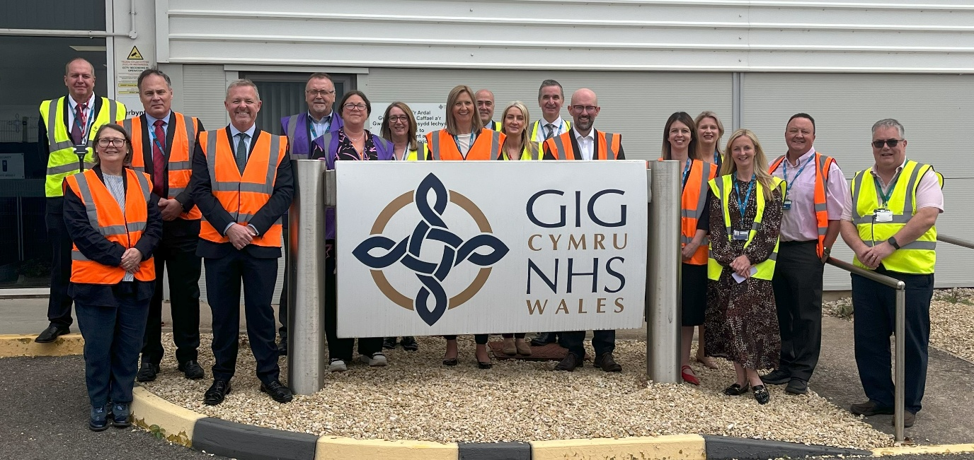

Our services
The following is a list of our current portfolio of services:

- Audit and Assurance | - Medical Examiner
- Accounts Payable | - NHS Wales Employers (hosted)
- Counter Fraud Wales | - Primary Care Services
- Central E-Business Team | - Salary Sacrifice
- Digital Workforce Solutions | - Specialist Estates
- Employment Services | - Surgical Materials Testing Laboratory
- E-Enablement | - Welsh Infected Blood Supply
- Finance Academy (hosted)  - Legal and Risk | - Procurement Services, Supply Chain Logistic and Transport
- Laundry Services | - Lead Employer – Medical, Dental and Pharmacy trainees (including GPs)

Our Culture and Leadership Approach
NWSSP has embedded a clearer organisational leadership model. The culture is defined by:
- Compassionate leadership
- Inclusivity and respect
- Innovation and embracing change
- A commitment to positive workplace culture
- Agile working principles supporting flexibility and staff wellbeing

The Chair is expected to champion and model these behaviours.

Our committee
The committee (SSPC) is the decision-making body responsible for exercising NHS Wales Shared Service Partnership functions in relation to shared services, including the setting of policy and strategy and the management and provision of shared services to Local Health Boards, National Health Service Trusts and Special Health Authorities.

The purpose of the SSPC is to:
- Set policy and strategy for NWSSP
- Oversee delivery of services and strategic programmes through the Managing Director of NWSSP
- Monitor quality, performance and value for money
- Support collaborative models and system-wide efficiency
- Ensure the efficient and effective leadership direction and control of NWSSP and
- Ensure NWSSP contributes to national priorities and future generations obligations


The role of the SSPC is to:
- Take into account NHS Wales organisations’ plans and objectives when considering the strategy of NWSSP;
- Encourage and support the aims and objectives of NWSSP;
- Identify synergies between each of the Shared Services and ensure that future strategies incorporate synergistic opportunities;
- Foster and encourage partnership working between all key stakeholders and staff;
- Oversee the identification and sharing of financial benefits to NHS Wales’s organisations on a fair basis that minimises administrative costs and financial transactional arrangements;
- Seek to identify potential opportunities for further collaboration across the wider public sector;
- Consider implications for Shared Services in relation to any reviews / reports undertaken by internal auditors, external auditors, and regulators, including Healthcare Inspectorate Wales; and
- Seek assurance, through the Managing Director of NWSSP, on the adequacy and robustness of systems, processes, procedures and risk management, staffing issues and that risks and benefits are shared on an equitable basis in relation to Shared Services.
The responsibilities of the SSPC are to:
- Produce an Integrated Medium-Term Plan, including the balanced Medium-Term Financial Plan for agreement by the Committee, following the publication of the individual Health Board, Trust and Special Health Authority Integrated Medium-Term Plans;
- Agree, on an annual basis, Service Improvement Plans (prepared by the Managing Director of NWSSP) for the delivery by services;
- Be accountable for the development and agreement of policies and strategies in relation to Shared Services and for monitoring the performance and delivery of agreed targets for Shared Services through the Managing Director of NWSSP;
- Take the lead in overseeing the effective and efficient use of the resources of Shared Services;
- Benchmark the performance of Shared Services against the best in class;
- Consider extended-scope opportunities for Shared Services;
- Monitor compliance of best practice within Shared Services with NHS Wales recommended best practice;
- Oversee the identification and delivery of “invest to save” opportunities;
- Explore future Shared Services organisational delivery models across the NHS and the broader public sector; and
- Embed NWSSP’s strategic objectives and priorities through the conduct of its business and in so doing, and transacting its business shall ensure that adequate consideration has been given to the sustainable development principle and in meeting the requirements of the Well-Being of Future Generations (Wales) Act 2015, the Welsh Government Guidance on Ethical Procurement and the Code of Practice on Ethical Employment in Supply Chains.

The SSPC must ensure that all its activities are in exercise of these functions or any other functions that may be conferred on it. Each Health Board, Trust and Special Health Authority, shall be bound by the decisions of the SSPC in the exercise of its roles. In the event that the SSPC is unable to reach unanimous agreement in relation to the funding levels to be provided by each Health Board, Trust and Special Health Authority, then this matter shall be escalated to the Welsh Government for resolution ultimately by Welsh Ministers.

To fulfil its functions, the SSPC shall lead and scrutinise the operations, functions and decision making of the NWSSP Senior Management Team (SMT) undertaken at the direction of the SSPC.

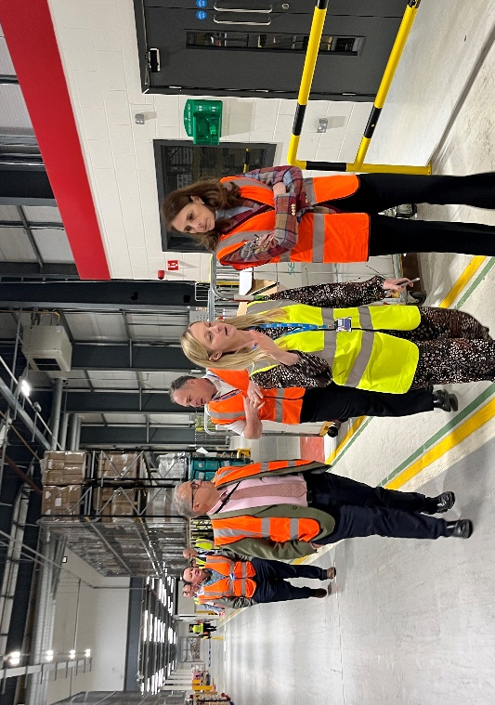
The SSPC shall work with all its Partners and stakeholders in the best interests of its population across Wales.

The Chair – role description
The Chair of the SSPC must act in a balanced manner, ensuring that any opinion expressed is impartial and based upon the best interests of the health service across Wales.

The Chair is responsible for the effective operation of the SSPC:
- Chairing SSPC meetings;
- Establishing and ensuring adherence to the standards of good governance set for the NHS in Wales, ensuring that all SSPC business is conducted in accordance with these SSPC Standing Orders; and
- Developing positive and professional relationships amongst the SSPC’s membership and between the SSPC and each Health Board, Trust and Special Health Authority’s Board.

The Chair shall work in close harmony with the Chief Executives of each of the Health Boards, Trusts and Special Health Authorities (or their nominated representatives) and, supported by the Assistant Director of Corporate Services, NWSSP, shall ensure that key and appropriate issues are discussed by the SSPC in a timely manner with all the necessary information and advice being made available to members to inform the debate and ultimate resolutions.

The Chair is accountable to the SSPC in relation to the delivery of the functions exercised by the SSPC on its behalf and, through Velindre’s Chair, as the hosting organisation, for the conduct of business in accordance with the defined governance and operating framework.

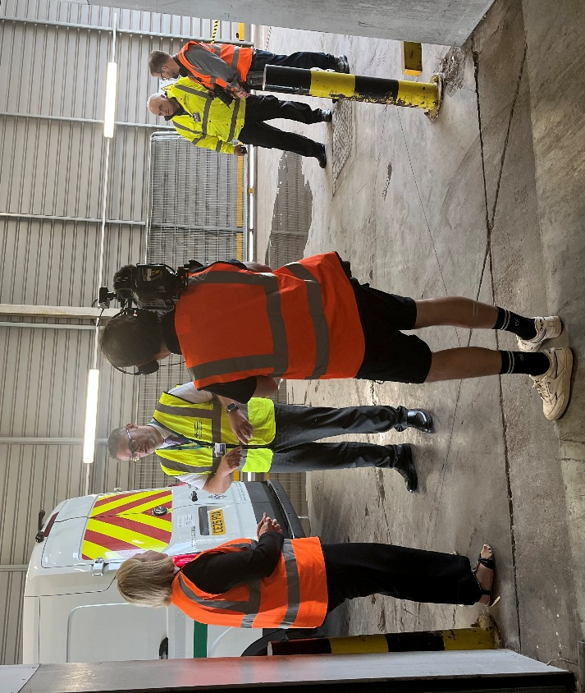

Person Specification
The Chair will demonstrate the following qualities:

Knowledge and experience
- Experience of leading and developing a successful private, public or third sector organisation at a senior level, with the ability to look ahead and provide strategic leadership
- A proven track record in building highly effective relationships with a range of stakeholders
- Knowledge and understanding of the health service, specialist service provision and/or come from a clinical background
- Experience operating within complex system-wide change environments
- Understanding of national transformation programmes

Personal attributes and skills
- Strong interpersonal, influencing and negotiating skills
- An effective advocate and ambassador for better health outcomes through partnership, innovation, and service excellence
- Credible with an ability to make an impact
- Drive and determination, with the ability to instil vision and develop defined strategies to pursue long and short-term goals
- Excellent communication skills, with the ability to be clear and succinct and to facilitate understanding of complex issues while demonstrating respect for the views of others
- Sound judgement, sensitivity and political awareness
- Capacity to be independent and resilient
- Commitment to psychological safety and inclusive leadership

Candidates must also demonstrate:
- Alignment with NWSSP’s cultural commitments and future-focused workforce principles
- A clear understanding and commitment to equality issues and challenging discriminatory practices; and
- A clear understanding and commitment to Nolan’s ‘Seven Principles of Public Life’.

Welsh language skills are desirable. All candidates will be expected to display empathy towards the language and demonstrate leadership to strengthen bilingual service provision within the NHS in Wales.

Candidates shortlisted for interview will be required to expand on how they meet the criteria above using examples and evidence.

Diversity Statement
NWSSPC recognises the value of having public bodies reflecting a wide range of cultures, identities and backgrounds. We encourage applications from all parts of society and want to appoint from the widest and most diverse pool of talent.

We welcome applications from everyone regardless of age, marriage (including same-sex marriage) and civil partnership, sexual orientation, sex, gender identity, impairment or health condition, race, religion or belief or pregnancy. We are committed to recruiting women, Black, Asian and Minority Ethnic people, disabled people and members of the LGBTQ+ community, who are currently under-represented in Board positions at public bodies.

Standards in public life
You will be expected to demonstrate high standards of corporate and personal conduct. All successful candidates will be asked to subscribe to the Code of Conduct for Board Members of Public Bodies and Codes of Conduct and Accountability for NHS Boards and the Code of Conduct for NHS Managers Directions 2006.
Code of Conduct for Board Members of Public Bodies (gov.uk)

Personal Development
NWSSPC values the contribution made by public appointees and wishes to ensure, in association with NHS Wales Bodies that post holders are able to access a range of personal development opportunities.

Conflict of Interests
When applying you will be asked to declare any interests which may, or may be perceived to, conflict with the role and responsibilities, including any business interests and positions of authority outside of the organisation you are applying to. Any conflicts of interest will be explored at interview. If appointed, you will also be required to declare these interests on a register which is available to the public.

Due Diligence
NWSSPC Workforce team will undertake due diligence checks on all candidates successfully sifted to interview. This will include, but not necessarily be limited to, social media and internet searches. As a result, any due diligence findings may be explored further at interview.

Terms of engagement
The appointment will be made by the Shared Services Partnership Committee.

Duration of appointment
The Chair may be appointed for a period of two years. There will be an option to extend for a further two years in the first term.

Location of appointment
Whilst the post is based at our head office in Nantgarw, there is significant flexibility around remote working arrangements. IT facilities will be provided to support agile working.

Eligibility

A person shall be disqualified from appointment if he/she:
- Has within the preceding five years been convicted in the UK, Channel Islands or the Isle of Man of any offence and has received a sentence of imprisonment (whether suspended or not) for a period of not less than three months without the option of a fine;
- Is the subject of a bankruptcy restrictions order or an interim order or has made a composition or arrangement with creditors;
- Has been dismissed, other than by reason of redundancy, from paid employment with a health service body; or
- Has had his/her membership as chair, member or director of a health service body terminated, other than by reason of redundancy, voluntary resignation, reorganisation of the health service body, or expiry of the period of office for which that person was appointed.
Any other information that may materially affect your application for appointment should be declared in the application form under the ‘Conflict of Interests’ section.
Applicants should be persons who conduct themselves at all times in a manner which will maintain public confidence.

Applicants are required to declare whether they are aware of anything in their private or professional life that would be an embarrassment to themselves or to the Welsh Government if it became known in the event of appointment.

Time commitment
The post of Chair is based on a time commitment of 96 days per year. This may be the subject of review.

Remuneration
The Chair is entitled to receive a taxable remuneration of £330 per day.
Expenses
You will be entitled to be reimbursed, if appropriate, against receipts for travel and subsistence expenses incurred while on Committee business.

Childcare and other dependent expenses may also be paid, on production of receipts, for additional costs incurred while undertaking Committee work.

Assistance for disabled members
Where appropriate all reasonable adjustments will be made to enable members to effectively carry out their duties.

NWSSP accepts the social definition of disability, in which it is recognised that barriers in society act to disable people who have impairments or health conditions or who use British Sign Language. We are committed to removing barriers so that all staff can perform at their best. The Equality Act 2010 uses the medical definition of disability (“a physical or mental impairment which has a substantial and long-term impact on a person’s ability to carry out normal day to day activities”).
If you have an impairment or health condition or use British Sign Language and need to discuss reasonable adjustments for any part of this recruitment process, please contact Gareth Hardacre as above as soon as possible and a member of the team will contact you to discuss your requirements and any questions you may have.

Selection process
Although appointments to the NWSSP do not come within the remit of the Commissioner for Public Appointments these appointments are made using a process which considers the Commissioner’s Code of Practice on Ministerial Appointments to Public Bodies as best practice.

It is the policy of the Welsh Government to promote and integrate equality of opportunity into all aspects of its business including appointments to public bodies. Applications are welcomed and encouraged from all groups, and we ensure that no eligible candidate for public office receives less favourable treatment on the grounds of age, disability, gender, marital status, sexual orientation, gender reassignment, race, religion or belief, or pregnancy and maternity. The principles of fair and open competition will apply, and appointments will be made on merit.

Interview process
There will be a two-stage recruitment process including a presentation with a stakeholder panel followed by a formal panel interview. These processes will take place on separate days and depending on circumstances may be conducted virtually.

Start date
To be agreed after the 1st of May 2026

Further information and queries
For further information on the application process and to apply, please visit:
Current Vacancies - NHS Wales Shared Services Partnership

Specific queries can be directed to Gareth Hardacre, Director of People, Organisational Development and Employment Services: gareth.hardacre2@wales.nhs.uk.

Application
Applications should be made by completing the online application form and attaching a CV of no longer than 3 pages as well as a personal statement outlining how you match the requirements for the role.

Closing date
The closing date for applications is 30th April 2026.

Application forms received after this date will not be considered.

