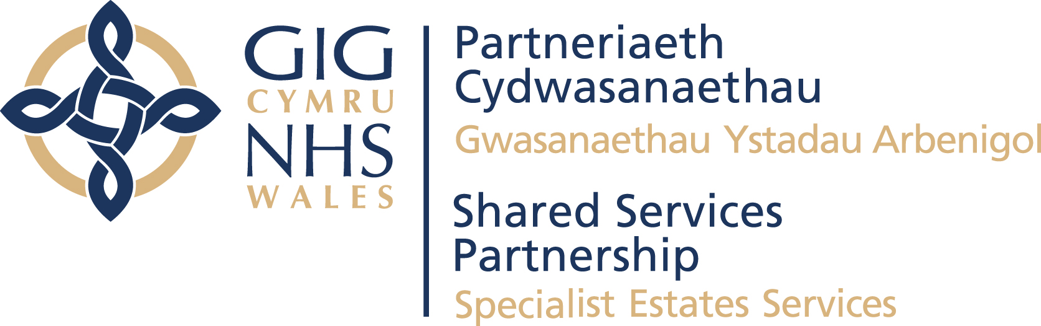


SUMMARY OF LESSONS LEARNED FROM THE
HYWEL DDA UNIVERSITY HEALTH BOARD
DAY SURGERY DEVELOPMENT
AT PRINCE PHILIP HOSPITAL
DECEMBER 2023

Introduction and Purpose

Hywel Dda University Health Board (HDUHB) has kindly shared a Project Completion and Lessons Learned Report for its Day Surgery Unit Development at Prince Phillip Hospital, in Llanelli.

The purpose of this paper is to provide a brief summary of project details and key changes the health board would consider for future developments and to share the learning from this complex scheme. The focus of this summary is therefore on areas which might be strengthened in the future and not on the many areas of success in the project.

Project background

The COVID-19 pandemic was well documented in having significant impact on the UHB’s capability to maintain adequate capacity for scheduled care procedures. Services were severely restricted, and a number of challenges were faced in maintaining elective pathways during the height of the pandemic.

HDUHB initiated a project to pursue a modular solution to facilitate and support the return of elective services within Hywel Dda. It approved a procurement / tender exercise, with a stipulation of achieving technically commissioned works by 29 March 22 and achieving delivery of services during April 2022.

The solution comprised:
- 2 x Laminar Flow Theatres including Preparation Rooms / Anaesthetic Rooms / Dirty Utility
- Recovery Area
- Patient Changing / WC
- Ward area including WC
- Staff Changing including WC / showering facilities
- Storage Facilities
- Reception

A mini-competition was held and led by NWSSP Cardiff and Vale University Health Board Front Line team via NHS SBS, Modular Buildings, Lot 3/4 Modular Healthcare Units for Purchase/Hire, Framework Reference: SBS/10091

During November 2021, it was agreed by WG to make available £20m capital funding to purchase the modular solution on HDUHB’s proposed accelerated programme to achieve completion by 31 March 2022.

A contract was awarded to the successful bidder (Not named). The award was predicated on several key factors including:
- The ability to provide a full turnkey solution – a core requirement of the specification
- Assurances on achievement of handover by end of March 2022
- Compliance to all technical standards i.e. HTM’s

Construction, commissioning and post-handover stages saw an array of issues occur which required considerable management and remedial actions in order to achieve a successful outcome. This did include a very small number of design brief changes by the Client which did result in some minimal additional works necessary.

The key issues to note however, are directly attributable to contractor performance in designing to the client brief/HTM requirements as part of the turnkey contract in place. These are expanded on further as part of lessons learnt, but include:
- Non-compliance of HVAC systems to engineering standards
- Multiple abortive technical commissioning & validation exercises
- Ongoing concerns on considerable defects arisen post-handover
- Approximately a 26 week delay on construction handover
- The facility was not operational until December 2022

Lessons Learned
A summary of what the health board would do differently for delivery of future projects is provided in the tables below:

- Project Governance / Management
1 | A small technical team could’ve supported the project structure to provide assurance to the PD and SRO throughout the life cycle of the project. This could include a “clerk of works” type role.
2 | On schemes which reflect the level of complexity seen on this project, review the role of Project Director and the required experience, skills and knowledge of technical estates issues.
3 | To frequently review governance arrangements and whether these are adequate for this type of project which is progressing at pace.
4 | Instil risk counter measures to mitigate the risk areas of a scheme of this nature.
5 | Building on the agile approach, accurately define a blueprint for managing the project governance as a whole, for a fast tracked scheme.
6 | This agile approach must consider the technical issues such as the engineering components that make up a capital project within the NHS
7 | The use of a RAID document to manage risks, assumptions, issues and dependencies

Stakeholder engagement / involvement including technical support
1 | As a general principle, to review all stakeholders in the project and seek their involvement at the most appropriate point. In this instance, SES could’ve been involved much sooner in the process.
2 | The technical review of design and compliance should take place as part of the tender evaluation process. This could have avoided compliance issues having to be addressed post contract award. This includes adequate scrutiny of the design of a facility which in this case due to inaccuracies on the design brief for the dirty utility room, would’ve impacted the requirements for air flow / air changes etc.
3 | The involvement of key stakeholders in the lifecycle of a fast tracked scheme should take the form of who are interested parties, and who needs to take ownership in the process

Procurement/ commercial strategy / including contractor issues
1 | Building on the points above, ensuring SES involvement in early phases of the project. Issues in design and tender can be addressed at the outset. It is more difficult to address once a contract has been agreed.
2 | On future schemes of this nature where scrutiny needs to be fast tracked, be clear on which areas need to be covered within adequate scrutiny, such as specification, programme, contract and compliance.
3 | When benchmarking other schemes who have taken a similar approach, explore some of the technical queries.

Clinical & Operational Workforce
1 | Take the offer of support from the contractor in developing media content to support a recruitment campaign. This was not taken forward due to existing arrangements for media support for recruitment campaigns as BAU.
2 | More time for recruitment of key posts e.g. medical posts due to recruitment timescales/shortages in some of these roles
3 | Key individuals across all disciplines to be involved from outset of project to enable full scope for recruitment/pathway design – better stakeholder engagement with wider teams from initial tender process

Commissioning group feedback
- More time!
- Scrutiny within the design phase
- More time available for various equipping requirements, schedules / equipping forums etc
- More information available for design workshops (c-sheets etc)
- Greater involvement of senior clinicians throughout the process
- Better identification of who the stakeholders might be
- More in depth planning of the commissioning period
- Better communication during the construction phase

Concluding Comments

It is evident that modular construction has the potential to offer fast track solutions to clinical service needs, although health organisations clearly need to be thoroughly prepared and resourced to be able to oversee planning, procurement, delivery and commissioning stages.

