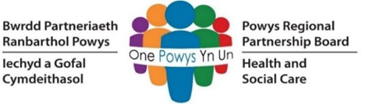
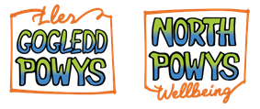

Programme Business Case
North Powys Wellbeing Programme

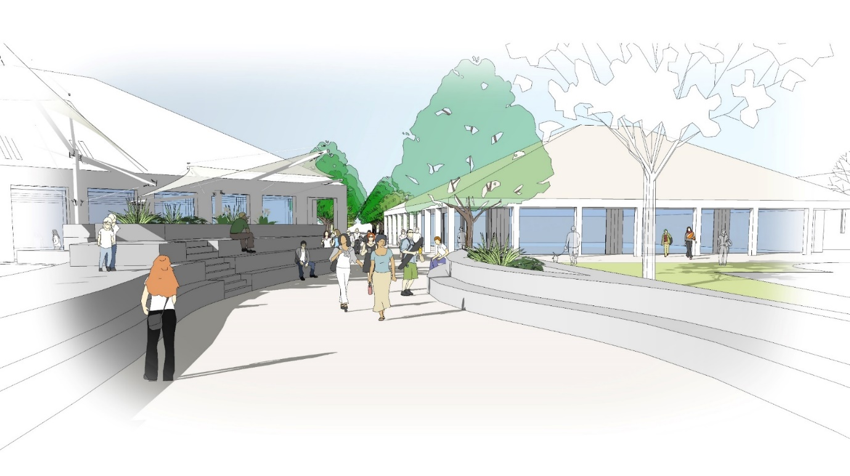

23 June 2021
Version 2
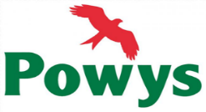
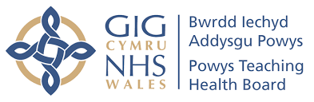

Date | Version | Issued to:
03.04.20 | Draft 1 | PTHB
09.04.20 | Draft 2 | PTHB
17.04.20 | Draft 3 | PTHB for onward transmission to team
22.04.20 | Draft 4 | PTHB for onward transmission to team
30.04.20 | Draft 5 | PTHB for onward transmission to team
07.05.20 | Draft 6 | PTHB; costs included in exec summary, economic/financial cases
28.09.20 | Final Draft | PTHB for Strategy & Planning Committee
03.11.20 | Version 1 | Submission to Welsh Government
23.06.2021 | Version 2 | Inclusion of Scrutiny Grid Comments in relation to Infrastructure, Decarbonisation & Synergies

Contents

1 Document Structure 7
1 Executive Summary 8
1.1 Recommendation 29
2 The Strategic Case 30
2.1 Part A: Strategic Context 31
2.2 Part B: The Case for Change 84
3 Economic Case 124
3.1 Introduction 124
3.2 Critical Success Factors (CSF’s) 124
3.3 Main Options for Investment 124
3.4 Preferred Way Forward 129
3.5 Economic Appraisal of Short-Listed Options 130
4 Commercial Case 135
4.1 Introduction 135
4.2 Commercial Objectives 135
4.3 Procurement Process 136
4.4 Required Services 138
4.5 Contractual Arrangements 138
4.6 Funding 139
4.7 Timing 139
4.8 Personnel Implications (including TUPE) 141
4.9 Accountancy Treatment 142
5 Financial Case 143
5.1 Introduction 143
5.2 Financial Appraisal of Options 143
5.3 Revenue Affordability 146
6 Management Case 147
6.1 Introduction 147
6.2 Programme Management Arrangements 147
6.3 Use of Special Advisors 152
6.4 Arrangements for Change Management and Evaluation 152
6.5 Stakeholder Engagement 152
6.6 Arrangements for Benefits Realisation 154
6.7 Arrangements for Risk Management 154
7 Appendices 155
7.1 Appendix A: Health and Care Strategy: A Healthy Caring Powys 155
7.2 Appendix B: North Powys Property Database 155
7.3 Appendix C: Decarbonisation Measures 155
7.4 Appendix D: Case Studies 155
7.5 Appendix E: Health Indicators: Newtown North East and Newtown South West 155
7.6 Appendix F: Integrated Model of Care 155
7.7 Appendix G: North Powys Wellbeing Programme Case for Change 155
7.8 Appendix H: Open Newtown 155
7.9 Appendix I: Site Analysis and Concept Masterplan 155
7.10 Appendix J: Benefits Framework 155
7.11 Appendix K: Arcadis Site Feasibility Study January 2019 155
7.12 Appendix L: Financial Appraisal of Short-Listed Options 155
7.13 Appendix M: Programme 155
7.14 Appendix N: Programme Risk Register 155

List of Tables
Table 1: Buildings on and in close proximity to the Preferred Site 21
Table 2: Preferred Way Forward 22
Table 3: Options Summary 23
Table 4: Spatial Requirements 23
Table 5:High Level Economic Options Appraisal 26
Table 6:Reconciliation of Economic to Financial Case costings 27
Table 7: NIFC multi-agency groups 42
Table 8: District Hospitals serving North Powys residents (with min and max travel time) 57
Table 9: Initial Assessment of the NPWP against "A Healthier Wales" principles 63
Table 10: 5 Key ways of Working in the context of the NPWP 65
Table 11: Wellbeing Objectives: NPWP Contribution 69
Table 12: Strategy for Transforming Education in Powys 2020-2030 Strategic Aims 71
Table 13: PTHB’s Environmental Management System and Estates Decarbonisation Plan 78
Table 14: Ladywell Green Infant School and Hafren Junior School Building Condition 87
Table 15: Condition Survey Grades 87
Table 16: Powys Adult Social Care Service Delivery 88
Table 17: Children's Services 89
Table 18: Mental Health Services 92
Table 19: Health and Social Care Estate 97
Table 20: Newtown Library Services 98
Table 21: PCC and Housing Association Stock in Newtown 102
Table 22: Housing Pressures and Supply in North Powys 104
Table 23: Benefits of Integrating Services 110
Table 24: Potential Sharing with Education 110
Table 25: Potential Sharing Opportunities 111
Table 26: Spending Objectives 121
Table 27: Critical Success Factors 124
Table 28: Buildings on and in close proximity to the Preferred Site 125
Table 29: Long List of Options: Technical Scope 127
Table 30: Long List of Options: Service Solution 128
Table 31: Long List of Options: Service Delivery 128
Table 32: Long List of Options: Implementation 129
Table 33: Long List of Options: Funding 129
Table 34: Preferred Way Forward 129
Table 35: Cost Comparison of Options 131
Table 36: Spatial Requirements 131
Table 37: High Level Capital Cost Appraisal 132
Table 38: High Level Economic Options Appraisal 133
Table 39: Risk Transfer Matrix 139
Table 40: Schedule of Key Dates 140
Table 41: Capital Cost Comparison 144
Table 42: Capital Cost Summary 145
Table 43: Roles and Responsibilities 150
List of Figures
Figure 1: Multi-Agency Wellbeing Campus Emerging Model 9
Figure 2: Business Case Plan 9
Figure 3: Proposed Programme Timeline 10
Figure 4: Model of Care for Powys 15
Figure 5: Current Backlog Maintenance in Newtown 16
Figure 6: Benefits Framework 18
Figure 7: Integration Opportunities 18
Figure 8: Design Opportunities 20
Figure 9: Service Strategy 20
Figure 10: Preferred Site Plan 21
Figure 11: North Powys Programme Governance Structure: Reporting and Approvals 28
Figure 12: PTHB Secondary Care Commissioning 33
Figure 13: Current Backlog Maintenance in Newtown 34
Figure 14: NPWP Case studies 41
Figure 15: Service Strategy 43
Figure 16: Integration Opportunities 49
Figure 17: Integration Opportunities 52
Figure 18: North Powys Demography 53
Figure 19: Conditions that make up the social determinants of health 54
Figure 20: Map of North Powys depicting population of largest towns 55
Figure 21: North Powys population age banding percentages 56
Figure 22: North Powys health indicators (wellbeing, big 4, joined-up care) 59
Figure 23: North Powys health indicators (detailed analysis) 60
Figure 24: Well-being Goals 65
Figure 25: Well-being Objectives 68
Figure 26: Powys Health and Care Strategy "at a glance" 72
Figure 27: The Model of Care for Powys 73
Figure 28: Draft Strategic Outcome Framework 76
Figure 29: The new facilities at LWH, visited by Vaughan Gething, Minister for Health and Social Services 80
Figure 30: Basil Webb Hall, Bronllys 81
Figure 31: Progress March 2021 82
Figure 32: Visualisations of complete H&C Academy 82
Figure 33: Ysgol Dafydd Llwyd, Newtown, opened in January 2016 83
Figure 34: Bookable Services at the Integrated Family Centre 89
Figure 35: Services delivered from Newtown Hospital 91
Figure 36:Wellbeing Services in North Powys 93
Figure 37: Key Buildings in Newtown 100
Figure 38: Multi-Agency Wellbeing Campus Emerging Model 106
Figure 39: Merger of Ladywell Green Infant and Hafren Junior Schools 109
Figure 40: Potential Role of Library Services 112
Figure 41: Site Plan to test Maximum Scope will fit on site 118
Figure 42: Benefits Framework 122
Figure 43: Preferred Site Plan 125
Figure 44: North Powys Programme Governance Structure (Overarching) 147
Figure 45: North Powys Programme Governance (Reporting) 148
Figure 46: Programme Governance: Roles/Reporting 149
Figure 47: North Powys Programme Communication Strategy 151
Figure 48: Key Stakeholders 153

Document Structure
This Programme Business Case (PBC) has been prepared using the agreed standard and format for business cases using the Five Case Model, which comprises the following key components:
- The Strategic Case: this sets out the strategic context and the case for change, together with the supporting investment objectives for the programme
- The Economic Case: this dimension of the five cases focuses on options appraisal and demonstrates that the proposals will maximise social value to society through the selection of the optimal combination of projects and related activities
- The Commercial Case: this describes the development and procurement of the potential deal, ensuring it is commercially viable and attractive to the supply side
- The Financial Case: this focuses on the whole life costs of the proposed deal, confirming the programme is affordable and is fundable over time
- The Management Case: this demonstrates that the scheme is achievable and can be delivered successfully to cost, time and quality and focuses on the implementation arrangements for the proposal

Executive Summary
This Programme Business Case (PBC) seeks endorsement for the Regional Partnership Board (RPB), led by Powys Teaching Health Board (PTHB) and Powys County Council (PCC) (“the Partnership”) to further develop plans to create a collaborative, multi-agency wellbeing campus (the “Campus”) for the population of north Powys, delivered by the North Powys Wellbeing Programme (NPWP). The Programme, established in 2019, is a once in a generation opportunity to bring together partner organisations to enhance and transform the way services are delivered to the local community.
The PBC will demonstrate the ambition across partner organisations to develop a new integrated model for the area, bringing partners together across education, health and social care, housing, community and third sector, with opportunities for further linkages to leisure, police and ambulance services. It will also maximise wellbeing and leisure opportunities via essential links with green spaces through Open Newtown and collaborative working with partners in the Third Sector and local business. Recognising the specific needs of the populations across north Powys, the development will include provision of bespoke information, advice and assistance to support and empower the local population to manage their own wellbeing needs. Adopting this approach and targeting wider determinants of health will provide a valuable contribution to improving health and wellbeing of the present and future generations living in north Powys.
It will support economic growth and regeneration of the area, in line with the National Development Framework, which identified Newtown as an important regional centre. It will also have strong links with the town centre supporting Welsh Government’s initiative “Town Centres First”. The emerging model for the campus is illustrated below:
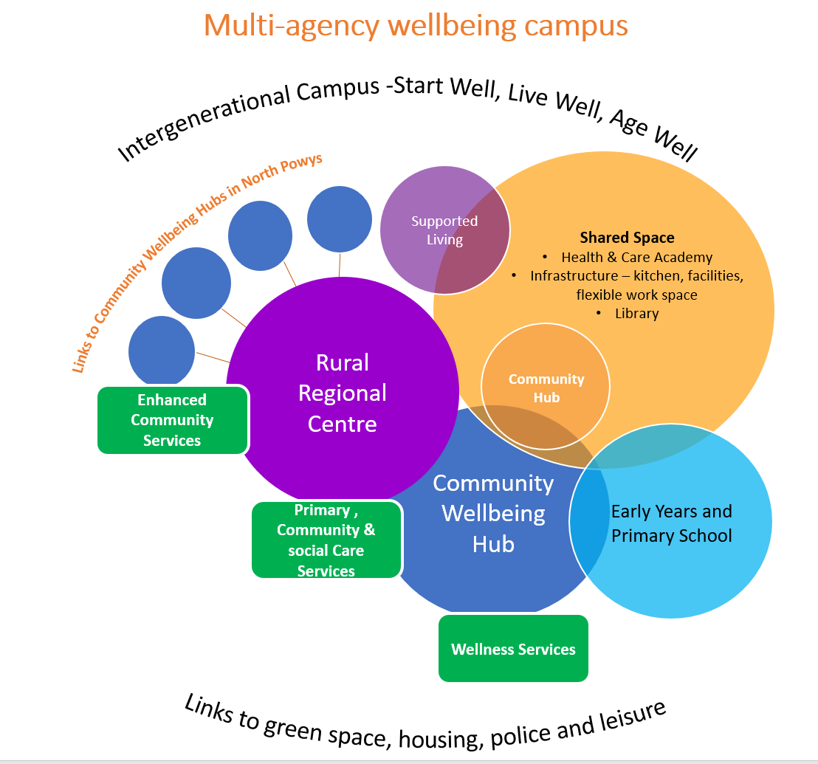
Figure 1: Multi-Agency Wellbeing Campus Emerging Model
A core aim of the programme is to provide significantly improved and enhanced local services, delivered from a single location within sustainable and fit-for-purpose accommodation. This approach will maximise efficiency, integration and innovation across multiple sectors which will represent significant benefits for the local community, including a wider range of services being delivered in county. The PBC is an overarching “live” document detailing the RPB’s strategic direction and will be supported by a series of sector specific Business Cases as detailed below:
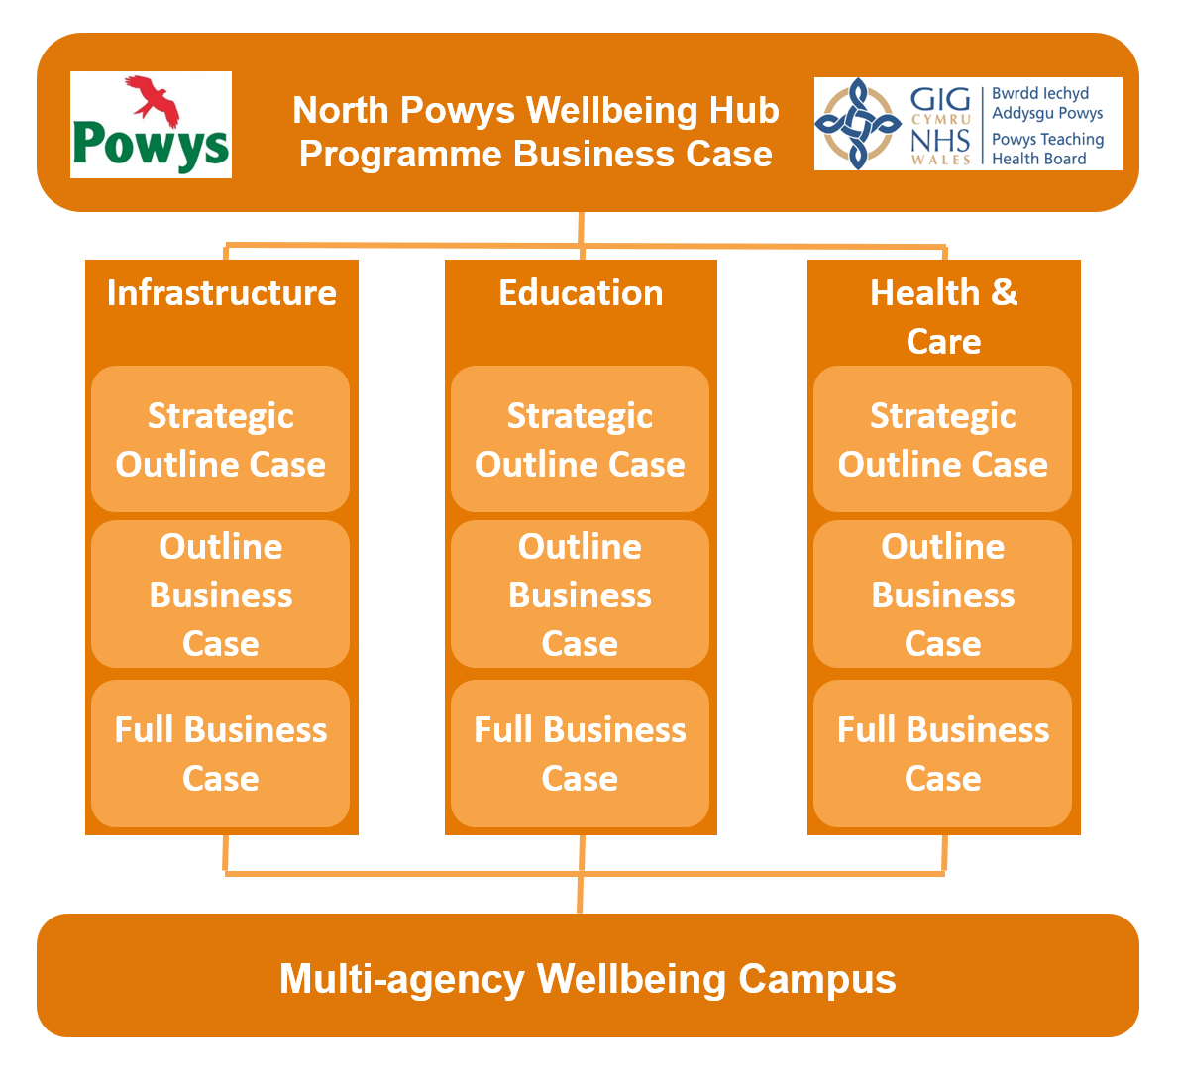
Figure 2: Business Case Plan
These supporting Business Cases will further develop the principles outlined in this PBC, which itself will also be updated as individual projects progress. The proposed sequencing for the programme is outlined below:
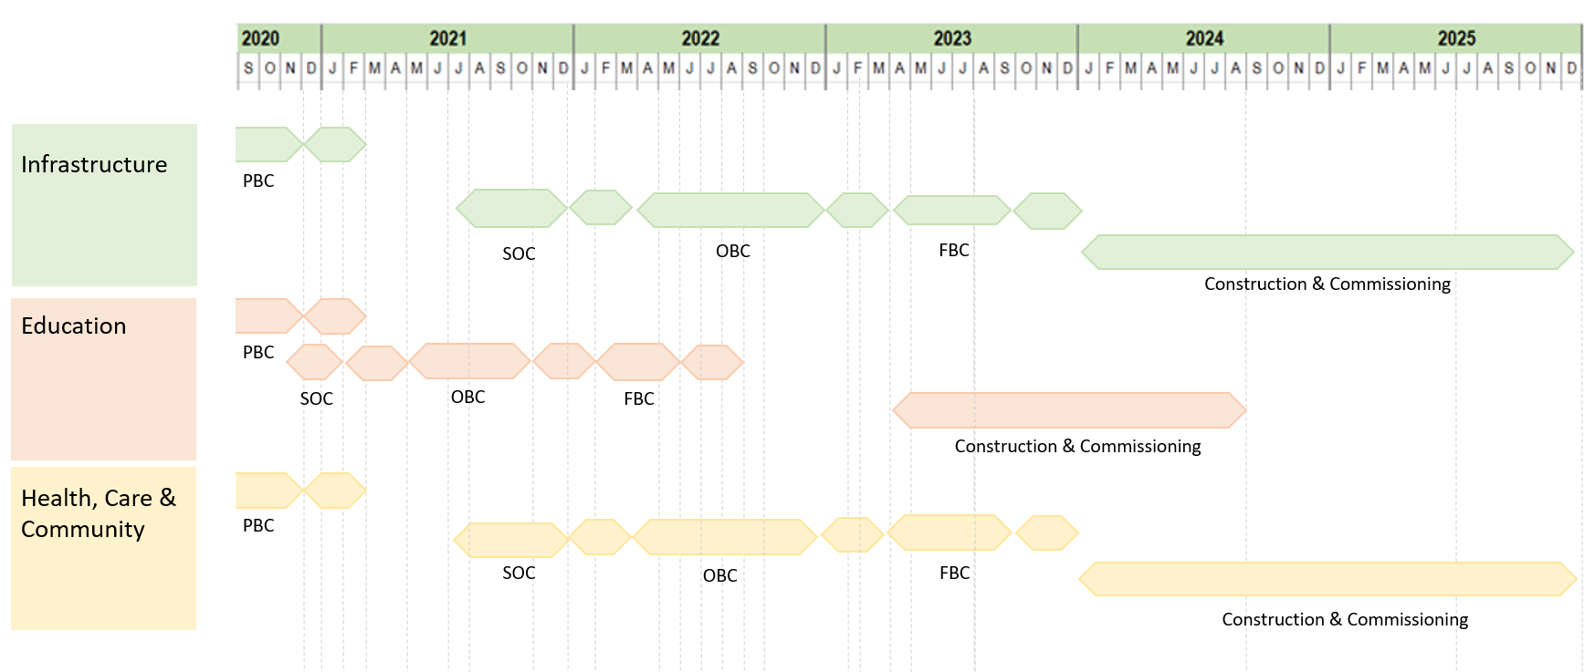
Figure 3: Proposed Programme Timeline
These core workstreams will be overseen by the ‘Innovative Environment Oversight Group’ (IEOG). This group will focus on innovation and ensure that the ‘golden thread’ of the synergies that can be achieved by adopting a campus approach, including opportunities for flexible and shared spaces, remain central to each individual business case.
The possible ‘synergies’ associated with adopting this approach are further defined in section 2.1.3.2 and will focus on how the integration of services via a ‘campus’ will support addressing key social determinants which influence a person’s health and wellbeing. These will include:
- Early years support – The campus will enable agencies to work together to offer activities which improve emotional health and wellbeing of children as demonstrated by such initiatives as the Bach a lach project and the work being undertaken with the Oriel Davies Art Gallery to support children and young people through arts and culture. A multi-agency approach will also strive to support families to prevent children from going into care, and when they do investing in local services so they can live closer to home with the right multi-agency in place to support their emotional health and wellbeing needs.
The campus will also provide community spaces, 1:1 rooms, dedicated early years classrooms and direct outdoor learning facilities which will enable; school based visits such as school nurse and social care, wider community use and involvement, parent and toddler group activities, Powys County Council and the school to provide a 30-hour childcare offer. This wider family support and wrap-around services will establish, build and encourage early attachments with the school and support services from birth.
- Employment opportunities – Education and training (including virtual training) will be provided on the campus through the development of the Rural Health and Care Academy. This will help to develop a skilled sustainable workforce, opportunities for employment, recruitment and retention of staff. Making Powys a more attractive place to live and work. There is also a prominent opportunity with having a school situated on the campus in that it allows PTHB and PCC to collaborate with local schools as well as community organisations to expose more young people to careers in health and social care, raise the profile of different types of health and care jobs and help support skills development locally.
- Access to health services – As health care is a significant determinant of health and health status, the social model acts to enable all people to have appropriate health care regardless of their social situation. The social model of health allows individuals and communities to participate in decision making about their health. Individuals are more likely to participate in healthy behaviours if they feel they have a sense of power and control over their situation.
There will be focus on developing an integrated care pathway which promotes health and wellbeing through prevention and community resilience, creating social value. The proximity of service will support a holistic offer and harness the ability to successfully embed green and social prescribing as an alternative to relying on traditional prescription methods where appropriate.
- Recreational and leisure opportunities – Core to the development of the campus will be consideration of outdoor spaces. Forest school and outdoor classrooms will be included which can also be utilised by the wider community out of hours. In addition, the campus will provide safe spaces for extra curricular sport and outdoor leisure activities. There is also a unique opportunity for the campus through links with ‘Open Newtown’ and local leisure facilities. Wider social and community groups and activities are supported through the development of shared community spaces as well as the library development which already offer a wide range of services including; Homework clubs and afterschool and holiday clubs, all provided in one place. Links with groups utilising recreational and leisure activities to improve wellbeing include Montgomeryshire Wildlife Trust and Walking Newtown.
- Access to housing and utility services – Opportunities to support vulnerable groups will be created through integration of housing, health, social care and wellbeing services potentially within the shared space – supporting the homeless amongst other groups. Co-locating the Supported Living accommodation on site provides proximity to a range of wellbeing services for people, improving their recovery from hospital, but also by supporting young people transitioning out of care. The step-down element of the supported living facility will build on the new model/facility due to open in Welshpool Cae Glas and will be underpinned by a new integrated community model for intermediate care enabling a period of intensive reablement to support people back to normal activities promptly.
- Nutrition – Schools already work to ensure that all pupils have access to nutritionally balanced school meals. The wider benefits of the campus approach means that organisations across health and social care can offer nutritional help and advice to families and young people including healthy eating demonstrations and cookery lessons to empower communities to support their own health and wellbeing and encourage healthy choices.
- Environmental Factors –The climate crisis has serious direct and indirect consequences for health; Climate change and air pollution contribute to acute and chronic health conditions that are costly to health and social care services. These factors also disproportionately affect disadvantaged and vulnerable populations, thereby further entrenching inequalities. The campus will be developed with the latest in carbon-reducing technologies at the forefront which will have a wider positive impact on the health of the population. In addition, innovative decarbonisation initiatives are planned to minimise carbon emissions from the built environment construction and operation, along with improved public transport and electric vehicle support infrastructure, which will realise improvements to air quality for the community and beyond. Another core aim for the North Powys Wellbeing Programme is to deliver health and care services closer to people’s homes through a locally enhanced offer and maximising digital capabilities thus reducing travel. The integrated campus will deliver a common infrastructure which will permit high efficiency, low carbon emitting buildings and shared support services, which will help alleviate the environmental impact from health, education and social care services, and facilitate the public sector to realise its 2030 net zero carbon emissions compulsions to the Welsh government and citizens of Wales. Additionally, a shared campus will permit the most efficient use of land and building space from full utilisation of term-time and non term-time periods of room occupation.
- Social inequality – This involves a range of government and nongovernment organisations working together to promote health and reduce the impact of social inequality. This collaborative approach offers open access services in one place, at one time, enabling organisations to provide services efficiently and cost effectively whilst meeting the immediate needs of the local population.
- Social support and community inclusivity - Communities are more resilient when people are connected through social networks, using the campus for community use or supporting the development of surrounding green spaces can provide vital opportunities for social interaction and intergenerational activities. There are a diverse range of third sector groups and organisations who have expressed a strong desire to operate from or link into the campus in Newtown, offering wellbeing and preventative services to minimise the reliance on statutory services and enhance the health and wellbeing of the local population.
The campus will provide a ‘One stop shop’ for the local community offering a range of services closer to home with a focus on multi-disciplinary working within health but also multi-agency and cross-sector working to support wellbeing, prevention, early help and support, information and advice – it is envisaged that this will lead to a greater uptake of services as this will provide a convenient, social ‘destination’ for people. In focusing on wellbeing there are also benefits in relieving pressure on the health and social care system which will be further developed at the next stage but helping to build community resilience through social, green and blue prescribing will encourage cultural wellbeing, physical activity and social interaction leading to improved mental and physical wellbeing.
The North Powys Wellbeing Programme recognises that the social determinants of health and wellbeing would be better addressed by a broad range of third sector organisations rather than statutory services, however people don’t always know what is available or where to access third sector support and naturally defer to statutory service support. Addressing the social determinants of health requires a collaborative approach, bringing organisations together on one site to provide more holistic person-centred services.
The development of a multi-agency campus will create a whole system change to move from a focus of illness to a focus on wellness. This means embracing a social model of health, addressing every aspect of life that can impact on a person’s health and wellbeing.
The Strategic Case describes how the North Powys Wellbeing Programme fits within the existing business strategies of PTHB, PCC and third sector organisations, outlining a compelling case for change in terms of existing and future needs.
The Strategic Context provides an overview of PTHB/PCC and the current services being delivered in north Powys. This section confirms that there is a strategic fit between the proposed programme and national/local policy and objectives and that the programme supports the proposed vision for service delivery and changes in activity.
Nationally, this will focus on how the programme supports The Well-being of Future Generations (Wales) Act 2015 , The Environment (Wales) Act 2016 and Prosperity for All: A Low Carbon Wales 2019. There will be particular reference to the National Climate Change Emergency and how the proposed works will contribute to a Net Zero Carbon Public Sector by 2030. The programme has considered a broad range of viable low carbon construction options (See Section 2.1.2.1) which will be fully investigated through subsequent business cases. In order to support this work several workshops have already been undertaken and PTHB and PCC are continuing to work jointly with the Welsh Government Energy Service (WGES) and Re:Fit Cymru, who provide technical guidance and potential access to additional funding. In addition, the programme will set ambitious targets against standards beyond the minimum requirements such as BREEAM, Passivhaus, and Building Regulations, responding also to Aurp’s Net Zero Carbon Healthcare, UK Green Building Council’s Net Zero Standard and the UK government’s Common Minimum Standards. Modern Methods of Construction shall be employed to deliver on time, quality controlled, better performance buildings with reduced disruption and less impact from construction-related personnel requirements to the local community, whilst at the same time ensuring a less hazardous construction site which will deliver less waste and fewer transport loads through the construction phase. Low carbon engineering options such as ground or water source heat pumps, energy storage, solar panels and hybrid heating systems will be considered and evaluated including their impacts on the environment and society both upstream and downstream whilst also considering carbon offsetting and biodiversity impacts. The proposals also support a move to a “Carbon Positive Powys” as set out in the Public Service Board’s Wellbeing Plan and the emerging Regional Energy Plan. These measures will be embedded in the programme through the appointment of a dedicated Sustainability representative.
Other primary national guidance includes: A Healthier Wales: our Plan for Health and Social Care, Prosperity for All: The National Strategy (Wales) and the 21st Century Schools and Colleges Programme.
Locally, this programme supports the vision, objectives and outcomes of the RPB’s Health and Care Strategy: ‘A Healthy Caring Powys’, including the development of health services to form Rural Regional Centres and Community Wellbeing Hubs and is fully aligned with PCC’s Vision 2025 and PTHB’s Integrated Medium Term Plan 2019/20-2021/22 (IMTP).
The development of the school element of the campus is also aligned with the Strategy for Transforming Education in Powys 2020-2030 which sets out the following vision statement for education in Powys:
“All children and young people in Powys will experience a high-quality, inspiring education to help develop the knowledge, skills and attributes that will enable them to become healthy, personally fulfilled, economically productive, socially responsible and globally engaged citizens of 21st century Wales”.
The Strategic Context will also demonstrate that the projects and activities detailed in this programme align with other programmes and projects within the Partnership’s strategic portfolio. This will include other examples of successful integration, such as the Newtown Integrated Family Centre (NIFC) where agencies are already working together to improve the emotional health and wellbeing of children and families.
The Case for Change examines the existing arrangements/Business as Usual (BAU) and related business needs for the future of north Powys. This element of the case will focus on improvements/developments required under the main headings of Service delivery and Estates compliance.
In service delivery terms, the programme offers the Partnership the opportunity to redesign the way in which services are delivered across north Powys and implement changes to support the service strategy and integrated model of care.
In order to enable residents in Powys to live longer, healthier and happier lives, there is a need to shift the focus of the model of health and care away from service delivery in acute and specialist hospital settings and offer a more holistic, integrated model with more wellbeing, prevention and early help services delivered closer to people’s homes and communities.
The new integrated model of care for Powys is part of a Wales-wide response to the increasing demands and new challenges facing the NHS and social care. These include an ageing population, lifestyle changes, public expectation and new and emerging medical and digital technologies. This enables health, social care and other partner systems to work together, to help people live well in their communities, meet their health and care needs effectively and provide more services closer to or at home, so that people only need to use a hospital for treatment that cannot be provided safely anywhere else.
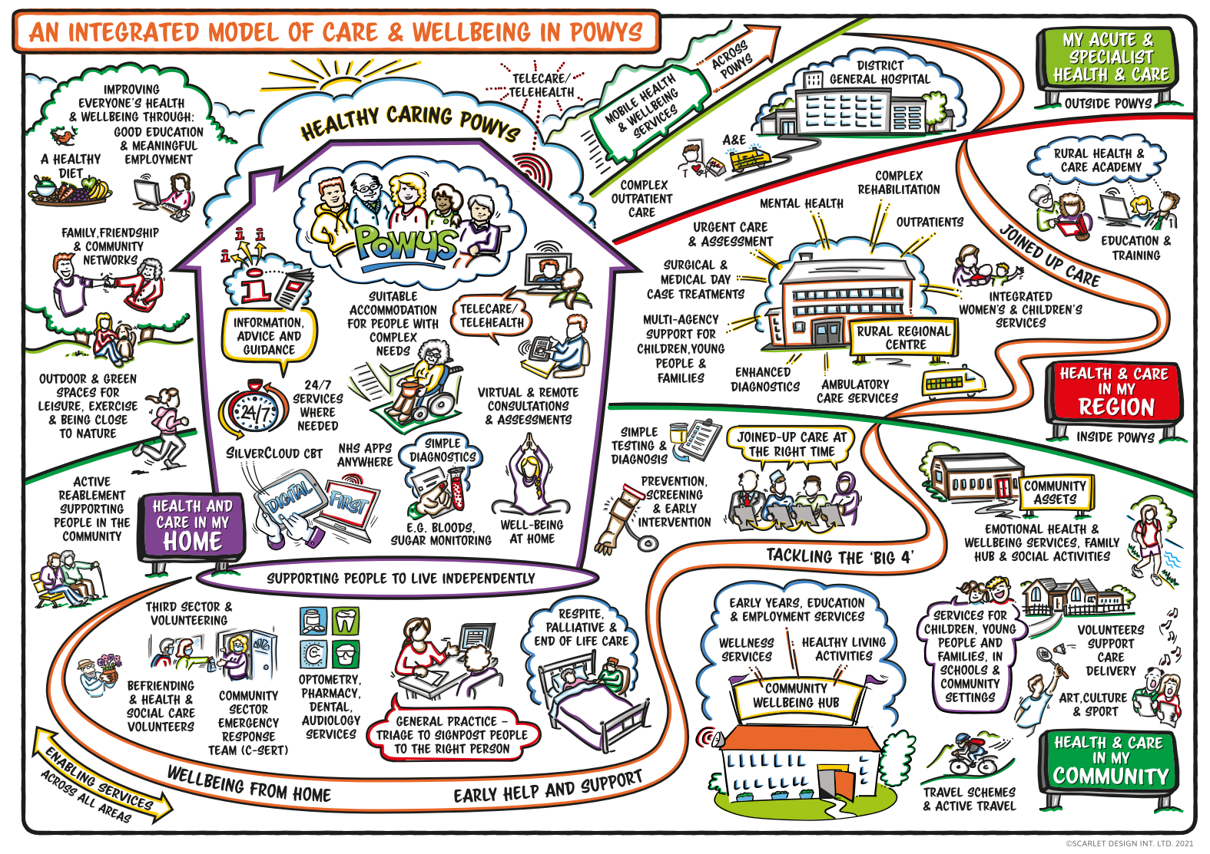
Figure 4: Model of Care for Powys
The Campus will support the current and future population needs and provide more care closer to home in north Powys in order to mitigate against the impact on planned care arising from the Future Fit programme, in addition to addressing compliance issues of an ageing estate.
During 2019, work has been undertaken to assess the local population needs and to develop a robust case for change to underpin a new integrated model. Communities, staff, partners and key stakeholders have been extensively engaged during this time and co-participated in the development of a new integrated model of care which was approved by the RPB and sovereign bodies in March 2020. Further development of the integrated model of care, including demand, activity and capacity planning, is due to be undertaken in 2020/21 as part of the Health and Social Care Strategic Outline Case (SOC) which will further support the development of these services.
For Education, PCC has already received approval in principle of its Strategic Outline Programme (SOP) for Band B of the 21st Century Schools Programme to invest in Newtown (summer 2017). Feasibility work has been concluded, indicating a preference for a new build English-medium primary school within the Campus, replacing the current Ladywell Green Infants School and Hafren Junior School.
Schools in Powys play a central role in their communities, therefore this programme will consider how the development can support more collaborative working to improve wellbeing through early years provision, childcare support, multi-agency services, library services, and include areas for community activity, where appropriate. Not only does this provide an efficient, value-for-money approach that will support the continuation of community services especially in rural areas, it also provides a unique opportunity to deliver an innovative service model.
The Library service is underpinned by a holistic community-centric philosophy and works closely with other public services to provide for the information and learning needs of the whole community. The service promotes wellbeing and aims to counter loneliness. There is therefore an opportunity for this service to draw together the other elements of the PBC and act as the front door to all the other services, reinforcing the philosophy of “no wrong door”.
In compliance terms, PTHB has one of the oldest estates within Wales with over 38% pre-dating the NHS (pre 1948). Similarly, much of PCC’s existing estate is of poor quality, with the two existing schools being identified as condition categories C and D. As such, the Partnership is managing sites with high levels of backlog maintenance, which have significant or high risks of non-compliance or failure. By working collaboratively and combining services into a Campus-style approach, the programme aims to significantly reduce the backlog maintenance across a number of sites whilst benefiting from more efficient space utilisation. In addition, this would release surplus building stock, delivering either cash releasing benefits or potential development opportunities.
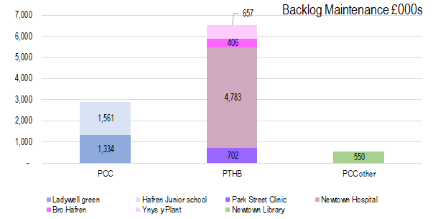
Figure 5: Current Backlog Maintenance in Newtown
As demonstrated in the diagram above the current backlog maintenance across the built estate is circa £10 million. Properties that are no longer suitable for service delivery will be identified when progressing with the Campus, resulting in an estate of better performing buildings leading to a reduction in the running costs and a more sustainable, innovative “fit for purpose” property portfolio, with no residual high or significant compliance risks across the Partnership.
The development of the campus will also result in:
- Improved efficiency – through consolidation and sharing, improving space utilisation and reducing duplication
- ‘Right space right place’ – ensuring all spaces are fit for their intended purpose i.e. not over/under engineered. This will also maximise flexibility with the use of generic, repeatable and digitally enabled multi-use spaces.
- New ways of working – The development of the Interim Innovative Environments Strategic Framework will ensure that learning from COVID-19 is embedded and considers the impact of digital and new workforce models such as the implementation of agile working, and describing how innovative environments support a more holistic integrated model of care.
- Environmental quality – Cleaner, more efficient and effectively-designed and utilised built environment will have direct and indirect benefits to the health and wellbeing for the local population. Direct benefits will be achieved from having more diverse, local, enhanced and specialised education, social and health care facilities. The provision of local, clean and modern facilities close to where people live will provide a feeling of contentment, with enhanced emotional wellbeing and lessened anxiety with respect to current sporadic provisions from spread-out, tired and dated locations.
- Improved digital infrastructure - Digital infrastructure is one of the key priorities for the RPB supporting both immediate priorities of COVID response as well as taking a longer term view to support connectivity in rural Powys and further alignment with the National Digital Health and Care Wales plan.
- Decarbonisation - The campus represents a unique opportunity for north Powys to create an efficient, consolidated network of buildings with single service strategy – an opportunity to utilise ‘green’ building techniques and technologies as well as supporting reduced travel and promoting green travel plans including the provision of EV charging. The IEOG includes environmental specialists from both organisations and are being supported by Welsh Government Energy Service (WGES) and Re:Fit Cymru, who provide technical guidance and potential access to additional funding. The proposals also support a move to a “Carbon Positive Powys” as set out in the Public Service Board’s Wellbeing Plan and the emerging Regional Energy Plan. A number of workshops have taken place to develop a long list of potential decarbonisation options (see section 2.1.2.1) which will be further developed and defined in subsequent business cases.
The Key Benefits associated with this programme are further detailed in Section 2.2.10 and are summarised below:
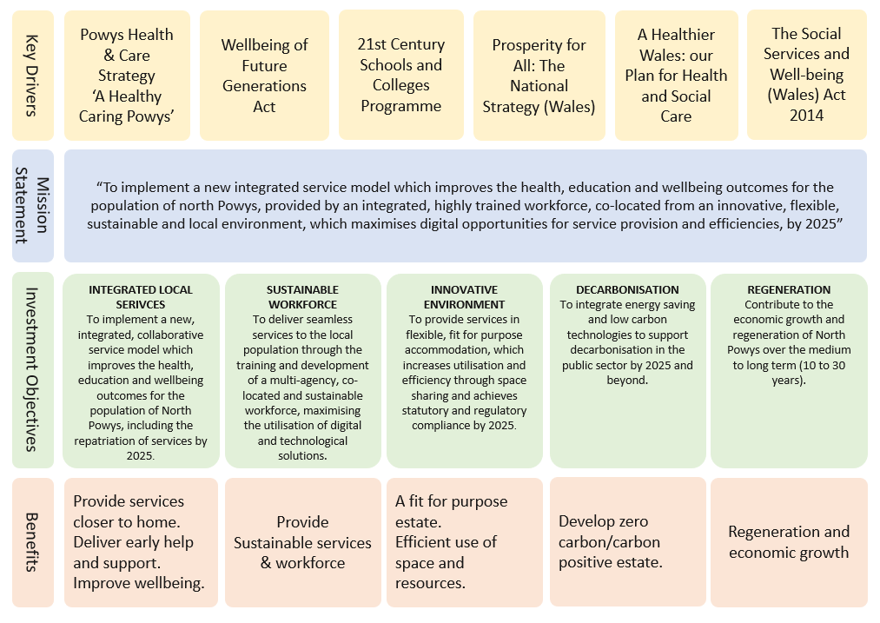
Figure 6: Benefits Framework
It is acknowledged that some benefits will be sector specific, however, a primary focus of this programme is to identify the benefits associated with the integration and co-location of services. The key themes are outlined in the diagram below:
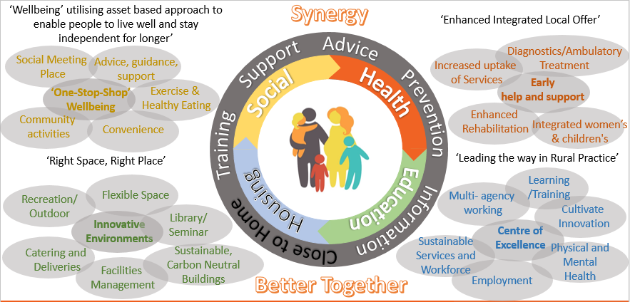
Figure 7: Integration Opportunities
Further information regarding synergies can be found in section 2.1.3.2, though one of the primary benefits of this approach are those associated with integrated working. This will be further defined at Strategic Outline Case (SOC) stage as the demand and capacity modelling is concluded however, the main benefits are highlighted below:
- More efficient pathways through multi-agency assessment and holistic, personalised care and support.
- ‘one stop shop’ approach which can identify and support individuals broadest health and wellbeing needs.
- The campus will be a centre for education, training and employment making north Powys a more attractive place to live and work assisting with the recruitment and retention of staff and supporting a sustainable rural workforce.
- For education staff, a campus approach offers an opportunity to work more closely with child health professionals, care givers, social workers etc ensuring that children’s wider educational, social and wellbeing needs are identified and supported.
- Children attending school on the campus will have access to a wide network of social, leisure and wellbeing activities as well as further education opportunities such as health, wellbeing and nutrition.
- Reduction in clinical risk through standardised practice by removing artificial barriers and a clear framework of integrated accountability for patient wellbeing.
- Enhanced digital capability; offering improvements in diagnostic and ambulatory care, consultations and supporting people in their own homes. Improvements in digital infrastructure will also support agile and flexible working practices, improve access to training and enable multi organisational communication via Microsoft Teams.
- Reduce inefficiencies and duplication.
- Resources directed to where they are most needed.
- Early intervention and anticipatory care to mitigate the risk of more intensive care by offering more flexibility to remain at home with comprehensive, wrap-around support.
- Better communication – anecdotally referred to as the ‘water cooler moment’ - staff across different departments/organisations working in close proximity enhances innovation, staff morale and networking opportunities.
The Campus approach has allowed the programme team to explore the opportunities for integrated, shared and flexible spaces which can offer a number of benefits including maximised space utilisation, more efficient use of building footprint, economic benefits and greater opportunities for integration, collaboration and innovation across disciplines. The key opportunities to be further investigated include the following:

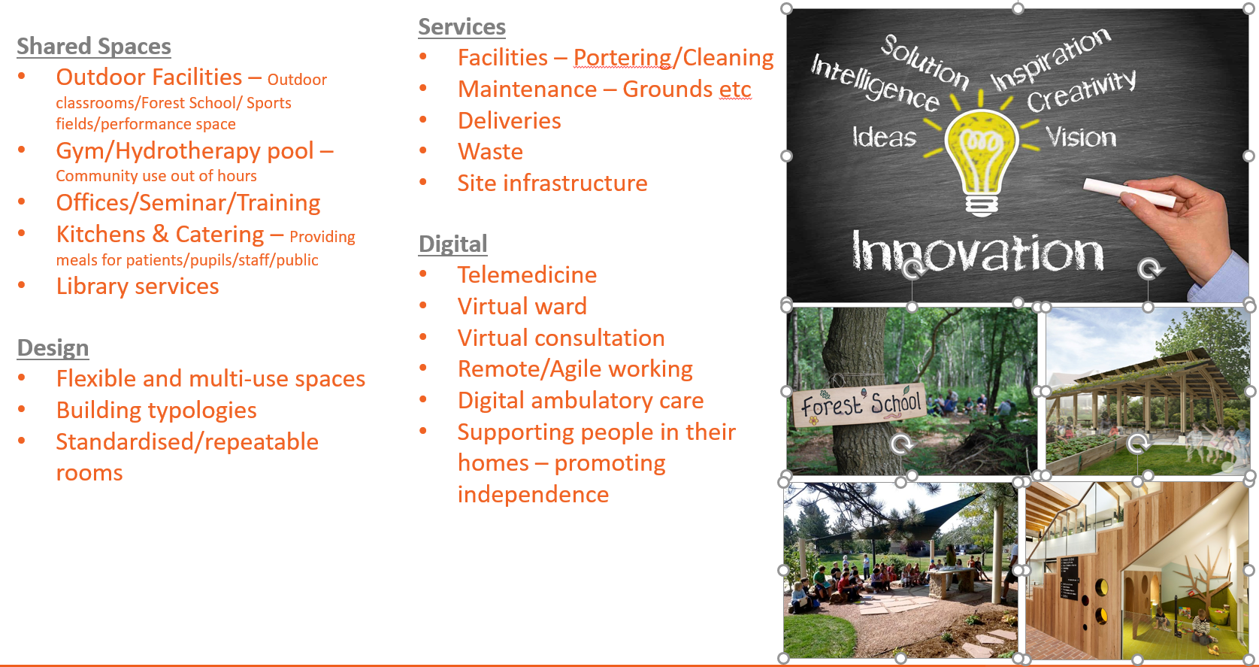
Figure 8: Design Opportunities
Details of the potential scope of the programme are detailed in Section 2.2.8, however the main services and key integration links are as follows:
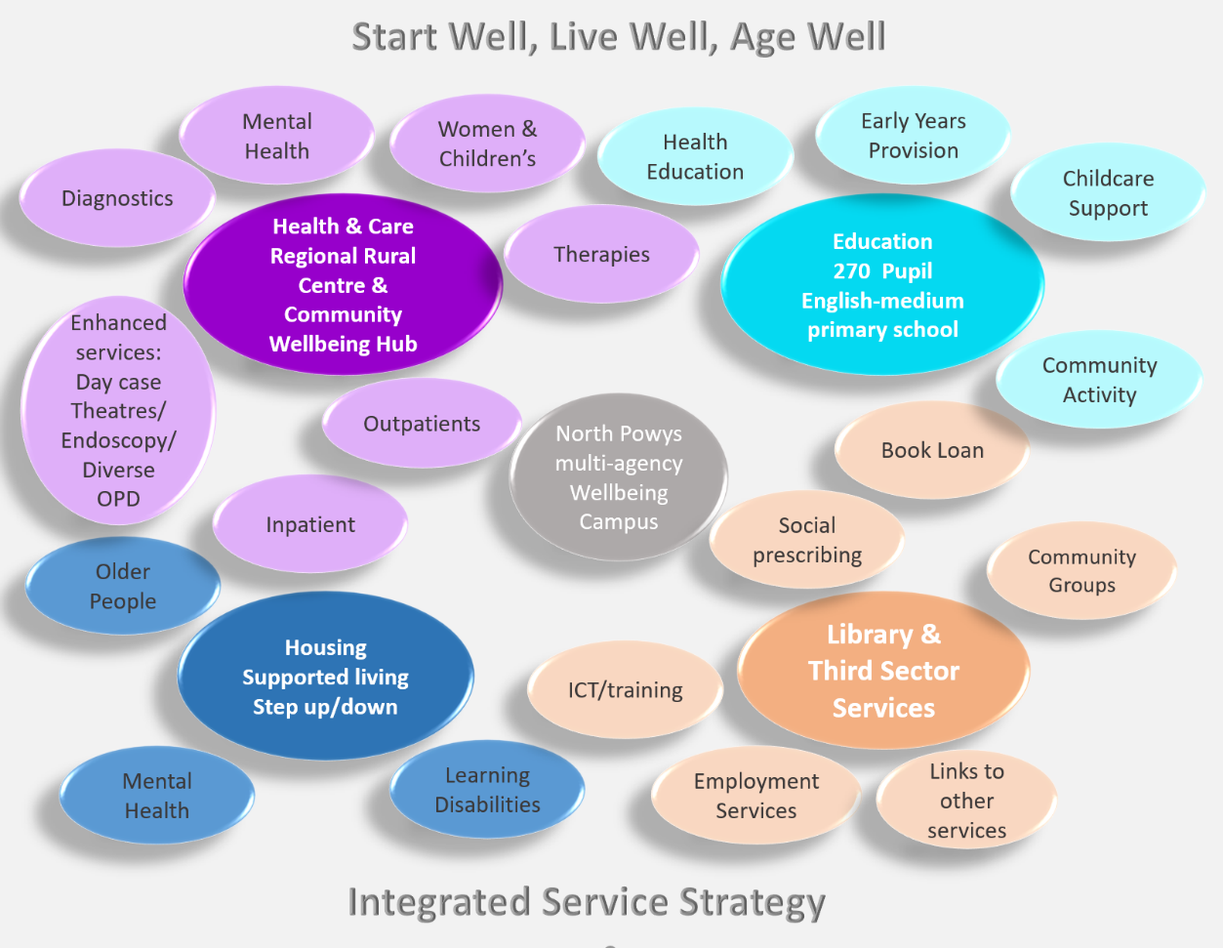
Figure 9: Service Strategy
The purpose of the Economic Case is to identify and appraise the options for the delivery of the programme objectives and benefits and to recommend the option that is most likely to offer best Value for Money (VfM) or social value to society, including wider social and environmental effects as well as economic value.
As part of initial feasibility work, a full site options appraisal has been undertaken, details of which can be found in section 2.2.8.2 The preferred site is illustrated in the image below:
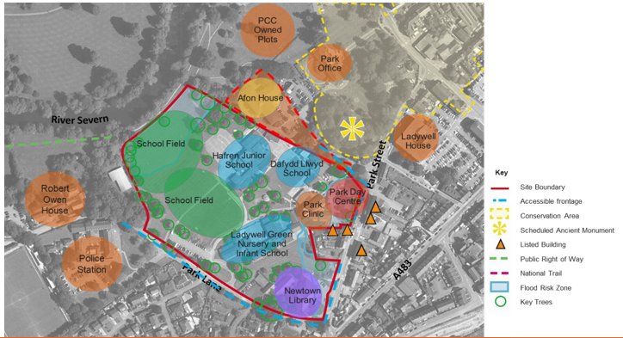
Figure 10: Preferred Site Plan
The preferred site measures 4.6 hectares (45,904sqm). The table below details what the preferred site currently comprises of and what buildings are in close proximity to the site:
Current Site | Close Proximity
Ladywell Green Infant and Nursery School | Afon House (Job Centre)
Hafren Junior School | Park Office (Council Offices)
Newtown Library | Ladywell House (Council Offices)
Integrated Family Centre | Newtown Police Station
Park Day Centre | Robert Owen House (formerly mental health team office and now a housing development opportunity)
Park Clinic
Table 1: Buildings on and in close proximity to the Preferred Site
The consensus of the site appraisal was that the preferred site offers:
- A good location, accessible to centre of the town, to the Open Newtown programme, recent housing initiatives and to other transport and amenities
- Links to the school’s investment in the area
- Appropriate size to facilitate the potential scope of the programme
- No policy designations
- Owned and know site near existing public amenities and assets
- Flat, serviced site with potential expansion scope
- A therapeutic site, ideal for promoting well-being; open green spaces, views, on the banks of the Severn
Having identified a preferred site, the options appraisal focuses on developing the proposed scope of the programme. A long list of options has been developed and categorised under the headings of Technical Scope, Service Solution, Service Delivery, Implementation and Funding (see Section 3.3). By appraising a wide range of realistic and possible options, the following short list of options for economic appraisal has been identified, which will be developed further in subsequent Business Cases.
 | Option 1 | Option 2 | Option 3 | Option 4
Scope/Technical | Intermediate 1 | Intermediate 1 | Intermediate 2 | Intermediate 2
Service Solution | Core & Desirable | Core & Desirable plus | Core & Desirable | Core & Desirable plus
Delivery | In-House | In-House | In-House | In-House
Implementation | Phased | Phased | Phased | Phased
Funding | Public | Public | Public | Public
Table 2: Preferred Way Forward
The technical and service scope of these options is summarised below:
Options | Description
1 | New build – combined English medium primary school (270 pupils) alongside new Health and Wellbeing facilities  Health and Care: consolidation of new integrated model of care into a single location. “Do minimum” in terms of opportunities for repatriation, diagnostics, primary care, inpatient beds, therapy services, family services, mental health services and urgent care  Education services amalgamated to provide a 270-pupil primary school with further links to Health and Social Care  Library and Third Sector services enhanced to provide greater links to Health, Social, Housing & employment services
2 | New build – combined English medium primary school (270 pupils) alongside new Health and Wellbeing facilities  Health and Care: consolidation of new integrated model of care into a single location. “Do maximum” in terms of opportunities for repatriation, diagnostics (to include MRI), primary care, inpatient beds (to include level 2 rehab centre), therapy services, family services, mental health services and urgent care  Education services amalgamated to provide a 270-pupil primary school with further links to Health and Social Care  Library and Third Sector services as above with the addition of Health promotion and community resource centre  Develop site as a joint training academy
3 | New build – combined English medium primary school (360 pupils) alongside new Health and Wellbeing facilities to include library services and additional supported living accommodation  Health and Care: consolidation of new integrated model of care into a single location. “Do minimum” in terms of opportunities for repatriation, diagnostics, primary care, inpatient beds, therapy services, family services, mental health services and urgent care  Education services amalgamated to provide a 360-pupil primary school with further links to Health and Social Care  Library and Third Sector services enhanced to provide greater links to Health, Social, Housing & employment services
4 | New build – combined English medium primary school (360 pupils) alongside new Health and Wellbeing facilities to include library services and additional supported living accommodation  Health and Care: consolidation of new integrated model of care into a single location. “Do maximum” in terms of opportunities for repatriation, diagnostics (to include MRI), primary care, inpatient beds (to include level 2 rehab centre), therapy services, family services, mental health services and urgent care  Education services amalgamated to provide a 360-pupil primary school with further links to Health and Social Care  Library and Third Sector services as above with the addition of Health promotion and community resource centre  Develop site as a joint training academy
Table 3: Options Summary
The shortlisted options indicate that the spatial requirements for the identified site would range from 23,350sqm to 30,595sqm:
Campus Elements | Minimum (sqm) | Maximum (sqm)
School/Field | 15,000  [Inc. 2,215 building] | 18,000  [Inc. 2,620 building]
Health & Care | 7,500 | 10,500
Library | 850 | 850
Specialist Housing | - | 1,245
Sub Total | 23,350 | 30,595
External Space tbc | 22,554 | 15,309
TOTAL | 45,904 | 45,904
Table 4: Spatial Requirements
Using the proposed areas derived from the preferred way forward, the potential configuration of the site can be developed. A core objective of this PBC is to demonstrate that the range of options above will “fit” on the site facilitating the desired campus approach, considering the desired location of each service on the site and consideration of issues such as safeguarding. It is appreciated that access, green and shared spaces, infrastructure and car parking are key to “unlocking” the preferred site and phasing requirements. Further work is ongoing in terms of defining the infrastructure scope and is being led by a cross agency workstream and in consultation with Heart of Wales Property Services (including council Highways colleagues, etc.) and NHS Building for Wales. The Infrastructure SOC will further develop the approach and will consider:
- Campus access /routes and deliveries (considering centralised FM).
- Phasing: the school is programmed to be complete by September 2024, with the two schools operating as usual; planning will ensure that the construction does not disrupt live services on the site
- The site has minimal access points (they only exist as entrances to the current buildings on site) so consideration needs to be given to access to the site and construction traffic during the build
- There is a floodplain to the north of the site that cannot be built on
- The level and nature of car parking needs to be determined
- Campus wide service strategy – particular reference to decarbonisation and carbon reducing technologies such as river source heat pump/PV/electrical charging.
- Open and Green Spaces
- Outside of the Core Health and Care or Education offering there is an opportunity to create a fully integrated community building to include a range of services (but not limited to):
  - Transformation of library services
  - Integrated Education Academy
  - Third Sector/community groups and local business
This approach will maximise the opportunities of shared flexible spaces and increase space utilisation.
The infrastructure element, scope and cost, is one of the most challenging but also important pieces of work, which, in collaboration with WG colleagues, has been identified as the means by which the site can be ‘unlocked’. By necessity, this must be one of the first stages of the scheme to be developed and this is needed to support and underpin all elements of the project but, in addition to the more traditional roads and utilities, this could also include the more innovative ‘public sector’ and community space in terms of the built shared environment. The innovative approach and pushing the boundaries means there is no clear template to follow, although the workstream is looking at lessons learned from other collaborative projects across Wales and beyond, and more work is needed before more detailed analysis can be done. An early joint partnership approach is evidenced by the engagement of the Heart of Wales Property Services joint venture team to undertake campus wide site surveys (circa £100K).
Further work on the site masterplan will be undertaken during the development of the SOC’s. However, during the PBC development, several site configurations were appraised at a high level with a number of stakeholders, with feedback being incorporated into a potential site configuration (pictured below):
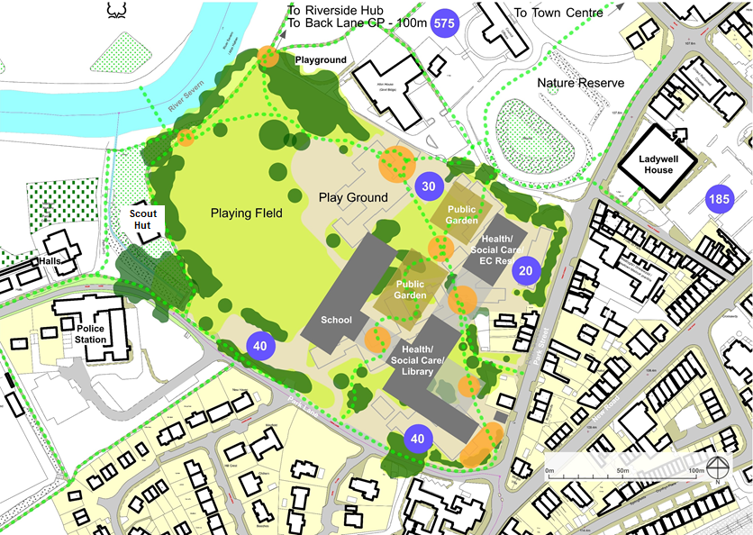
Figure 9: Potential Site Configuration
Having established that the range of options to be taken forward could work on the proposed site, a high-level financial appraisal was undertaken on the preferred way forward:

Economic appraisal summary  £000s | BAU | Option 1 | Option 2 | Option 3 | Option 4
Capital Costs (excl VAT) | - | 54,736 | 65,235 | 58,058 | 70,038
Backlog Maintenance | 9,993 | - | - | - | -
Disposal Proceeds
- Montgomery County Hospital | - | (550) | (550) | (550) | (550)
- Bro Hafren | - | (140) | (140) | (140) | (140)
- Ynys Y Plant | - | (160) | (160) | (160) | (160)
- Park Street Clinic | - | (130) | (130) | (130) | (130)
Socio Economic Benefits | - | NQ | NQ | NQ | NQ
Net Capital Cost (excl VAT) | 9,993 | 53,756 | 64,255 | 57,078 | 69,058
Table 5:High Level Economic Options Appraisal
The preferred option will need to be determined once benefits, risks and revenue costs have been factored into the assessment, which will be included in each of the subsequent project business cases.
The Commercial Case outlines the procurement/delivery options available for the programme and will allow for the flexibility to complete specific elements of work as part of a wider project.
The Partnership has a track record of working together to develop services for the people of Powys and have a history of working with communities and other stakeholders and partners to deliver improvements for their population. The Partnership is well placed to jointly contribute to the exciting development of a multi-agency wellbeing Campus for north Powys.
The Partnership is keen to minimise the revenue implications of the overall programme as a key objective. Capital investment and asset ownership is therefore the preferred method of delivery for the programme but would be the subject of detailed review in each of the supporting business cases. The Partnership is flexible in terms of the approach to land ownership having worked collaboratively on land transfers, and is keen to support the more appropriate ownership structure for each element of the programme as required.
To unlock the site, the most appropriate first stage would be to consider the roads, parking and services infrastructure for the Campus to ensure that this key first stage of the development has the appropriate capacity, orientation and resilience to support the scheme as a whole. This also has the advantage of allowing the stakeholders to deliver their specific built environment requirements within their areas of expertise (housing, education, health & care) using their familiar procurement delivery methods as subsequent phases.
Due to the indicative timescales (driven by the need for the school to be completed by September 2024) it is anticipated that the enabling works, infrastructure and school construction will be undertaken by a single contractor who will be appointed via the 21st Century schools programme framework. Procurement options would include utilising a regional framework such as SEWSCAP, South West Wales Regional Contractor Framework (SWWRCF) or North Wales Schools and Public Buildings Contractor Framework or via a separate OJEU Procurement route.
The Health & Care elements of the programme are likely to be procured via the Building for Wales framework. The framework aims to deliver core objectives on behalf of the Welsh Government, including Best Value for Money and Development of Best Practice and Sustainability, amongst others, and is managed by a dedicated team of professionals employed by NWSSP.
It is assumed that the majority of this programme will be funded by public funding (All Wales Capital Funding), with the school being funded by Welsh Government and PCC (50/50 split). However, due to the complexity of the Campus, with wide-ranging services, buildings and policies governing the site, it is recognised that there are multiple funding streams that could contribute to its development. The ability to access a single point of funding would make the development of the Campus simpler.
The Financial Case will detail the capital funding requirements for the programme, which is currently estimated at £64m to £83m (including VAT) across the options, after including VAT but before the benefit of any disposal proceeds (estimated to be in the range of £0.9m to £1.1m), as set out below:
Cost Summary  £000s | BAU | Option 1 | Option 2 | Option 3 | Option 4
GIFA m² | 5,703 | 10,641 | 14,046 | 11,641 | 15,291
Capital costs (excl VAT) | 9,993 | 54,736 | 65,235 | 58,058 | 70,038
Less disposal proceeds | - | (980) | (980) | (980) | (980)
Economic Case | 9,993 | 53,756 | 64,255 | 57,078 | 69,058
Add back disposal proceeds | - | 980 | 980 | 980 | 980
Add VAT | - | 10,947 | 13,047 | 11,612 | 14,008
Financial Case (funding requirement) | 9,993 | 65,683 | 78,281 | 69,670 | 84,045
Subsequent reduction for disposal process | - | (980) | (980) | (980) | (980)
Net funding requirement | 9,993 | 64,703 | 77,301 | 68,690 | 83,065
Table 6:Reconciliation of Economic to Financial Case costings
The investment would also eradicate the need to incur approximately £10m of backlog maintenance costs as previously noted. Furthermore, the programme would deliver a number of additional social and economic benefits that are, as yet, unquantified, but include job creation from both construction and general increased activity post build phase, increased footfall on the high street and retail activity, from both new facilities and the potential developments on the disposal sites, as well as opportunities for additional Local Authority revenues such as rates and council tax resulting from the above.
Some initial revenue savings have been identified such as those relating to maintenance and running costs and those associated with travel however, more detailed revenue assessment including the benefits of repatriating services and associated staff costs will be further developed during SOC/OBC development.
The Management Case demonstrates that each element of the programme is achievable and can be delivered successfully to cost, time and quality. This section details RPB’s programme management arrangements as well as the key appointments required to deliver the programme. The governance arrangements are illustrated below:
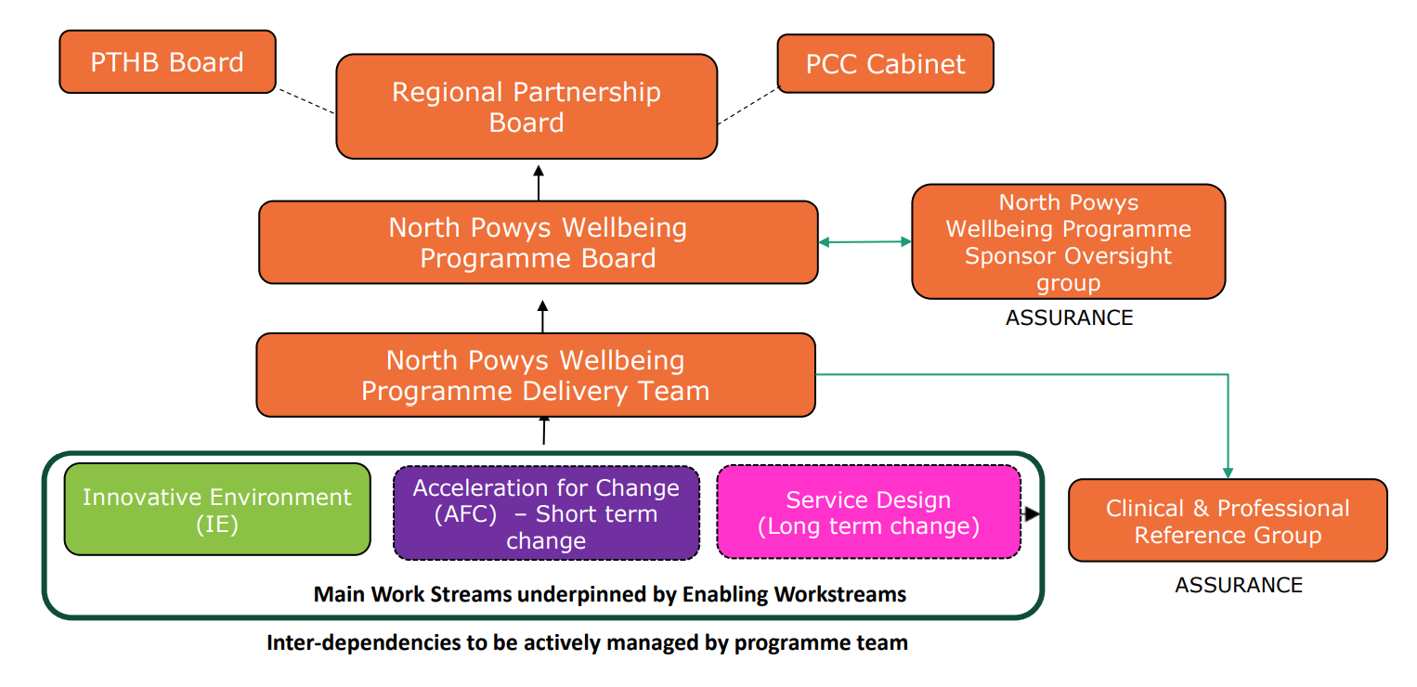
Figure 11: North Powys Programme Governance Structure: Reporting and Approvals
The Programme operates within the agreed Governance arrangements as per the diagram above. A Programme Oversight Group is in place and meets quarterly, this includes Independent Members and Portfolio Holders. The Programme Board meets monthly and is jointly chaired by the CEO’s of the Council and the Health Board. The day to day management of the Programme is run through the Programme team and four workstreams with links to other key operational groups to support with delivery.

The production of this PBC began a few months before the COVID-19 pandemic escalated in the UK in March 2020. Partnership staff were redeployed from “business as usual” to strategic and operational roles surrounding the control of the coronavirus.
Once resumed, the PBC was updated to include learning from the COVID-19 pandemic and what impact this may have on current and future services including; virtual consultation, agile working, digital, social distancing and planning for future pandemics. Whilst it is understood that work on the development of these services are ongoing, a formal “lessons learned” process is currently underway and will be further detailed in subsequent SOCs.

Recommendation
Based on the information contained within this PBC, it is recommended that the programme be endorsed to continue to develop a series of SOCs/OBCs/FBCs, to create a collaborative, multi-agency, well-being Campus for the population of north Powys to support delivery of the RPB outcomes via the integrated model of services.
Signed: |  | Signed:
Dated: |  | Dated:
Alison Bulman, Powys County Council  Senior Responsible Owner,  North Powys Wellbeing Programme |  | Hayley Thomas, Powys Teaching Health Board  Senior Responsible Owner,  North Powys Wellbeing Programme

Signed: |  | Signed:
Dated: |  | Dated:
Dr Caroline Turner, Powys County Council  Programme Sponsor,  North Powys Wellbeing Programme |  | Carol Shillabeer, Powys Teaching Health Board  Programme Sponsor,  North Powys Wellbeing Programme

The Strategic Case
This Business Case is seeking approval to proceed with a programme of works in order to develop a multi-agency wellbeing campus in Newtown (the “Campus”). The purpose of this section is to demonstrate how the proposed North Powys Wellbeing Programme of works fit within the existing business strategies of the RPB and outlines a compelling case for change, in terms of existing and future service and estate needs. The strategic case is split into 2 sections:
Part A: The Strategic Context
The Strategic Context contains an overview of the partnership organisations, confirms that there is a strategic fit between the proposed programme and national/local policy and objectives and that the scheme supports the proposed vision for care delivery and changes in activity.
Part B: The Case for Change
The Case for Change describes the current challenges faced by the Partnership and the need for increased focus on wellbeing, early help and support, new/improved services and facilities. This section highlights ‘Business as Usual’ (BAU), describing the problems with the existing service model and facilities in Newtown, as well as detailing the investment objectives, benefits and risks associated with the proposed programme.

Part A: Strategic Context
The purpose of this programme of work is to develop a new integrated model of health, care and wellbeing services in north Powys. The North Powys Wellbeing Programme (NPWP) is a once in a generation opportunity to bring together partner organisations to enhance and transform the way we deliver health, care and wellbeing services in north Powys.
The RPB is fully committed to the delivery of a new integrated model of care for north Powys, which includes a Rural Regional Centre (to enhance the local service offer) and Community Wellbeing Hub (to improve wellbeing and reduce demand on future service provision), both of which were set in Health and Care Strategy: ‘A Healthy Caring Powys’ which was agreed in 2018. “A Health Caring Powys” (Appendix A) is fully aligned with PCC’s Vision 2025 and PTHB’s Integrated Medium Term Plan. To support delivery of the programme, Transformation Funding was secured from Welsh Government in mid-2019, enabling the delivery of the long-term change associated with the new integrated model of care which includes the Campus as well as short-term areas of acceleration of change in relation to new ways of working that can be implemented now to deliver the new integrated model of services. The scope of the programme includes:
- The testing and delivery of a new integrated model to a rural population which focuses strongly on evidence based of innovative practice to deliver the highest value and efficient system
- The development of a multi-agency wellbeing campus in Newtown which includes education, housing, health and social care and leisure/wellbeing activities
- Working with local communities to co-design and address the practical implementation of a new integrated model which is based on future needs, addressing “what matters” to people, has ownership by communities, and builds the capacity of individuals and communities to develop and evolve formal and informal community services that enable people to live independent and healthier lives
- Effective learning, evaluation and transfer, acting as a flagship scheme to support the broader roll out of a new integrated model across Powys
The programme aims to bring partners together across education, health and social care, housing and third sector, with opportunities for further linkages to leisure, police and ambulance services. It will also maximise essential links with green spaces through Open Newtown as well as the town centre supporting Welsh Governments initiative “Town Centres First”. The purpose of this section is to explain how the development of the Campus fits within the existing business strategies of the Partnership.

Organisational Overview
The Strategic Context provides an overview of PTHB/PCC and the current services being delivered in north Powys. This section confirms that there is a strategic fit between the proposed programme and national/local policy and objectives and that the programme supports the proposed vision for service delivery and changes in activity.

Powys County Council
PCC is responsible for delivering a range of services to approximately 132,000 residents across Powys and has a strong vision for the future, with four strategic priorities which focus on the economy, health and care, learning and skills, and residents and communities. It is one of the largest employers in Powys delivering health and social care services, education, highways and leisure. The county of Powys covers a quarter of the land mass of Wales and is one of the most sparsely populated areas in the UK, with many residents living in rural upland areas and historic market towns. Some of the services PCC delivers include:
- Social care (including adult and children’s services)
- Schools and Nurseries
- Construction and maintenance of roads, parks and other infrastructure
- Planning and building control services
- Waste collections
- Environmental Health
- Libraries
- Housing (including homelessness)
PCC receives money in three ways:
- Welsh Government
- Income raised through fees and charges
- Council tax
Key challenges for PCC are to continue to manage demand for social care whilst achieving significant financial savings. Key to achieving this will be keeping people safe and independent at home through increased use of digitally enhanced services and more integrated ways of working, as well as increased wellbeing, early help and support services to reduce demands on statutory provision. This programme will support the integration of community wellbeing services, to improve health outcomes and reduce health inequalities for residents in deprived communities in north Powys, thus reducing the need for admission to hospital and care homes in the future.
Since early 2018, PCC has been working with schools in Newtown to develop plans for the development of a schools’ infrastructure which will strengthen local communities. A primary aim of this programme is to integrate an “all through” primary school (which is to be developed following the merger of an infant school and junior school in Newtown) into the Campus in line with PCC’s Strategy for Transforming Education in Powys 2020-2030, which states that new developments should support community-focussed schools which act as a central point for multi-agency services to support children, young people, families and the community.

Powys Teaching Health Board
Like PCC, PTHB is one of the largest employers within Powys and shares many of the same challenges in terms of delivering diverse services across a large and sparsely populated rural region. It is responsible for commissioning secondary health care and hospital services and co-ordinating the delivery of primary care services. It also directly delivers community care services such as district nursing, child health, midwifery, and community services in nine local community hospitals.
As PTHB is primarily a commissioning organisation, the largest proportion of its budget is devoted to commissioning NHS services in the community by primary care contractors and the Third Sector. Additionally, secondary care services are provided through commissioning arrangements with other Health Boards in Wales and NHS Trusts in England as shown in the figure below:
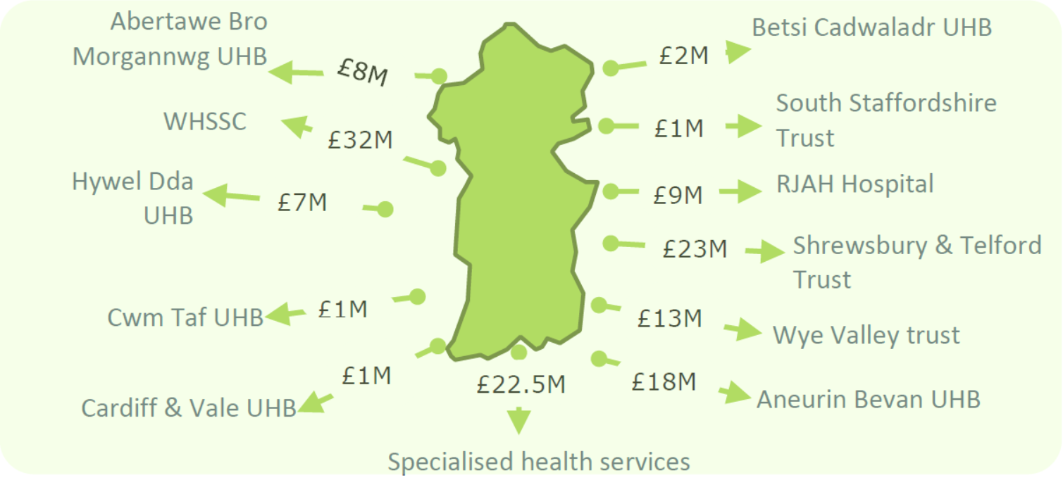
Figure 12: PTHB Secondary Care Commissioning
These multiple complex arrangements mean that, as an organisation, PTHB has a highly developed ability to provide coherence across multiple strategies, providers and pathways. PTHB has three strategic challenges for the future:
- Designing and delivering a clinically and financially sustainable rural service model, providing as much care as close to home as possible through a continued shift from hospital to community-based models of care
- Meeting the changing needs of Powys residents as demographic change and improvements in healthcare continue to make their impact felt on demand for, and cost of, services
- Working with partners and the public to support sustainable rural communities in a period of public sector austerity
A primary aim of this programme is to support the development of a Rural Regional Centre in Newtown, a key priority of the Integrated Medium-Term Plan 2019/20-2021/22 (IMTP). Rural Regional Centres are already under development within existing healthcare buildings in Llandrindod Wells and Brecon, and the development of this model at Newtown will create a central spine through Powys, focussing on enhanced and extended local services to reduce inequity of the current offer, improving care closer to home and maximising the range of services which can sustainably be delivered in county.

The Built Estate
The geographical distribution of PTHB’s estate and its functionality has evolved around traditional patterns of care and much of the estate is now outdated. PTHB has the oldest built estate with 38% predating 1948 (compared to the Wales average of 12%) as well as the ‘least new’ estate with only 5% being built post 2005 (compared to the Wales average of 23%). This means that the HB has some unique challenges in terms of maintaining building stock.
Similarly, much of PCC’s existing estate is of poor quality, with the two existing schools being identified as condition categories C and D. As such, the Partnership is managing sites with high levels of backlog maintenance, which have significant or high risks of non-compliance or failure. By working collaboratively and combining services into a Campus-style approach, the programme aims to significantly reduce the backlog maintenance across a number of sites whilst benefiting from more efficient space utilisation. In addition, this would release surplus building stock, delivering either cash releasing benefits or potential development opportunities.
Figure 13: Current Backlog Maintenance in Newtown
As demonstrated in the diagram above the current backlog maintenance across the built estate is £10 million. Properties that are no longer suitable for service delivery will be identified when progressing with the Campus, resulting in an estate of better performing buildings leading to a reduction in the running costs and a more sustainable, innovative “fit for purpose” property portfolio, with no residual high or significant compliance risks across the Partnership. In developing this PBC a full property analysis has been undertaken and a property database has been developed (See Appendix B)
Developing a ‘fit for purpose’ estate is a key enabler to the delivery of the eight objectives defined in’ A Healthy Caring Powys’.
These consist of four Well-being Objectives: Supported by four Enabling Objectives:
- Focus on Wellbeing - Workforce Futures
- Early Help and Support - Innovative Environments
- The Big Four - Digital First
- Joined Up Care - Transforming in Partnership

Innovative Environments
The IEOG will ensure that innovation is embedded throughout the programme both in relation to the ‘synergies’ that can be achieved as well the main themes in relation to Design, infrastructure, Digital and Decarbonisation:

Design
The development of a campus approach ensures that each space is being utilised is fit for purpose (utilising clinical spaces for office or storage for example is inefficient – and expensive). A building typology approach will mean that highly clinical, technical spaces are focussed where they are appropriate and less technical spaces such as office and meeting spaces which are more cost effective are also designed appropriately. The design will also consider the use of ‘repeatable’ or standardised rooms which streamline both design and construction processes. The benefits associated with this design approach include:
- Space Utilisation – bringing multiple disparate buildings/services into a single location will lead to better space utilisation and reduce duplication. Baseline data will be developed to detail potential savings in; offices/training/IT, generic multi-use consulting rooms, catering & dining, communal areas such as kitchens/WC’s, outdoor spaces, car parking, hard and soft FM.
- Improved efficiency – through consolidation and sharing, improving space utilisation and reducing duplication
- ‘Right space right place’ – ensuring all spaces are fit for their intended purpose i.e. not over/under engineered
- New ways of working – The development of the Interim Innovative Environments Strategic Framework will ensure that learning from COVID-19 is embedded and considers the impact of digital and new workforce models such as the implementation of agile working, and describing how innovative environments support a more holistic integrated model of care.
- Environmental quality – impact of our environment on our health and wellbeing
- Improved digital infrastructure - Digital infrastructure is one of the key priorities for the RPB supporting both immediate priorities of COVID response as well as taking a longer term view to support connectivity in rural Powys and further alignment with the National Digital Health and Care Wales plan.
- Shared Spaces - The Campus approach has allowed the programme team to explore the opportunities for multi-use, flexible and shared spaces which can offer a number of benefits including maximised space utilisation, more efficient use of building footprint, economic benefits and greater opportunities for integration, collaboration and innovation across disciplines. The key opportunities to be further investigated include the following:
  - Offices/Seminar Rooms/Training Suite/IT Suite
  - Catering and Dining
  - Car Parking
  - Hydrotherapy Pool
  - Outdoor Spaces
  - Carbon Reducing Technologies
  - Hard and soft FM services including deliveries, receipt and distribution, domestic services

Infrastructure
The infrastructure element, scope and cost, is one of the most challenging but also important pieces of work, which, in collaboration with WG colleagues, has been identified as the means by which the site can be ‘unlocked’. By necessity, this must be one of the first stages of the scheme to be developed and this is needed to support and underpin all elements of the project but, in addition to the more traditional roads and utilities, this could also include the more innovative ‘public sector’ and community space in terms of the built shared environment. The innovative approach and pushing the boundaries means there is no clear template to follow, although the workstream is looking at lessons learned from other collaborative projects across Wales and beyond, and more work is needed before more detailed analysis can be done. An early joint partnership approach is evidenced by the engagement of the Heart of Wales Property Services joint venture team to undertake campus wide site surveys (circa £100K).
Further work is ongoing in terms of defining the infrastructure scope and is being led by a cross agency workstream and in consultation with Heart of Wales Property Services (including council Highways colleagues, etc.) and NHS Building for Wales. The Infrastructure SOC will further develop the approach and will consider:
- Campus access /routes and deliveries (considering centralised FM).
- Phasing: the school is programmed to be complete by September 2024, with the two schools operating as usual; planning will ensure that the construction does not disrupt live services on the site
- The site has minimal access points (they only exist as entrances to the current buildings on site) so consideration needs to be given to access to the site and construction traffic during the build
- There is a floodplain to the north of the site that cannot be built on
- The level and nature of car parking needs to be determined
- Campus wide service strategy – particular reference to decarbonisation and carbon reducing technologies such as river source heat pump/PV/electrical charging.
- Open and Green Spaces
- Outside of the Core Health and Care or Education offering there is an opportunity to create a fully integrated community building to include a range of services (but not limited to):
  - Transformation of library services
  - Integrated Education Academy
  - Third Sector/community groups and local business

Digital
Digital infrastructure is one of the key priorities for the RPB taking a longer term view to support connectivity in rural Powys and further alignment with the National Digital Health and Care Wales plan.
The Digital rollout plan remains a high priority, supporting both immediate priorities of COVID response, including a huge acceleration in agile and new ways of working, as well as essential service delivery and the scoping of the renewal priorities. The development of a ‘campus’ provides a real opportunity to ensure that infrastructure is in place to enable targets for increased digital rollout. This will be a key thread to the service planning and pathway work that the partnership are currently undertaking. Short term opportunities already being developed are:
- Supporting Digital Ambulatory Care – virtual clinics for outpatients utilising Attend Anywhere, access to consultant connect is enabling primary care case management.
- Use of MS Teams is enabling more integrated working in a timely way (such as virtual consultation and bed management) but does not negate the need for some face to face meetings.
- E-learning platforms are being developed to support people with long term conditions/pain management and support recovery i.e. prehab.
- Increase in use of technology to support individuals and their families, enable people to take greater control, and live independently for longer by preventing hospital admissions and preventing premature moves to residential care.
- Provide remote treatment and care for people with mental health conditions and learning disabilities.
- Increase digital therapies and online support.
- Delivery of technology enabled care to support people in their homes to live independently.
- Use of immersive technologies such as augmented reality to provide health and care services
- Developing use of LoRaWAN IOT to provide connected care to people’s homes
- Provision of immersive meeting technology to provide inclusive patient/client support reducing the need for experts to travel
The longer term ambition for the campus will build on the above and further provide:
- Fully enabled digital ambulatory care services – provide the latest state of the art diagnostics, virtual consultations and e-learning platforms. Where clinically safe and effective provide remote diagnostics which will enable primary and community care teams to undertake local diagnostic investigations in Powys which can be seen by secondary care consultants. Develop virtual consultation suites enabling patients to be seen and treated locally in Powys with remote access to consultants when needed.
- Urgent care – Where clinically safe and effective, provide ambulatory urgent care with links with A&E consultants to reduce admissions to hospital.
- More digital pathways where diagnostics are worked up locally
- Digital hub room with ear scopes and heart monitors to access remote consultants
- Everyone in Powys is able to access self-management apps and digital technology with assistance from third sector, these services could also be provided from the shared space / Community Wellbeing hub, as evidence suggests some people are happy to utilise technology when they are supported by other professionals.
- Digitally enabled working spaces, which enables electronic booking linked to screens outside rooms to show the usage of that room for the day.
Opportunities for the broader model of care include:
- Multi-agency support available from third sector to assist people in their own homes to access technology.
- Consultant Connect can be used and accessed by all GPs to manage demand and reduce number of referrals to secondary care.
- Technology enabled care available to all in need across all of Powys.
- Technology enhanced exercise programmes to target The Big 4
- Improving internet/wifi access across the county will enable greater use of GP telephone triage.
- Technology enhanced care to support hospital at home services

Decarbonisation
The campus represents a unique opportunity for north Powys to create an efficient, consolidated network of buildings with single service strategy – an opportunity to utilise ‘green’ building techniques and technologies as well as supporting reduced travel and promoting green travel plans including the provision of Electric Vehicle (EV) charging. The IEOG includes environmental specialists from both organisations and are being supported by Welsh Government Energy Service (WGES) and Re:Fit Cymru, who provide technical guidance and potential access to additional funding. The proposals also support a move to a “Carbon Positive Powys” as set out in the Public Service Board’s Wellbeing Plan and the emerging Regional Energy Plan. A number of workshops have taken place to develop a long list of potential decarbonisation options (Appendix C) which will be further developed and defined in subsequent business cases. The main considerations are summarised below:
- In line with funding requirements the campus will be designed to meet BREEAM ‘excellent’ but will also set ambitious targets for decarbonisation considering passive house standards ensuring all elements of the build and its use will be scrutinised from an environmental impact and decarbonisation perspective. As an example of our ambition, Passive house standard set a minimum requirement of 15kw per m² of floor space per annum (15 kWh/m²a) compared to Newtown hospital’s present consumption of 398kWh/m²a for heating and 224kWh/m²a for electricity (DEC rated G).
- With a suggested building size of 10,000 – 15,000 m² it represents a total energy demand of 150,000kw-225,000kw which, if split equally between Gas and Electric, is an annual total commodity cost only of £21,000- £32,000 at current energy rates. Its hoped that heat from catering, office and medical equipment will cover most of the buildings heating needs, shifting the burden of energy demand to ‘cooling’. Because of the strict and necessary air quality controls and high air exchange rates 15kWh/m²a might not be possible, but it’s a benchmark that the campus as a whole shall endeavour to achieve.
- We recognise that all construction materials and methods of construction have an impact on the environment but through a ‘life cycle analysis’ the project team and specialist environment managers will be able to make informed and justified decisions to ensure as low an impact as possible whist not compromising the functionality of the building and the serveries delivered.
- There will be a whole campus approach to service energy strategy, with technologies such as river source heat pumps being considered to control the thermal comfort across the site. In addition, we are offering innovative plans to control building temperatures based on occupancy detection and temperature, rather than conventional ‘space’ temperature.
- Many companies are reducing their products CO₂e but also investing in carbon offsetting to reach carbon neutral goals. Through this project and procurement processes, we hope to recognise private sector endeavours through procurement scoring criteria. Its hoped that by asking these questions of providers and contractors it will help shift the supply chain towards an added value decarbonised sector.
- To help deliver against the Wellbeing of Future Generation Act decarbonisation benefits will be carefully balanced against social and economic benefits. If there is a case for working with local contractors and supporting them to develop into a decarbonised business with a workforce fit for the future then this will be part of the assessment criteria.
- As a partnership scheme the campus will support PCC’s “Wood Encouragement” policy which is used when tendering for new Council Housing developments, as the greater use of timber is seen as beneficial in terms of decarbonisation and the wellbeing of buildings. In addition, the study on Home Grown Homes, led by Powys County Council has just issued its research findings in particular work package 6 of the study “Technical Specifications of Zero Carbon Building Solutions” provides advice on build solutions that can be delivered by Welsh timber product manufacturers and maximise carbon capture. The results of this study can be applied to the scheme
- In use the building function and resource demands are as important as during the construction phase. Building orientation, passive heating, cooling, lighting and ventilation will be designed in harmony with nature enhanced with centralised monitoring and controls to optimise the working environment. Natural resources will be used to best effect, new and emerging technologies including river, ground and air source heat pumps, solar PV, energy storage and solar thermal panels will all be considered with the final design spec being one that integrates technologies to best effect.
- Technologies installed will help to significantly reduce the total offsite generated energy. Any procured energy will be REGO-backed as with all PTHB sites since 2021 and through the Energy Price Risk Management Group and NWSSP procurement a proportion of gas will be guaranteed biogas. It’s hoped that at times the onsite energy generation will exceed demand and so allow an amount of onsite excess. Any excess onsite energy generated and heat that cannot be used or stored will be distributed through local distribution network and provide revenue stream for the campus. Local, resilient electricity supply will enhance the network structure and bolster the supply to predicted future energy scenarios from Western Power Distribution and Scottish Power Manweb.
- Delivery against PTHB’s sustainable transport plan will be critical in driving down the health board’s CO₂e emissions from both scope 2 and 3 and this project is key. In line with Welsh government guidance the scheme will include a minimum of 10% EV charging spaces, but with a goal of 50% by 2030 supporting the reduction of 2390-11,950 tCO2e per annum from patient, visitor and staff transport-related emissions based on 200 carparking spaces. Further evidence to build this case will be included in subsequent business cases. This will be a significant step forward for both organisations but will also be part of a growing public sector drive to move away from diesel and petrol cars and a key enabler in moving towards electric ‘pool’ vehicles.
- This project is an opportunity to champion sustainable products and engineering solutions which could be scaled up or down to help meet the challenge we all face in Wales meeting national climate change targets whilst protecting and caring for the present and future population of Wales.
- Additionally, biodiversity is a key consideration for the project. Following ecological assessments of the site, important species and habitats will be considered in the design to reduce negative impacts, the site could even be enhanced to support transient and migratory species with permanent and ephemeral ponds and scrapes, which would also act as Sustainable Urban Draining Scheme (SUDS). Aspects could include courtyard gardens and growing spaces, vertical growing which could double up as passive insulation to help heat and cool the building. Planting of trees helping to shade the site and sowing of wildflowers to increase habitat for pollinators. Biodiversity mitigation and CO₂e offsetting will also be taken off site with planting of trees form PTHB’s tree nursery (with third-sector partners) on publicly-accessible land and appropriate land management plans in place.

Working in Partnership
The Partnership serves the same population, largely experiencing the same challenges and opportunities of the sparsely populated, highly rural county. The Partnership have a track record of working together to develop services for the people of Powys and have a history of working with communities and other stakeholders and partners to deliver improvements. Powys is also the first region in Wales to have an approved joint Health and Care strategy.
PCC and PTHB are key partners in the Regional Partnership and Public Service Boards. Integrated working is a key priority with a series of Section 33 arrangements bringing teams together to deliver integrated backroom and frontline services.
The impact of this integration is to shift the balance of services towards an increased emphasis of wellbeing, early help and support and to provide more joined up care when people need to access services. This is being demonstrated across Powys, including at planned developments such as those at Bro Ddyfi Community Hospital in Machynlleth as well as within Newtown where partners are already working together to improve wellbeing. There are many initiatives where the community is being drawn together in Newtown, with linkages to the school, police, PAVO, Open Newtown and many other organisations.
The RPB are already successfully working together on a number of initiatives to improve the health and well being for the community of north Powys. Details of these can be found in Appendix D and include:
- Open Spaces Project, Newtown
- Bach a lach Circus Skills
- Wild Skills Wild Spaces
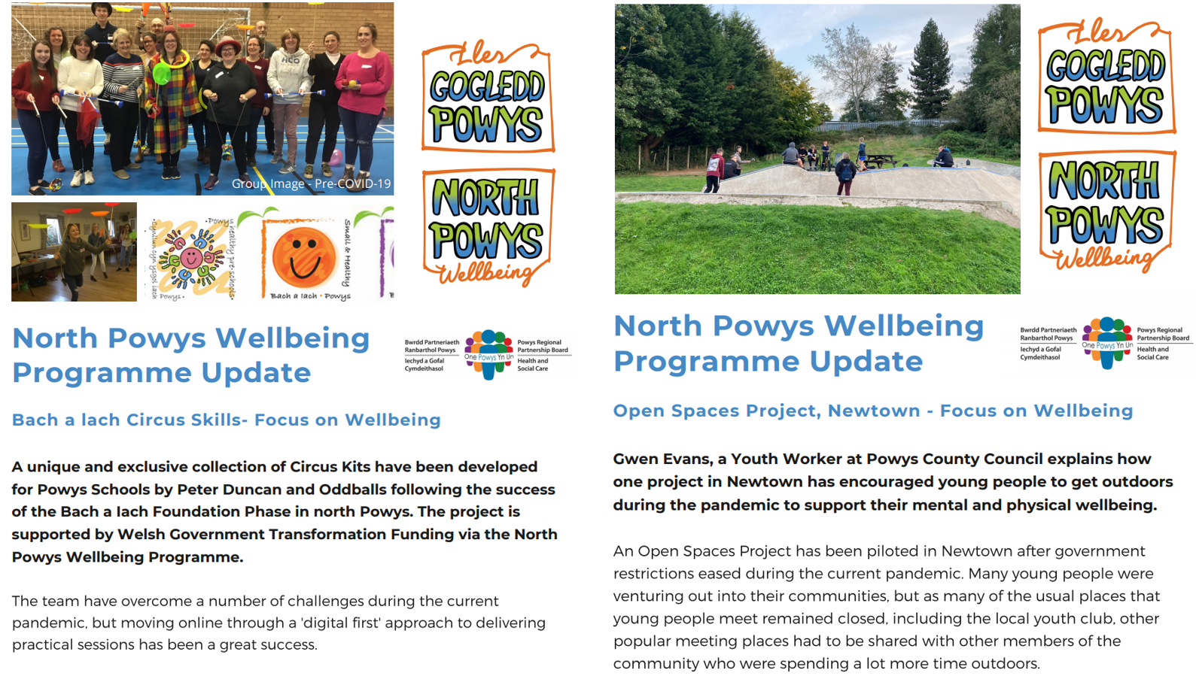
Figure 14: NPWP Case studies
Successful integration can also be demonstrated by the Newtown Integrated Family Centre (NIFC) where agencies are working together to improve the emotional health and wellbeing of children and families. The table below shows the number of groups currently using the centre:
 | PTHB | PCC | PAVO | Other 3RD Sector | Private Sector | Voluntary
Drop in Clinics, Regular Groups, Solihull with Midwifes, MIND, Buggy Walking, General Team Meetings, Immunisations, 1:1 Appointments and C Card
Action for Children
Early Help – IY Groups, Baby Groups, Specific Groups such as Young Parents, First Aid, Cooking, Meetings, TAF Panels, Team Meetings and Supervision
Flying Start – Summer and other Holiday Events, School Uniform Swaps, Admissions Support, Craft Sessions, Drop in Sessions with DWP, PACE and Community Connector, SALT let’s talk groups, Food Bank pick ups
Pyjama drama – Regular Groups
Baby Bird Music – Classical Music for Babies
Training/Corporate
Young Carers – Regular Groups
MFCC – Supervision, Meetings and Regular Groups such as Star and Freedom Programme
Breast Feeding – Regular Groups
Baby Sling – Regular Groups
Home Education – Regular Groups
PRU – Daily teaching from the site for key stage 3
YIS – Groups and 1:1 support for Young People
Xenzone – Counselling sessions
Magik – Parent and Toddler Group
Childrens Services – Supervised Contact
Biscuit Tin – Regular supervised contact thru courts
Newtown Together – Meetings, Events and Sessions with Schools, Events open to all ages
Reflect – Meeting with families to offer Support
Fostering and Adoption – Regular Support Meetings for our Foster Carers
Table 7: NIFC multi-agency groups
The work started at NIFC provides a solid foundation for the vision of the campus, brining groups and services together in one space. Other groups that have been keen to use the Centre (but have been unable to due to capacity), are as follows:
- Private Counsellors
- Dental Health
- PTHB – other staff to be used as Clinics for appointments
- Disabilities team
- Physio team
- Private nursery
- YIS team members
- Baby basics and storage of items to support families
- Community Café
- Local church group
- Other Children Services Contact – supervised sessions from out of county
- And IDVA

Colocation
The campus approach will build on the examples above by bringing a wide range of services together in a single location. Details of the potential scope of the programme are detailed in Section 2.2.8 however, the main services and key integration links are as follows:
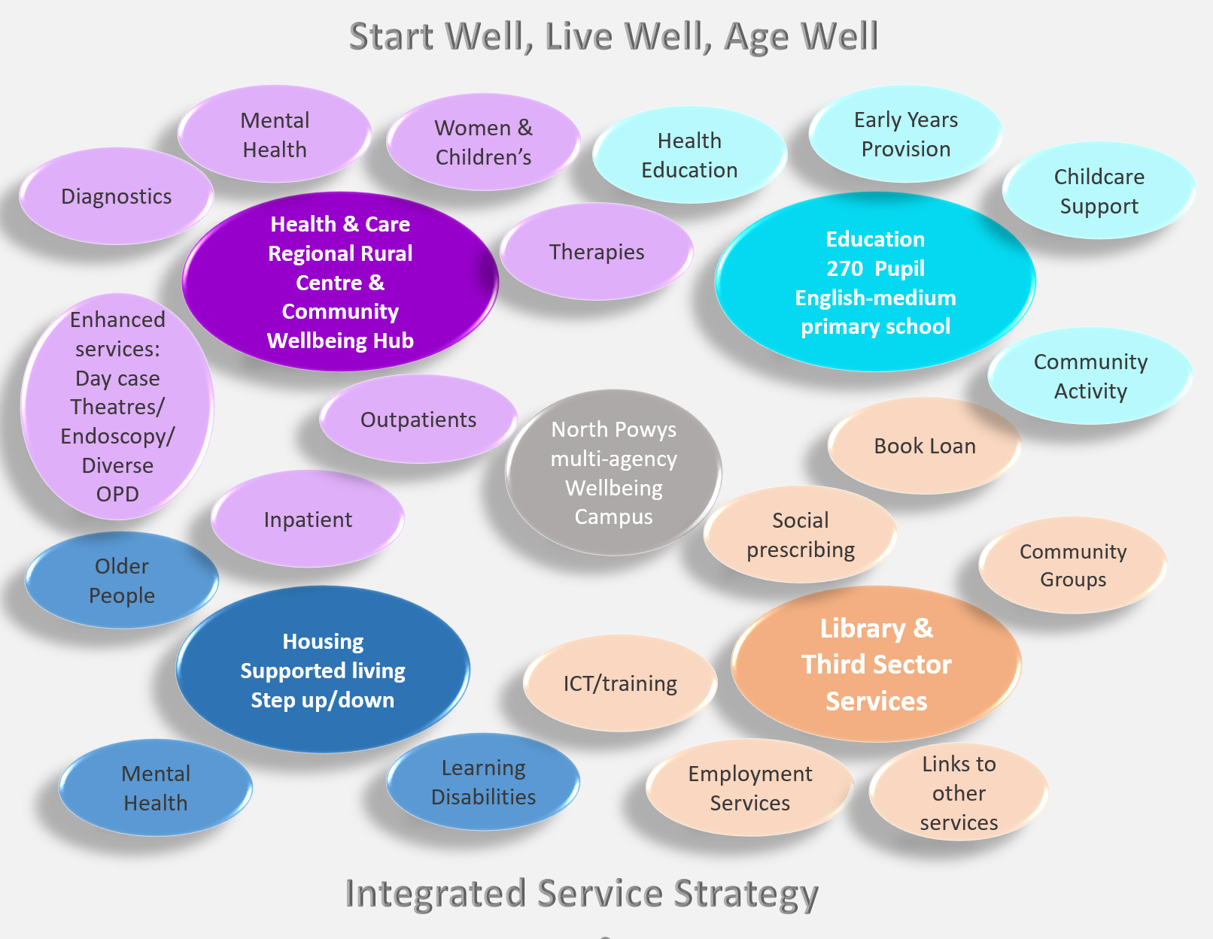
Figure 15: Service Strategy
It is acknowledged that some benefits will be sector specific, however, a primary focus of this programme is to identify the benefits associated with the integration and co-location of services.
The key benefits associated with colocation are summarised below:-
- Cost savings
- Space Utilisation/efficiency
- Security
- Convenience
- Social destination
- Community involvement
- Flexibility and scalability
- A sustainable workforce
- 24/7 Support.
- Decarbonisation
  - The space efficiencies highlighted above will also ensure that energy is not wasted in heating/lighting redundant or unused space.
  - Co-location of services along with a wider range of services available locally will contribute to a significant reduction in travel to multiple sites for staff and visitors. Digital and the increase in home working will also contribute towards the decarbonisation agenda.

Synergies
A synergy is defined as “an interaction or cooperation giving rise to a whole that is greater than the simple sum of its parts”. Some of the key themes identified in this business case are summarised below:
The possible ‘synergies’ associated with adopting this approach focus on how the integration of services via a ‘campus’ will support addressing key social determinants which influence a person’s health and wellbeing. These will include:
- Early years support – Development of Community spaces and 1:1 rooms within the school will form part of the community offer and be embedded with the wellbeing model for the campus. This will particularly provide greater support through joint working between the children’s team in health and social care. To enable optimum benefit, the school-based facility will adopt a unique community use strategy which will enable use during and out of school hours to maximise the benefits to the wider community. The school development will be developed in line with already established and successful models of delivery elsewhere in Powys, for example, the recently completed 21st Century Schools Programme Welshpool CIW Primary School project where the strategy was to establish, build, and encourage early attachments, synergies, and links between prospective school parents, services, and the school to provide wrap-around facilities from birth to when the children are ready to enter secondary school provision. In adopting a community use strategy early within the programme planning and designing processes, safeguarding and secure lines will be considered and will complement and cultivate the model of delivery. Dedicated bookable community meeting rooms and 1:1 spaces will be designed within the community wing of the school building, which will enable the facilitation of parent and toddler group activities. Dedicated meeting spaces for school-based visits such as school nurse and social care will also be catered for. Within the school-based wing, dedicated early years classrooms and direct outdoor learning facilities will be designed, ensuring that Powys County Council and the school is able to provide the 30-hour childcare offer. Out of school hours, the facilities will be bookable spaces for wider community use. This is being considered in partnership with Open Newtown and the Riverside development.
There will be a focus on early years and exploring how agencies can work together to improve emotional health and wellbeing of children. With the use of transformation funding the RPB are already scaling up good practice in this area, working with schools to improve education and offer activities which increase health and wellbeing through the Bach a Iach project. The NPWP are working together to prevent children from going into care, and when they do investing in local services so they can live closer to home with the right multi-agency in place to support their emotional health and wellbeing needs. The campus would support to further enhance the positive work that has already been undertaken, and would create and environment whereby the community would view some of the spaces as their own, allowing third sector groups more opportunity to integrate themselves into supporting the health and wellbeing needs of the population. One example is the Oriel Davies Art Gallery who have expressed a strong interest in being a key partner on site, and have a multitude of experience in supporting children and young people through arts and culture by establishing workshops focused on them, giving them a voice via development of a youth board, and focusing on the idea of family within the community of Newtown by developing programmes and activity that is relevant and makes art meaningful to the broader community. It is through integrating third sector organisations and groups into the statutory service offer that we will achieve the ability to connect with young people to develop a sense of value and investment in the lives of adolescents, raising their sense of self-wroth and supporting wellbeing through mindful activity.
- Employment opportunities –There is a strong link between work and health; for work to have a positive impact on health, it must provide stable employment, pay a living wage, offer fair working conditions, work-life balance and career progression. By helping more residents into quality work through the ‘grow your own’ ethos of the Rural Health and Care Academy, the welfare of the local community can be improved and inequalities will begin to narrow. Furthermore, employing those from within the local community can contribute to carbon footprint reduction through reduction of numbers of staff reliant on transport to travel to and from work. There is also a prominent opportunity with having a school situated on the campus in that it allows PTHB and PCC to collaborate with local schools as well as community organisations to expose more young people to careers in health and social care, raise the profile of different types of health and care jobs and help support skills development locally.
- Access to health services – As health care is a significant determinant of health and health status, the social model acts to enable all people to have appropriate health care regardless of their social situation. The social model of health allows individuals and communities to participate in decision making about their health. Individuals are more likely to participate in healthy behaviours if they feel they have a sense of power and control over their situation.
There will be focus on developing an integrated care pathway which promotes health and wellbeing through prevention and community resilience, creating social value. The different elements of the campus will enable this by integrating health and, wellbeing and social care services and maximising the natural existing synergies across education, housing, health and social care. The proximity of service will support a holistic offer and harness the ability to successfully embed green and social prescribing as an alternative to relying on traditional prescription methods where appropriate.
- Recreational and leisure opportunities – Core to the development of the campus will be consideration of outdoor spaces. Forest school and outdoor classrooms will be included which can also be utilised by the wider community out of hours. In addition, the campus will provide safe spaces for extra curricular sport and outdoor leisure activities. There is also a unique opportunity for the campus through links with ‘Open Newtown’ and local leisure facilities. Wider social and community clubs and activities are supported through the development of shared community spaces as well as the library development which already offer a wide range of services including; Homework clubs and afterschool and holiday clubs, all provided in one place.
- Access to housing and utility services – Opportunities to support vulnerable groups will be created through integration of housing, health, social care and wellbeing services potentially within the shared space – supporting the homeless amongst other groups, this has worked well in other areas of Wales (Wrexham Community Care Collaborative) and achieved positive outcomes for the homeless population and our ambition is to create a similar model to support the homeless in north Powys. A Covid-19 impact assessment identified that homelessness has become a particular issue in Newtown. This will further build on good practice already developed during the pandemic of multi-agency working and provide access to a range of holistic services to support the homeless. Co-locating the Supported Living accommodation on site provides proximity to a range of wellbeing services for people, improving their recovery from hospital, but also by supporting young people transitioning out of care. The step-down element of the supported living facility will build on the new model/facility due to open in Welshpool Cae Glas and will be underpinned by a new integrated community model for intermediate care enabling a period of intensive reablement to support people back to normal activities promptly.
- Nutrition – Schools already work to ensure that all pupils have access to nutritionally balanced school meals. The wider benefits of the campus approach, means that organisations across health and social care can offer nutritional help and advice to families and young people including healthy eating demonstrations and cookery lessons to empower communities to support their own health and wellbeing and encourage healthy choices.
- Environmental Factors –The climate crisis has serious direct and indirect consequences for health; Climate change and air pollution contribute to acute and chronic health conditions that are costly to health and social care services. These factors also disproportionately affect disadvantaged and vulnerable populations, thereby further entrenching inequalities. The campus will be developed with the latest in carbon-reducing technologies at the forefront which will have a wider positive impact on the health of the population. In addition, innovative decarbonisation initiatives are planned to minimise carbon emissions from the built environment construction and operation, along with improved public transport and electric vehicle support infrastructure, which will realise improvements to air quality for the community and beyond. Another core aim for the North Powys Wellbeing Programme is to deliver health and care services closer to people’s homes through a locally enhanced offer and maximising digital capabilities thus reducing travel. The integrated campus will deliver a common infrastructure which will permit high efficiency, low carbon emitting buildings and shared support services, which will help alleviate the environmental impact from health, education and social care services, and facilitate the public sector to realise its 2030 net zero carbon emissions compulsions to the Welsh government and citizens of Wales. Additionally, a shared campus will permit the most efficient use of land and building space from full utilisation of term-time and non term-time periods of room occupation.
- Social inequality – This involves a range of government and nongovernment organisations working together to promote health and reduce the impact of social inequality. This collaborative approach offers open access services in one place, at one time, enabling organisations to provide services efficiently and cost effectively whilst meeting the immediate needs of the local population.
- Social support and community inclusivity – The creation of a ‘One stop shop’ for the local community offering a range of services closer to home with a focus on multi-disciplinary working within health but also multi-agency and cross-sector working to support wellbeing, prevention, early help and support, information and advice – it is envisaged that this will lead to a greater uptake of services as this will provide a convenient, social ‘destination’ for people. In focusing on wellbeing there are also benefits in relieving pressure on the health and social care system which will be further developed at the next stage but helping to build community resilience through social, green and blue prescribing will encourage cultural wellbeing, physical activity and social interaction leading to improved mental and physical wellbeing.
Communities are more resilient when people are connected through social networks, using the campus for community use or supporting the development of surrounding green spaces can provide vital opportunities for social interaction and intergenerational activities. There are a diverse range of third sector groups and organisations who have expressed a strong desire to operate from or link into the campus in Newtown, offering wellbeing and preventative services to minimise the reliance on statutory services and enhance the health and wellbeing of the local population, examples include:
  - Montgomeryshire Wildlife Trust, the service is provided by a fully trained outdoor psychologically informed practitioner team, based on 5 themes to wellbeing, with the referral process pathway direct with PTHB (either Adult mental health services or CAMHS), Ponthafren, Kaleidoscope, Social Services or Youth Intervention Services. Their ecotherapy programme aims to support and empower people and their communities to connect with local environments in order to learn new skills, build resilience, meet new people and improve their physical health and mental wellbeing while making a positive change for wildlife within their communities.
  - Walking Newtown, supporting all ages and all abilities, creating walks in the Newtown area for the local community. They initiated the provision of a new walking/cycling bridge in the town, promoting active travel amongst the population. Walking is a cheap, effective and safe method to improve physical and mental health, reducing obesity, diabetes and dementia risk, among other benefits. It is suggested walking should be prescribed in the community and treatment of physical and mental health problems, relieving pressure on statutory services further down the line.
The North Powys Wellbeing Programme recognises that the social determinants of health and wellbeing would be better addressed by a broad range of third sector organisations rather than statutory services, however people don’t always know what is available or where to access third sector support and naturally defer to statutory service support. Addressing the social determinants of health requires a collaborative approach, bringing organisations together on one site to provide more holistic person-centred services.
The development of a multi-agency campus will create a whole system change to move from a focus of illness to a focus on wellness. This means embracing a social model of health, addressing every aspect of life that can impact on a person’s health and wellbeing.
Figure 16: Integration Opportunities
In addition to the above one of the key drivers of developing a campus will be the benefits associated with multi-agency working and integration, as described below:
- A single integrated pathway across health and care will be created as a result of the campus model with a shift in focus from ‘illness’ to ‘wellness’ across the whole system. Multi-agency assessment and holistic, personalised care can reduce duplication, eliminate gaps in service provision, address equity issues and ensure the needs of an individual are shared, understood and met in a timely way.
- Integration of primary and community care will enable earlier identification of people who are at risk of developing a disease and enable prompt local diagnosis, one-stop services including counselling and psychology.
- Digitally enhanced ambulatory care services (diagnostics, outpatients and day cases) on the campus will create greater opportunities for joint working between primary (GP’s optometrists and dentists) and secondary care providers to enhance our rural offer and improve population outcomes. Improved access to diagnostics on site and increased use of digital technology will enable primary care to case manage more patients and reduce the number of referrals to secondary care consultants.
- Integrated multi agency services address peoples’ broadest health and wellbeing needs in a joined-up way. Voluntary sector, social networks and increase green and social prescribing can help people take part in more community-based activities to improve their health and wellbeing. There is already evidence of good practice of multiple agencies working together to improve wellbeing, community resilience and provide early help and support. There is also a huge appetite from staff to further expand on this in response to the pandemic. Further engagement is required with front line staff to look at exactly how we will implement more effective structures and processes that enable multiagency community focused response to wellbeing, early help and support.
- Bringing teams together will benefit the individual and the wider organisation in simplifying the patient pathway – this also increases efficiency of services. Opportunities for physical integration of services, co-location of services with utilisation of shared spaces to encourage and enable joint working and an increased focus on community led activities to support emotional health and wellbeing. Specific services that will benefit from integration on the campus include mental health, alcohol and substance misuse, homeless, primary care, community services (district nursing, domiciliary care, D2RA, reablement, specialist nursing, therapies, pharmacy, women’s and children’s and social care, ambulatory urgent care).
- Children and Young People – Physical integration and new ways of working will be developed for children’s services which are currently provided on different sites (health, social care, mental health and wellbeing services with links to education will all be considered as part of a more joined up model). The site will also present opportunities to utilise a combined shared space and wellbeing services which are supported by other partners such as Third Sector, Fire Services, Arts, Wildlife etc to ensure appropriate focus on early years emotional health and wellbeing.
- A Health and Care Academy Model that will be truly integrated, and core to the delivery of the in-service education, training and development across the county that focuses on direct care, shared care and care delivered through digital, embracing the welsh language.
Optimising these shared spaces within the campus lead to:
- A sustainable workforce – Shared spaces for education and training to develop a skilled workforce, opportunities for employment, recruitment and retention of staff. Making Powys a more attractive place to live and work. A Health and Care Academy Model that will be truly integrated, and core to the delivery of the in-service education, training and development across the county that focuses on early years, direct care, shared care and care delivered through digital, embracing the welsh language. Links between the Academy, virtual training and rural practice can be facilitated as part of the campus. This shared space, enhanced use of digital and development of services will help clinicians and professionals with specialist interests work together to improve local services through a more integrated approach across agencies and enable training and development of staff in rural practice.
- Integration of wellbeing and community services - Facilities from which communities and providers can bring children, young people and adults together to share skills and experience through a wide range of intergenerational activities. This will build on the current transformation of library services to offer more wellbeing services, increase and improve multi-agency working to reduce health inequalities by providing education, housing, welfare, leisure and health and social care services, as well as third sector and voluntary services to support social networks, green and social prescribing to improve their health and wellbeing. Multi-agency assessment and holistic, personalised care can reduce duplication, eliminate gaps in service provision, address equity issues and ensure the needs of an individual are shared, understood and met in a timely way. Flexible generic spaces will enable agile working and reduce carbon footprint through better use of space. Integration of primary and community care will enable earlier identification of people who are at risk of developing a disease and enable prompt local diagnosis, one-stop services including counselling and psychology.
- Better communication – anecdotally referred to as the ‘water cooler moment’ - staff across different departments/organisations working in close proximity enhances innovation, staff morale and networking opportunities.
- Workforce integration – A key aspect of co-location is the opportunity it provides for closer working between health and care professionals, facilitating mutual learning. It supports good practice, ensures an integrated and patient-centred approach to delivering care enabling health inequalities to be addressed. Not only does co-location assist in the direct care of individuals but the opportunity for professional conversations provides invaluable opportunities for informal learning and information sharing. These discussions provide an efficient way to resolve issues, improving care and reducing administrative burden.
A major driver for successful workforce integration is a clear focus on delivering better health impact and outcomes, improved patient access and experience of care.
- Holistic Care - Multi-agency assessment and holistic, personalised care can reduce duplication, eliminate gaps in service provision, address equity issues and ensure the needs of an individual are shared, understood and met in a timely way.

Powys: The Rural County
Powys is predominantly rural in character, covering 25% of the land mass of Wales with only 5% of the population making it the most sparsely populated county in England and Wales, with just 26 persons per square kilometre. This leads to many particular challenges, including those of isolation, transport demands and lack of critical mass. It is widely recognised that some of the major determinants of health such as physical and social isolation, access to transport services, poor housing and lower than average earnings, impact disproportionately on rural communities.

Why North Powys?
The Powys Population Wellbeing Assessment identified that the health and social care need was greater in north Powys compared to mid and south Powys, making it a priority for investment and more innovative and effective health and care delivery, as well as being identified as requiring investment in education services. The key issues are described below; with further details available in Appendix E.
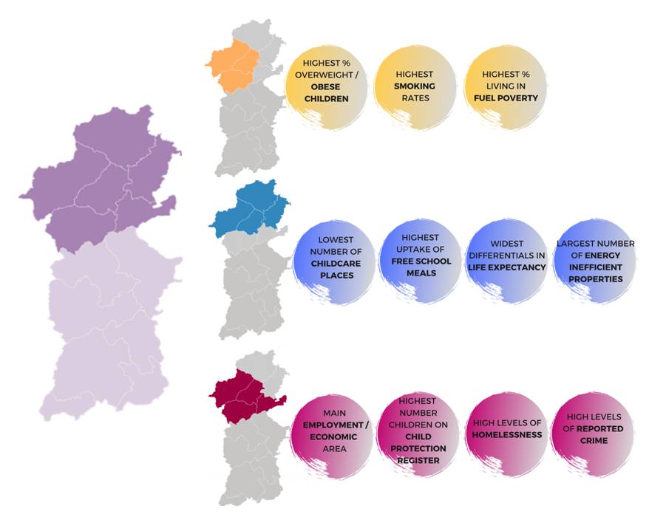
Figure 18: North Powys Demography

Determinants of Health
Social determinants of health are the conditions in which people are born, grow up, live, work and age. These conditions influence a person’s opportunity to be healthy, his/her risk of illness and life expectancy. Social inequities in health, the unfair and avoidable differences in health status across groups in society, are those that result from the uneven distribution of social determinants. The conditions which make up the social determinants of health are wide-ranging and include the following:

Figure 19: Conditions that make up the social determinants of health
In addition to each individual factor, these influences interact with each other in a complex way. For example, poor health or lack of education can impact on employment opportunities which in turn constrain income. Health is certainly influenced by behaviours, with smoking, alcohol consumption, unhealthy diet and physical inactivity most prominent among behaviours that are related to ill health in the UK. However, these behaviours are largely themselves influenced by social determinants of health including income, employment and access to healthy environments. Also, where healthcare is important for improving health and combatting illness, the access to and use made of that healthcare is affected by social determinants of health. This has led some people to call social determinants the causes of the causes of poor health.
The impact of the social determinants of health and especially material deprivation is shown clearly through health inequalities as set out 10 years ago in the Marmot report. People in richer areas live longer than those in poorer areas. Not only that, but there is an even bigger difference in healthy life expectancy, the length of time that people live in good health. People in poorer areas live shorter lives and for more of that time they are in poor health. There are many reasons for these differences, but most at their core come down to social determinants of health.
The NPWP and proposed Campus aims to reduce the inequalities faced by the residents in north Powys and enable residents to “Start Well, Live Well, Age Well”.

Demography
The population of north Powys is 63,271, with Newtown being the largest town not just in north Powys, but the whole of Powys (population 11,319). Apart from the 4 largest towns, the rest of the population are widely dispersed in smaller centres, hamlets and across many rural properties.
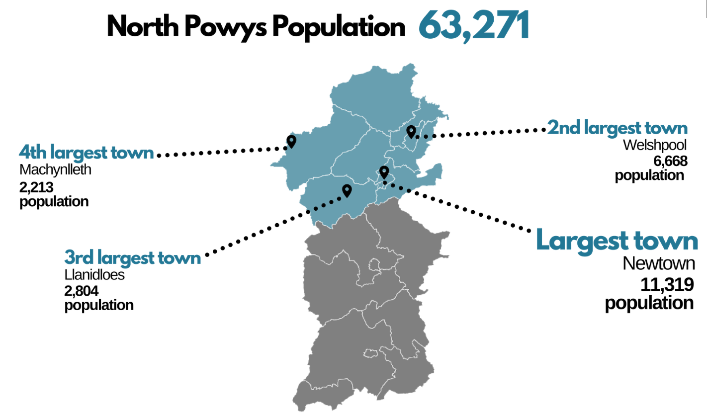
Figure 20: Map of North Powys depicting population of largest towns
Powys has an ageing population and it is projected that 38% of the population will be aged over 65 by 2036, who will require access to services, public transport, and accommodation. While people are living longer, these years are not always healthy. New treatments are also being developed which could help more people live for longer, but they are costly. To meet future demand, the way in which services are delivered must be changed, so that they are both affordable and sustainable.
Powys also has a dispersed rural population with nearly 59% of the population living in villages, hamlets and rural areas, making access to services challenging and, in some areas, limited. The age bandings for North Powys are detailed below:
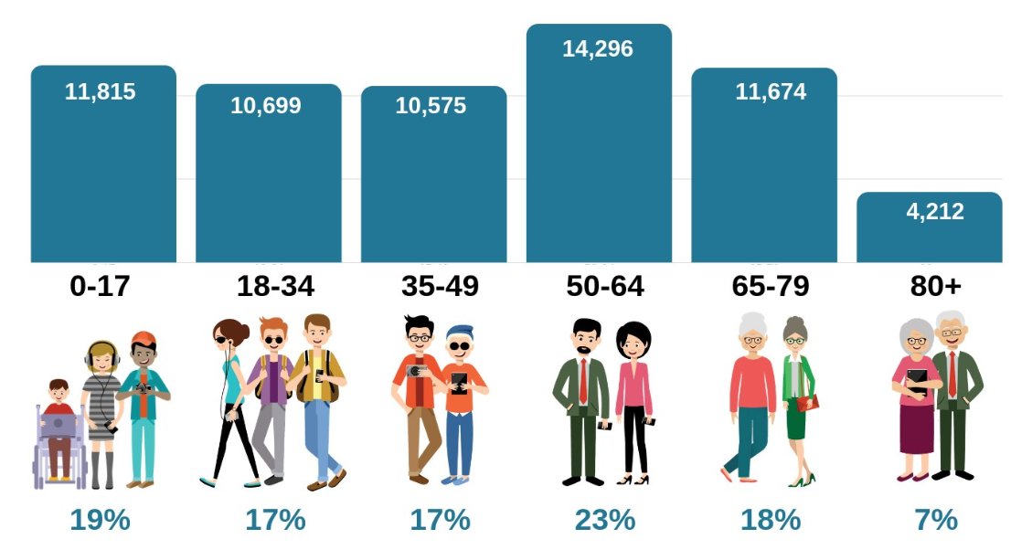
Figure 21: North Powys population age banding percentages

Accessibility
Powys’ rurality affects every element of service development and delivery. The indicators are already clear that the workforce of Powys is shrinking. This is in all areas of the Powys economy, not just the health and social care sector. The population is ageing both because older people see rurality as a retirement dream (only to see it become challenging as frailty begins to manifest itself) and the younger age groups see moving away as the route to achieve their own ambitions.
The Department for Transport estimates that people in rural areas of England and Wales travel approximately 40% further than people in most urban areas and almost all of this extra distance travelled by rural residents is by car. The car-dependent nature of travel in many rural areas means that there is a rising risk of mobility-related exclusion particularly amongst the oldest and those with health needs and Community Hospitals are an integral part of healthcare provision in many rural areas.
People in Powys rely on health services around the county’s borders. Each of these systems link into their own wider health economies which mean people can travel further away from Powys for specialist care. Due to the geography and population size of Powys, it is not feasible to develop a District General Hospital in the county, and as a result most specialist care has continued to be provided through the five health systems around its borders.
Closest Hospitals by Rank | Distance  (miles) | Min Travel Time  (mins) | Max Travel Time  (mins)⁷
Royal Shrewsbury Hospital | 32 | 58.1 | 155.2
Robert Jones& Agnes Hunt | 32 | 57.8 | 155.8
Bronglais Hospital | 44 | 56.8 | 154.9
Wrexham Maelor Hospital | 44 | 56.9 | 156.4
Telford Hospital | 48 | 56.7 | 155.5
Table 8: District Hospitals serving North Powys residents (with min and max travel time)
North Powys is strategically important in strengthening health and care services for mid Wales and providing an opportunity to reduce the impact of reconfiguration proposals around its borders. There are also opportunities to work in partnership with these health systems and to upskill our local workforce to provide some of these services more locally in north Powys.
A key consideration for service providers is to deliver as much care as possible in Powys, avoiding out of county travel and providing a better experience for the individual. The current hospital model is proving increasingly challenging to sustain, and a key future goal is to redesign this clinical model and, in the process, strengthen the primary care sector to support a sustainable future for health and social care in the community.
In north Powys there is currently no local service provision for day cases; approximately 5,000 people travel out of county each year for relatively straight forward operations that could be undertaken in a day-case facility in north Powys. There are also around 60,000 outpatient appointments which take place each year outside Powys, a large proportion of which could be delivered more locally or via virtual digital clinics if there was access to the right infrastructure, diagnostics, workforce and facilities. Investment in digital technology and new facilities will enable the delivery of local day cases, diagnostics and one stop services in north Powys, this will hugely overcome travel distances and multiple visits to District General Hospitals providing value-based healthcare and improving the experiences for some of the most deprived communities in Wales by reducing unnecessary travel.
Inequalities in service provision are significant in north Powys. People in north Powys rely heavily on health services from within Shropshire’s Shrewsbury and Telford Hospital Trust (SaTH). Many of these services are changing under the Future Fit reconfiguration programme and a large proportion of services including planned care are going to be transferred to the Telford Hospital site, resulting in people having to travel much further for routine care that could be provided locally in Powys. Recently the CQC have reported concerning quality issues in relation to the standards of care at the Shrewsbury and Telford Hospital Trust, and discussions are ongoing in partnership around more short term measures which could be taken to support a reduction in admissions to SaTH and to improve discharge planning.

Deprivation
By growing up in a deprived area, children are more likely to have poorer health and adults are more likely to adopt unhealthy lifestyles which will impact on the rest of their lives. Evidence shows that over a 10-year period, cognitive outcomes for children from a low socio-economic status is significantly lower than for those from a high socio-economic status.
In Powys, just over 1 in 5 children are estimated to be living in poverty after housing costs are taken into consideration. Across Wales, there is a clear correlation between levels of deprivation and rates of overweight or obesity, ranging from 28.4% of children living in the most deprived areas being overweight or obese to 20.9% in the least deprived. This is particular concern in the Newtown and Welshpool areas which both score highly on a number of factors associated with the Welsh Index of Multiple Deprivation (WIMD). With a reducing child population, resources need to be focused on both universal and targeted support to those families with the highest needs or risk.
Unhealthy lifestyles increase demand on health and social care services and reduce people’s ability to live a fulfilling life. Although rates of physical activity in Powys are above the Wales average, nearly 6 in 10 adults are overweight or obese and this figure is predicted to rise. Just under 1 in 5 adults in the county smoke, and 4 in 10 drink more than the recommended amount.

Health and Wellbeing Indicators
The PCC Business Intelligence Unit conducted a detailed analysis of over 40 datasets split into three reports:
- Focus on Wellbeing
- The Big Four
- Joined Up Care
The same methodology was utilised in all three reports: indicators were coloured red, amber or green, depending on how far off the Powys Average (mean average) they were, with green being better than average. The ratings have been converted into percentages, allowing the team to analyse the areas with the greatest proportion of “red”. The figure overleaf shows that the north Powys area with the highest level of “below average” measures relating is Newtown South-West:

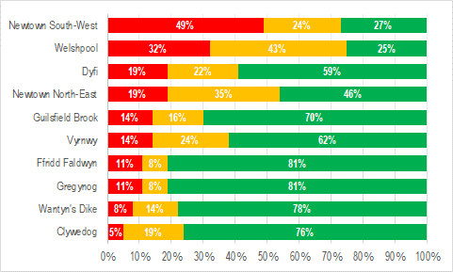
Figure 22: North Powys health indicators (wellbeing, big 4, joined-up care)
The analysis also found:
- Newtown has a higher average of children living in poverty
- The lowest levels of home ownership for north Powys are in Newtown and Welshpool
- People in Newtown South West have a higher average for those struggling to keep up with bills
- Newtown South West has the highest average unemployment and, in general, unemployment is rising steeply in Powys
- The lowest level of satisfaction with the local area is Newtown South West
- Lowest levels of two parent households are in Newtown South West
- Children on the child protection register average rates are high in Newtown and Welshpool
- The number of unpaid carers on average is higher in Welshpool and Newtown South West
- The rate of people receiving domiciliary care is higher in Newtown South West and Dyfi localities
The following visual shows the variation across the ten areas in north Powys. The overall RAG for an area is shown on the top row, and the underlying rows represent The Big Four, Focus on Wellbeing and Joined Up Care. It can be seen that the areas with the lowest RAG ratings are Newtown North East and Newtown South West (full details can be found in Appendix E)

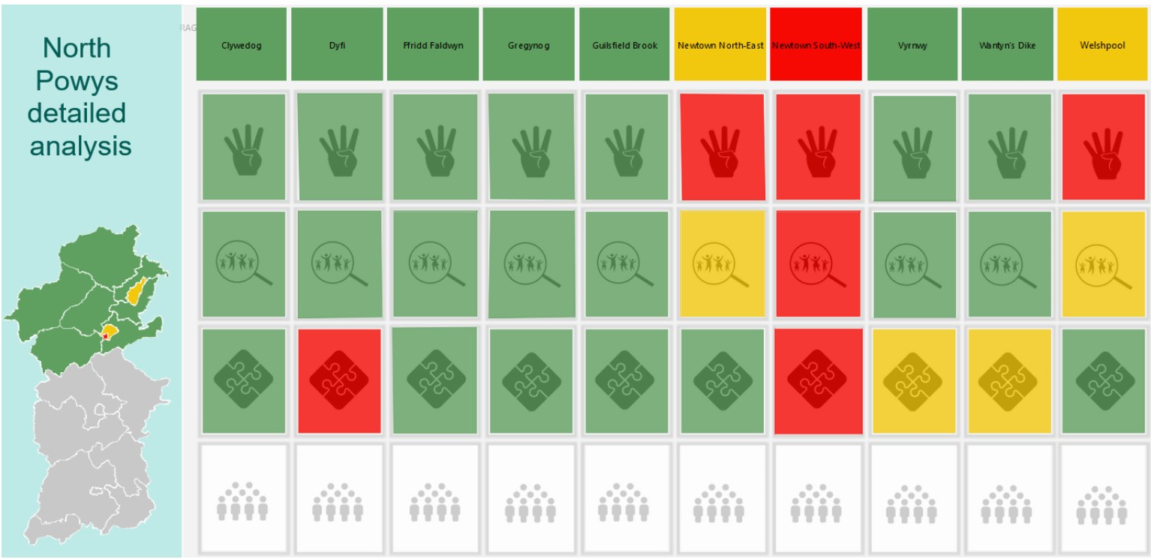

Figure 23: North Powys health indicators (detailed analysis)

Education Indicators
Between 2014 and 2019, Powys’ population fell by around 0.71%, or 949 people. This decline is set to continue for the foreseeable future. This population decline will not be evenly distributed across all age groups and it is expected that the number of young people in the county will reduce by 14% over the next 20 years. This will create additional pressures on an already stretched education system, necessitating the removal of the infant/junior split in some areas to create “all-through” primary schools, as in the proposed Campus.
As is the case nationally, there is a significant gap in educational outcomes between pupils from low-income families and those from more affluent backgrounds in Powys. The schools included in the Campus have between 22%-27% of children eligible for free school meals, compared to a national average of 18%. With a focus being placed on tackling inequality across Wales, concentrated effort is required to close the attainment gap between those eligible for free school meals and those who are not.

Housing and Regeneration
The average household size in Powys is projected to decrease from 2.24 persons in 2011 to 2.13 persons in 2026 (based on the 2011-based Local Authority Population Projections produced by the Welsh Government). Smaller households, and changes to the welfare system, will increase the need and demand for 1- and 2-bedroom properties, although these must be designed with adequate amenity space.

National Policy Drivers
Nationally, the programme aligns with the key principles of The Well-being of Future Generations (Wales) Act 2015 and The Environment (Wales) Act 2016, with particular reference to the National Climate Change Emergency and how the proposed works will contribute to carbon reduction. The key national drivers for this programme are outlined below:

A Healthier Wales: Our Plan for Health and Social Care (2019)
This document sets out a level of ambition to bring health and social care services together, working seamlessly across the whole system, designed and delivered around the needs and preferences of individuals, with much greater emphasis on keeping people healthy and well. It sets out ten national design principles for change and transformation. The NPWP is driven by these design principles as follows:

Principles | Initial Assessment of the NPWP against “A Healthier Wales” Principles
Prevention and Early Intervention | - shift the whole system to focus on prevention, early help and support in a rural setting to reduce unnecessary hospital admissions and attendances
Safety | - a sustainable workforce will underpin the new integrated model, this will upskill people and provide effective learning and development through a networked approach  - ensure seamless service provision and provide a fit for purpose environment
Independence | - support people to remain independent at home for as long as possible, but feel connected to their communities  - support carers and disabled people to live a fulfilled life utilising new technology where possible
Voice | - embed a co-production approach in the programme of work  - develop the workforce and systems to be flexible enough to achieve what matters most to the individual and their families
Personalised | - joint care planning will be fundamental  - we will support a cultural change which enables people to respond to people’s holistic needs and reach their potential through a coaching approach
Seamless | - service will be designed from the service user perspective  - integrate services, through multiple levels of integration i.e.  1) health, social care, education, housing, ambulance and leisure  2) physical and mental health  3) secondary, community and primary care
High Value | - project evaluation will provide evidence of value  - integrated, system-wide planning and resource deployment will be designed to reduce avoidable and duplicated demand, services and cost.  - Condition and procedure specific, whole system pathways will be designed to provide right service in the right place at the right time to minimise avoidable demand and provision.
Evidence Driven | - The design of the new integrated model will be based on both national and international best practice.  - The benefits realisation and project evaluation will provide evidence on effectiveness of the new integrated model before roll out across Powys.
Scalable | - A programme management approach will allow project outcomes to be  - defined and measured, along with system wide performance. This will provide evidence of what works well and what doesn’t work well.
Transformative | - A new integrated model to redesign the whole health and care system will transform the way health and care is provided in the future in Powys. The stakeholder involvement in the work will be key to support the broader roll out across Powys.
Table 9: Initial Assessment of the NPWP against "A Healthier Wales" principles

Prudent Health Care (2015)
The principles of prudent health and care informed and influenced the Health and Care Strategy and the local principles for Powys. They will be a core part of the design framework that have underpinned the process for developing a new integrated model for north Powys.

The Social Services and Wellbeing Act (2014)
This Act imposes duties on local authorities, health boards and Welsh Ministers to promote the wellbeing of those who need care and support, or carers who need support. It seeks to ensure people have greater control over what support they need with an equal say in the support they receive; partnership and co-operation underpin service delivery and prevention of escalating needs.
This Act has been fundamental to the design of the new integrated model, shifting the focus of the current system to wellbeing and early help. It will prevent people from becoming ill in the longer term, reduce people being admitted to hospital, help people to remain independent at home and to enable people to live a fulfilled life.
For those people who continue to need to access services, these will be joined up through effective care coordination and integrated multi-disciplinary teams which provide seamless care in the community and at home. These teams will be supported via Community Wellbeing Hubs and Rural Regional Centres.

The Well-being of Future Generations (Wales) Act 2015
Wales faces several challenges both now and in the future. These include climate change, poverty, health inequalities, jobs and growth. To tackle these issues the National Assembly for Wales passed legislation in 2015 which requires a range of public bodies across Wales to work together to give current and future generations a better quality of life.
The Act places a duty on all public bodies to carry out sustainable development - the process of improving the economic, social, environmental and cultural well-being of Wales. It requires all public bodies to change the way they work in order to improve well-being for the whole population, by acting in accordance with the sustainable development principle, and meeting the 7 Well-being Goals (see figure below):
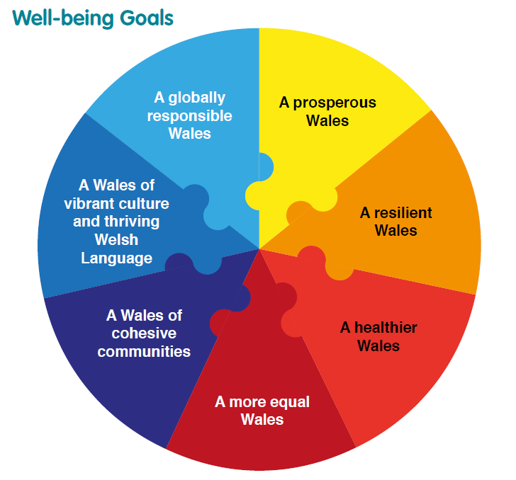
Figure 24: Well-being Goals
By considering the 7-well-being goals, PTHB can better meet the needs of its current population without compromising the ability of future generations to meet their own needs. Sustainable developments connect the environment in which we live, the economy in which we work, the society which we enjoy and the cultures that we share to the people that we serve and their quality of life. The Act places duties on public bodies to consider how key decisions impact on the longer term. It sets out 5 key ways of working. The five ways of working will provide a framework for the programme as follows:
5 Key Ways of Working | North Powys Wellbeing Programme
Long-Term | Developed within the context of the Powys Wellbeing Plan setting out what the Public Service Board wants Powys to look like in 2040
Prevention | Key focus on wellbeing and the provision of early help and support, healthy lifestyles, early years and maintaining independence
Integration | Joined up services to improve people’s experiences, through new models of care, co-location and integration of services
Collaboration | Collaboration between communities, public, partners, universities and other organisations to deliver greater benefits and opportunities, involving health, care and wellbeing
Involvement | New models of care, services and facilities co-produced with communities, public, partners, and other organisations around “what matters most to the individual”
Table 10: 5 Key ways of Working in the context of the NPWP
During 2019, the programme was audited by the Future Generations Commission against its ability to deliver the five ways of working under the Act; the outcomes of the audit demonstrated that there was alignment and some aspects were identified as good practice for other regions to consider.

National Development Framework 2020-2040
The National Development Framework (2020-2040) (NDF) identifies a range of important regional centres which, through specific policies in Strategic and Local Development Plans, should retain and enhance the commercial and public service base that make them focal points in their areas.
The Welsh Government supports the role of the regional centres of Carmarthen, Llandrindod Wells, Newtown, Aberystwyth and the four Haven Towns (Milford Haven, Haverfordwest, Pembroke and Pembroke Dock), recognising that these places play important sub-regional roles, providing jobs; leisure and retail; education and health services; and connectivity infrastructure that is used and relied on by both their own populations and communities around them. It is important that these settlements maintain their regional role and support a managed growth approach that allows their roles to be enhanced.

The Environment (Wales) Act 2016
The Environment (Wales) Act 2016 aims to promote the sustainable management of Natural Resources through ensuring the use of, and the impacts on, our natural resources, do not result in their long-term decline. The Act aims to achieve this through sustainably managing natural resources in a way and at a rate that meets the needs of the present generation without compromising the needs of future generations and which contribute to the seven well-being goals in the Well-being of Future Generations (Wales) Act 2015.

NHS Decarbonisation Strategic Delivery Plan 2020/2030
The Well-being of Future Generations Act places a duty on us to act today in a way that will preserve the planet for future generations. Decarbonisation has a critical role to play to meet our duty to achieve a resilient, prosperous, cohesive, more equal, globally responsible and healthier Wales. NHS Wales Decarbonisation Strategic Delivery Plan was written by the Carbon Trust with NWSSP in response to the Welsh Government’s declared climate emergency in 2019 and to allow public sector to be “net zero” by 2030. NHS Wales will need to reduce emissions by 34% to meet our contribution to the public sector’s combined goal of net zero by 2030. This relies on minimising waste, increasing efficiencies, and investing heavily in decarbonisation of buildings, vehicles, procurement and healthcare. Low carbon must be core to the decisions, and embedded into everyday processes so that it becomes integral to the decision making. The Delivery Plan records 46 initiatives to decarbonise NHS Wales. The Initiatives are decarbonisation activities, or projects, that NHS Wales will undertake to contribute to the public sector achieving carbon net zero position by 2030.

The Public Health (Wales) Bill (November 2016)
The Public Health (Wales) Bill was introduced into the National Assembly on 7th November 2016. Whilst health is improving, Wales still faces a number of specific and significant challenges. These range from challenges such as an ageing population, high levels of chronic disease and differences in the health of people in different areas.
The Bill brings together a range of practical actions for improving and protecting health. It focuses on shaping social conditions that are conducive to good health, and where avoidable health harms can be prevented. If passed, the Bill will, amongst other things, restrict smoking in school grounds, hospital grounds and public playgrounds, require local authorities to prepare a local strategy for toilet facilities for public use, require public bodies to carry out health impact assessments in specified circumstances and change the pharmaceutical list of health boards to a system based on the needs of local communities.

Taking Wales Forward (2016-2017)
More recently the Welsh Government document, Taking Wales Forward (2016-2017) affirms the NHS needs to reflect the needs of the modern society, with closer links between health and social services, strengthened community provision and better organisation of general hospital and specialised services. The document emphasises that more care and services will move from hospitals into communities, supported by integrated and sustainable Health and Care Services capable of meeting current demand and future need. Services will deliver timely care and treatment to patients when they need it. Key priorities for delivering improvements include:
- Improving our Healthcare Services
  - Continuing to improve access to GP surgeries, making it easier to get an appointment
  - Investing in community pharmacies to take pressure off our GP surgeries
  - Increase investment in facilities to reduce waiting times and exploit digital technologies to help speed up the diagnosis of illness
  - Invest in a new generation of integrated health and social services centres alongside the transformation of our hospital estate
- Healthcare Staff
  - Take action to attract and train more GPs, nurses and other health professionals across Wales
  - Ensure more nurses, in more settings, through an extended nurse staffing levels law
- Healthy and Active
  - Implement the Healthy Child Wales programme to ensure consistent delivery of universal health services up to age seven
  - Work with schools to promote children and young people’s activity and awareness of the importance of healthy lifestyle choices
  - Continue to promote exercise and good nutrition, reduce excessive alcohol consumption and cut smoking rates in Wales to 16% by 2020

Prosperity for All: The National Strategy (Wales) 2017
The four key themes of this strategy are the same as those in Taking Wales Forward. Each theme consists of a vision, showing how they will contribute to prosperity for all, and how delivering in a more integrated and collaborative way can enhance the well-being of the people of Wales. The key themes and objectives are pictured below:
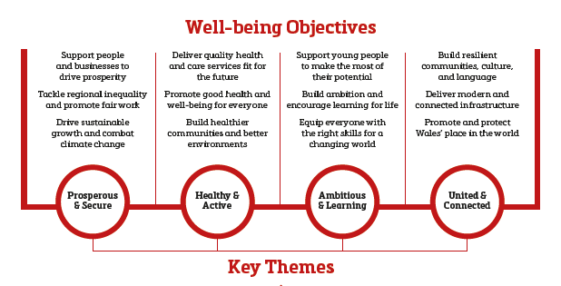
Figure 25: Well-being Objectives
The strategy identifies five cross-cutting themes as having the greatest potential contribution to long-term prosperity and well-being, where fully integrated services and early intervention will have the greatest impact. The North Powys Wellbeing programme will contribute to the five cross-cutting themes as follows:
Theme | North Powys Wellbeing Programme Contribution
Early Years | The new model will focus on “start well” and the importance of the first 1,000 days in preventing adverse childhood experiences. Focus will be on family planning; keeping children safe, emotional health and wellbeing and preparing children for school
Housing | There is an ambition to provide intergenerational supported living accommodation on the Campus in Newtown. This could provide technology enabled accommodation for older people, people with mental health conditions, continuing healthcare needs and people with learning disabilities and/or in transition. This will prevent people from being placed out of county
Social Care | The new integrated model will provide greater focus on wellbeing and early help and support, integration of physical and mental health, and improving quality and effectiveness of services
Mental Health | Keeping people healthy and independent for longer and enabling them to live within their home and be part of the community will be fundamental to the new integrated model
Skills and Employability | The proposed capital development includes a potential Rural Academy for Health and Care to be based on the Campus in Newtown. This will enable local training and development in rural care
Education | Education is the most important determinant of health. It drives aspiration, the ability to synthesise information and make informed choices. It enables getting a better job which will have an effect on relative poverty and mental health and will enable accessing better accommodation and have a better working environment.
Relative Poverty | Relative poverty has an effect on mental health as well as physical health through living in poorer accommodation. People in relative poverty are also more likely to have less health working environments.
Table 11: Wellbeing Objectives: NPWP Contribution

The Housing (Wales) Act 2014
The Housing (Wales) Act 2014 introduced several new duties in relation to homelessness for local authorities. It brought into law the “prevention of homelessness” focus which had been the key direction of national policy development over recent years. This approach focussed on providing services which focussed on finding housing solutions for all households in housing need, rather than processing people through the legal “homelessness” process. This reflects a broader national policy direction around areas such as health and social services which aim to put prevention at the heart of services to avoid more costly options.
There is also increasing evidence through international research that the usual approach to managing homelessness is focussing too much on the point of crisis, rather than on prevention and longer-term support. A recent Welsh Audit Office report concluded that “Local Authorities continue to focus on managing people in crisis rather than stop it from happening”.

21st Century Schools and Education Programme
The 21st Century Schools and Education Programme is a unique collaboration between Welsh Government and Local Authorities. It is a major long-term strategic capital investment programme with the aim of creating a generation of 21st Century Schools in Wales. The Programme represents the largest strategic investment in Welsh educational infrastructure since the 1960s and has been designed to end the piecemeal “patch and mend” approach to investment in educational infrastructure that characterised earlier funding packages. Key Criteria of the programme include:
- Improving the condition of educational assets;
- Reductions of surplus capacity and inefficiency in the system;
- Expansion of schools and colleges in areas of increased demand for educational services;
- Provision of sufficient places to address growth in demand for Welsh medium education

Additional Welsh Guidance
Other significant national policy drivers which have influenced this PBC are listed below:
- The Welsh Government’s Tackling Poverty Plan
- The Welsh Language Measure (Wales) 2011
- The Housing (Wales) Act 2014

Local Policy Drivers
Locally, this programme supports objectives of “A Healthy Caring Powys” and supports a move to a “Carbon Positive Powys” as set out in the Public Service Boards Wellbeing Plan and the emerging Regional Energy Plan. The key local drivers for this programme are outlined below:

Strategy for Transforming Education in Powys 2020-2030
In April 2020, PCC launched a new Strategy for Transforming Education in Powys 2020-2030. The strategy was developed following engagement with a range of stakeholders between October 2019 and March 2020. The strategy sets out a new vision statement for education in Powys, which is as follows:
“All children and young people in Powys will experience a high-quality, inspiring education to help develop the knowledge, skills and attributes that will enable them to become healthy, personally fulfilled, economically productive, socially responsible and globally engaged citizens of 21st century Wales”.
The strategy also sets out a number of guiding principles which will become the foundation of the Powys education system going forward. These are as follows:
- A world class rural education system that has learner entitlement at its core
- Schools that are fully inclusive, with a culture of deep collaboration in order to improve learner outcomes and experience
- A broad choice and high quality of provision for 14-19 year old learners, that includes both academic and vocational provision, meeting the needs of all learners, communities and the Powys economy
- Welsh-medium provision that is accessible and provides a full curriculum in Welsh from Meithrin (early years) to age 19 and beyond
- Provision for learners with Special Educational Needs (SEN)/Additional Learning Needs (ALN) that is accessible as near to home as is practicably possible, with the appropriate specialist teaching, support and facilities that enables every learner to meet their potential
- A digitally-rich schools’ sector that enables all learners and staff to enhance their teaching and learning experience
- Community-focused schools that are the central point for multi-agency services to support children, young people, families and the community
- Early years provision that is designed to meet the needs of all children, mindful of their particular circumstances, language requirements or any special or additional learning needs
- Financially and environmentally sustainable schools
- The highest priority is given to staff wellbeing and professional development
In bringing forward any proposals, PCC will adhere with the Welsh Government’s School Organisation Code, but, in addition, the following will apply:
- The best interests of learners are at the forefront of all proposals and decision-making
- PCC will always operate in an open and transparent manner
- Staff and learners will be fully supported through any process of change.
The strategy also includes the following four Strategic Aims, which will shape PCC’s work to transform the Powys education system over the coming years:
STRATEGIC AIMS
1 | 2 | 3 | 4
We will improve learner entitlement and experience for pre-16 learners | We will improve learner entitlement and experience for post-16 learners | We will improve access to Welsh-medium provision across all key stages | We will improve the provision for learners with SEN/ALN
Table 12: Strategy for Transforming Education in Powys 2020-2030 Strategic Aims
The Strategy also includes a number of Enabling Actions (EA), which will support the implementation of the four Strategic Aims, one of which (EA1) is the implementation of a major capital investment programme that will ensure that schools in Powys have inspiring, environmentally sustainable buildings that can provide opportunities for wider community activity, including where possible childcare services, early years, ALN, multi-agency support and community and leisure facilities. This will also include developing a reliable high-quality digital infrastructure.

The Health and Care Strategy: A Healthy Caring Powys
The RPB jointly developed “The Health and Care Strategy for Powys” in 2017. The strategy builds on the early insights from the Powys Well-being Assessment which has been developed by the Powys Public Services Board in support of the Well-being and Future Generations Act 2014. The strategy is not a response to the act but the vision for Health and Care in Powys which also forms a key component of the Powys Well-being Plan.
The strategy sets out the direction of travel for health and care in Powys to 2027 and beyond. It offers ideas built on the contributions of over 1,000 people to what the future could look like. The vision for the future is ‘a Healthy Caring Powys’ to be delivered throughout people’s lives to enable children and young people to “Start Well”, for people to “Live Well” and older people to “Age Well”. The strategy focuses on wellbeing, early help and support, tackling the big four and joined up care; to be achieved by a number of enablers to include workforce, digital, innovative environment and working in partnership.
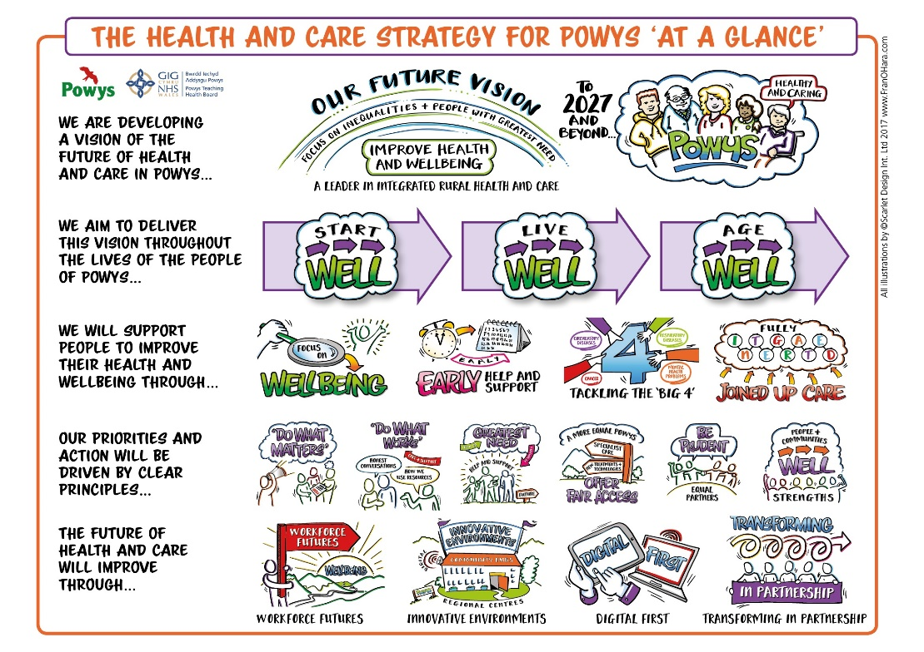
Figure 26: Powys Health and Care Strategy "at a glance"
The Strategy sets out an integrated model of care predicated on a network approach, with four angles to the model:
- Care closer to home
- Community Wellbeing Hubs within key market towns
- Rural Regional Centres to provide more enhanced services within the county
- Out of county to access acute and specialist provision

Model of Care
Significant work has been undertaken during the last 18 months to further design, define and update the integrated model of care initially developed to support the delivery of a Joint Health and Care Strategy for Powys. This has been underpinned by a detailed population needs assessment and evidence to support a robust case for change. This information has been used alongside a co-designed approach with key stakeholders with “what matters to you” at the core of the engagement methodology. An extensive engagement exercise was undertaken to obtain the views of a range of stakeholders, spanning residents of all ages, clinical/non-clinical staff, and specialist groups that included Syrian family refugees, people who access mental health services via Ponthfaren and their staff, arts groups, Open Newtown and school children across north Powys. The integrated model of care was approved by RPB and Cabinet Member Decision, PTHB Board in March 2020. (see Appendix F).
Figure 27: The Model of Care for Powys
To enable residents in Powys to live longer, healthier and therefore happier lives, there is a need to shift the focus of the model of health and care away from service delivery in acute and specialist hospital settings and offer a more holistic, integrated model of care with more wellbeing, prevention and early help services delivered closer to people’s homes and communities.
The new integrated model of care for Powys is part of a Wales-wide response to the increasing demands and new challenges facing the NHS and social care. These include an ageing population, lifestyle changes, public expectation and new and emerging medical and digital technologies. This model is fully aligned to delivery of the Welsh Government “A Healthier Wales: Our Plan for Health and Social Care”. It enables health, social care and other partner organisations to work together, to help people live well in their communities, meet their health and care needs effectively, and provide more services closer to or at home, so that people only need to use a hospital for treatment that cannot be provided safely anywhere else.
The rural geography of Powys and the complex commissioning arrangements are key factors in bringing care closer to home wherever possible. The RPB are seeking to shift the balance of outpatient, day care, diagnostic and elective inpatient services to community or primary care settings to improve access and quality of care within Powys, and to promote independence and reduce demand and dependence on high cost intervention services. Moving healthcare closer to home is important in addressing the pressures of future demand and ensuring people get care and support in an environment which best meets their needs, this may also avoid further costs in the long term of expensive hospital environments.
Investment in digital technology and new facilities will enable the delivery of local day cases, diagnostics and one stop services in north Powys, this will hugely overcome travel distances and multiple visits to District General Hospitals providing value-based healthcare and improving the experiences for some of the most deprived communities in Wales by reducing unnecessary travel. The Rural Regional Centre is key to strengthening local provision, minimising the impact of the strategic changes taking place around Powys’ border and improving outcomes and experiences for the local population.
The multi-agency wellbeing campus will facilitate a new integrated model for the area, bringing partners together across education, health and social care, housing, community development and third sector, with opportunities for further linkages to leisure, police and ambulance services. It will also maximise wellbeing and leisure opportunities via essential links with green spaces through Open Newtown and collaborative working with partners in the Third Sector and local businesses.

Rural Regional Centre and Community Wellbeing Hub
A hub and spoke network will link Home and Community Wellbeing Hubs to Rural Regional Centres across Powys; there will be no wrong door.
The RPB will work with local communities to develop and strengthen community assets that support people to feel safe, with opportunities to benefit from and take part in environmentally based schemes, live healthily for longer and contribute to their communities for the benefit of all. Community Wellbeing Hubs will be a key feature in supporting delivery of this approach.
Rural Regional Centres will introduce an innovative “investigative and diagnostic” treatment model which reduces the number of outpatient appointments and reduces the number of people needing to travel to hospital or out of county for routine non-complex services. It will provide an opportunity to develop skills in primary and community care through strong networks with neighbouring acute hospitals. Enabling more enhanced services such as medical and surgical day cases, local and remote diagnostics and one stop ambulatory care services to be provided within the region.
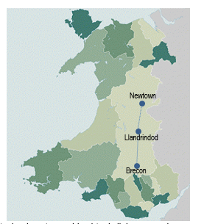 | Such centres should reflect the unique nature of the rural context of Powys and therefore include strong relationships with providers of services that cannot be delivered currently in Powys. The Health and Care Strategy set out three areas as being strategically important in developing Rural Regional Centres; these are Newtown, Llandrindod Wells and Brecon. According to the Welsh Index of Multiple Deprivation (WIMD) these pockets of these areas have been identified as being among the worst 30% of areas in Wales. The link between deprivation and poor health is well recognised. People in the most deprived areas have higher levels of mental illness, hearing and sight problems, and long-term conditions.

Model of Care Benefits and Outcomes
The following high-level benefits will be derived from the delivery of the integrated model of care:
- Integration of health and care services
- Improve access and reduce unnecessary travel time for people
- Strengthen Powys as a place to work
- Create new service development and partnership opportunities
- Improve service user experience
The integrated model of care will support delivery of the following RPB outcomes, as set out in their Outcomes Framework (overleaf). The Framework has recently been developed by conducting a desktop review of key strategic documentation across Powys RPB and undertaking interviews with stakeholders and key partners. This aligns with Welsh Government policy and will be underpinned by an indicator dashboard and monitoring arrangements to support with decision making in relation to priorities and deployment of resources. The NPWP will be monitored and evaluated against its ability to deliver these outcomes through the new integrated model.

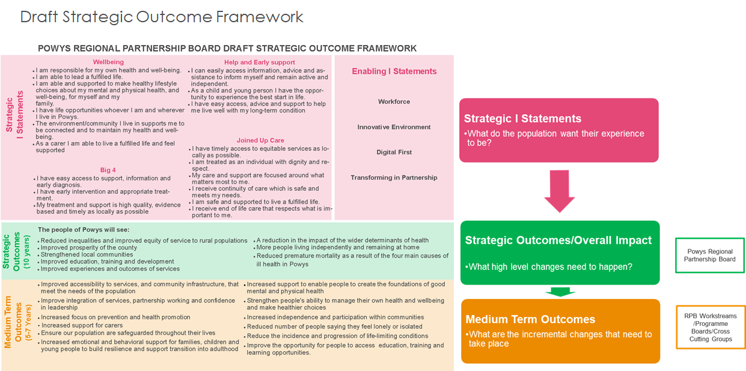
Figure 28: Draft Strategic Outcome Framework

Powys Environmental Policy
In line with Welsh Government’s Seven Wellbeing Goals, PTHB’s ISO14001 (2015) accredited Environmental Management System and Estates Decarbonisation Plan are both effective systems for driving through and monitoring the changes needed to help meet government ambitious environmental targets as set out in the Environment (Wales) Act 2016:
 | Goal | PTHB Response
 | A prosperous Wales | By linking in with national and regional developments, this co-produced program and subsequent work will support delivery of an innovative, productive and low carbon future. PTHB aims to support and upskill staff and contractors to prepare for a decarbonised future whilst ensuring buildings and services use resources productively, efficiently and effectively
 | A globally responsible Wales | Through this program, PTHB will be working towards a long-term strategy of its estates and the services it provides, by balancing the decisions it makes on the short-term needs with the long-term impacts and the ability of future generations to meet their needs. Through support and effective communications, PTHB will bring about a culture change within the organisation to one of proactive actions, to safeguard what is good and to improve areas where negative long-term impacts might otherwise occur. By working in partnership, it will tackle the supply chain to better address the three pillars of sustainability: economy, environment, society.
 | A resilient Wales | This program will look to understand the important natural aspects of the site and look to protect and enhance them, leading to an increase in biodiversity provision supporting Nature Recovery aspirations. Opportunities will be realised throughout the program to support a well-educated workforce and general public as well as providing space for ‘social prescribing’.
 | A healthier Wales | By supporting a decarbonised future, PTHB will help avoid the worst impacts of Climate Change and help mitigate unavoidable effects. By protecting and enhancing functioning green spaces, PTHB will support the delivery of the Health and Care strategy and its wellbeing objectives.
 | A more equal Wales | PTHB will work in a way which identifies and consults with stakeholders and allows them a chance to develop ideas co-productively for a better, more joined up future. By working with procurement and commissioning services, PTHB will look to implement better and fairer systems which are inclusive and open to all. PTHB will work with businesses and organisations to upskill staff so they are better able to deliver appropriate services in the future.
 | A Wales of cohesive communities | Local communities and stakeholders have been engaged from the very start and will continue to be throughout. This will ensure a truly co-produced and effective development which will be sympathetic to the local needs and add to local and national culture as an integral part of our Environment and Decarbonisation framework; from development to delivery. PTHB recognises climate change and sustainability affects everyone everywhere and so a co-productive approach is essential to ensure joined up and effective project delivery.
 | A Wales of vibrant culture and thriving Welsh language | Through careful and considerate development and delivery, the Campus will be sympathetic to local cultures and engender a sense of pride in Wales; a small nation who now has a big international role to play. Engagement is enhanced with the acknowledgement that this is a bilingual country and its culture is engrained in that language.
Table 13: PTHB’s Environmental Management System and Estates Decarbonisation Plan

Response to Policy and Strategic Drivers
In response to the strategic drivers outlined above, the RPB is working towards a model of services which aims to:
- further develop the integrated delivery of community-based services
- reduce carbon emissions by addressing compliance and backlog maintenance issues and embracing less carbon intensive technologies
- develop an estate that is fit-for-purpose and better meets service needs
- maximise opportunities to deliver integrated services as close as possible to where people live
- make best use of the resources available
- reduce commissioning costs for out-of-county providers by striving to bring as many services back into Powys as possible
- deliver services in county where it is both safe and appropriate to do so
- extend the range and volume of services available
- ensure children and young people get the best start in life to enable them to become personally fulfilled, economically productive, socially responsible and globally engaged citizens

PTHB Capital Developments
In response to the strategic objective to develop an estate that is fit-for-purpose and better meets service needs, PTHB has completed a Strategic Outline Programme to outline a five year programme of capital investment to address the considerable concerns in respect of health and safety compliance in the health board’s estate. During 2020/21, PTHB will develop a long-term estates strategy building on the Health and Care Strategy to ensure the best use of the current built environment and ensuring that opportunities to deliver modern fit-for-purpose facilities across the public sector footprint is achieved for the citizens of Powys. The following capital developments are already completed/underway:

Brecon War Memorial Hospital Development
In order to develop BWMH into a Rural Regional Centre the hospital has already benefitted from significant investment over the past 5 years (Circa £2m) to improve and enhance services. Most notably significant improvements to Endoscopy, X-ray, the Children’s Centre (including a new audiology booth and changing places facility) and ward upgrades. In addition, BWMH already offers the following enhanced services, which is part of the Health Boards model for Rural Regional Centres:
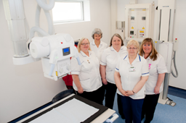 | - Day Surgery Unit with laminar air flow theatres  - A dedicated, JAG accredited endoscopy suite sitting within Theatre environment  - Wet AMD Service; from April 2016 patients needing treatment for wet AMD have been able to receive it in Brecon Hospital, saving them from having to travel out of the county for treatment

Llandrindod Wells Community Hospital Development
Initial development phases at Llandrindod Wells Community Hospital (LWH) have already seen in excess of £10M Capital investment since 2016 in order to reconfigure departments, maximise capacity, improve experience and productivity, and provide fit for purpose accommodation.
The hospital is strategically placed in Powys to support the repatriation of services from neighbouring District General Hospitals. This phase of the development, which completed in early 2020, provides further capacity to repatriate activity from secondary care and to opportunities to develop and expand existing services within the hospital. Some of the enhanced services now being offered at LWH include:
- a dedicated JAG accredited endoscopy suite adjacent to main theatres
- an extended outpatient department to facilitate increased activity and support the “do more in Powys” strategy
- an extended Renal Dialysis service including isolation room (ensuring more patients can be treated in County)
- a new midwife-led Birth Centre with a dedicated Day Assessment Unit (DAU)
- improved access, waiting and support facilities to dental
- enhanced public facilities including enhanced waiting area and sanitary facilities
- improved reception area, FM and staff facilities
- a new “off-site” staff car park in order to alleviate parking pressures associated with increased activity
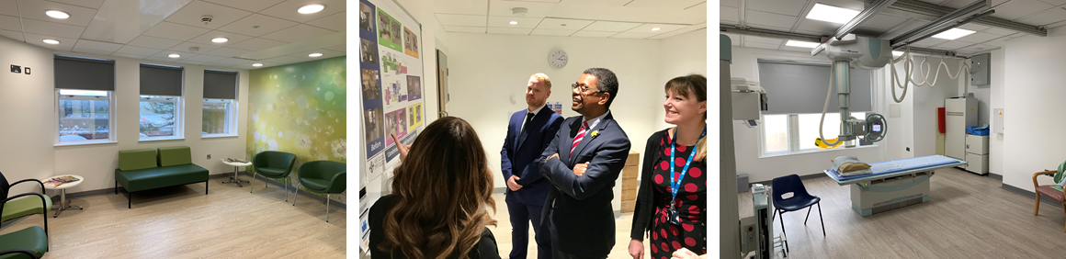
Figure 29: The new facilities at LWH, visited by Vaughan Gething, Minister for Health and Social Services
A Programme Business Case has now been submitted for phase 2 of the upgrade of LWH which will see the remainder of the hospital being upgraded to provide modern fit for purpose accommodation, reduce remaining backlog maintenance and focus on further service reconfiguration.

Bro Ddyfi Community Hospital Health and Well-being Project
PTHB are developing a business case (due for submission to WG in Q3 2020) in order to upgrade of the front block of Bro Ddyfi Community Hospital (BDCH). The works will address essential estate compliance and fabric issues alongside clinical reconfiguration/refurbishment of the area in order to support the Health Board’s plans to integrate primary care services onto the site and establish BDCH as a health and well-being facility for the local community. The facility will also provide a base for health, local authority and third sector teams, encouraging improved integration and efficiency and create a community ‘hub’ to improve access to health and social care, wellbeing, prevention and health promotion facilities.

Powys Health and Care Academy, Bronllys
In 2020, Integrated Care Funding (ICF) was secured to upgrade Basil Webb Hall (located at Bronllys Hospital) to provide a Health and Care Academy. The facility will act as a ‘hub’ for South Powys and would be supported by a further ‘hub’ which will form part of the North Powys Wellbeing Campus.
The Powys Workforce Futures Health and Care Strategic Framework is a key enabler of the Health and Care Strategy; A Healthy Caring Powys and is designed to ensure there is a strong, cross sector workforce to help improve health and wellbeing for the people of Powys. It also responds to the Quadruple Aim of the Healthier Wales: Our National Plan for Health and Social Care in terms of achieving ‘a motivated and sustainable health and social care workforce’.
The strategic framework articulates the RPB’s vision for the health and care workforce in Powys over the next seven years, focusing on six key themes:
  - Designing, Planning and Attracting the Workforce
  - Leading the Workforce
  - Engagement and Wellbeing
  - Education, Training and Development
  - Partnership and Citizenship
  - Cross-cutting theme: Technology and Digital Infrastructure
Under the Education, Training and Development theme, the Framework commits us to deliver the following by 2022, with further commitments for 2025 and 2027:
- Laying the foundations for the development of a Health and Care Academy in Powys (aligned to the broader ambition for a Rural Learning Academy for Mid Wales under the Mid-Wales Growth Deal) through, which over time would offer a broad range of practical, academic and digital post-16 learning opportunities for people of all ages, including employed staff, volunteers and careers.
- Using accurate and up-to-date training needs analyses to inform our education and training needs and emerging offer.
- Through increased partnerships with training and education providers, providing learning opportunities up to degree level.
- Increased apprenticeships and work experience opportunities for all ages.
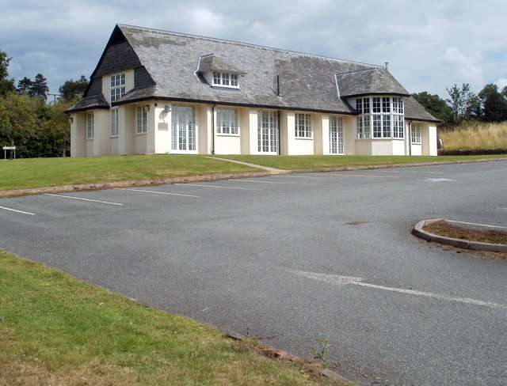
Figure 30: Basil Webb Hall, Bronllys
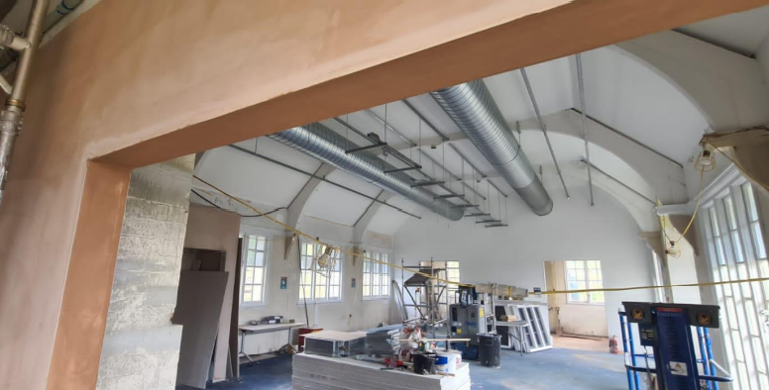
Figure 31: Progress March 2021

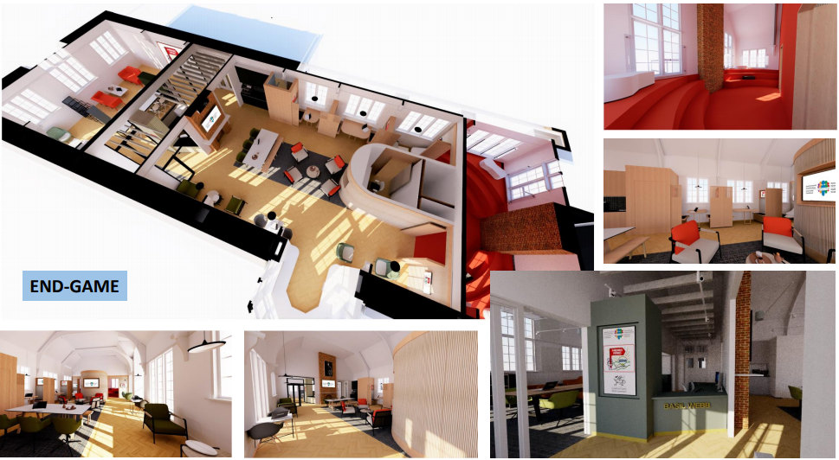
Figure 32: Visualisations of complete H&C Academy

21st Century School Programme Developments
During Phase A of the 21st Century School Programme, nine school building projects have been completed in Powys, with almost £56m being invested by PCC and the Welsh Government as part of the programme's first wave of investment. One high school and seven primary schools have been built and another primary school refurbished.
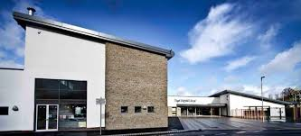
Figure 33: Ysgol Dafydd Llwyd, Newtown, opened in January 2016
Every project is unique and responds to local needs with a strong emphasis on community benefits, including examples of co-location of library services, community meeting and sporting facilities as well as facilities which centre around the needs of the family. Many developments have also seen the amalgamation of schools by removing the infant/junior split and creating “all-through” primary schools in order to secure long-term sustainability.
These developments also provide a model for providing additional services to the community e.g. early years provision, childcare support, multi-agency services, library services, and include areas for community activity, where appropriate. Not only does this provide an efficient, value-for-money approach that will support the continuation of community services, it also provides a unique opportunity to deliver an innovative service model.
The NPWP aims to continue PCC’s objectives of maximising integration and amalgamation of resources where appropriate, in order to improve the school estate, create workforce resilience and contribute to the long-term sustainability of the local community.

Part B: The Case for Change
As part of the NPWP the RPB have developed a case for change document which supports the information detailed in this section as well as detailing some of the key engagement which has taken place in the development of this PBC. The case for change document in included in Appendix G.

Existing Arrangements
This section will examine the existing arrangements/Business as Usual (BAU) and related business needs which will form the proposed scope of the programme. It will also detail the main benefits and objectives for the scheme as well as its risks, constraints and dependencies.
It sets out some of the detailed information that describes the key challenges faced by the Partnership. It serves to confirm that if we do not respond now to the challenges across the whole system, it is almost inevitable that we will fail to improve wellbeing and deliver the future services that the residents of north Powys need and deserve.

Education
Primary education in Newtown is delivered by the following schools:
- Ladywell Green Infants School (English-medium infant schools)
- Hafren Junior School (English-medium junior school)
- Penygloddfa C.P. School (English-medium primary school)
- Treowen C.P. School (English-medium primary school)
- Maesyrhandir C.P. School (English-medium primary school)
- St. Mary’s R.C. (A) School (English-medium Roman Catholic primary school)
- Ysgol Dafydd Llwyd (Welsh-medium primary school)
In addition, Newtown High School delivers secondary education to pupils aged 11-18, and Ysgol Cedewain is a special school for pupils aged 2-19. In total, over 1,000 primary pupils are currently taught in Newtown.
Pupil numbers at the primary providers have decreased over the last few years, mainly as a result of the change in the age of admission to primary schools in September 2017. Going forward, total primary pupil numbers in the town are projected to remain fairly stable over the coming years.
Apart from Ysgol Dafydd Llwyd, which opened in a new building funded by the 21st Century Schools Programme in 2016, there has been no significant investment in Newtown schools for many years. Plans are currently being developed for a new building for Ysgol Cedewain.
Ladywell Green Infant School and Hafren C.P. Junior School are two English-medium schools located on the proposed site of the Campus in Newtown and mainly serve the pupils living within the town.

Ladywell Green Nursery and Infant School
There are 107 pupils aged four to seven years at the school. Pupils are taught in two ordinary and two mixed age classes. There are three full-time and three part-time teachers, including headteacher. Statistically:
- around 27.4% of pupils are eligible for free school meals, which is above the national average of 18%
- 89% of pupils are white British and come from homes where English is the main language
- 7.3% of children are learning English as an additional language
- a very few children speak Welsh at home
- around 20% of pupils have additional learning needs, which is close to the national average of 21%
- 3.1% of pupils are looked after by the local authority
- no children have a statement of special educational needs
Ladywell Children’s Centre is a private provider operating from Ladywell Green Infant School, offering both morning and afternoon sessions for the over 3’s.

Hafren Junior School
There are 168 pupils aged seven to eleven at the school. There are five classes taught by four full-time and four part-time teachers. These include three mixed age classes. Statistically:
- around 22% of pupils are eligible for free school meals, which is above the national average of 18%
- 91% of pupils are white British and come from homes where English is the main language
- 4.2% of children are learning English as an additional language
- a very few children speak Welsh at home
- around 31% of pupils have additional learning needs, which is above the national average of 21%
- 0.6% of pupils are looked after by the local authority
- no children have a statement of special educational needs

Schools Merger
PCC has recently carried out the statutory process to merge Ladywell Green Infant School and Hafren C.P. Junior School, to establish a new primary school for pupils aged 4-11 in the buildings currently occupied by the two schools. In March 2020, the PCC’s Cabinet made a final decision to proceed with this merger, which will take effect from the 1 September 2021.

Case for Change
In the summer of 2017, PCC identified its priorities for Band B of the Welsh Government’s 21st Century Schools Programme. This identified the need for investment in a number of projects in Newtown and the surrounding area. Since then, PCC has been working with schools in Newtown to develop future plans for the school’s infrastructure, and identified the need to proceed with merging Ladywell Green Infants School and Hafren Junior School, as a first step towards replacing the current poor quality accommodation in the future.

Estate
There are significant concerns regarding the quality of accommodation at both Ladywell Green and Hafren schools. The latest condition assessments carried out for the two schools has assessed building condition as follows:

School | Condition
Ladywell Green Infants School | C/D
Hafren Junior School | C
Table 14: Ladywell Green Infant School and Hafren Junior School Building Condition
The following table provides descriptions of the condition grades:
Condition | Description
Category A | Good; performing as intended
Category B | Satisfactory, performing as intended, but exhibiting minor deterioration
Category C | Poor; exhibiting major defects and/or not operating as intended.
Category D | Bad; life expired and/or serious risk of imminent failure
Table 15: Condition Survey Grades
Ladywell Green Infants School is the building in the poorest condition, assessed to be condition C/D, suggesting that the building is nearing end of life.
The schools have an estimated combined backlog maintenance cost of £2.9 million.

Pupil Numbers
There are over 300 surplus places across the primary estate in Newtown, suggesting a need to review
provision in the town in accordance with the Council’s new Strategy for Transforming Education in Powys, which includes a strategic objective to “reconfigure and rationalise primary provision”.

University
There is no university in Powys; the closest Welsh university is in Aberystwyth. Part of the reason for the reduction in the population of the 18-45 age group is that students leave Powys to go to university and do not come back. The lack of a university contributes to the large net outward migration of 18-20-year olds from the county. Although there is a net gain from inward migration of this age group, it needs to be higher if the size of workforce is to be sustained in Powys.

Health and Social Care
The following health and social care services are currently undertaken in Newtown, serving the town and surrounding areas:

Children’s and Adult’s Social Care
To support families across Powys there approximately 220 staff in Children’s Services across a range of teams including fostering, adoption, children’s locality teams (0–18), care leavers teams, children with disabilities, youth justice service, integrated family service ream, Powys people direct, safeguarding & quality assurance and children & young people’s partnership.
Powys Adult Services works alongside people in need of support, in partnership with others to enable people to make decisions about how they can live as independently as possible. The work is broad ranging, but all delivered through the principles of identifying how people’s needs can be met by exploring their strengths, understanding what matters, and meeting eligible needs in a cost-effective way. The service delivers against the following broad areas:
Adult Social Care | Service Delivery
Managing demand through the front door of the Council | Adult Social Care operate an effective front door which provides information, advice and signposting which enables residents to make informed choices in relation to their care and wellbeing. A service which focuses on resolution at the earliest opportunity for the resident
Managing demand from hospitals | To work with NHS Partners to have in place a set of arrangements that allow for the speedy transfer of people from hospital, to achieve the best possible outcomes for those people
Working in partnership with Health to promote recovery | To work with the Powys Teaching Health Board to adopt and reinvigorate a recovery approach to all health and social care services
Effective short-term interventions for people in the community | There is timely, targeted and effective use of reablement, rehabilitation and support that has a focus on enabling independence and self-management and avoiding the over-prescription of care
Designing the care system for people with long term care and support needs | People with long-term care needs have a care and support plan with a focus on achieving the maximum possible independence (as is realistic and possible for their individual circumstances) and delivers the desired outcome. Plans are regularly reviewed based on outcomes achieved
Table 16: Powys Adult Social Care Service Delivery
Increasingly, the social care team is working more closely with PTHB, with several integrated teams, and working towards more joined up working with partners across the county. There are also strong ties with the voluntary and independent sectors in order to build resilience within communities. Staff are based in the Park Offices, Newtown.

Children’s Services
The following children’s services for north Powys are delivered from three different buildings in Newtown:
Ynys Y Plant | Park Street Clinic | Integrated Family Centre
- Action for Children  - ALAS (wheelchair assessment, adjustment)  - CAMHS  - Speech & Language Therapy  - Community Paediatric Nursing  - Community Paediatrician  - Health Visitors  - Occupational Therapy  - Orthotics  - Physiotherapy  - Safeguarding  - School Nursing  - Social Services  (Children with Disabilities) | - Flying Start (Health Visitors)  - Children's Speech & Language Therapy | - Flying Start (Health Visitors)  - Children’s Services  - Early Help  - Family Information Service  - Parenting  - Youth Service  - Action for Children  - Health Visitors.  - Home Start Cymru  - Reflect Project  - Powys County Council  - Youth Services  - Credu
Table 17: Children's Services
Newtown Integrated Family Centre was developed following a Welsh Government grant allowing for shared office, training, family and contact spaces for professionals, children, young people and families. This has resulted in a number of teams working together in one office space, allowing for sharing of information and a joined multi-agency approach and staff have gained awareness of each other’s roles and all that can be offered from a wealth of teams. Working in this way will encourage creative, new and innovative ways to deliver services. For example, creative projects encouraging children and young people to explore and develop their artistic skills. There are also many groups using the Integrated Family Centre on a bookable basis:

Figure 34: Bookable Services at the Integrated Family Centre
Children's Services undertook a complete restructure in April 2019; the focus has been on recruitment of new staff alongside training, development and upskilling of existing staff. However, due to the configuration of the buildings, staff are working in cramped conditions and it is not possible to maximise opportunities for joint or multi professional working centred on the individual’s needs.

Primary Care Services
Primary care services are facing increasingly unsustainable pressures and, as such, need to transform the way services are provided to reflect these growing challenges. These include:
- an ageing population, growing co-morbidities and increasing patient expectations, resulting in a large increase in consultations
- increasing pressure on NHS financial resources
- the need to address access to services
- the need to address inequalities in access to primary care
- workforce pressures including recruitment and retention

GP Practice
The GP practices close to the proposed site are:
- Newtown Medical Practice
- Ladywell Surgery (branch of Montgomery Medical Practice in Montgomery)
The main surgery, Newtown Medical Practice, offers generic GP primary care services in addition to Baby Clinics (health visitors), Diabetic Clinics, Asthma Management, Heart Disease Clinics, Chronic Obstructive Pulmonary Disease (C.O.P.D) Clinic, Hypertension Clinic (High Blood Pressure) and Minor Surgery.

Pharmacy
There is a dispensary adjoining Newtown Medical Practice in addition to the Superdrug, Boots, Lloyds and Morrison’s pharmacies in the town.

Optometry
There are three optometrist practices operating from Newtown town centre:
- Evans and Jones Opticians
- Specsavers
- Mehta Opticians

Minor Injuries
Newtown Medical Practice also provides a Minor Injuries services, operating 08:00-18:30 weekdays (not at the weekend or on Bank Holidays). Patients requiring this service need to report to reception and are seen by healthcare professional within 15 minutes.

Community Dentistry
The community dentist service practices from two dental surgery rooms at Park Street Clinic. Treatment and care is provided for a wide and very diverse group of patients, who are unable to obtain the more specialised and tailored care that they require within the primary dental services. The dental rooms are small, particularly for those in a wheelchair, and do not meet the requirements of the Equality Act 2010.

Podiatry
The podiatry service is delivered from one room at Park Street Clinic. The podiatry room does not have any support facilities and does not meet the recommendations of either the Welsh Health Building Notes (WHBN) or Welsh Health Technical Memoranda (WHTM).

Hospital Services
The following services are delivered from the Montgomeryshire Royal Infirmary (Newtown Hospital) site:

Figure 35: Services delivered from Newtown Hospital
Not only do some patients have to contend with going out of county for services, but they are having to go to multiple sites in order to be fully assessed, diagnosed and treated, rather than having a one stop shop where most aspects of treatment can be done in one place. For some disciplines, almost all activity goes out of north Powys, particularly to Shrewsbury and Telford and, in some cases, as far as Cardiff for a face to face consultation.

Mental Health Services
The following children’s services for north Powys are delivered from three different buildings in Newtown:
Park Street Clinic | Fan Gorau | Bro Hafren
- Psychology  - Primary care mental health team  - Learning disability clinical services | - Base for health and social care mental health staff and facilities for clinical meetings with service users | - Learning disabilities team, mental health, crisis team, social workers
Table 18: Mental Health Services
Mental Health Primary Care are mainly provided by GPs and their teams in Powys. Out of Hours Services are provided by “ShropDoc”. There are plans in place to transfer the Park Street Clinic mental health services to the Old College as a short-term solution.
The Powys Community Mental Health Teams (CMHTs) are a secondary care service for adults made up of Psychiatrists, Community Psychiatric Nurses (CPNs), Support Workers and Social Workers. The team are based Fan Gorau on the Newtown Hospital site.
Powys Child and Adolescent Mental Health Services (CAMHS) offers assessment and treatment for children and young people, up until their 18th birthday, who have or are thought to have mental health problems or emotional health difficulties. The team includes Clinical Psychologists, Consultant Child & Adolescent Psychiatrists, Specialist Nurses, Primary Mental Health Workers, Child Psychotherapists and Counsellors. The teams work from Ynys y Plant and Park Street Clinic (detailed in Section 2.2.3.2 above).
The learning disabilities team, mental health, crisis team, social workers have had to move into Bro Hafren, a building that had been vacated as it was not fit for purpose. However, due to a fire in Robert Owen House, staff have had to be temporarily placed there until something more suitable can be procured.

Third Sector Services
The Third Sector has a strong presence in north Powys and there are many examples of Wellbeing services that are in operation and could be offered from the Campus (some of which are listed in Figure 36 below). By providing spaces in a wellbeing hub, that are accessible and multi- purpose; groups and wider will offer services in a more joined up way. Sharing resources, together offering and meeting the needs of individuals and groups. Building and developing their skills and transferring knowledge. When groups and teams work from the same spaces it provides opportunities to try new ways of working, to test innovative approaches. For example, taking an art project into the outdoors following discussions with young people, listening to their ideas and producing a mural that showcases their work, thoughts and ideas, for everyone to see and notice.
• Pilates • Tea and Old Time Singing • Men’s Shed • Seated Exercise/Yoga • Art Club • Dru Yoga • Dance Exercise • Wellbeing Wednesday including Family History • Tai Chi • Hatha Yoga • Wellbeing Club • Gardening • Advice: all age including Family Information • Financial Guidance • Knitting • Crochet Club • Self-Care • Mind • Learn a Language • Montgomeryshire Parkinson’s Group • MS Society Montgomeryshire Group • Newtown Access Group/Accessibility Group • Dementia Friendly Newtown • Dementia Meeting Centre • Newtown (Dementia Matters in Powys) • Age Cymru • Salvation Army • Food Bank • Rotary Club: runs Memory Café • A Voice for You: Advocacy for people with LD • Severn Valley Social Club • Action on Hearing Loss: Hear to Help • ECLO: Eye Care Liaison Officer RNIB • Visually-Impaired Club • Celf Able: inclusive art • Cruse Bereavement Care • Severn Hospice •, Montgomeryshire Family Crisis Centre • British Red Cross: Home from Hospital • Powys Befriending Services • Credu • Open Newtown • Walking Newtown • Ponthafren • Oriel Gallery • Homestart • Breastfeeding Support • Baby Massage • Incredible Years Parenting and School Based Programmes • Early Help • Youth Support and Groups • Healthy Eating/Cooking • Café run by volunteers with locally-sourced food •
Figure 36:Wellbeing Services in North Powys

Case for Change
There are many elements that influence the case for change for health and social care in north Powys, including demography and epidemiology, deprivation and accessibility as detailed in Section 2.4.1.2, in addition to:
- promoting wellbeing
- offering early help and support to people
- tackling the big four diseases that limit life (cancer, circulatory diseases, mental health, respiratory diseases)
- providing joined up, holistic care
Supporting healthy lifestyles will be a key contributor, as unhealthy lifestyles place greater demand on health and social care services and reduce people's opportunity to live fulfilling lives. In Powys, although rates of physical activity are above the Wales average, nearly 6 in 10 adults are overweight or obese, this is predicted to continue to rise. Just under 1 in 5 adults currently smoke and 4 in 10 adults drink in excess of guideline amounts. The impact of unhealthy lifestyles on individuals and wider health and social care services means that prevention and early help and support is a key strategic focus in relation to delivering a new model in north Powys.

North Powys Residents
In order to develop a new integrated model of care, we first had to listen and learn about ‘what matters most’ to people in their home and community to further understand what is good now, and what they would like to see change in the future. As we were asking people to share a comment about their health and wellbeing, we needed to frame it in a way that would start a ‘conversation’ and then guide the response to frame it to home, community, region, or out of county.
A full programme of meaningful face to face and online engagement with residents on health and care related issues is paramount in the co-production of a new integrated model of care for north Powys. Giving residents the opportunity to have their say on what they would like to see improved, their personal experiences, insights and own perspective on how that could happen, will ensure residents feel empowered in the knowledge that their feedback has contributed to the new service design and delivery of a new integrated model of care. This programme of engagement has been guided by the National Principles for Public Engagement in Wales.
In response to engagement undertaken in June 2019 by the NPWP team, to the question “what could be done better” resident feedback includes the following:
- “most hospital services are outside the county”
- “I find it hard to access healthcare around my own work and care commitments”
- “I’m having to travel to Shrewsbury for treatment”
- “the move to Telford of specialist outpatient appointments means a longer, regular journey. We need a hospital and for consultants to come to us”
- “many services are currently available over the telephone only, it can be hard getting through to someone, most people like to be able to speak to individuals face to face”
- “should have a life skills club at schools with an after-school club that has a wellbeing officer to do groups of kids to learn to cook, pay taxes, write cheques, do a CV, apply for a job, clean a house, learn to live”
- “I would like to see community wellbeing services in the local area; things that people can access, such as yoga, meditation and other proven improvers of health and wellbeing”
- “a community-funded exercise class with advice on keeping healthy”
- “in Llanfyllin we find it useful to use people of our community to lead on local activities, i.e. patients with a condition leading an activity session”
- “wellbeing courses need to be run more often in our communities”
- “more services, e.g. yoga, tai chi in order to keep the person active and then healthy”
- “it would be lovely/beneficial to see mindfulness in our health/education system as a first stop to help improvement. Teachers would benefit from mindfulness too”
From the feedback above, it is clear that no two communities in Powys are the same. The face-to-face conversations and online feedback highlighted that people each have a different perspective as to what keeps them safe and well in their community, and what they feel needs to change. There are a number of common themes where change is felt needed; improved access to GP; public and private transport, improved road and path infrastructure; mental health services; locally enhanced health and care services; and activities for young people and adults alike. But there are many deep-rooted behaviours that keep many people well in their community, especially from a cultural perspective.

Workforce
The current configuration of health and care services in Powys is fragile in areas, often it is difficult to staff services in multiple locations with low levels of activity and this results in services being provided less frequently, with reduced productivity and high costs. The key reasons are due to the geographical size of Powys and the population base, this makes it difficult to provide services in multiple locations and for staff to gain the right level of experience and skills working in a rural setting.
Effective teamwork and collaboration are fundamental to the delivery of continually improving, high-quality care. Where multi-professional teams work together, patient satisfaction is higher, health care delivery is more effective, there are higher levels of innovation in ways of caring for patients, lower levels of stress, absenteeism and turnover, and more consistent communication with patients. Additionally, recruitment and retention of staff are often issues experienced in rural areas, and for this reason the Partnership is committed to establishing a sustainable rural workforce. Central to this is the development of “centres of excellence” and creating facilities which provide the best environments in which to train and to work.

Services
At present, north Powys cannot always provide patient-centred, holistic care as some services are not undertaken in Powys which can be challenging for residents and clinicians alike. The feasibility of repatriating services is a key aim of the integrated model of care work in addition to:
- Greater use of technology enabled care can enable more people to be able to access health and social care support closer to home, and with many technologies being accessible directly from people's homes
- Affordability and sustainability of current services
- There are increased opportunities to support people in their own homes and communities
- Services around the county’s borders are changing. Some District General Hospital services are becoming more concentrated whilst others can be delivered more locally. There are timely opportunities to respond to the reconfiguration of services in the Shrewsbury and Telford Hospital NHS Trust which is the main acute hospital provider for many north Powys communities
- There is variation in service provision across the county. Some services are not provided in Powys, and people rely on services around the county’s borders and access can be challenging.
- In north Powys there is currently no local service provision for day cases; approximately 5,000 people travel out of county each year for relatively straight forward operations that could be undertaken in a day-case facility in north Powys
- There are approximately 60,000 outpatient appointments which take place each year outside of Powys, a large proportion of these could be delivered more locally with access to the right digital infrastructure, diagnostics, workforce and facilities

Estate
The geographical distribution of PTHB’s estate and its functionality has evolved around traditional patterns of care and much of the estate is now outdated. Similarly, the majority of PCC’s estate is based on outdated models of delivery and requires significant investment to transform the way care is provided. Backlog maintenance in Health and Social Care PTHB and PCC sites in Newtown currently stands at £6.9 million as follows:
Property | Age of Building | Backlog Maintenance | Comment
Park Day Centre | 1970s | £0.2m | the building needs substantial improvement works to ensure it continues to be capable of delivering day services as it is not functional for its current use, the roof requires replacing and the internal fabric requires updating
Park Street Clinic | 1970 | £0.7m | too small and has limited facilities that support children and young people
Integrated Family Centre | 1980 | £0 | the building is in need of significant improvement. The building had circa £250,000 improvement works undertaken to maintain the facility for its current use, but it remains unviable longer term. It lacks toilet provision and is not fit for purpose for delivering multiagency support.
Park Offices | 1950 | £0.2m | the building is not easily adapted. Changes to service delivery requires significant remodelling of the building to provide a space where service users can be met in a safe and mutually beneficial environment
Newtown Hospital, Inc. Fan Gorau | 1911-2000 | £4.8m | Various departments are encountering difficulties with the size and capacity of their current location and the lack of space for expansion will hinder the delivery of the new integrated model of care
Bro Hafren | 1991 | £0.4m | had been unoccupied due to the building condition/suitability. However, staff have been temporarily moved in due to the unexpected closure of PCC Robert Owen House
Ynys Y Plant | 1980 | £0.6m | A report undertaken in November 2016 identified several shortcomings in this accommodation and stated that “there is a clear and pressing need for the issues with the physical environment to be addressed”
Old College | unknown | leasehold | provides office accommodation and a small area for delivering contact with service users. It cannot be adapted well for service users with a physical disability and cannot be extended. Changes to service delivery are likely to mean the building becomes unfit for purpose in the coming years
Table 19: Health and Social Care Estate
Full details of PCC and PTHB properties in north Powys can be found in Appendix B
Properties that are no longer suitable for service delivery will be identified when progressing with the Campus, resulting in an estate of better performing buildings leading to a reduction in the running costs and a more sustainable, “fit for purpose” property portfolio, with no residual high or significant compliance risks across the Partnership.

Library Services
The library service is run by Powys County Council, which currently has 18 branches made up of:
- six core branches (Ystradgynlais, Brecon, Llandrindod Wells, Newtown, Welshpool and Machynlleth)
- ten smaller branches (Builth Wells, Llanwrtyd Wells, Knighton, Presteigne, Talgarth, Llanfair Caereinion, Llanfyllin, Hay on Wye, Llanidloes and Rhayader)
- two mobile library services visiting rural locations on a monthly basis
Newtown Library is the county headquarters and new books are delivered here for onward transmission to the other libraries in Powys. It welcomes an average of 500 people per day. As well as traditional library activity (reading on site, borrowing from the loan collection, and using computer workstations) it supports a surprising range and quantity of other activities as follows:
Education | Wellbeing | Health | Infrastructure
- Book loan  - PCs  - iPads (in child area plus access to online catalogue)  - local studies  - school visits to learn about books, local history, finding info  - Lego Club  - After School homework  - Newspapers  - Adult Learners Wales hire meeting room | - Customer service for council (pay council tax, phone and online access to Council, blue badge application, bus pass and parking permits)  - Document scan for housing benefits and Blue Badge  - Knit and Natter  - Poetry Group  - Reading Group  - Craft activities  - Baby Yoga and rhyme-time  - Bus timetables  - Mental Health wellbeing coffee, cake and conversation  - Prime Cymru group (those out of work who are aged 54+)  - Tai Chi | - Books on prescription  - Dementia service: singing with Hafren school – intergenerational friendly music group  - Loaning of blood pressure monitors  - Drop in hearing aid clinic  - PAVO – Community Connector drop-ins  - Counselling course  - Sensory Garden  - Victim support  - Carer library cards  - Large print and audio books for visually impaired | - Support for people who don’t have their own computer (digital strategy)  - Wi-Fi  - Computer course  - One to one digital drop-in sessions  - Local job hunting
Table 20: Newtown Library Services
The library service is underpinned by a holistic community-centric philosophy and works closely with other public services to provide for the information and learning needs of the whole community. The service promotes wellbeing and aims to counter loneliness. Displays and exhibitions on topics of interest are frequently mounted, attracting local residents into the premises.
Libraries are regarded as trusted spaces that welcome everyone and offer safe environments. Consequently, libraries can reach many different audiences, particularly children, young people and their families, as well as older people. All of these groups have specific information and learning needs. The service provides assisted on-line access to key health information sites, valuable information and signposting.
Library staff have a high skill base and have the capability and capacity to assist users in the search for information; either traditional or on-line.

Case for Change

Finance
Over the past decade, funding to local authorities across the whole of the UK has been reducing year on year as part of the government’s austerity measures and often library services are affected. For 2019/20 Powys had a cut of 0.5%, which equates to £0.87m in funding.
Over the past decade, PCC has saved over £100m by restructuring and reducing its workforce and changing the way it delivers some services. More savings, which could total up to £46m, are likely to be required over the next three years. This puts huge pressure on all services, and libraries are not exempt from this pressure, even though engagement has shown that resident satisfaction with them remains high. In order to counteract the cuts, some libraries have been relocated into other public sector buildings in order to save on costs.

Estate
Newtown Library is located on the proposed site in a 1970s building that has had considerable extensions and was refurbished in 2011. Backlog maintenance was identified as £550,000 over 10 years in a condition survey undertaken by Capita Symonds in 2011.
By co-locating this service with education and health and social care, the library can fully realise its central role in signposting and providing resource for wellbeing services in north Powys.

Infrastructure and Shared Space
The services currently provided in Newtown are delivered from disparate buildings located within the town (as shown in the diagram below):
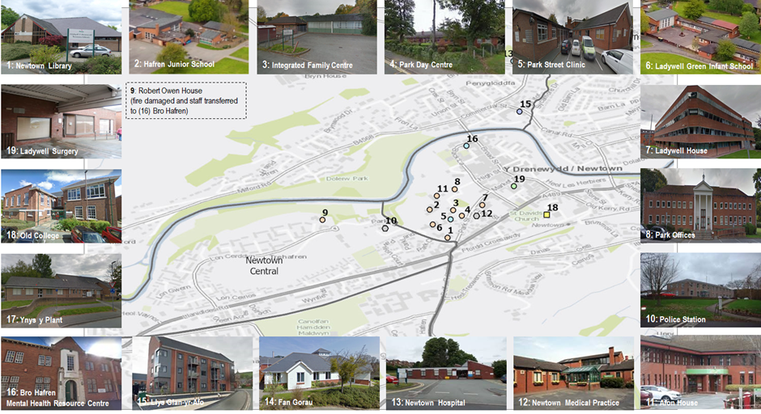
Figure 37: Key Buildings in Newtown
A number of these buildings are now not fit for purpose and are in poor condition and/or are struggling with capacity issues. The buildings are often not functional as they were designed for different purposes, or for different models of care. In addition, several services are being delivered from multiple sites which can have a negative impact on the workforce providing seamless, joined up care.

Case for Change

Workforce
Powys already knows that it faces several significant challenges for future years ahead as its rurality affects every element of service development and delivery. The indicators are already clear that the workforce of Powys is shrinking, hence the necessity for more training and development in order to create a sustainable rural workforce. The RPB is committed to work together to achieve the following by 2022:
- lay the foundations for a Health and Care Faculty in Powys that offers a wide range of practical, academic and digital learning opportunities for employed staff, volunteers and carers
- use accurate and up-to-date training needs analyses to inform the education offer
- provide learning opportunities up to degree level through increased partnerships with training and education providers
- increase apprenticeships and work experience opportunities for all ages
The Powys workforce will benefit with improved access to education, training and development and employment. Powys needs environments that encourage learning and development for partners across health and care and improving research and development (R&D) capacity, whilst building better relationships with education providers. This will also be reliant on a digital infrastructure to support better access across a wide rural county.
Investment in laying the foundations for a Health and Care Academy of Learning in Powys, that offers a wide range of practical, academic and digital learning opportunities for employed staff, volunteers and careers, and local communities, will not only support the Partnership locally to achieve aspirational health and care outcomes for communities of Powys, but will have a significant impact on the economy of Powys and improve employment opportunities.

Service Provision
Due to the rurality of north Powys, there are occasions when residents need to make multiple journeys to different locations in order to receive diagnosis and treatment.
The sharing of services will enable more joined up services, the development of one-stop-shops, with greater convenience for the residents of north Powys. By designing more efficient pathways through integrated teams, residents can be treated holistically, improving health outcomes.

Estate
The estate in Newtown needs updating and streamlining. The creation of a Campus will enable the sharing of services that will:
- create efficient, functional and flexible space that is future-proofed and can be used by multiple services
- reduce backlog maintenance (as detailed in Section 2.2.3.10.4)
- enable the integrated model of care
- provide opportunities for getting more value from the estate, for example, by supporting multi-purpose spaces that can be shared and saving money by avoiding duplication of estate
- enable collaboration between the Partnership and other organisations, such as voluntary sector organisations, and taking advantage of the opportunities that come from working at scale
- enable the disposal of ageing buildings that cannot support future service delivery

Housing
PCC acts as landlord of 5,400 homes, in addition to a small portfolio of shops and garages throughout the county. The housing service provides the following services:
- help with the prevention of homelessness
- strategic housing
- housing enforcement in the private sector (i.e. inspecting premises for standards)
- disability grants
- housing regeneration

Demand for Accommodation
PCC has the ambition of building 250 council houses by 2023 and is investing in housing stock, one third of which will be for older people. There is a requirement to ensure properties are fit for purpose for the next generation of older people to allow them to be as independent as possible.
There is a large housing stock in Newtown (detailed in the table below). As of February 2020, there were 1,226 on PCC’s housing waiting list in north Powys, 700 of which are considered to be in Bands 1-3 (i.e. they have the most urgent requirement). The majority of applicants require one-bedroom accommodation and, as demonstrated in the table below, there is not enough supply of one-bedroom accommodation to meet demand:
Newtown | Bedrooms |  |  |  |  |  | Total
Newtown | 1 | 2 | 3 | 4 | 5 | 6 | Total
Bungalow | 33 | 34 | 0 | 0 | 0 | 0 | 67
Flat | 339 | 177 | 2 | 0 | 0 | 0 | 518
House | 2 | 349 | 687 | 68 | 2 | 2 | 1,110
Maisonette | 1 | 8 | 6 | 0 | 0 | 0 | 15
TOTAL | 375 | 568 | 695 | 68 | 2 | 2 | 1,710
Waiting List | 713 | 330 | 127 | 47 | 6 | 3 | 1,226
Surplus/Deficit | -338 | 238 | 568 | 21 | -4 | -1 | 484
Table 21: PCC and Housing Association Stock in Newtown
The current pipeline for Registered Social Landlord (RSL) developments in Montgomeryshire amount to 220 units, dependent on available funding. These schemes will be social rent, or a mix of social rent and rent to own, the majority of which will be one-bedroomed. Current developments at planning stage in Newtown include:
- Robert Owen House: 18-20 one/two-bed flats
- Bowling Green: 30-40 one-bed flats
- Red Dragon Public House: 18 affordable dwellings

Learning Disabilities
A range of long-term and short-term accommodation services are commissioned in Powys, including residential care placements and supported living tenancies. However, there are also people that are placed out of county. These placements include small domestic settings, residential homes, residential specialist colleges, specialist behavioural facilities and larger residential communities catering for a diversity of service users with differing disabilities, care needs and behaviours which challenge services. To enable these people to return home would require an appropriate infrastructure within health and social care to sustain local placements.

Extra Care Housing
Extra Care schemes provide an independent living option where older people can live in their own self-contained home while accessing a wide range of communal facilities and access to personal care support packages.
PCC has invested in these schemes via the Integrated Care Fund, including the first one in Newtown; 47 one-bed apartments developed in partnership with Wales and West Housing at Llys Glan-yr-Afon. In addition to older people, this development has a block that also houses adults with learning difficulties.
There is also a further scheme planned in Welshpool; 66 one-bed apartments developed in partnership with ClwydAlyn Housing at Neuadd Maldwyn.
Whilst it is recognised that there is a need for further extra care facilities in Newtown, PCC cannot support the development of extra care apartments on the Campus, as other towns in Powys also have a need and have not benefited from investment to date like Newtown. If such a provision was to be included, it would require a private provider. However, there is a need to reduce admissions to care homes by providing interim accommodation for people who need an enhanced level of reablement post admission, which could be linked to Campus.

Homelessness
Whilst Powys does not have the level of rough sleeping that the more urban areas of the country experience, the numbers of people reported as rough sleeping is increasing. Homelessness is, of course, more than about rough sleeping. It is often referred to as the “hidden homeless”; people may be in insecure accommodation, fleeing domestic abuse, or experienced a relationship breakdown with family or partner.
Homelessness is highest in north Powys (approximately 60-70% of the 700 homeless in Powys are in north Powys) and is often accompanied by mental health issues, including drugs and alcohol. PCC has a small dedicated homelessness prevention and housing options team which comprises of a Team Leader, four homelessness prevention and housing options officers, 2 officers who engage with the private rented sector to secure accommodation options and an apprentice; one of the offices is based in Newtown. The team is responsible for the prevention and relief of homelessness across the County, sourcing suitable housing options and the provision and management of temporary accommodation.
During COVID19, PCC has accommodated a number of complex cases and over 70% of households accommodated, have been single person households. Currently the largest age group are the under 35’s, who present with complex care and support needs, needing a wide range of interventions, including police, mental health, substance misuse and trauma informed services.

Triage Centre Bid
PCC is currently bidding for funds under Phase 2 of the Planning Guidance for Homelessness and Housing Related Support Services (3 June 2020).The main principle of the bid is to establish Triage Centres in Powys, which will establish new provision but also consolidate and co-ordinate existing multi-agency provision, enabling the implementation of the Homeless Strategy objectives and the transition to the “New Normal”. It is proposed to establish two main Triage Centres, in Newtown and Llandrindod Wells, which will support and resource, three satellite centres in Welshpool, Brecon and Ystradgynlais.

Case for Change

Finance
When comparing need, the Newtown area has more extra care provision than the rest of north Powys:
North East Powys: Llanfyllin, Welshpool & Montgomery | North Central Powys: Newtown, Llanfair Caereinion & Llanidloes | North West Powys:  Machynlleth
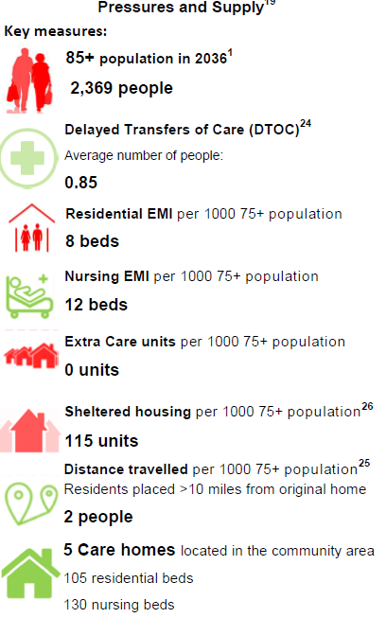 | 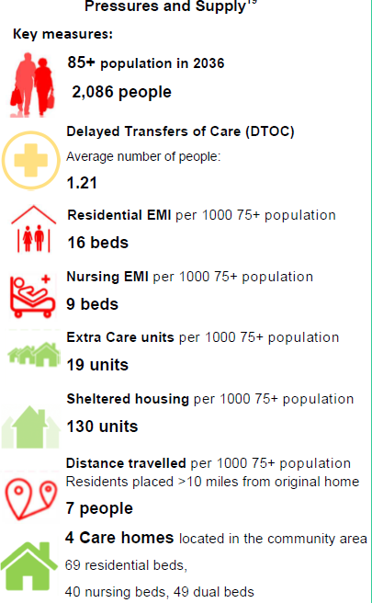 | 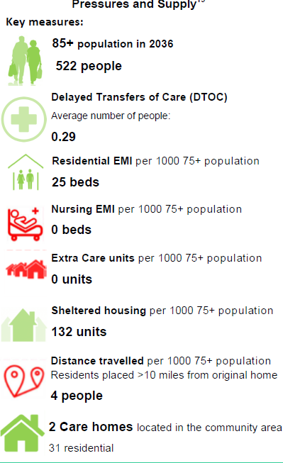
Table 22: Housing Pressures and Supply in North Powys
Whilst the need remains in Newtown and its surrounds for extra care housing, the focus of PCC funding will not be here, as there are currently other areas in Powys with a greater need for this resource.
There is an aspiration to move from residential care to preventative community-based services, in line with a strong strategic fit to the Powys Health and Care Strategy, the Older Person’s Commissioning Strategy, and the Adult Social Care Service Improvement Plan.
Financial savings have to be delivered and in part expected to be achieved through new models of care to older people. In addition, the longer-term Medium-Term Financial Plan has an expectation of additional savings through the accommodation strategy. Collaborative working will be a necessity in respect of developments, capital funding and asset/land availability. It is anticipated that there will be a shift in revenue spend from long-term care with reinvestment into preventative models.

Estate
PCC requires a market that offers good quality specialist housing that meets the needs of Powys residents and enables them to live independently for as long as they can. There is currently insufficient accommodation choice to meet the projected demand.
The current supply of accommodation available across the county is limited and there is a clear message from Powys residents that they generally want to stay at home and therefore require alternative provision to residential care. Research suggests that inaccessible or inappropriate housing can significantly reduce the ability of people who have ill-health or a disability to lead good quality lives and in many cases is a direct contributor to unnecessary entry into long-term care.

Commissioning Intentions
Powys is expected to see an increase in the number of elderly residents unable to perform basic domestic tasks and requiring domiciliary care and assistive technology. Home ownership for older people is in line with the National average for England and Wales and feedback from our older population suggests they want to stay in their homes for longer.
Some current care provision is no longer suitable and other options need to be explored such as specialist housing with and without care, sheltered housing and/or extra care, to support people to live independent lives and remain in the community of their choice.

Business Needs
The business needs for the programme are detailed as follows:
- To deliver a new primary school to replace Ladywell Green Infant School and Hafren Junior School
- To transform health and wellbeing services through a new integrated model of care
- To create a Multi-agency Wellbeing Campus in the heart of Newtown
- To improve the condition, functionality, utilisation and efficiency of the Partnership estate in Newtown
- To make financial savings by delivering services that deliver best value for money
- To provide good quality specialist housing that enables people to live independently
- To improve access to services
- To provide service, estate and workforce integration
- To create a sustainable rural workforce
- To reduce backlog maintenance costs
- To maximise opportunities for repatriation and provide as many services as possible close to where people live

Potential Scope
The scope of the Campus is highlighted in the diagram below. The multi-agency approach aims to deliver a number of benefits as set out in Section 2.2.10.
Figure 38: Multi-Agency Wellbeing Campus Emerging Model
There is already a lot of joined up working in the Newtown area and the Campus will strengthen this by providing further opportunities to deliver joined-up services to particularly support wellbeing and early help and support to enable people to start well, live well and age well.
In terms of Health and Care, the Campus will support the delivery of the new integrated model of care, incorporating a Rural Regional Centre and a Community Wellbeing Hub. The vision for the integrated model of care is to enable the following:
- To provide as many services as possible locally reducing the need for residents to travel out of county
- Access a range of personalised, joined up services enabling them to improve their wellbeing and access early help and support when needed
- Develop services that fit around peoples’ busy lives; providing choice, accessible and equitable services more locally
- Information, guidance, self-help community/ exercise activities and social space
- Flexible working areas for staff and partners, improving communication and joined up working
- Technology enabled environment improving access to services and facilitating a network of care and support across north Powys
- Co-location and integration of services/assets where it provides benefits to individuals through a one stop shop experience
- Learning and development opportunities for staff and people living in or wanting to move to Powys
Work is ongoing regarding the range of services to be delivered from the centres. Growth assumptions have not been fully explored and demand and capacity modelling work will be undertaken at SOC stage. However, preliminary discussions have allowed a range of options to be developed, representing a range between a “minimum/core” requirement and a “maximum” requirement (see Section 3.3).
The Campus will support the development of a satellite Health and Social Care Academy which will enable Powys to “grow their own workforce” and to attract people to come and work in Powys by being an innovator in rural practice. In January 2020, the RPB approved a Joint Framework for the Powys Health & Care Workforce, this is closely aligned to the NPWP and will be key to developing a sustainable workforce to underpin the new integrated model of care.
The integration links already existing with the Third Sector in north Powys will be strengthened by delivering wellbeing services on the Campus. Colleagues across voluntary, statutory and private sectors will have more seamless ways of communicating, ensuring that support offered to individuals, families and carers can be provided in a timely fashion.
The inclusion of Third Sector health and wellbeing services are expected to reap many benefits, including:
- Less social isolation and a reduction in reports of loneliness, leading to increased membership within the community in activities such as sports teams, singing, and drama
- “One front door” for access to support, information and advice for individuals, families and carers
- Reduced use of GP’s for non-medical needs
- An increase in people likely to engage with other services and attend a group/service/activity
- Third Sector involvement in multi-disciplinary team meetings, making referrals seamless and improve response times
In the longer term, it is hoped that the Campus will enable the community to have trust and confidence in the health and social care systems, including the third sector, where the needs of the community can be more simply fed into the commissioners, resulting in jointly commissioned services and pooled resources.
The Primary School is considered to be the anchor of the site due to the fact that funding is in place to rebuild the schools as one English-medium primary school through the 21st Century Schools and Education Programme and is due for completion in September 2024.
The plans for investment in Newtown primary provision to date have focussed on a replacement building for Ladywell Green Infants School and Hafren Junior School as part of the North Powys Well-being Programme, in order to address the immediate issues with the Ladywell Green building. However, the development has also been considered in the context of the broader plans for Newtown schools and the site has been tested in order to consider whether a maximum option of a 360-pupil school is feasible. However, on 18 September 2020, PCC’s Transformation Delivery Board endorsed the development of a new 270-place school on the site of Hafren/Ladywell schools.
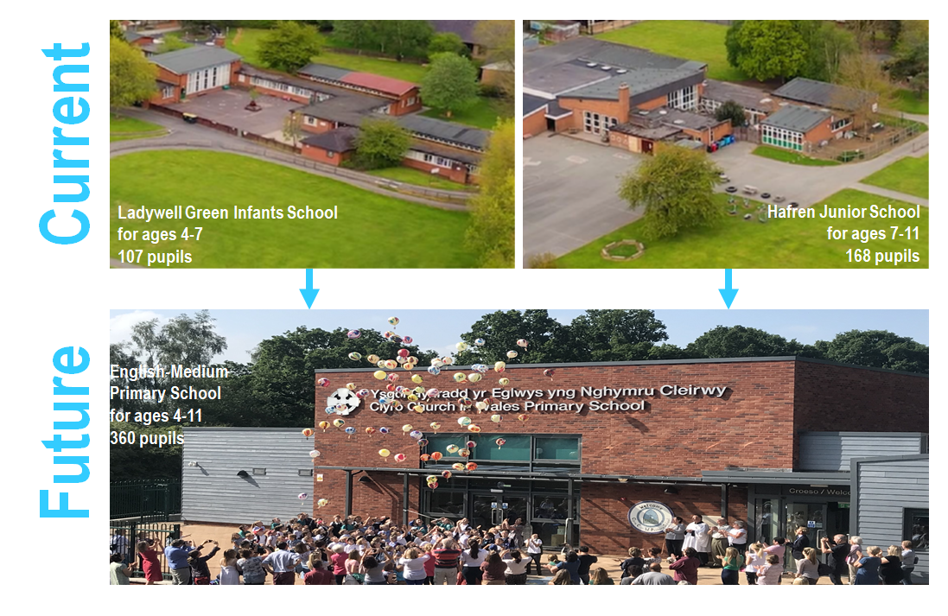
Figure 39: Merger of Ladywell Green Infant and Hafren Junior Schools
Within the school infrastructure element, PCC is required to provide Nursery Accommodation for aged 3+ children for 10-hours education and 20-hours childcare. It is assessed that 2 classrooms will be required, but this will be reviewed. In determining whether a nursery is designed into a new primary school building, the decision is based on community need and the evaluation of local competition. It is unlikely that additional space will be provided for a private nursery in Newtown as there are several private nurseries already delivering this service.
Infrastructure and Shared Space are key to “unlocking” the preferred site and phasing requirements. This programme also offers further opportunities for the Partnership (as well as voluntary and third-party service providers) to integrate services, which will offer the following potential benefits:

Table 23: Benefits of Integrating Services
In developing the proposed scope for the programme, the innovative environment work stream (along with other key stakeholders) have held a number of workshops to evaluate which elements could potentially be shared whilst remaining sensitive to potential conflicts such as safeguarding and privacy and dignity. Work with the school explored the potential synergies between education and the rest of the site (below):

Table 24: Potential Sharing with Education

The workshops demonstrated that sharing spaces offer a number of benefits including maximising space utilisation, more efficient use of building footprint, economic benefits and greater opportunities for integration and innovation across disciplines. The key opportunities to be further investigated in the Infrastructure SOC are detailed in the table below:
Sharing Opportunity | Description
Offices/Seminar Rooms/Training Suite/IT Suite | ensuring people are working from appropriate facilities will be more efficient (right place, right space approach). This should include the consideration of adjacencies to the site such as Ladywell House, over the road from the preferred site, which provides newly refurbished office facilities; separate office accommodation will be more cost effective than office accommodation spread across clinical buildings
Health and Care Academy of Learning | creation of a shared space to house education, development and training for the workforce across Health and Care, including more opportunities for paid staff, carers and volunteers across multi-generations
Catering and Dining | central kitchens could provide a range of services including school meals, patient meals, staff canteen and healthy eating education. The full opportunities for sharing are to be fully explored during the design stage
Car Parking | for the site, regardless of service
Hydrotherapy Pool | to support children with special needs, adult/child rehabilitation, as well as community use
Outdoor Spaces | school fields or “outdoor classrooms” that could be utilised by the community out-of-hours, to include an interactive outside space set within the wonderful countryside that typifies Powys, bringing the benefits of green space to the creative and learning experience and well as offering fantastic opportunities for reflection in a peaceful setting with woodland walks and mature gardens  See Appendix H for details of Newtown’s green spaces run by Open Newtown
Carbon Reducing Technologies | such as river source heat pump for the entire Campus
Deliveries | Hard and Soft Facilities Management (FM) services
Table 25: Potential Sharing Opportunities
The Library offers a variety of services, which draws together the other elements of the PBC together and will support focus on wellbeing services. Further engagement is required with the library service in terms of future plans and inclusion in the Campus, however, there is an opportunity for the library service role to be extended and act as the front door to all the other services, reinforcing the philosophy of “no wrong door”, signposting people to services, care, support and information, as demonstrated below:
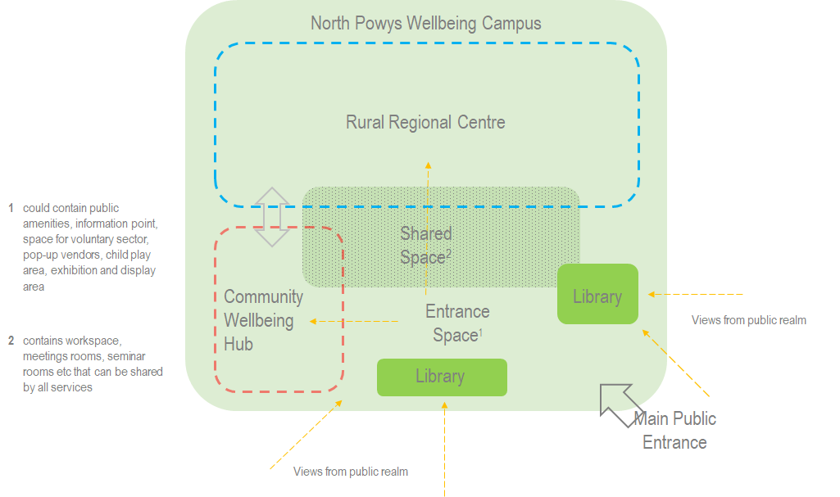
Figure 40: Potential Role of Library Services
The exact scope of the Housing element needs further development, but early discussions have indicated a requirement for:12-15 one-bedroom flats serving the following potential service groups:
- Training Flat: transition from child to adult with a stay of approximately 6 months
- Older Person transition/reablement flats
- 16+ supported accommodation (children on the verge of becoming homeless)
- Children and Young People temporary/emergency out of hours accommodation
- People with Learning Disabilities (PLD) step down/step up
- Supported living: 150 people with disabilities living out of county at the moment
There are developments in and around Newtown already, which will act as a “do minimum” option for housing, with the aim that these sites link with the services in the Campus. Children’s and adult services are currently in discussions as both are seeking accommodation for crisis scenarios, under a variety of different needs (mental health, looked after children, learning disabilities, care being provided outside of county). There is also a need for additional extra care units within the Newtown area; however, PCC has allocated its extra care funding to other parts of Powys with greater need, such as Machynlleth, but this does not preclude inviting interest from private providers.
Workshops have been held in order to define how the team could deliver the programmes investment objectives and benefits through energy efficient building performance and sustainable design. The programme will consider all viable low carbon construction options such as Passivhaus and set ambitious targets against standards such as BREEAM and Building Regulations. Low carbon engineering options such as ground or water source heat pumps, solar panels and hybrid heating systems will be considered and the most appropriate applied to the entire Campus to reduce carbon emissions from the building, embodied energy from materials, upstream and downstream environmental impacts in its widest sense, including social and socioeconomic factors.
It will be the projects’ objective to generate and source as much local “green energy” as possible. The flat unshaded site with the River Severn running alongside presents a number of viable options for energy generation and all engineering solutions will be considered. It may even be possible to, at times, generate excess energy and heat which can be sold into the grid or networked locally as a community benefit.
As an important local green space in Newtown, there are also opportunities to enhance biodiversity through sympathetic site design with green walls and green roofs through to planting schemes to created habitats. This also lends itself to the creation of environmental outdoor learning areas for children attending the school, and the local community. The Welsh Government recognises outdoor space as an important part of the nation’s education and is now part of the national curriculum and the government funded “Eco Schools” program.
The RPB recognises that the construction and use of the proposed Campus will be carbon positive, however, through design and well considered service planning (reducing the need for out of area travel) the programme can be a sustainable model for the future which maximises community benefits.
Finally, the program will look to directly offset build and run carbon emissions by planting plants and trees on and offsite with partner organisations which will also act as a community benefit, a place for recreation and a place for nature to thrive.
Should housing be part of the scope following economic appraisal, the programme will look at the “Home Grown Homes Project”; using UK and Welsh grown timber to help the local supply chain, which will benefit the rural economy of Wales. The Bowling Green in Newtown is a three-storey development of one and two-bedroom flats. Through the Project, Woodknowledge Wales and delivery partners TRADA, Coed Cymru and Cardiff Metropolitan University are helping to inform on the construction method to help improve the quality of the build and the use of locally sourced timber.

Impact of COVID-19
The production of this PBC began a few months before the COVID-19 pandemic escalated in the UK in March 2020. Partnership staff were redeployed from “business as usual” to strategic and operational roles surrounding the control of the coronavirus. Since then, it is apparent that the COVID-19 pandemic has forced massive transformation on the public sector by:
- forcing organisations to work together, recognising the need for system leadership and joint working at a national and sub-national level
- children being taught remotely
- cancelled school examinations
- clinicians seeing patients virtually where possible via phone or video calls
- staff working from home where possible, for example, Multi-Disciplinary Team (MDT) meetings are happening online
- behaviours have completely changed where people are reluctant to go into hospitals, health facilities and public buildings for concern about contracting the virus or burdening services
Whilst the COVID-19 pandemic has resulted in some transformation change activities being reduced, it has also forced massive transformation on the system by enabling some areas to accelerate at significant pace, particularly digital technology: virtual self-care Apps, virtual clinics via ”Attend Anywhere” and “Consultant Connect” and virtual triage and assessment services have all been accelerated. Many teams are also working virtually in Powys to develop new ways of delivering services and the workforce has adapted and changed to respond to this. There has also been significant work with the Voluntary sector to develop the Community Emergency Response Services. All of these have contributed towards delivery of the integrated model of care.
Undoubtedly many of the changes due to COVID-19 have been undertaken as part of the emergency response and further work is being undertaken to assess longer term sustainability and to take advantage of this window of opportunity to support new ways of working in the long-term. It is paramount that any changes are supported by the estate and digital infrastructure, particularly around digital support which will need to improve as virtual consultations continue. Without the urgent implementation of these enablers there is a risk that we return to the old ways of working by default.
This PBC has been updated to include learning from the COVID-19 pandemic and what impact this may have on current and future services including; increase in virtual consultations, agile working, digital, social distancing and planning for future pandemics. Whilst it is understood that work on the development of these services are ongoing, a formal “lessons learned” process is currently underway and will be further detailed in subsequent SOCs. There are a number of strategic priorities to consider which include:

Clinical Accommodation
- Enablement for clinicians to consult remotely
- Integrated Mental Health Services: bringing both existing and new staff into a single location aligning with the Health and Care Strategy for Powys, as it will provide the opportunity for integrated working between PTHB, PCC and the third sector
- Greatly improved patient accommodation, increased infection prevention and improved health and safety requirements and statutory compliance, including compliance with the Equality Act 2010 and Standards for Healthcare
- PTHB is currently developing a scheme to put 12 ac/hr (air changes per hour) for all hospitals (apart from Knighton) in a small number of rooms and full ventilation at Brecon, Welshpool and Llandrindod. The Project will be completed at pace before winter pressures

Office Accommodation
COVID-19 has fast-tracked home working and many people are now considering whether they need to work at the office every day of the week. Social distancing measures have been implemented in many offices, such as:
- larger spacing between desks
- reduction in hot-desking
- introducing screening
- creating one-way systems
- creating safe entry and exit points
Space could be used to make more of an office hub where people come together for team building or training, leaving the more focused style of work for the home.
To reduce the number of people being in the office at the same time, other changes to working patterns could be applied, for instance, whole teams could come into the office for a couple of days a week and work remotely for the remainder of the week, whilst other teams came in on opposing days. This has the added benefits of allowing teams to have the face to face contact that is necessary for team building, planning, peer support etc but reduces the space requirement in the office thus allowing the creation of a safe working environment.

Design
Whilst it is still unclear what the full impact of COVID-19 will be, it is clear that there will be a long-term requirement for staff, pupils, visitors, etc, to maintain a safe distance between each other. Potential changes in the office environment will be considered during the design of new office/admin space, such as:
- greatly reducing the number of desks required
- separating large open plan offices into smaller areas with screening, whilst still keeping workstations a safe distance apart
- hot desks needing to be “booked” and fully cleaned in between users
- reducing the capacity of single, cellular offices to one person
- providing hand-sanitiser at entry and exit points
- providing additional lockers for storage of personal items and clothing

Car Parking
Consideration will be given about how staff get into the office, for example, staff may not want to use public transport, especially trains, during peak travel time. More people may choose to drive into work and therefore would require parking spaces, but the number of parking spaces required overall may actually reduce if staff are only occasionally coming into the office. This may also have the added benefit of reducing staff parking subsidies. Greater flexibility around working hours could mitigate some of the public travel concerns, maybe with staff working longer days to allow them to spend some time with colleagues, but to come in less frequently.

Housing
When the COVID-19 pandemic emerged, the pressures facing the service increased significantly. At one stage, presentations to the service increased by 300%.
In response to the pandemic, the service set up a Centralised Homelessness Co-ordination Cell, as did other local authorities across the country. The purpose of the Cell was to co-ordinate the response to homelessness in the County and bring together partners who could form a multi-agency approach to dealing with issues that arose and finding viable solutions.
The Cell, which currently meets twice per week for one hour, pulls together partners including the homelessness service, Police, Probation, PTHB, social services, youth services, mental health services, substance misuse experts and the third sector. The Cell has been recognised as working very effectively, with Powys highlighted as being an example of excellent multi agency working.
The service has brought additional units of temporary accommodation into use in order to ensure anybody in need of a roof over their heads is provided with one. The development of the single bed flats will provide flexibility for supporting any future pandemics and any learnings will be further considered as part of the SOC.

Third Sector
A number of organisations joined as a group, known as the Newtown Network, with the initial objective of supporting meal and food deliveries to the needy in the town, to work with the Powys Library Service to provide a home delivery for readers, and to assist in the development of a Volunteer networks.

Development of the Preferred Site
In the development of the PBC, desktop analysis of the site was undertaken, to provide current site information in the following key areas:
- Use Zones: schools occupy the largest area (71.3%), health and social care (12.9%) and the library (9.7%)
- Built Area: the footprint of all the buildings occupy only 14% of the total site
- Green Areas and Landscaping: a significant proportion of the site contains grass and garden (59%);
there are mature trees around the perimeter of the site
- Parking: there are approximately 116 parking spaces on the site
- Permeability: the site is impermeable and acts as a barrier between the town centre & residential areas
- Flood Plain: the area affected is relatively small at the North West end of the site
- Sun Path: the site configuration does not indicate any constraint on building orientation to sun path

Concept Site Plan
A core objective of this PBC is to demonstrate that the scope of services developed in Section 2.2.8 will “fit” on the site facilitating the desired campus-style approach. It is also critical for local stakeholders to confirm that the following seven key design concepts can also be delivered on the site:
- flexibility
- supporting collaboration
- managing safeguarding
- ability to potentially expand into nearby sites
- access and car parking
- connectivity/social catalyst/cohesion
- buildability/deliverability (such as the timescales required for the completion of the new school)
Using the maximum scope derived from the programme scoping, the potential configuration of the site has been tested. This accounts for the desired location of the school and other services on the site and consideration of the seven key design concepts. Access, green and shared spaces, infrastructure and car parking are key to “unlocking” the preferred site and phasing requirements
Work on the masterplan design will be undertaken during the development of the SOC’s and OBC’s, however, during the PBC development, several site configurations were appraised at a high level with a number of stakeholders and their feedback has been incorporated into an initial concept site configuration plan (pictured below). This concept plan is produced only to demonstrate that the site can deliver a collaborative multi-agency wellbeing campus and the plan will undoubtedly change as a result of further design work:
Figure 41: Site Plan to test Maximum Scope will fit on site
The ideas and concepts that have been incorporated into the concept site plan include:
- Idea 1: co-locate buildings around public space to enable shared use of “front of house space” and clear civic impact
- Idea 2: create new walking routes within/through the site that link with existing walking routes
- Idea 3: create new buildings that avoid existing buildings, specially the schools, so that the new school can be built without disruption to existing services
- Idea 4: preserve as much existing landscape as possible
- Idea 5: suggested access: Park Lane is a principal public frontage with parking and access to school and health hub
Please see the attached Appendix I for an initial analysis of the preferred site.

Site Masterplan
The next step following the approval of the PBC will be the production of a detailed site masterplan, with the aim of addressing the following key issues:
- sustainability and energy to deliver carbon targets and green initiatives
- delivering an integrated community of services by connecting the buildings, the site and the Town
- creating an open, green site with public space (whilst managing school safeguarding issues)
- promoting health and wellbeing by encouraging walking, cycling and social interaction
- delivering a detailed transport plan, including access and car parking
- delivering a detailed ecological plan

Planning
High level planning advice has been sought regarding the preferred site and the following points will be considered at the masterplanning stage:
- Place-making is at the forefront of planning, so to re-use a previously developed town centre site close to other services and facilities will be viewed favourably
- The site is adjacent to listed buildings, a conservation area and a SAM; understanding and assessing the development proposal’s impact on heritage assets will be important and will inform the design
- Highway access is important. Access by non-car modes/active travel will be considered, particularly with the site’s connections to adjoining areas
- Sustainable drainage will be designed in from the outset to avoid being an after-thought
- Ecology and biodiversity enhancement measures will be considered
- Avoidance of the C2 flood-zone to the north of the site
- Consider of the scale of development upon adjoining land uses such as the existing residential developments

Next Steps
Further concepts to be considered at the next stage include:
- The opportunity exists to introduce sustainable technologies into the new development that may be linked to and provide environmentally and economically beneficial source(s) of heat/energy to the new build, Key drivers for this are:
  - carbon reduction
  - decarbonisation
  - Public Sector cost reduction: futureproof spend on energy against future price rises
  - local economic regeneration
  - effective building and facilities management
- Engagement with the Centre for Alternative Technology (CAT) based in Machynlleth
- Newtown & Llanllwchaiarn Town Council (NLTC) has received a £0.5 million grant to improve access from Newtown railway station to the town centre, providing a more attractive walkway. In addition, improvement works are planned for the bus interchange, close to the preferred site
- Engagement with Open Newtown regarding internal and external connectivity
- A travel plan for the north Powys area and beyond the borders, with a view to the repatriation of services and development of the Rural Regional Centre, which could also increase traffic to the area

Spending Objectives
The following table describes the spending objectives of the NPWP:
INVESTMENT OBJECTIVE 1: INTEGRATED LOCAL SERVICES | INVESTMENT OBJECTIVE 2: SUSTAINABLE WORKFORCE | INVESTMENT OBJECTIVE 3: DECARBONISATION | INVESTMENT OBJECTIVE 4: REGENERATION | INVESTMENT OBJECTIVE 5: INNOVATIVE ENVIRONMENT
To implement a new, integrated, collaborative service model which improves the health, education and wellbeing outcomes for the population of north Powys, including the repatriation of services by 2025 | To deliver seamless services to the local population of north Powys, through the training and development of a multi-agency, collocated and sustainable workforce, maximising the utilisation of digital and technological solutions for the long term (10 to 30 years) | To integrate energy saving and low carbon technologies to support decarbonisation in the public sector by 2025 and beyond | Contribute to the economic growth and regeneration of north Powys over the medium to long term (10 to 30 years) | To provide services in flexible, fit for purpose accommodation, which increases utilisation and efficiency through space sharing and achieves statutory and regulatory compliance by 2025
Table 26: Spending Objectives

Main Benefits Criteria
The key benefits are summarised in the table overleaf, with benefit measurements detailed in Appendix J:

Figure 42: Benefits Framework

Main Risks
The main business and service risks associated with the potential scope for this programme are shown below and will be developed further in separate SOCs:
- Risks associate with COVID-19
  - Impact on programme whilst responding to the pandemic
  - Impact on programme should there be an increase in new cases
  - Changes in working practices which underpin current thinking
  - Impact on clinical and office accommodation requirement
- Planning permission
- Delays in business case process
- Failure to secure funding/affordability
- Stakeholder support
- Increase in Cost
- Increase in timescales

Constraints and Dependencies
The proposed NPWP scheme has the following constraints and dependencies:

Constraints
- There is a floodplain to the north of the site that cannot be built on
- The school must be constructed first, with the infant school and junior school open as usual until the end of the Summer term 2024
- The available site area is limited with little or no room for expansion as there are live services on site, any proposed build solution is constrained by existing site boundaries
- The site has minimal access points (they only exist as entrances to the current buildings on site) so consideration needs to be given to access to the site and construction traffic during the build
- The projects detailed within the programme should be flexible to respond to fluctuations in resource and available Welsh Government Funding

Dependencies
- Works must be planned to have the minimum possible disruption to live services
- The Campus will be built in phases, each phase dependent on the previous; plans will be put in place to mitigate the failure of any phase not proceeding
- Each phase will be carefully planned in order to position services on the site to dovetail with the requirement to decant services and keep them operational

Economic Case

Introduction
In accordance with the Capital Investment Manual and requirements of HM Treasury’s Green Book (A Guide to Investment Appraisal in the Public Sector), this section of the PBC documents the options appraisal and demonstrates that the proposals will maximise social value to society through the selection of the optimal combination of projects and related activities.

Critical Success Factors (CSF’s)
The Critical Success Factors (CSF’s) identified for this programme are as follows:
Critical Success Factors | How well does the option…
Strategic Fit and Business Needs (Strategic Case) | - meet and support the over-arching aims of local and national strategy/legislation
Potential Value for Money (Economic Case) | - maximise the return on the required investment in terms of the economy  - minimise associated risks
Capacity and Capability (Commercial Case) | - deliver the required level of service and functionality
Potential Affordability (Financial Case) | - deliver the projects within the ascribed capital and revenue envelope
Potential Achievability (Management Case) | - deliver the projects within the agreed timescale  - deliver operational and fit-for-purpose facilities  - satisfy the level of skills required to deliver the projects successfully
Table 27: Critical Success Factors

Main Options for Investment
As part of initial feasibility work, a full site options appraisal has been undertaken (see Appendix K). The preferred site is illustrated in the image below:
Figure 43: Preferred Site Plan
The preferred site measures 4.6 hectares (45,904sqm). The table below details what the preferred site currently comprises of and what buildings are in close proximity to the site:
Current Site | Close Proximity
Ladywell Green Infant and Nursery School | Afon House (Job Centre)
Hafren Junior School | Park Office (Council Offices)
Newtown Library | Ladywell House (Council Offices)
Integrated Family Centre | Newtown Police Station
Park Day Centre | Robert Owen House (formerly mental health team office and now a housing development opportunity)
Park Clinic
Table 28: Buildings on and in close proximity to the Preferred Site
The consensus of the site appraisal was that the preferred site offers:
- A good location, accessible to centre of the town, to the Open Newtown programme, recent housing initiatives and to other transport and amenities
- Links to the school’s investment in the area
- Appropriate size to facilitate the potential scope of the programme
- No policy designations
- Owned and know site near existing public amenities and assets
- Flat, serviced site with potential expansion scope
- A therapeutic site, ideal for promoting well-being; open green spaces, views, on the banks of the Severn
Having identified a preferred site, the options appraisal focuses on developing the proposed scope of the programme.
After examination of the issues associated with Business as Usual (BAU), the potential benefits as well as risks and constraints, the Programme Team have identified the following potential options:
Technical Scope
 | Option | Brief Description | Investment Appraisal
1.1 | Do nothing:  No Action | All services would continue to be delivered from their current locations with no improvements | This option would fail to address any of the investment objectives. The built estate would continue to deteriorate with an increased risk of failure. This option would not support strategic plans for service improvement, integration or environmental impact. Listed as a comparator only  Discounted
1.2 | Do minimum:  Refurbishment of existing facilities | All services would continue to be delivered from their current locations refurbishing the existing estate to address all significant and high compliance risks and improve environment quality | This option would address the significant and high compliance risks associated with the Estate. However, it would not support strategic plans for service improvement, integration or environmental impact  Discounted
1.3 | Intermediate:  New build – combined English medium primary school (270 pupils). Refurbish Health and Social Care provision | Replacement of the current Ladywell Green Infants School and Hafren Junior School. Health and Social Care would continue to be delivered from the existing buildings which would benefit from a refurbishment to address all significant and high compliance risks and improve environment quality | This option would achieve PCC’s vision for the future delivery of school services and also address significant and high compliance risks associated with the remaining estate. However, it would not support strategic plans for service improvement & integration  Discounted
1.4 | Intermediate 1:  New build – combined English medium primary school (270 pupils) alongside new Health and Wellbeing facilities | Replacement of the current Ladywell Green Infants School and Hafren Junior School in addition to new Health and Wellbeing accommodation. Re-provide Library and associated services | The Partnership would benefit from new build accommodation addressing backlog maintenance and compliance issues and reducing environmental impact. However, it would not fully support strategic plans for service improvement & integration  Possible
1.5 | Intermediate 2:  New build – combined English medium primary school (360 pupils) alongside new Health and Wellbeing facilities to include library services and additional supported living accommodation | Replacement of the current Ladywell Green Infants School and Hafren Junior School in addition to new Health and Wellbeing accommodation. Re-provide Library and associated services as well as the creation of purpose-built supported living accommodation | The Partnership would benefit from new build accommodation addressing backlog maintenance and compliance issues and reducing environmental impact. It would also maximise opportunities for service improvement & integration  Possible
1.6 | Do Maximum:  As above plus housing development | As above but including a new build private accommodation development | As above, however the need and appetite for a further housing development co-located on the site remains unknown  Not taken forward at present
Table 29: Long List of Options: Technical Scope
Service Solution
 | Option | Brief Description | Investment Appraisal
2.1 | Do nothing:  Business as Usual | Services would remain unchanged | This option would fail to meet key investment objectives including integration, repatriation and services closer to home. Listed as a comparator only  Discounted
2.2 | Core:  Business as usual with enhanced services | Re-provide existing services enhanced to include further integrated family and mental health services and greater links with third sector services  Education services amalgamated to provide a 270-pupil primary school  Library and Third Sector services remain unchanged | This option would address education objectives and partially meets the Partnership aspirations for greater integration. However, it will not maximise repatriation and efficiency opportunities  Discounted
2.3 | Core + Desirable:  As above with further opportunities for repatriation and integration | Health and Care: consolidation of new integrated model of care into a single location. “Do minimum” in terms of opportunities for repatriation, diagnostics, primary care, inpatient beds, therapy services, family services, mental health services and urgent care  Education services amalgamated to provide a 270-pupil primary school with further links to Health and Social Care  Library and Third Sector services enhanced to provide greater links to Health, Social, Housing & employment services | This option would address education objectives and partially meets the Partnership aspirations for greater integration. PTHB would be able to offer a wider range of services closer to home  Possible
2.4 | Core + Desirable plus:  As above with further opportunities for repatriation, integration and enhanced services | Health and Care: consolidation of new integrated model of care into a single location. “Do maximum” in terms of opportunities for repatriation, diagnostics (to include MRI), primary care, inpatient beds (to include level 2 rehab centre), therapy services, family services, mental health services and urgent care  Education services amalgamated to provide a 360-pupil primary school with further links to Health and Social Care  Library and Third Sector services as above with the addition of Health promotion and community resource centre  Develop site as a joint training academy | This option will maximise the value of the investment and would address education objectives and fully meet the Partnership aspirations for greater integration. PTHB would be able to offer a wider range of services closer to home. The Partnership would benefit from training facilities, supporting a sustainable rural workforce  Possible
2.5 | Core + Desirable plus + Optional:  As above with additional services | As above with further enhancement of services  Education services as above with enhanced leisure facilities  Library services as above  Further housing provision | As above, however the need and appetite for a further housing development co-located on the site remains unknown  Not taken forward at present
Table 30: Long List of Options: Service Solution
Service Delivery
 | Option | Investment Appraisal
3.1 | In-House | Preferred: This option provides the most acceptable solution in terms of use of staff, skills and resources
3.2 | Outsource | Discounted: This option has been discounted as it fails to deliver integration of services
3.3 | Strategic Partnership | Discounted: This option has been discounted as it is unclear whether it delivers integration of services, and because of the increased complexity and achievability issues
Table 31: Long List of Options: Service Delivery
Implementation
 | Option | Investment Appraisal
4.1 | Single Phase | Discounted: Due to the extent of the works, a single phased approach would fail to provide the required flexibility
4.2 | Phased | Preferred: This option offers the most flexibility. Elements of the works can be phased in terms of clinical demand, resource and available funding
Table 32: Long List of Options: Implementation
Funding
 | Option | Investment Appraisal
5.1 | Private Funding | Discounted: Third Party Development funding has been excluded as a viable funding option as the Health Board is not in a position to absorb the revenue pressures that this would entail
5.2 | Public Funding | Preferred: This scheme will be publicly funded and is part of the NHS Capital Expenditure Programme
Table 33: Long List of Options: Funding

Preferred Way Forward
By appraising a wide range of realistic and possible options, the following preferred way forward has been identified, which will be developed further in subsequent Business Cases.
 | Option 1 | Option 2 | Option 3 | Option 4
Scope/Technical | Intermediate 1 | Intermediate 1 | Intermediate 2 | Intermediate 2
Service Solution | Core & Desirable | Core & Desirable plus | Core & Desirable | Core & Desirable plus
Delivery | In-House | In-House | In-House | In-House
Implementation | Phased | Phased | Phased | Phased
Funding | Public | Public | Public | Public
Table 34: Preferred Way Forward

Economic Appraisal of Short-Listed Options
The table below details the estimated costs for the available options. The cost analysis is in Appendix L:
Options | Description | Estimated capital cost (excl VAT)
1 | New build – combined English medium primary school (270 pupils) alongside new Health and Wellbeing facilities  Health and Care: consolidation of new integrated model of care into a single location. “Do minimum” in terms of opportunities for repatriation, diagnostics, primary care, inpatient beds, therapy services, family services, mental health services and urgent care  Education services amalgamated to provide a 270-pupil primary school with further links to Health and Social Care  Library and Third Sector services enhanced to provide greater links to Health, Social, Housing & employment services | £54m – £55m  (range includes estimated disposal proceeds for surplus sites)
2 | New build – combined English medium primary school (270 pupils) alongside new Health and Wellbeing facilities  Health and Care: consolidation of new integrated model of care into a single location. “Do maximum” in terms of opportunities for repatriation, diagnostics (to include MRI), primary care, inpatient beds (to include level 2 rehab centre), therapy services, family services, mental health services and urgent care  Education services amalgamated to provide a 270-pupil primary school with further links to Health and Social Care  Library and Third Sector services as above with the addition of Health promotion and community resource centre  Develop site as a joint training academy | £64m – £65m  (range includes estimated disposal proceeds for surplus sites)
3 | New build – combined English medium primary school (360 pupils) alongside new Health and Wellbeing facilities to include library services and additional supported living accommodation  Health and Care: consolidation of new integrated model of care into a single location. “Do minimum” in terms of opportunities for repatriation, diagnostics, primary care, inpatient beds, therapy services, family services, mental health services and urgent care  Education services amalgamated to provide a 360-pupil primary school with further links to Health and Social Care  Library and Third Sector services enhanced to provide greater links to Health, Social, Housing & employment services | £57m – £58m  (range includes estimated disposal proceeds for surplus sites)
4 | New build – combined English medium primary school (360 pupils) alongside new Health and Wellbeing facilities to include library services and additional supported living accommodation  Health and Care: consolidation of new integrated model of care into a single location. “Do maximum” in terms of opportunities for repatriation, diagnostics (to include MRI), primary care, inpatient beds (to include level 2 rehab centre), therapy services, family services, mental health services and urgent care  Education services amalgamated to provide a 360-pupil primary school with further links to Health and Social Care  Library and Third Sector services as above with the addition of Health promotion and community resource centre  Develop site as a joint training academy | £69m – £70m  (range includes estimated disposal proceeds for surplus sites)
Table 35: Cost Comparison of Options
High level schedules of accommodation were developed in order to describe the minimum and maximum scope of services required for the Campus. The shortlisted options indicate that the spatial requirements for the identified site would range from 23,350sqm to 30,595sqm:
Campus Elements | Minimum (sqm) | Maximum (sqm)
School/Field | 15,000  [Inc. 2,215 building] | 18,000  [Inc. 2,620 building]
Health & Care | 7,500 | 10,500
Library | 850 | 850
Specialist Housing | - | 1,245
Sub Total | 23,350 | 30,595
External Space tbc | 22,554 | 15,309
TOTAL | 45,904 | 45,904
Table 36: Spatial Requirements
The table above shows the entire footprint requirement for each of the Campus elements. The table below sets out the high-level capital cost estimates for the built element of the shortlisted options:
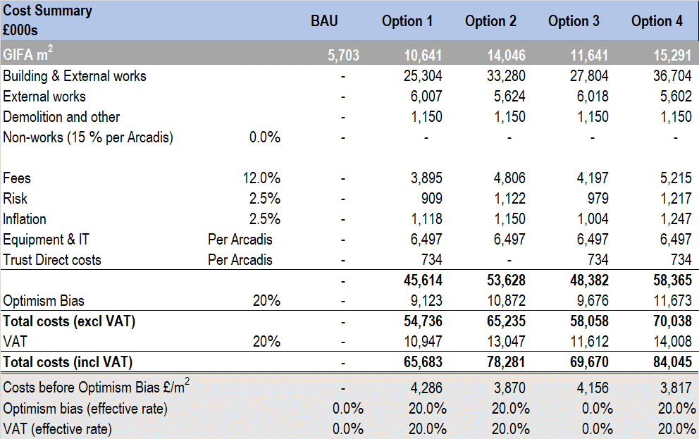
Table 37: High Level Capital Cost Appraisal
Appendix L sets out the detailed workings in respect of the above, including notes from the cost consultants in preparing the base construction costs (buildings, external works and demolition).
Other assumptions have then been included to represent additional capital costs such as fees, inflation, equipment, contingency and optimism bias. By necessity, these are high level and have not been reviewed by either the finance teams of the Partnership. The key assumptions are:
- Optimism Bias (estimated at 20%)
- Equipment costs (included at a total cost of £6.5m per the previous feasibility study)
- Direct Health Board costs (estimated at £0.75m)
- No provision for additional costs in respect of sustainable, green initiatives (e.g. Passivhaus requirements)
The costs and assumptions will be reviewed in detail as part of the ensuing projects.
Based on the cost assumptions noted above and calculations set out in Appendix L, the table below summarises the high-level financial assessment for each of the above options:
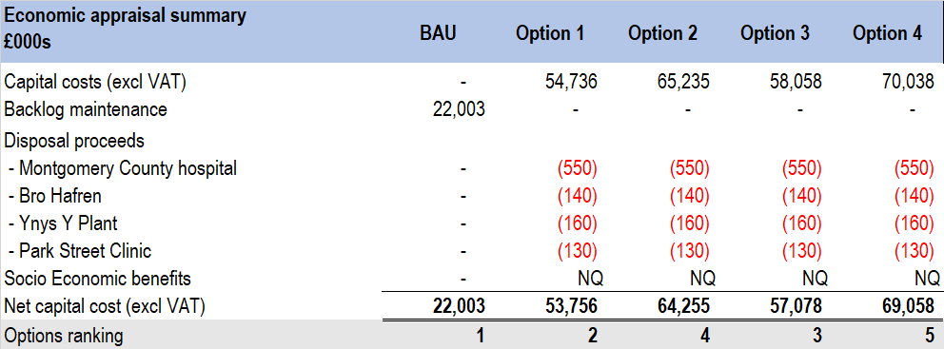
Table 38: High Level Economic Options Appraisal
The capital costs are as previously set out. The backlog maintenance costs are included for the business as usual options but would not be incurred under Options 1 to 4, as the existing buildings would be replaced and/or be disposed of on completion of the programme.
The BAU option has been presented above, however, this is included as a comparator only as this is not a viable option. Furthermore, whilst this is the lowest cost option, once benefits and risk have been factored into the rankings, this would be ranked below the options, as it does not meet the strategic objectives of the programme.
As a result of the creation of the Campus, several existing sites would become surplus to requirements and therefore an estimate of disposal proceeds has been included above. These are illustrative and do not represent a formal valuation (see notes in Appendix L). Furthermore, these proceeds would only be available once the Campus was operational and services had been fully transferred.
Given the anticipated redevelopment of the site, a number of additional social and economic benefits could reasonably be expected from the programme. Whilst these have not been quantified at this stage, an assessment could be made to quantify the following benefits:
- Employment Impacts: Gross Value Added (GVA) is an indicator of wealth creation, measuring the contribution to the economy of economic activity associated with the construction of the development proposal. The programme is expected to generate temporary jobs during the construction period and permanent jobs at the operational stage
- Local Authority benefits: Following the development of the community hub, certain sites will be released for development. If these are subsequently developed for residential purposes, additional PCC revenues could be generated from council tax, and potentially provide an increase in affordable housing, subject to specific development plans
- Retail footfall: the additional economic activity is likely to increase footfall to the high street. Further footfall could also result from additional developments on released sites, whether commercial or residential. Increased footfall is likely to increase spend on the high street, bringing overall benefits to the area, including the potential for increased business rates, council tax and other local authority revenues
The expected benefits for the programme have been assessed in detail. These have been summarised in the Strategic Case section of this report and a template for assessing each benefit is detailed in Appendix J. These will, therefore, be reviewed and scored for each of the project business cases, in line with the template, to ensure that the full benefits of the programme are captured and included in the detailed economic appraisals.

Commercial Case

Introduction
This section of the PBC sets out the potential arrangements in relation to the preferred way forward outlined in The Economic Case. The aim of the Commercial Case is to demonstrate that the preferred way forward will result in a viable procurement and well-structured deal. It will set out the high-level intentions and over-arching principles to be applied to the underlying projects, rather than a specific and detailed commercial project plan.
As this PBC consists of individual projects and/or collections of projects, different procurement arrangements will be implemented at different stages of the development and will be detailed further in subsequent project business cases. However, all procurement arrangements will comply with PCC’s and PTHB’s Capital Procedures and will be managed by NWSSP Procurement.

Commercial Objectives
The development of the commercial objectives in each SOC will seek to support the overall Campus by:
- delivering on time and on budget
- delivering value for money
- supporting supplier innovation and seeking innovative solutions from suppliers
- contributing towards Powys’ commitment to the sustainability agenda
- supporting joined up working
- providing an opportunity for local employment and stimulating the local economy
The Partnership have a track record of working together to develop services for the people of Powys and have a history of working with communities and other stakeholders and partners to deliver improvements for their population. The Partnership is well placed to jointly contribute to the exciting development of a multi-agency wellbeing Campus for north Powys.
The Partnership is keen to minimise the revenue implications of the overall programme as a key objective. Capital investment and asset ownership is therefore the preferred method of delivery for the programme but would be the subject of detailed review in each of the supporting business cases.

Land and Asset Ownership
The proposed 4.6Ha site is largely owned by PCC; PTHB owns the Park Street Clinic (measuring approximately 500sqm/0.05Ha). The Partnership is flexible in terms of the approach to land ownership having worked collaboratively on land transfers and is keen to support the more appropriate ownership structure for each element of the programme as required. Furthermore, the development of the Campus will create opportunities to dispose of unfit-for-purpose public sector estate to deliver the optimum solution for the area as a whole.
Regarding the ownership of buildings and public space for the Campus, early thoughts indicate that it is likely that PTHB will own the Rural Regional Centre and Community Wellbeing Hub, with PCC retaining ownership of the school. Further consideration will need to be given to the shared elements of the Campus, requiring detailed negotiation between the Partnership to derive an optimum, yet equitable, solution.

Campus Management
PCC, along with Kier Group (a leading property, residential, construction and services group), entered into a 50:50 joint venture partnership in 2017, known as Heart of Wales Property Services Limited (HoWPS). The partnership is responsible for the repairs and maintenance work to council homes and public buildings across Powys. A consultancy service is also provided, which delivers PCC’s major capital investment programme, small works projects and a design and build service. In addition, PTHB has an Estate’s Works department located in Newtown, which would be relocated to the Campus. Whilst the Partnership have experience of jointly operating and maintaining sites, it is intended to evaluate the benefits of PTHB accessing services from HoWPS, which will need to be agreed and negotiated before putting forward for approval.

Procurement Process

Consultants
The RPB has currently procured business case writer consultants to work in collaboration with the Partnership to produce the Programme Business Case (PBC). In December 2019, gbpartnerships was appointed via an open tender manager through NHS Wales Shared Services Partnership Specialist Estates Services (NWSSP-SES). Consultants will be appointed to produce subsequent business cases including the SOC/OBC/FBC for both Health and Care and Infrastructure projects via the Healthcare Planning Framework. The business case for Education and Community will continue to be managed directly by PCC.

Construction
Sustainable procurement will be undertaken to best effect in order to bring the embodied energy from the design and construction phases down and carbon offsetting will be explored to mitigate a proportion of the rest, helping to move this programme towards carbon neutral. For example, through procurement, it will be possible to source local recycled materials for the build and specify low environmental and social impact materials such as FSC (Forest Stewardship Council), PEFC (Programme for the Endorsement of Forest Certification) or BRE (Building Research Establishment) green-rated products. Procurement scoring will be weighted towards contractors and manufacturers with good corporate social responsibility (CSR) practices to recognise their efforts and to support an industry fit for the future in keeping with the Partnership and the Welsh Government’s vision for a low carbon economy.

21st Century Schools Programme Framework
Due to the indicative timescales (driven by the need for the school to be completed by September 2024) it is anticipated that the enabling works, infrastructure and school construction will be undertaken by a single contractor who will be appointed via the 21st Century schools programme framework. It is anticipated that the procurement will be via a regional framework such as (SEWSCAP3), South West Wales Regional Contractor Framework (SWWRCF) or North Wales Schools and Public Buildings Contractor Framework (NWSPBCF) or via a separate OJEU Procurement route.

Health and Social Care: Building for Wales Framework
The Health & Care elements of the programme are likely to be procured via the Building for Wales Framework. The framework is the NHS in Wales’s construction procurement and delivery vehicle for major capital projects with construction costs in excess of £4 million, based on the fundamental principles of collaborative working, integrated supply chains and continual improvement. The framework aims to deliver core objectives on behalf of the Welsh Government, including Best Value for Money and Development of Best Practice and Sustainability, amongst others, and is managed by a dedicated team of professionals employed by NWSSP.

Framework Benefits
Each of the above frameworks have been pre-procured through an OJEU tender process which enables Public Organisation schemes to begin immediately, without mini competition, whether a new build, maintenance or refurbishment programme. As a result, frameworks benefit public sector clients in diverse ways:
- Each framework has been through an “OJEU” tender, satisfying requirements of EU Procurement Directives
- These frameworks are accessible by any UK public sector organisation
- Open book costing ensures Value for Money can be demonstrated
- Typically, the processes are simple to follow
- Sub-contract work would be subject to competitive tendering allowing local suppliers to bid for aspects of the project
- Early engagement of the contractor in the process typically leads to:
  - Improved Risk management
  - Reduced programme of design and construction
  - Greater predictability in relation to cost and programme
- Such frameworks result in improved performance monitoring procedures, with higher quality of design and construction, less defects and reduced accident rates on site
- Community benefits can also be delivered
It is important to note that the current stage means framework selection is currently flexible and more detailed, specific arrangements will be set out in subsequent project business cases.

Required Services
At this stage in the development, the following key appointments/specialist advisors are to be determined:
- Ecology surveys
- Site investigation and topographical survey
- BREEAM
- Demand and Capacity Modelling
- Masterplanning and transport planning
- Energy assessment and feasibility study
The programme team has had high level discussions with various consultants regarding the above, in order to inform the PBC, and these will be developed further as each project progresses.

Contractual Arrangements
Different forms of contracts are likely to apply for different projects and the contractual relationships between the various parties are subject to the rules and regulations of the individual frameworks. However, each project should set out, with respect to their individual adopted framework, the following key terms and clauses:
- Details of whether the contracts are pro-forma or bespoke contracts (and the reason for any deviation from standard contracts)
- Pricing mechanisms, including agreed fixed price schedules for works and services
- The process for any changes to the scheme and the impact on pricing and timing
- The proposed timeline of the project, phasing arrangements and key milestones
- Risk transfer (see below)
The general principle is that risks are passed to “the party best able to manage them”, subject to value for money. The table below highlights the typical apportionment of service risks in the design, build and operational phases for a project, which should be reviewed and assessed for each project:

 | Risk Category | Risk Allocation
 | Risk Category | Public | Private | Shared
1 | Design risk
2 | Construction and development risk
3 | Transition and implementation risk
4 | Availability and performance risk
5 | Operating risk
6 | Variability of revenue risks
7 | Termination risks
8 | Technology and obsolescence risks
9 | Control risks
10 | Residual value risks
11 | Financing risks
12 | Legislative risks
13 | Other project risks
Table 39: Risk Transfer Matrix

Funding
It is assumed that the majority of this programme will be funded by public funding (All Wales Capital Funding), with the school being funded by Welsh Government and PCC (50/50 split). However, due to the complexity of the Campus, with wide-ranging services, buildings and policies governing the site, it is recognised that there are multiple funding streams that could contribute to its development. The ability to access a single point of funding would make the development of the Campus simpler.

Timing
The proposed timeline of the programme is estimated as 3-5 years, dependant on phasing arrangements and the availability of resource and funding. A schedule of key dates is summarised below:

Table 40: Schedule of Key Dates

Phasing
The Programme Team will further explore the development of the SOCs resulting from this PBC. However, to unlock the site, the most appropriate first stage would be to consider the roads, parking and services infrastructure for the Campus. This will require an appropriate level of understanding of the needs of all of the parties to ensure that this key first stage of the development has the appropriate capacity, orientation and resilience to support the scheme as a whole. This also has the advantage of allowing the stakeholders to deliver their specific built environment requirements within their areas of expertise (housing, education, health & care) using their familiar procurement delivery methods as subsequent phases.
It is essential that the stakeholders push the boundaries and leave preconceptions behind in terms of what shared space could look like across the sectors. Whilst the less visible innovative working patterns of the constituent parties will be one of the key determinants of success of the programme, the more visible built environment embodies an opportunity to act as a flagship and demonstrate the benefits of a shared Campus. It is anticipated that the shared space, more obviously elements such as offices, meeting and training facilities, canteens, engineering, etc. could be part of the cross-organisational core infrastructure offering.
Whist it is clear that SOCs will be developed for the School, for Health and Social Care Services, and for Infrastructure, further consideration needs to be given to the allocation of the remaining Campus services, as they have synergies with all SOCs (such as Third Sector, Library, Housing). Initial thoughts have considered that the Infrastructure SOC will also contain Housing and Community Development services. More clarity will be gained following the development of the SOCs and masterplanning work. It is envisaged that the phasing will be as follows:
1a. Infrastructure (which will unlock the site for subsequent projects, but specifically for the immediate requirements of the school given the timeline requirements)
1b. School
2. Housing/Community Development/Library (to be confirmed)
3. Health and Social Care
However, it will be dependent on the production of the masterplan and ability to fund and decant. The Oversight Group and Programme Board will come together to decide who is best placed to lead each project, ensuring that each element will be built in a sequence that benefits all parties.

Personnel Implications (including TUPE)
Transfer of Undertakings (Protection of Employment) Regulations 1981 (TUPE) will not apply, directly or indirectly to this programme proposal. Generally, the anticipated increase in staff resource to support enhanced activity, particularly Library Services in its proposed pivotal role, will be in accordance with the Partnership Workforce guidance.

Accountancy Treatment
The accountancy treatment for each project will be subject to the delivery route adopted and agreements as to who will own the land and buildings. As a result, the capital and revenue consequences of this will be different for each party.
For the owner of the fixed asset, upon completion of the works, the asset will be valued by the District Valuer when brought into use. As the asset will have been valued by an external professional, the life expectancy will be updated to reflect a revised life expectancy which will differ for each Campus building/project. Depreciation charges will then need to be calculated accordingly.
The accounting for capital and revenue implications will be set out in the individual project business cases, as each scheme evolves.

Financial Case

Introduction
This section sets out the financial case for the capital investment being requested. By necessity, the financial case for the PBC is high level, as each project will need to separately develop financial assumptions at the next stage of the programme. Furthermore, the financial case is dependent on elements of the commercial strategy in terms of delivery and procurement options and again further clarity on this area will be achieved as the programme evolves into individual business cases.

Financial Appraisal of Options
An appraisal of the identified options has been undertaken to assess the overall value for money in the Economic Case (Section 3.5). The capital cost of each option has been quantified and compared. Annual revenue costs will be detailed in the individual business cases, with an analysis of current “Business as Usual” (BAU) revenue property costs included in Appendix L. A summary of the capital costs of the shortlisted options is shown below:

Capital Cost Comparison
A high-level summary of the capital cost for each short-listed option is shown below.
Options | Brief Description | Capital Costs
1 | New build – combined English medium primary school (270 pupils) alongside new Health and Wellbeing facilities  Health and Care: consolidation of new integrated model of care into a single location. “Do minimum” in terms of opportunities for repatriation, diagnostics, primary care, inpatient beds, therapy services, family services, mental health services and urgent care  Education services amalgamated to provide a 270-pupil primary school with further links to Health and Social Care  Library and Third Sector services enhanced to provide greater links to Health, Social, Housing & employment services | £54m (excl. VAT)  £65m (incl. VAT)  before disposal proceeds
2 | New build – combined English medium primary school (270 pupils) alongside new Health and Wellbeing facilities  Health and Care: consolidation of new integrated model of care into a single location. “Do maximum” in terms of opportunities for repatriation, diagnostics (to include MRI), primary care, inpatient beds (to include level 2 rehab centre), therapy services, family services, mental health services and urgent care  Education services amalgamated to provide a 270-pupil primary school with further links to Health and Social Care  Library and Third Sector services as above with the addition of Health promotion and community resource centre  Develop site as a joint training academy | £65m (excl. VAT)  £78m (incl. VAT)  before disposal proceeds
3 | New build – combined English medium primary school (360 pupils) alongside new Health and Wellbeing facilities to include library services and additional supported living accommodation  Health and Care: consolidation of new integrated model of care into a single location. “Do minimum” in terms of opportunities for repatriation, diagnostics, primary care, inpatient beds, therapy services, family services, mental health services and urgent care  Education services amalgamated to provide a 360-pupil primary school with further links to Health and Social Care  Library and Third Sector services enhanced to provide greater links to Health, Social, Housing & employment services | £58m (excl. VAT)  £70m (incl. VAT)  before disposal proceeds
4 | New build – combined English medium primary school (360 pupils) alongside new Health and Wellbeing facilities to include library services and additional supported living accommodation  Health and Care: consolidation of new integrated model of care into a single location. “Do maximum” in terms of opportunities for repatriation, diagnostics (to include MRI), primary care, inpatient beds (to include level 2 rehab centre), therapy services, family services, mental health services and urgent care  Education services amalgamated to provide a 360-pupil primary school with further links to Health and Social Care  Library and Third Sector services as above with the addition of Health promotion and community resource centre  Develop site as a joint training academy | £70m (excl. VAT)  £84m (incl. VAT)  before disposal proceeds
Table 41: Capital Cost Comparison

Capital Costs of Preferred Option
It is assumed that the capital costs of the development will be funded by the Welsh Government (WG) and, based on the preferred programme options, these are summarised in the table below
Table 42: Capital Cost Summary
A further breakdown of costs can also be found in Appendix L. These costs are a high-level estimate, prepared by gbpartnerships, based on discussions with the Partnership, by reference to earlier feasibility work (undertaken by Arcadis) and reports provided by Cost Consultants providing a high-level appraisal of construction costs. It should be noted that these are illustrative only, and that detailed costs will be prepared for each project, at the relevant stage of the business case preparation process. These will, therefore, be subject to further economic scrutiny as each project progresses.

Value Added Tax (VAT)
VAT set out above has been applied to the capital cost forecast at the current rate of 20%, with the exception of professional fees regarding Employer appointed consultants. The recoverability or otherwise of VAT will partly depend on the delivery and procurement options selected. For example, VAT is typically a non-recoverable cost for the health sector, but could be recoverable by PCC, assuming they own and opt to tax the building. This, however, would need a detailed review by the individual public sector bodies to assess the impact of this on any VAT partial exemption calculations and implications for the wider organisations. Overall, the assessment of VAT is particularly complex, and it is suggested that a specialist is appointed to assess the likely liability.

Impact on the Statement of Financial Position
The impact on the Partnership’s Statement of Financial Position will need consideration and will depend on the procurement and delivery options selected.

Revenue Affordability
The current revenue costs for Business as Usual are set out in Appendix L, together with data gathered on the existing estate (including backlog maintenance costs). Revenue costs for each of the options have not been estimated at this stage of the programme and will depend on the commercial and procurement strategy for each project. The detailed revenue costs will, therefore, be set out in the individual project business cases as they develop.

Management Case

Introduction
This section of the PBC focuses on the implementation arrangements demonstrating how the programme will be delivered successfully to time, cost and quality verifying that it will adopt a methodology that is based on standards of best practice and quality management principles. The management of future projects will be described in more detail in subsequent SOC’s.

Programme Management Arrangements
Under the sovereign body of the Partnership, the governance arrangements for the North Powys Wellbeing Programme (NPWP) are delivered under the Regional Partnership Board (RPB) via the Cross-Cutting Resource Overview Group (CCROG).

Programme Structure
The programme is supported by a number work-streams as set out in the figure below. There may also be a requirement to establish sub task and finish groups as the programme progresses:
Figure 44: North Powys Programme Governance Structure (Overarching)

Workstream Delivery Mechanisms
Reporting and assurance mechanisms are summarised below:
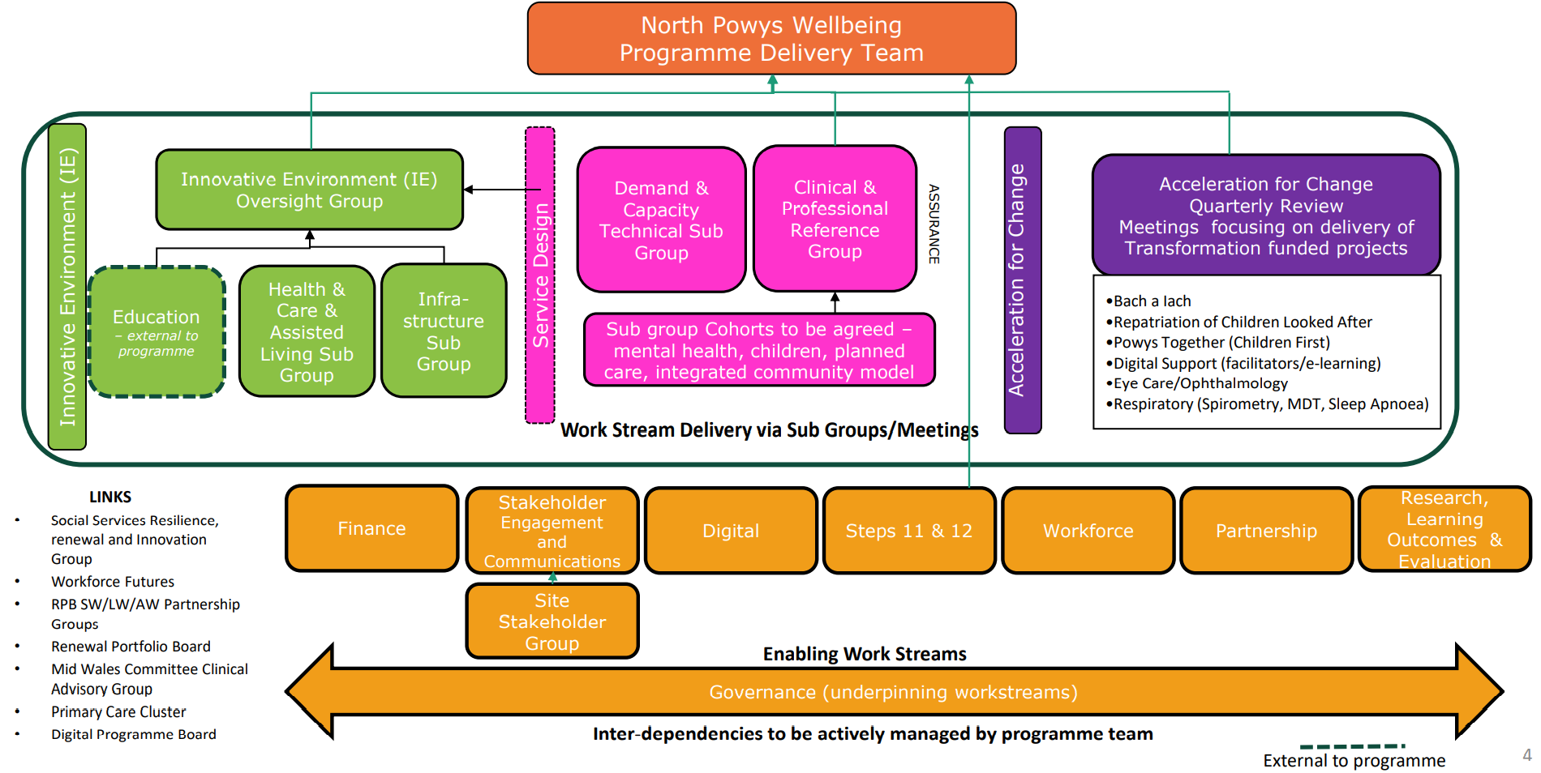
Figure 45: North Powys Programme Governance (Reporting)
Reporting will be undertaken as follows:
- Workstream progress will be reported monthly to the Programme Team (chaired by the Programme Lead)
- The Programme Team will present all programme related documentation for approval via the Programme Board. The escalation process will follow the same pattern
- Quarterly Integrated Care Fund and Transformation Fund reports will be via the Programme Board (RPB membership present) followed by quarterly reporting to Welsh Government
- Progress to be reported to the Regional Partnership Board (via the Cross-Cutting Resource Overview Group) every six months to ensure strategic oversight
- Progress Reports will also be reported quarterly to the Public Service Board and to PCC Transformation Board in line with an agreed timetable
- The Programme Board will report progress quarterly to the North Powys Programme Oversight Group. The Programme Oversight Group will provide strategic assurance, scrutiny, guidance and feedback to the Programme Board to ensure the best possible outcome
Throughout the programme, progress reports, assurance and approval of key documents or proposals will be presented to the governing body of each sovereign organisation as required, and sufficient time will be allowed to meet all approvals and governance requirements of the programme.

Programme Roles and Responsibilities
The following figure details the governance regarding programme roles and responsibilities:
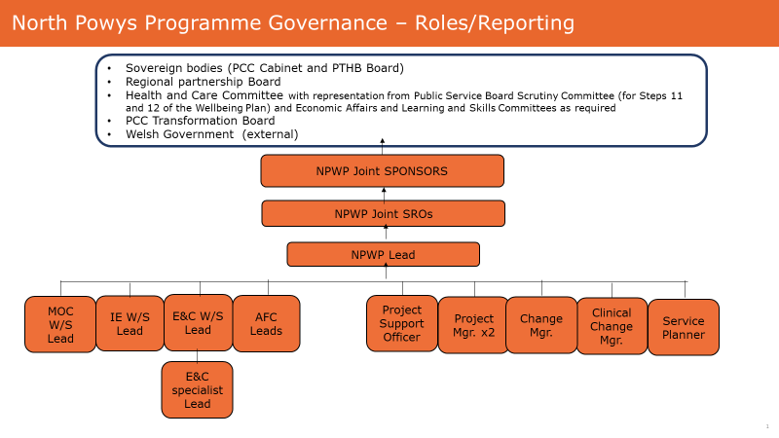
Figure 46: Programme Governance: Roles/Reporting
The table below details the responsibilities of each role:
Role | Description
Programme Sponsors:  Carol Shillabeer (PTHB)  Dr Caroline Turner (PCC) | - Accountable to the Board/Cabinet  - To sponsor and own the business case  - To champion the programme
Senior Responsible Owners:  Alison Bulman (PCC)  Hayley Thomas (PTHB) | - To define the programme objectives and ensure that they are met  - Appoint the Programme Lead  - Ensure appropriate reporting to reference committees and boards  - Resolve escalation of risks and issues
Programme Lead:  Carly Skitt (PTHB) | - To produce the programme mandate and plan  - Ensure all work is defined in a manner suitable for purposes of control  - Lead and direct efforts of the programme team towards successful delivery of the programme objectives  - Ensure adequate communication mechanisms exist within the programme between the programme and external stakeholders and between the programme and the rest of the Health Board and Cabinet  - Ensure all work is planned, resource is made available and work is carried out in accordance to the programme plan  - Let contracts and monitor performance of external contractors  - Ensure adequate procedures are in place to monitor and control cost, time and quality  - Ensure procedures are in place to manage issues  - Ensure full handover of the programme to the operational teams and manage post completion programme evaluation
Project Manager:  Tanya Summerfield (PTHB) | - To provide project management support to the programme lead and ensure adherence to an agreed methodology  - Ensure appropriate plans are in place to support delivery of workstream objectives  - Provide regular progress reporting  - To manage and escalate risks in accordance with the agreed risk framework
Project Manager:  Sali Campbell-Tate (PCC) | - To provide project management to the workstreams ensuring that the workstreams’ objectives are aligned to the programme mandate and ensure adherence to an agreed methodology  - Ensure appropriate workstream plans are in place to support delivery of the objectives and key outputs  - Provide regular workstream progress reporting  - To manage and escalate workstream risks in accordance with the agreed risk framework
Project Support Manager:  Hayley Grigg (PTHB) | - To provide programme support to assist the programme lead in delivering the programme objectives  - Manage the programme office to include updating and monitoring of workstream plans, programme reporting, document management, taking minutes and actions in all programme meetings
Workstream Leads | - To provide leadership to the workstream team, ensuring successful delivery of the agreed workstream objectives and outputs  - To chair workstream meetings  - To ensure workstream plans are developed and deliver the required outputs  - To provide regular progress reports  - To liaise with and ensure the input from their respective colleagues in PTHB/PCC
Service Planner | - Lead on the development of new models of care, service plans, service specifications and pathways  - Provide service planning expertise to support delivery of the programme business case
Clinical Change Manager | - Lead and implement agreed service change across the organisation to ensure the outcomes and benefits of the North Powys Wellbeing Programme are achieved  - Work with clinicians, managers, staff, professionals, partners and other key stakeholders to provide leadership and expertise in change management  - Accelerate and scale up changes to support a new integrated model across north Powys
Change Manager | - Lead and implement agree service change across the organisation to ensure the outcomes and benefits of the North Powys Wellbeing Programme are achieved  - Work with clinicians, managers, staff, professionals, partners and other key stakeholders to provide leadership and expertise in change management  - Accelerate and scale up changes to support a new integrated model across north Powys
Table 43: Roles and Responsibilities

Programme Plan

Programme
A Phase 1 master programme will be developed for the programme of projects up to December 2022 and is attached at Appendix M.

Communication
A communication strategy has been developed for the programme and is summarised below:
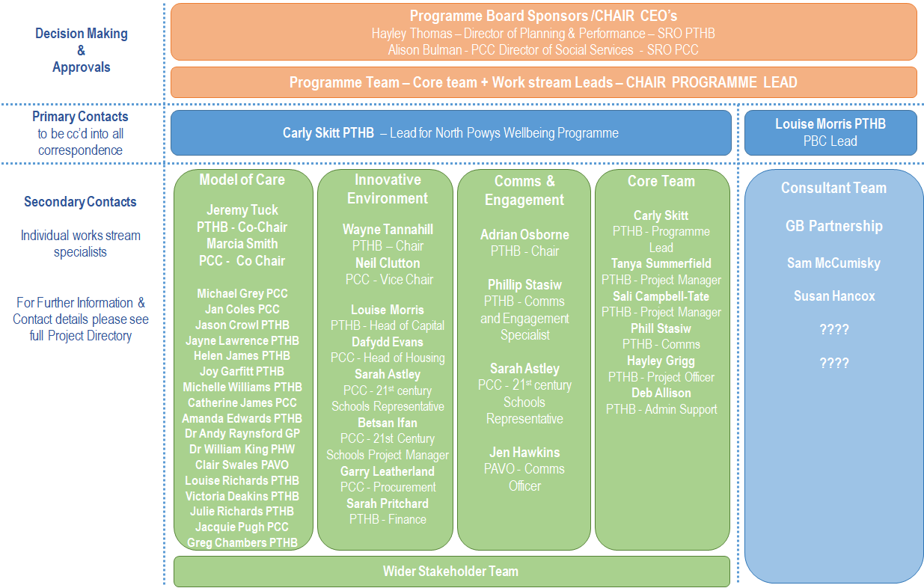
Figure 47: North Powys Programme Communication Strategy
This strategy will represent the flow of communication and information between the different stakeholder groups. The appointed Project Manager will manage the process to ensure the process functions effectively.

Meetings
The following groups currently meet on a monthly basis; however, the number and frequency of meetings will be reviewed regularly and be reflective of the stage and complexity of the projects being undertaken:
- Programme Sponsor Oversight Group
- Programme Board
- Programme Team
- Model of Care Workstream
- Innovative Environment Workstream
- Engagement and Communication Workstream
- Acceleration for Change Co-Ordination Group

Use of Special Advisors
A series of internal and specialist advisors will be required for each project in the programme:

Internal Advisors
As the programme and projects develop, the use of internal advisors from the Partnership will be determined.

External Advisors
At this stage in the programme, it is envisaged that the following key appointments/specialist advisors will be required:
- Ecology
- Site Investigation and topographical survey
- BREEAM
- Demand and Capacity Modelling
- Masterplanning and transport planning
- Energy assessment and feasibility study
If further expertise is required, this will be documented in each individual SOC going forward.

Arrangements for Change Management and Evaluation
Change management resource has been secured to support the whole system change required to underpin the delivery of the integrated model and to ensure the outcomes and benefits of the North Powys Wellbeing Programme are achieved. A combined programme and change management approach is being applied to delivery of the programme to support change and this is being linked with the evaluation approach to ensure transfer of learning and best practice across Powys. Independent evaluators have been appointed to support with evaluation, transfer and learning of the programme.

Stakeholder Engagement
On 14 June 2019, the programme team officially launched the North Powys Wellbeing Programme at two events in north Powys; one in Llanidloes (rural) and one in Newtown (urban). These two launch events started a series of engagement sessions with residents, staff and partners to learn about what matters most to people in the local communities across north Powys. Through this approach, the community and professional insights have supported the “Case for Change” to design and deliver a new integrated model, and further understand the unconstrained “ideas” people have about the future health and care system, what the current provision is, and what barriers may exist.
In order to develop a new integrated model, residents were consulted on “what matters most” to people in their home and community. Being able to understand what health and care services are like today, and what people would like to see change in the future, has helped to shape the future of health and care services to meet their needs for future years to come. This programme of engagement was guided by the National Principles for Public Engagement in Wales, where the programme team considered how, when and where engagement took place.
Our programme of engagement focussed on the following key stakeholders listed below.
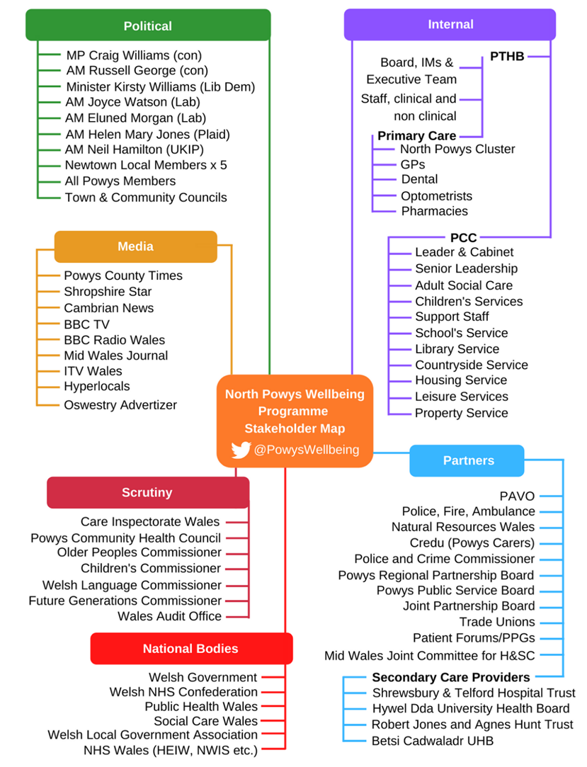
Figure 48: Key Stakeholders
The programme officially launched on 14 June 2019, ending 15 September 2019, with a further online survey in January 2020. Through engagement activity, responses have been received from:
- 250 people (approx.) attended drop-in sessions in different locations across north Powys providing over 1000 comments
- 59 people provided detailed comments online through the Citizen Space engagement portal
- 20 written submissions from people who have difficulty accessing the internet
- Local community representative and stakeholder groups through individual meetings; Hafren/Ladywell School Governors/Teachers; Newtown Town Council; Open Newtown; Montgomery Medical Practice Association; North Powys GP Cluster; Patient Forums; Syrian Families; NPTC Coleg, Newtown
- 60 people attended a Start Well/Live Well/Age Well workshop to ‘check & challenge’ the draft Model of Care
- School children from both primary and secondary schools have expressed their views through a mix of images and text

Arrangements for Benefits Realisation
Based on the benefits detailed in Section 2.2.10, a benefits realisation plan will be developed detailing the management and delivery of benefits. This will be aligned with the RPB Outcomes Framework to ensure appropriate baseline and monitoring underpins programme delivery and is linked with the evaluation process.
The plan will include the benefits of the programme, the category of each benefit (in economic terms) how they will be measured and quantified, and who is responsible for their realisation.
This document focuses on the key benefits which the programme is intended to deliver, rather than providing a comprehensive list of all benefits. This plan is a management tool which addresses the specific benefits as a result of the programme. An action plan will be developed to deliver the benefits, the results of which will be validated by the Project Board.

Arrangements for Risk Management
The Framework for Risk Management is attached at Appendix N and a programme risk register is under development which will set out who is responsible for the management of risks and the required counter measures.

Appendices

Appendix A: Health and Care Strategy: A Healthy Caring Powys

Appendix B: North Powys Property Database

Appendix C: Decarbonisation Measures

Appendix D: Case Studies

Appendix E: Health Indicators: Newtown North East and Newtown South West

Appendix F: Integrated Model of Care

Appendix G: North Powys Wellbeing Programme Case for Change

Appendix H: Open Newtown

Appendix I: Site Analysis and Concept Masterplan

Appendix J: Benefits Framework

Appendix K: Arcadis Site Feasibility Study January 2019

Appendix L: Financial Appraisal of Short-Listed Options

Appendix M: Programme

Appendix N: Programme Risk Register

Powys Public Service Board (2017) Well-Being Assessment
The World Health Organization (WHO) (https://www.who.int/)
Local Government Association (July 2020) Social determinants of health and the role of local government
Powys County Council Business Intelligence Unit February 2020
North Powys Wellbeing Programme (Jan 2020) Case for Change
https://www.rac.co.uk/route-planner/ using the town clock in Newtown SY16 2BB and the fastest route
Powys County Council Business Intelligence Unit February 2020
North Powys Wellbeing Programme (Jan 2020) Case for Change
Powys Wellbeing Bank: population projection 2014-2019 (all ages)
Powys Wellbeing Bank: population projection for 2039 (ages 0-15)
Powys County Council (August 2019) Options Appraisal
Powys County Council (August 2019) Options Appraisal
North Powys Wellbeing Programme (Jan 2020) Case for Change
Kings Fund: Improving NHS culture
Powys Community Health Council (25.11.16) CHC Inspection of Ynys y Plant Children’s Centre, Plantation Lane, Newtown
Powys County Council (June 2019) Feedback Report: The Future of Powys Libraries
Powys Teaching Health Board (March 2020) Health & Care Academy of Learning Hub-Proposal Paper
Powys County Council (June 2018) Accommodation for an Ageing Population: Market Position Statement

