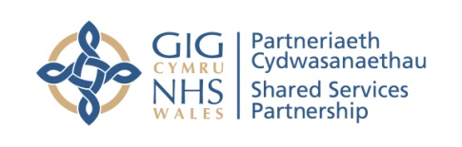

PCWIS REMINDER COMMS
Dear Contractor,
Following the successful roll out of Primary Care Workforce Intelligence System (PCWIS) during June and July, NWSSP are now working on the next phase of the project to develop reports for stakeholders and customers.
To ensure a high-quality level of reporting, NWSSP rely on you as the data controllers to check, validate and amend your data.
As Data controllers you will appreciate the need to ensure that your data is accurate and up-to-date and this will involve verifying and regularly reviewing your data submission.
If you are unable to amend any data due to access constraints, then please send us (data processor) your correct data via actionpoint & we will support you with amendments within the PCWIS , whilst maintaining a complete audit trail.
The contact email address for any data changes is nwssp-primarycareservices@wales.nhs.uk. Could you please title your action point submission with Data Change required. This will help us identify that support is required to enable the data change.
If you need to refer to the elearning to update any details, you will find the e-learning link in the table below.

Description | Link
E-learning link | https://learningiomad.nhs.wales/

Thank You
PCWIS Project Team

