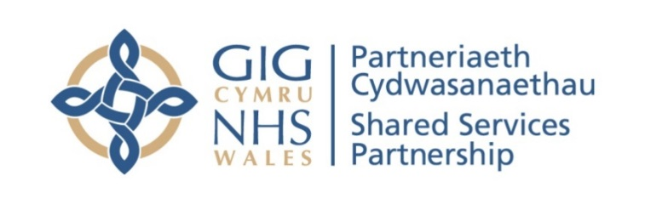


NHS WALES SHARED SERVICES PARTNERSHIP -

PRIMARY CARE SERVICES (NWSSP–PCS)
POST PAYMENT VERIFICATION (PPV) PROTOCOL
GENERAL OPHTHALMIC SERVICE CLAIMS (GOS)

1. Purpose

  - The purpose of the Post Payment Verification (PPV) process is to provide assurance to Health Boards that the claims for payment made by Primary Care contractors are appropriate and that the delivery of the service is as defined by NHS specification and relevant legislation.

  - This document sets out the All-Wales protocol agreed between NWSSP-PCS on behalf of Health Boards and Optical Committees. This protocol details the arrangements for either remote access by NWSSP-PCS staff into the Ophthalmic System via Microsoft TEAMS or conducting physical visits which will include access into the patient records to confirm that the Ophthalmic services claimed have been delivered in accordance with current requirements set out in the WGOS manuals.

WGOS Manuals - NHS Wales

1.3 The verification process will involve checking sample claims from categories of services provided, these may include:

- WGOS 1
- WGOS 2
- WGOS 4
- WGOS 5
- WGOS NHS Optical Voucher Scheme – provision of optical appliances

WGOS episode type | Form
WGOS 1 | GOS 1W
WGOS 1 Mobile Service | GOS 6W
WGOS 1 if patient has a HC3 certificate | GOS 5W
WGOS 2 | WECS 1
NHS funded optical appliance Voucher | GOS 3W
Repair / Replacement of NHS funded spectacles | GOS 4W

2. Ophthalmic Visit Arrangements

2.1 PPV will assess data available to form a plan of visits to ophthalmic practices and will then agree this with Health Boards. As well as the assessment of data to inform the visit schedule, it will also be based on the average number of GOS 3W Voucher claims submitted by a practice in the preceding 12 months, as below.

Average monthly number of GOS 3W Voucher claims | Sample size of patients | Normal number of visits within a 3-year cycle
Up to 200 | 103 | 1
201 – 400 | 103 | 2
401 – 600 | 103 | 3

2.2 The visit dates will then be agreed by prior arrangement between NWSSP-PCS staff and the ophthalmic contractor or nominated representative and usually within normal NWSSP-PCS and ophthalmic staff working hours. A minimum of ten working days’ notice will be provided to the contractor. Confirmation of the remote access/physical visit arrangements will be sent to the ophthalmic contractor or nominated representative by NWSSP-PCS.

2.3 NWSSP-PCS will select a sample of claims, utilising the data available, for which the ophthalmic contractor has received payment, and these claims will relate to the services provided in the list in section 1.3. Sample sizes may be influenced by claiming patterns that are identified through the payment system. A routine visit sample size will consist of 103 claims and will routinely comprise of the following structure.

Optical Voucher (GOS 3W) | 31
Optical Repair/Replacement (GOS 4W) | 31
WGOS 2 (WECS 1) | 11
WGOS 5 IPOS URGENT | 15
WGOS 1 Mobile Service (GOS 6W) | TBD on claim submission
WGOS 4 Medical retina/Glaucoma/ | 15

This routine sample structure is subject to change depending on availability of the claims, if less than this amount is available the NWSSP-PCS staff will bring all the claims to verify, and any external factors that may necessitate a different sample set, for example a request from Health Boards, Optical committees or Local Counter Fraud Service (LCFS).

2.4 Prior to the remote/physical access visit NWSSP-PCS staff will submit a list of patient records that will be required for the aspect of the visit. This list will be provided 48 hours before the visit and will be sent by email and will be password protected. This is subject to change and may potentially be removed as a requirement.

2.5 The PPV process will be undertaken in a remote access or physical visit where the team will log in to the practice optical system. The service provision has been proofed and assured by Information Governance and is in-line with GDPR principles. If a remote visit, details of the practice requirements to give access to the optical systems will be outlined at the time of booking and will also be outlined in the confirmation paperwork the Ophthalmic practice receives from PPV. During the visit process, ophthalmic contractors can expect two PCS/PPV staff to conduct the remote or physical visit on the agreed date and these staff members are respectful of patient confidentiality. The visiting process will comply with the Department of Health guidelines “The Protection and Use of Patient Information”, issued on 7th March 1996 (DGM (96) 43). NWSSP-PCS has the discretion to decide who undertakes the remote access or physical visit but will ensure that the staff involved comply with the Department of Health guidelines “The Protection and Use of Patient Information”, issued on 7th March 1996 (DGM (96) 43). Whenever possible, the NWSSP –PCS will inform the practice before the visit of the names of the NWSSP-PCS staff undertaking the remote access verification. All NWSSP-PCS staff can produce identification if requested.

2.6 The ophthalmic contractor or nominated representative does not need to be present with the NWSSP-PCS staff for the duration of the remote access or physical visit, but they should be available to provide any assistance or responses to queries from NWSSP-PCS staff during the PPV visit. The ophthalmic contractor or nominated representative is entitled to invite a ‘buddy’ to be present for the remote access visit; this should be arranged through Optometry Wales, if they wish to do so. Sometimes the decision cannot be finalised during the visit, and further advice is needed from our NWSSP-PCS Ophthalmic Advisors, who are referred to for clinical advice by the PPV staff conducting the visit.

2.7 If during the routine visit a claim error rate of 10% or more has been reached then it will trigger a re-visit from NWSSP-PCS staff within 12 months. At this re-visit, the sample will be made up of 100 claims per year for a three-year period. This is subject to change at the request of the Health Board who can request a further visit under different circumstances than the 10% threshold, which may be due to any concerns they may have. The revisit will have no impact to the period of the next routine visit, which is currently a 3-year rolling programme.

3. PPV Checking Process

3.1 During the visit the PPV team will examine:
- Records maintained by the ophthalmic contractor – to validate and evidence the service provided to patients.
- Any other relevant supporting documentation held at the practice.

3.2 The PPV team will also check that:
- There is satisfactory understanding and application of the provisions set out in The WGOS manuals.
- There is an adequate internal control system in place to ensure the accuracy of claim submissions.

3.3 The PPV team will strive to:
- Ensure that any queries raised on the day are discussed with the ophthalmic contractor or nominated representative where it is practicable to do so.
- Provide advice to ophthalmic staff where it is required or asked for during the discussion at the end of the remote access verification visit.

3.4 During the course of the visit the PPV team may identify claims where the contractor has under-claimed, and received, a lower fee than what they may have been entitled to. The PPV team will bring this to the attention of the ophthalmic contractor or nominated representative. Following the visit, the ophthalmic contractor or nominated representative should email the patient record entry in question, with a supporting letter, and then the NWSSP-PCS can put this forward for remuneration. It is important to note only claims identified during the PPV visit can be actioned in this manner.

4. Confidentiality and Disclosure of Information

4.1 Any NWSSP-PCS staff that are required to access ophthalmic patient records in order to verify claims will request access on the clear understanding that proper confidentiality safeguards are observed. They will also take account of the code of practice on Confidentiality and Disclosure of Information.

4.2 NWSSP-PCS staff may have an organisation purchased encrypted scanner, camera or mobile phone with camera capability with them during the visit. This enables NWSSP-PCS staff to photograph any evidence deemed necessary by the NWSSP-PCS staff. If the NWSSP-PCS staff have photographed any patient identifiable information, they are bound by patient confidentiality and data protection legislation to ensure the integrity of that patient record detail. This information would be uploaded onto the NWSSP-PCS systems and removed from the camera or mobile phone.

4.3 Access to data held by practices will be carried out in accordance with the requirements of the current data protection legislation, related statutory requirements and good practice guidance from National Assembly for Wales. Post Payment Verification falls under current data protection legislation and can undertake the process under these particular points from General Data Protection Regulations.

- Article 6 (1) (b): processing is necessary for the performance of a contract which the data subject is party or in order to take steps at the request of the data subject prior to entering into a contract
- Article 6 (1) (e): processing is necessary for the performance of a task carried out in the public interest or in the exercise of official authority vested in the controller
- Article 9 (2) (c): processing is necessary to protect the vital interests of the data subject or of another natural person where the data subject is physically or legally incapable of giving consent
- Article 9 (2) (d): processing is carried out in the course of its legitimate activities with appropriate safeguards by a foundation, association or any other not-for-profit body with a political, philosophical, religious or trade union aim and on condition that the processing relates solely to members or to former members of the body or to persons who have regular contact with it in connection with its purposes and that the personal data are not disclosed outside the body without the consent of the data subjects
- Article 9 (2) (g : processing is necessary for reasons of substantial public interest, on the basis of union or member state law which shall be proportionate to the aim pursued, respect the essence of the right to data protection and provide for suitable and specific measures to safeguard the fundamental rights and the interests of the data subject

5. Outcome of the Verification Process

5.1 After the PPV visit process has taken place, the staff members will speak with the Ophthalmic practice representative, when it is practicable to do so, to inform them of any observations, queries and where appropriate advice and feedback regarding the practice systems and procedures. Sometimes a decision cannot be finalised after the visit, and our NWWSP-PCS Ophthalmic Advisors are referred to for additional clinical advice. A confidential written report will be emailed within 28 days of the visit to the ophthalmic contractor or nominated representative for an opportunity to comment on the findings and submit any supporting information for queries if required. The ophthalmic contractor or nominated representative will have a further 28 days to return a signed copy of the report and any evidence being submitted to the NWSSP-PCS. Once the 28 days have elapsed, the NWSSP-PCS will forward a final report to the Health Board, even if the ophthalmic contractor or nominated representative has failed to respond to the report to agree and authorise any recoveries.

5.2 Within the report the NWSSP-PCS staff will identify any administrative errors that were discovered as part of the visit process; however, these types of errors would not be recovered. Administrative errors will be identified to the Health Board as part of the report to ensure that appropriate action is taken to promote best practice and patient safety with accuracy of the patient record.

5.3 Where it has been established that claims have been submitted erroneously or there are any doubts of their validity, the NWSSP-PCS PPV Team will inform the Health Board, as they have the final say on all decision, and the ophthalmic contractor or nominated representative will then recommend one or more of the following actions to the Health Board.

Action 1 – Making a recovery of an identified numerical value and closure of the visit file.

Action 2 – Making a recovery of an identified numerical value and arranging a revisit to the ophthalmic premises within the next 12 months to undertake a substantive review of claims (this would be a three-year sample period of claims).

5.4 Where the NWSSP-PCS staff are dissatisfied with the evidence or explanation for erroneous claims the matter will be referred to the Health Board for appropriate remedial action.

5.5 If the NWSSP-PCS PPV Team suspect any claims to be of a fraudulent nature they will contact the Local Counter Fraud Service (LCFS) to determine the most appropriate action. The LCFS team reserve the right to contact the Health Board or Director of Finance to discuss the matter and any further action.

6. Co-operation of Practices

6.1 This protocol is designed to continue the relationships of working together and creating trust between the Health Boards, NWSSP-PCS and optical committees’ and to allow the PPV remote or physical verification visit to be informative and constructive for all parties involved.

6.2 Should the ophthalmic contractor or nominated representative refuse to co-operate with the NWSSP-PCS in any way then the NWSSP-PCS staff will contact the Health Board and seek their help to resolve any problems as quickly and amicably as possible. The Health Board and contractor has the opportunity to contact Optometry Wales for advice and/or assistance.

6.3 Upon completion of the verification process there is opportunity for the practice if they are dissatisfied with the outcome to use the PPV Team appeals process. This outlines the process the contractor needs to take in order to have the case reviewed under regulation. Please see Appendix 1.

7. Feedback and Assistance

7.1 Any feedback from contractors is welcomed by the NWSSP-PCS staff and we have built a mechanism to capture this. Following the closure of a visit, contractors will be emailed a link and are encouraged to fill out the survey with their feedback for NWSSP-PCS staff to review.

8. Operation of this Protocol

8.1 Any queries relating to this protocol can be directed to:

Mrs Amanda Legge, All Wales Post Payment Verification Manager, NWSSP-Primary Care Services

Appendix 1

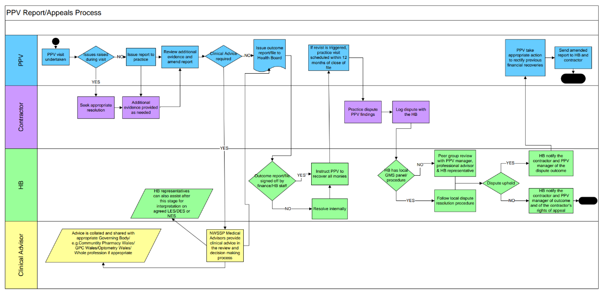

Appendix 2

IMPORTANT NOTICE TO PATIENTS

PLEASE NOTE THAT AS IN MANY OTHER AREAS OF ACTIVITY FUNDED FROM THE PUBLIC PURSE, THE NATIONAL HEALTH SERVICE IN WALES REQUIRES ALL PRACTICES TO ENABLE ACCESS TO RECORDS HELD HERE TO ENSURE THAT THE PAYMENTS IT MAKES ON BEHALF OF TAX PAYERS TO US ARE ACCURATE AND NO FRAUD HAS TAKEN PLACE.

THE NATIONAL HEALTH SERVICE CARRIES OUT PERIODIC CHECKS ON OCCASIONS AND ACCESSES DATA FROM RECORDS HELD HERE TO DISCHAGE ITS RESPONSIBILITES. THIS ACCESS IS CARRIED OUT IN ACCORDANCE WITH DATA PROTECTION LEGISLATION, RELATED STATUTORY REQUIREMENTS AND GOOD PRACTICE GUIDANCE FROM THE WELSH GOVERNMENT. ALL MEMBERS OF NHS STAFF INVOLVED HAVE SIGNED A CONFIDENTIALITY AGREEMENT COVERING PATIENT AND PERSONAL INFORMATION AND UNDERGO TRAINING.

IF YOU NEED TO KNOW MORE ABOUT THESE CHECKS OR IF YOU HAVE ANY ENQUIRIES ON THE INFORMATION GIVEN IN THIS NOTICE, THESE SHOULD BE MADE TO YOUR HEALTH BOARD. RECEPTION STAFF WILL BE ABLE TO GIVE YOU APPROPRIATE CONTACT DETAILS.



HYSBYSIAD PWYSIG I GLEIFION

NODER, FEL YMHOB MAES ARALL SY’N CAEL EI GYLLIDO GAN ARIAN CYHOEDDUS, FOD GWASANAETH IECHYD GWLADOL CYMRU YN MYNNU BOD POB PRACTIS YN SICRHAU BOD COFNODION SY’N CAEL EU CADW YMA AR GAEL I’W GWELD. NOD HYNNY YW SICRHAU BOD Y TALIADAU MAE’N EU GWNEUD I NI AR RAN TRETH DALWYR YN GYWIR.

MAE’R GWASANAETH IECHYD GWLADOL YN CYNNAL GWIRIADAU YN ACHLYSUROL AC MAE’N MYNNU GWELD COFNODION SY’N CAEL EU CADW YMA I GYFLAWNI’I DDYLETSWYDDAU. GWEIR HYN YN UNOL Â DEDDF DIOGELU DATA 1998, GOFYNION RHEOLIADAU STATUDOL CYSYLLTIEDIG A CHANLLAWIAU YMARFER DA GAN LYWODRAETH CYMRU. MAE POB AELOD O STAFF Y GIG SY’N RHAN O HYN WEDI LLOFNODI CYTUNDEB CYFRINACHEDD SY’N CWMPASU GWYBODAETH BERSONOL A GWYBODAETH AM GLEIFION.

OS OES UNRHYW YMHOLIADAU GENNYCH AM Y WYBODAETH AR YR HYSBYSIAD HWN, DYLECH HOLI’CH BWRDD IECHYD LLEOL. BYDD STAFF YN Y DDERBYNFA YN GALLU RHOI MANYLION CYSWLLT PRIODOL ICHI.

