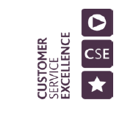
NHS WALES SHARED SERVICES PARTNERSHIP-PRIMARY CARE SERVICES (NWSSP – PCS)
POST PAYMENT VERIFICATION (PPV) PROTOCOL FOR COMMUNITY PHARMACY CONTRACTUAL FRAMEWORK

1. Purpose

  - The purpose of the Post Payment Verification (PPV) process is to provide assurance to Health Boards that the claims for payment made by Community Pharmacy Contractors are accurate and appropriate and that the delivery of the service is as defined by NHS specification and relevant legislation.

  - This document sets out the All-Wales protocol agreed between NWSSP-PCS on behalf of the Health Boards and Community Pharmacy Wales (CPW). This protocol details the arrangements for access by NWSSP-PCS staff to records held at pharmacy premises, including patient records where necessary.

  - This PPV process is effective from January 2023 and will be applied as necessary to the relating claim data submitted for us to verify. If there are any claims where it was established that they were made incorrectly or raise doubt of their validity, then NWSSP-PCS will inform the Health Board and the pharmacy contractor or nominated representative.

  - NWSSP-PCS will undertake PPV on the Quality & Safety Scheme and the Collaborative working scheme protocols, as agreed with the Health Boards and Community Pharmacy Wales (CPW).

2. Community Pharmacy Arrangements
NWSSP-PCS will assess data available to form a schedule of Verification checks of community pharmacies and will then agree the plan with Health Boards.
2.1 Quality and Safety Scheme
- NWSSP-PCS staff will contact the pharmacy contractor or nominated representative of the contractor, to ask them to provide copies of the certificates of completion for Mental Health Awareness e-learning and First Aid for Mental Health Training.
- NWSSP-PCS will check that the completion of the All-Wales Pharmacy Database on two occasions during the year that the pharmacy has undertaken.
- NWSSP-PCS will check the completion of the responsible disposal of inhalers use, that the pharmacy has completed the validation on NECAF.

2.2 Collaborative Working Scheme
NWSSP-PCS will check that the pharmacies have made a detailed report of each piece of collaborative working claimed for. The report may be in manual or electronic format and must include:
- The date and time of meeting
- The names and affiliation of the attendees
- A summary of the main points of discussion
- Any actions Agreed, the current status of those action is maintained at the pharmacy for inspection by the Local Health Board
3. PPV Checking Process

- PPV will verify the direct reports and action plans for the relevant annual periods that have been provided by the pharmacy contractor or nominated representative of the contractor.
- PPV with verify copies of all certificates/reports of the completion package that have been provided by the pharmacy contractor or nominated representative.
- Much of the checking process will be undertaken through NWSSP- PCS data held on their internal databases.
4. Recoveries
4.1 Recoveries could be made if insufficient evidence is provided, based on amounts stated and in line with the Drug Tariff.
5. Confidentiality and Disclosure of Information

5.1 In order to verify claims, NWSSP-PCS will request evidence on the clear understanding that proper confidentiality safeguards are observed, and the claim cannot be verified without access to this information. They will also take account of the Code of Practice on Confidentiality and Disclosure of Information. No manual records that include person identifiable data will be made or removed from the pharmacy under any circumstances.

5.2 Access to data held by pharmacies will be carried out in accordance with the requirements of the current data protection legislation, related statutory requirements, and good practice guidance from National Assembly for Wales. Post Payment Verification falls under current data protection legislation and can undertake the process under these particular points from General Data Protection Regulations.
Records of meetings should be maintained for 6 years, as per NHS Records Management Guidance. The same guidance suggests a retention period of 10 years for staff training records.
Community Pharmacy Wales advise of the requirement to retain records for 2 years for the purposes of PPV.

- Article 6 (1) (b): processing is necessary for the performance of a contract which the data subject is party or in order to take steps at the request of the data subject prior to entering a contract
- Article 6 (1) (e): processing is necessary for the performance of a task carried out in the public interest or in the exercise of official authority vested in the controller
- Article 9 (2) (g): processing is necessary for reasons of substantial public interest, on the basis of union or member state law which shall be proportionate to the aim pursued, respect the essence of the right to data protection and provide for suitable and specific measures to safeguard the fundamental rights and the interests of the data subject

6. Outcome of the Verification Process

6.1 After the process has been completed a confidential written report will be sent within 28 days to the pharmacy contractor or nominated representative of the pharmacy contractor, outlining the findings found during the audit. The contractor will have the opportunity to respond to the report or to supply further information of relevance.

6.2 Where it has been established that claims have been submitted erroneously or there are any doubts of their validity, the NWSSP-PCS PPV Team will inform the Health Board, as they have the final say on all decisions, and the pharmacy contractor or nominated representative. PPV will then recommend one or more of the following actions to the Health Board.

Action 1 – Making a recovery of an identified numerical value and closure of the visit file.

Action 2 – Making a recovery of an identified numerical value and arranging a revisit within the next 12 months to undertake a substantive review of claims (this would be a three-year sample period of claims).

6.3 Where the evidence or explanation for any erroneous claims is unable to meet specification or legislation requirements, the matter will be referred to the Health Board for appropriate remedial action.

6.4 If the NWSSP-PCS PPV Team suspect any claims to be of a fraudulent nature they will contact the Local Counter Fraud Service (LCFS) to determine the most appropriate action. The LCFS team reserve the right to contact all appropriate parties including the Director of Finance to discuss the matter and any further action.

7. Co-operation of Practices

7.1 This protocol is designed to support collaborative working arrangements and build trust between the Health Boards, NWSSP-PCS, and Community Pharmacies and to allow the PPV visits to be informative and constructive for all parties involved.
All visits will take place at a reasonable time and will be undertaken in a way that does not interfere with patient care or increase the risk to patient safety

7.2 Should the pharmacy contractor or nominated representative refuse to co-operate with the NWSSP-PCS in any way then the NWSSP-PCS staff will contact the Health Board explaining the reasons given by the contractor and seeking their help to resolve any problems as quickly and amicably as possible. The Health Board also has the opportunity to contact CPW for advice and/or assistance.

7.3 Upon completion of the verification process there is opportunity for the practice, if they are dissatisfied with the outcome, to use the PPV Team appeals process (see appendix 1). This outlines the process the contractor needs to take in order to have the case reviewed under regulation.

8. Operation of this Protocol

8.1 Any queries relating to this protocol can be directed to:
Mrs Amanda Legge, All Wales Post Payment Verification Manager, NWSSP-Primary Care Services.

Appendix 1
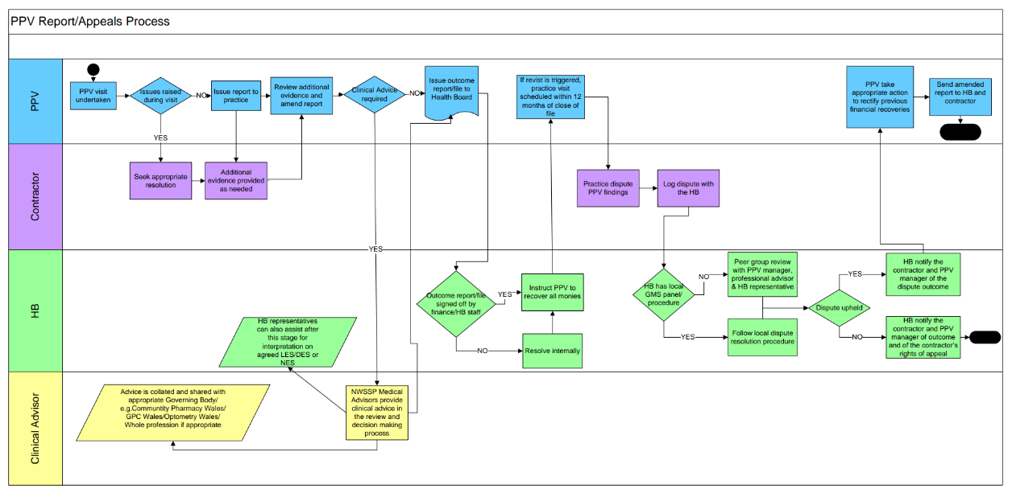
Appendix 2

Access to Confidential Pharmacy information – Authority Declaration

I confirm that I ____________________________________________ (enter full name)

am authorised in writing by __________________________________ (enter HB details)

to enter community pharmacies/via virtual means in the area of the Health Board for the purpose of ascertaining whether the pharmacy is complying with the terms of service; and / or to audit, monitor and analyse the provision made by the pharmacy providing NHS contractual services for patient care and treatment, and the management by the pharmacy of the Advanced Services he or she provides.

I require the responsible pharmacist of
______________________________________________ (enter pharmacy business name)

at ________________________________________________ (enter pharmacy address)

to allow me access to information, including patient identifiable information such as patient medication records and records made of Enhanced and Advanced Pharmaceutical Services provided by the pharmacy, for the purposes mentioned above.

I confirm that: -
- I have been asked to produce written evidence of my authorisation and have done so.
- I am bound by a duty of confidentiality and understand that breach of that duty of confidentiality could lead to action being taken against me including prosecution and / or referral to a professional regulator.
- any confidential information obtained will not be used for purposes other than those set out above.
- any confidential information (including sensitive personal information relating to patients) provided to me will not be disclosed by me to any other person unless I have legal authority to do so.

Signature _____________________________Date_______________________
Appendix 3

IMPORTANT NOTICE TO PATIENTS
PLEASE NOTE THAT AS IN MANY OTHER AREAS OF ACTIVITY FUNDED FROM THE PUBLIC PURSE, THE NATIONAL HEALTH SERVICE IN WALES REQUIRES ALL PRACTICES TO ENABLE ACCESS TO RECORDS HELD HERE TO ENSURE THAT THE PAYMENTS IT MAKES ON BEHALF OF TAXPAYERS TO US ARE ACCURATE AND NO FRAUD HAS TAKEN PLACE.

THE NATIONAL HEALTH SERVICE CARRIES OUT PERIODIC CHECKS ON OCCASIONS AND ACCESSES DATA FROM RECORDS HELD HERE TO DISCHAGE ITS RESPONSIBILITES. THIS ACCESS IS CARRIED OUT IN ACCORDANCE WITH DATA PROTECTION LEGISLATION, RELATED STATUTORY REQUIREMENTS AND GOOD PRACTICE GUIDANCE FROM THE WELSH GOVERNMENT. ALL MEMBERS OF NHS STAFF INVOLVED HAVE SIGNED A CONFIDENTIALITY AGREEMENT COVERING PATIENT AND PERSONAL INFORMATION AND UNDERGO TRAINING.

IF YOU NEED TO KNOW MORE ABOUT THESE CHECKS OR IF YOU HAVE ANY ENQUIRIES ON THE INFORMATION GIVEN IN THIS NOTICE, THESE SHOULD BE MADE TO YOUR HEALTH BOARD. PHARMACY STAFF WILL BE ABLE TO GIVE YOU APPROPRIATE CONTACT DETAILS.



HYSBYSIAD PWYSIG I GLEIFION
NODER, FEL YMHOB MAES ARALL SY’N CAEL EI GYLLIDO GAN ARIAN CYHOEDDUS, FOD GWASANAETH IECHYD GWLADOL CYMRU YN MYNNU BOD POB PRACTIS YN SICRHAU BOD COFNODION SY’N CAEL EU CADW YMA AR GAEL I’W GWELD. NOD HYNNY YW SICRHAU BOD Y TALIADAU MAE’N EU GWNEUD I NI AR RAN TRETH DALWYR YN GYWIR.
MAE’R GWASANAETH IECHYD GWLADOL YN CYNNAL GWIRIADAU YN ACHLYSUROL AC MAE’N MYNNU GWELD COFNODION SY’N CAEL EU CADW YMA I GYFLAWNI’I DDYLETSWYDDAU. GWEIR HYN YN UNOL Â DEDDF DIOGELU DATA 1998, GOFYNION RHEOLIADAU STATUDOL CYSYLLTIEDIG A CHANLLAWIAU YMARFER DA GAN LYWODRAETH CYMRU. MAE POB AELOD O STAFF Y GIG SY’N RHAN O HYN WEDI LLOFNODI CYTUNDEB CYFRINACHEDD SY’N CWMPASU GWYBODAETH BERSONOL A GWYBODAETH AM GLEIFION.
OS OES UNRHYW YMHOLIADAU GENNYCH AM Y WYBODAETH AR YR HYSBYSIAD HWN, DYLECH HOLI’CH BWRDD IECHYD LLEOL. BYDD STAFF YN Y DDERBYNFA YN GALLU RHOI MANYLION CYSWLLT PRIODOL ICHI.

