
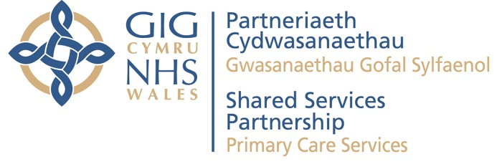

Pharmacy Post Payment Verification

Information Sheet
No. | Issue / Question | PPV action taken / Response
 | The GPHC number entered into NECAF differed from that of the pharmacist undertaking the review (applicable to MUR claims) | If the service has been provided by a Pharmacist who is not duly accredited, claims identified would be subject to financial recoveries under PPV arrangements
 | Targeted drugs entered into NECAF differed from that of the MUR | This would be noted within the PPV final report as an administration error.  Additional advice and support on reducing administration errors can be sought from the PPV teams
 | Targeted MUR entered into NECAF, general MUR completed | This would be noted within the PPV final report as an administration error.  Additional advice and support on reducing administration errors can be sought from the PPV teams
 | General MUR entered into NECAF, targeted MUR completed | This would be noted within the PPV final report as an administration error.  Additional advice and support on reducing administration errors can be sought from the PPV teams
5. | Number of actions entered into NECAF differed from that of the MUR | This would be noted within the PPV final report as an administration error.  Additional advice and support on reducing administration errors can be sought from the PPV teams
6. | Number of medications reviewed entered into NECAF differed from that of the MUR | This would be noted within the PPV final report as an administration error.  Additional advice and support on reducing administration errors can be sought from the PPV teams
7. | Not all high risk medications were identified in NECAF | This would be noted within the PPV final report as an administration error.  Additional advice and support on reducing administration errors can be sought from the PPV teams
8. | PMR number entered into NECAF differed from that of the MUR | This would be noted within the PPV final report as an administration error.  Additional advice and support on reducing administration errors can be sought from the PPV teams
9. | Is it a requirement of the MUR scheme to use the PMR or NHS number for all MUR claims submitted via the NECAF system? | Yes this requirement has been communicated to the service following the introduction of PPV within the Pharmacy Discipline.
10. | Is it a requirement to use a patient consent form for the MUR service? | Following Ministerial approval as at 1st April 2015 MUR Patient consent forms are no longer required. However it is still a requirement for the pharmacy to obtain consent from each patient and maintain an appropriate record of that consent.
11. | If administration errors are identified during the PPV visit what action would be taken? | Administration errors will be identified and reported but not subject to a financial recovery. PPV teams will work collaboratively to ensure appropriate actions are taken to promote best practice and reduce future administration error rates
12. | Date of intervention on NECAF is different to date of intervention on patient record | As at (May 16) this is reported as an administration error. However work in underway to enhance the NECAF system in order to provide a prompt to all data entry staff that the date of intervention should be the same on both the patient record and NECAF.
13. | What action is taken if PPV teams identify more than 1 MUR within the same year for the same patient? | This would be subject to review with the Pharmacist and if there was no clinical reason for the second claim then this would be subject to a financial recovery.
14. | A claim is made for an MUR in respect of a patient who is not in a target group and only on 1 medication however more than 1 medication has been entered in to NECAF | This would be subject to a financial recovery
15. | A claim is made for a patient only on 1 medication | MURs must only be carried out with patients taking two or more medicines. The only exception to this is when a patient is prescribed a high risk medicine, i.e. (a medicine in the National List of High Risk Medicines)
16. | If no record of service is evidenced during the PPV visit (applicable to both FLU and MUR claims) | This would be subject to a financial recovery
17. | If FLU consent form has not been signed | This would be subject to a financial recovery
18. | If duplicate claims are identified (applicable to both FLU and MUR claims) | This would be subject to a financial recovery
19. | The GPHC number on the FLU claim cannot be verified against the All Wales Pharmacy Database (AWPD) | If the service has been provided by a Pharmacist who is not on the AWPD, claims identified would be subject to financial recoveries under PPV arrangements
20. | FLU at risk group recorded does not match the claim form | This would be noted within the PPV final report as an administration error.  Additional advice and support on reducing administration errors can be sought from the PPV teams
21. | Some PMR (e.g Rx Web) only produces an NPA (English) MUR form. Will Pharmacists be penalised for using English forms? | The approved MUR form is one that collects the necessary NECAF data and satisfies the service objectives rather than a prescribed form for use in Wales and not England. No action will be taken if the English form has been generated and satisfies all Welsh service objectives.

