To Community Pharmacies and GP Practices
14th March 2016

Dear Colleague
Re Waste Management Audit Arrangements
I am writing to you with regards to the introduction of a waste management audit programme which will be facilitated by NHS Wales Shared Services Partnership (NWSSP), Primary Care Services (PCS), on behalf of your responsible Health Board.
On 16 July 2005 the Hazardous Waste (Wales) Regulations and the List of Waste (Wales) Regulations came into force replacing the Special Waste Regulations. The Regulations set out procedures to be followed when disposing of, carrying and receiving hazardous waste.
The Regulations place great emphasis on a producer’s duty of care to demonstrate due diligence in disposing of any waste they produce, but in particular if the waste is hazardous, in complying with the Hazardous Waste Regulations. The duty of care applies to all those involved in the process from ‘cradle to grave’, i.e., waste producers, waste carriers, waste contractors and waste brokers.
The Health Board provides the contract for the collection and disposal of clinical waste produced in a healthcare setting. Therefore, in accordance with the regulations, the Health Board acts as Waste Broker and could be liable in the event of any failure to comply with the regulations.
Natural Resources Wales enforces the regulations and has a statutory responsibility to inspect hazardous waste producers and they can attend premises un-announced. .
In order to demonstrate its duty of care, Health Boards have agreed that NWSSP-PCS will undertake clinical waste management audits at all GP and Community Pharmacy premises.
In order to maximise efficiencies and reduce the burden on practice resource it has been agreed that these audits will be undertaken by our Post Payment Verification (PPV) teams whilst they are present at the surgery / pharmacy premise.
I must stress however that whilst the PPV teams will be undertaking the waste management audits this is to provide guidance and support to the profession in respect of compliance with the waste management regulations and non compliance would not result in any financial penalties being imposed.
I have enclosed for your information a Waste Management Aid to Compliance document which highlights requirements in line with the regulations. In order to provide additional support to the GP practices and Community Pharmacies we have a dedicated waste management officer who will be able to assist with any queries you may have regarding these audits and who would also be available to provide advice on what you can do in preparation for your waste management audit.
Continued/
I trust you will find this communication informative, if however you require any additional information please do not hesitate to contact PCS using
nwssp-primarycareservices@wales.nhs.uk or alternatively contact Martin Regan, Waste Management Officer on 01495 332319.
Yours Sincerely

Nicola Phillips
Head of Engagement and Support Services, NWSSP – PCS
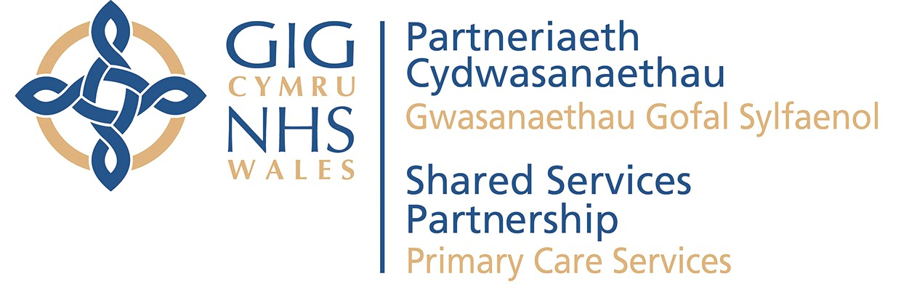
Primary Care Services is a division of the NHS Wales Shared Services Partnership
Mae’r Gwasanaethau Gofal Sylfaenol yn is-adran o fewn Partneriaeth Cydwasanaethau GIG Cymru

