GUIDANCE FOR INCLUSION IN THE MEDICAL PERFORMERS LIST DURING THE COVID-19 EMERGENCY

If you are a Returning GP and wish to assist NHS Wales in the provision of General Medical Services during the COVID-10 emergency, you must complete an application to join the Medical Performers List (MPL) in Wales. The application form has been designed in Word so that you can complete it on your own computer.

The completed form should be returned to NHS Wales Shared Services Partnership (NWSSP), by email to nwssp-primarycareservices@wales.nhs.uk or by post to the Medical Performers List Team, NWSSP – Primary Care Services, Cwmbran House, Mamhilad Park Estate, Mamhilad, Pontypool, Gwent, NP4 0XS, together with your supporting information which is detailed in the guidance below.

What documents do I need to submit?

In order to proceed with your application you must provide the following documents (scanned images by email are acceptable):

- Fully completed Medical Performers List application form.
- An enhanced DBS certificate, with both the Children and Adult Barred Lists checked dated within the last 3 years, or
- If you are signed up to the DBS Update Service, an Enhanced DBS Certificate, with both the Children and Adult Barred Lists checked, with a signed consent form, in order that your DBS status can be checked online; or
- If you do not hold either of the above, you must apply for a new DBS Certificate and supply three ID documents (please see notes below on how to apply for a new DBS check). This is a fast track service and will provide this office with a result within 24 hours once you have had your ID check. However, you must also provide this office with a scanned image of the full DBS certificate within 7 days of when you receive it.
- English language competency certificate (only applicable to citizens of EEA countries whose first language is not English and were trained in countries other than the UK or Republic of Ireland).

On receipt of a fully completed application, and DBS clearance has also been received for you, this office will write to you to let you know that you can commence work, whilst we continue processing your application. Please do not commence work until you have received a letter from this office.

Which Health Board list should I apply for?

You should apply to the list of the Local Health Board (LHB) for the area in which you intend to do the majority of your work.

Completing the MPL application form

In order that your application is not delayed, please ensure that you answer all questions in the application form. Please ensure that all sections are completed.

Professional experience

Please list your career history in date order commencing with your most recent position. If you have retired, please include this is your career history.

Referees

Please provide names and contact details of two referees who are willing to provide clinical references. These can be two GPs who you have previously worked with in your last post. It is appreciated that you may have worked with these GPs several years ago.

English language competency

The National Health Service (Performers Lists) (Wales) Regulations 2004, as amended, require the LHB to satisfy itself that the English language skills of applicants are sufficient for them to carry out NHS general medical services.

If your medical degree course was in the UK, the Irish Republic, outside the EEA or any university where the teaching was in English, your GMC registration is sufficient evidence of this.

If you are an EEA applicant you will be required to have passed Academic International English Language Testing System (IELTS) at level 7, in all components of speaking, listening, reading and writing with an overall score of 7.5.

DBS clearance

You will need provide one of the following to have DBS clearance:

- If you hold an Enhanced DBS Certificate with both the Children and Adult Barred Lists checked that is dated within the last 3 years, please provide a scanned image of this certificate with your application.

- If you hold an Enhanced DBS Certificate with both the Children and Adult Barred Lists checked and are registered with the DBS Update Service, please provide a scanned image of this certificate along with the signed consent form for us to check the Update Service with your application form.

- If you do not have either of the above, you will have to apply for a new Enhanced DBS check. You can access an on-line DBS application form by following the link below: https://disclosure.capitarvs.co.uk/cheqs/applicantLogin.do?applicationType=dbs
This is a fast track service and will provide this office with a result within 24 hours once you have had your ID check. However, you must also provide this office with a scanned image of the full DBS certificate within 7 days of when you receive it.

Please read the guidance notes below on how to complete the online DBS application form.

COMPLETING THE ON-LINE DISCLOSURE AND BARRING SERVICE (DBS) APPLICATION FORM

If you do not hold a valid DBS Certificate you will need to complete a new DBS application form. For GPs Returning to perform General Medical Services this is a fast track service and there is no charge to the applicant for this service.

COMPLETING THE FORM

Please note the following important points when completing your on-line DBS application form:

- When accessing the on-line form you will be asked to input an ‘Organisational Reference’ and an ‘Organisation Code’:

The Organisational Reference is: NWSSPPCS (uppercase)
The Organisation Code is: NHS (uppercase).

- When asked to provide information on the ‘Position Applied for’ please enter the following, in order that it is treated as a fast track application:

  - COVID nineteen GP

- Full details on how to complete the on-line DBS application form are detailed in Annex 1.

- You will be required to also submit scanned images of 3 ID documents to support your DBS application. Details of the documents that can be accepted are detailed below in Annex 2 and 3. You will also need to show these ID documents via a Skype for Business video ID check. Details on how to undertake this ID check are available in Annex 4. Failure to submit the ID documents and undertake the ID check will result in your DBS application not being submitted.

- Once your ID has been validated on the video check, this office will receive a result from DBS within 24 hours, however you are still required to send a copy of your full DBS certificate to this office within 7 days of receiving it from DBS. You can send a scanned image to this office via nwssp-primarycareservices@wales.nhs.uk.

- Transgender applicants should contact the DBS Transgender Line on 0151 676 1452 or email sensitive@dbs.gsi.gov.uk for further advice about completing the form.

ANNEX 1

CAPITA
RECRUITMENT VETTING SERVICE

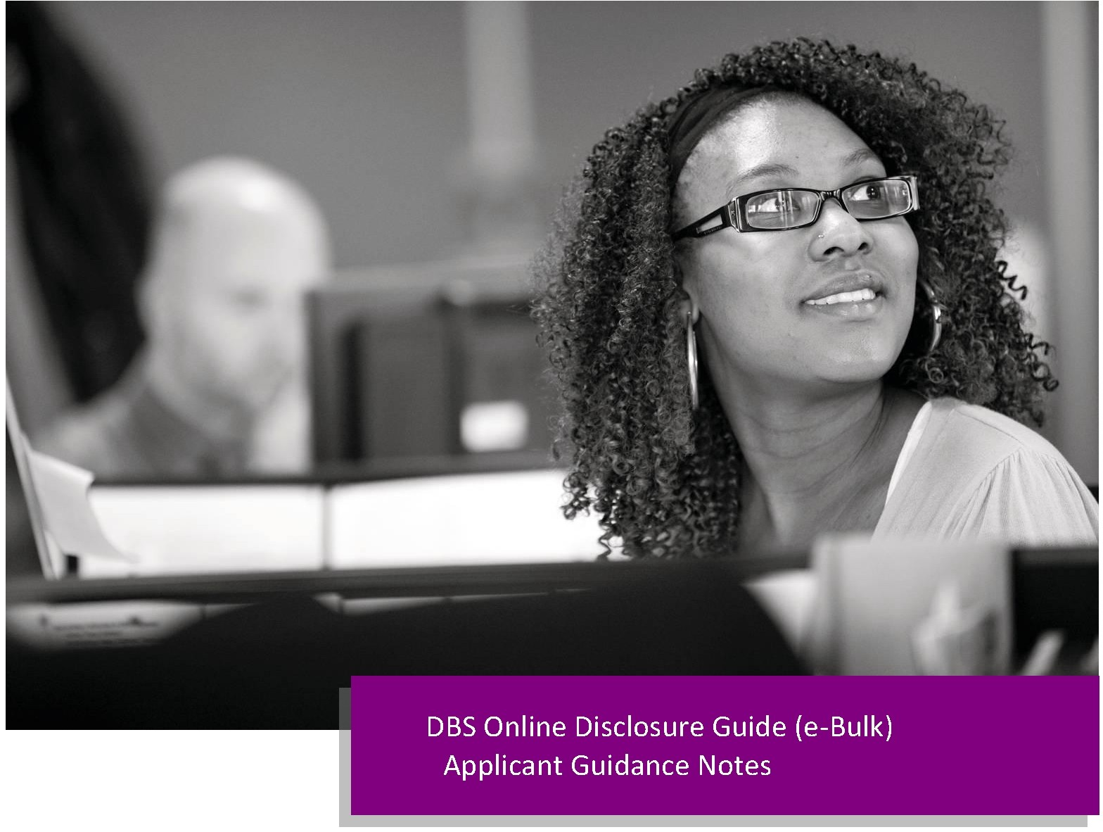

APPLICANT GUIDANCE NOTES

An online DBS check can be completed by accessing the internet from any PC/Laptop that has this facility. If you do not own your own computer you can go to any internet café or local library. Please be aware that you must complete your application form in full as part completed applications form cannot be saved.

LOGGING ONTO THE SYSTEM

Please enter the following address in the web browser:

https://disclosure.capitarvs.co.uk/cheqs/applicantLogin.do?applicationType=dbs

If you are not taken directly to the ‘Start New Application’ page, please click on ‘Start Application’ in the orange box entitled ‘DISCLOSURE AND BARRING SERVICE (DBS) APPLICATION’ to enter the system and start your application.

Please note at this stage of the process your login details are case sensitive.

1. Enter the Organisation Reference that has been supplied to you by the company that you will be/are working for.

2. Enter the Password that has been supplied to you by the company that you will be/are working for.
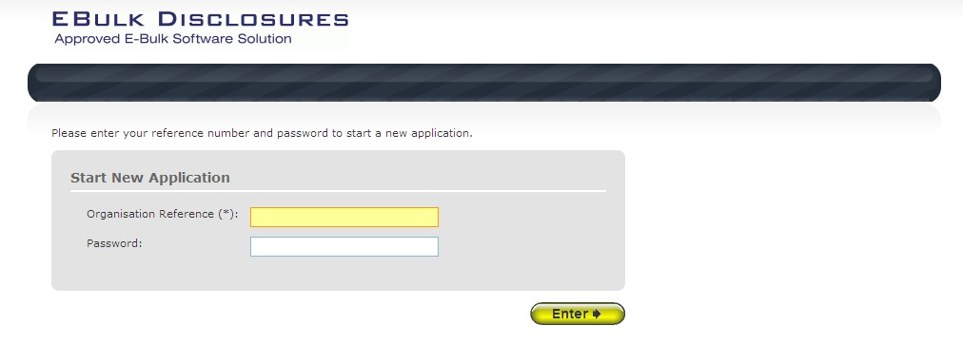

Once you have completed this section click ‘Enter’.

STATEMENT OF FAIR PROCESSING

You will now be taken to the ‘CRVS Statement of Fair Processing’ outlining CRVS’s terms and conditions. Please read the statement and tick the box to confirm this has been read and agreed to.
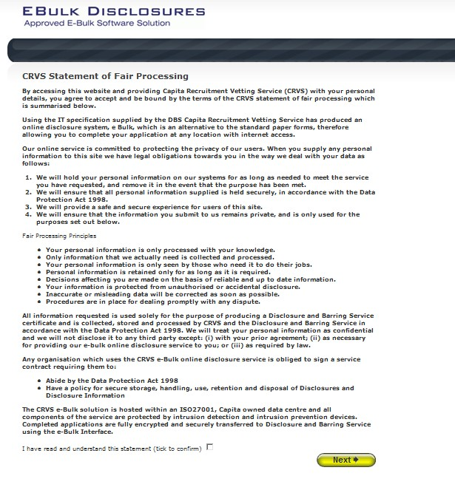

Once you have ticked the consent box please click ‘Next’

APPLICATION PRE-ENTRY STATEMENT

You will now see the application pre-entry statement; this gives concise information in regards to the requirements by the DBS regarding acceptable identification in support of your DBS application.

Once you have ticked the consent box please click ‘Next’
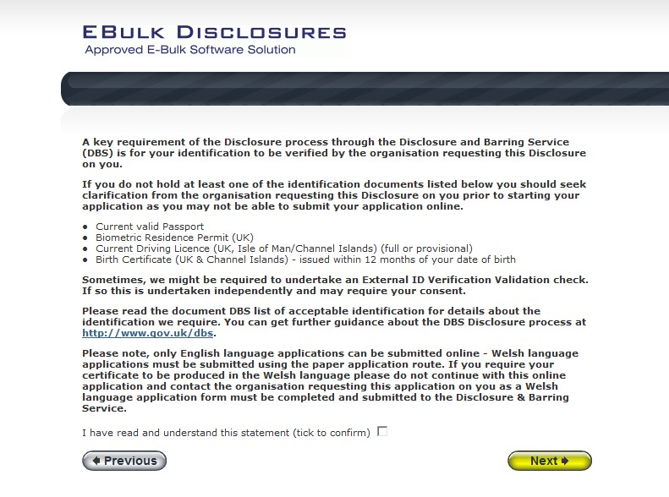

• The application form is a simple 5 step process. Please complete all fields.

• Mandatory fields are denoted by (*)

Mistakes on the application form will cause delays in processing.

SECTION 1 – ABOUT YOU

Please enter your personal details.

If you have any middle name(s) ensure that you enter these details, particularly those that appear on your identity documents, e.g. passport, driving licence, birth certificate, etc. Any missing information from this or any other section can severely delay the processing of your criminal record check.
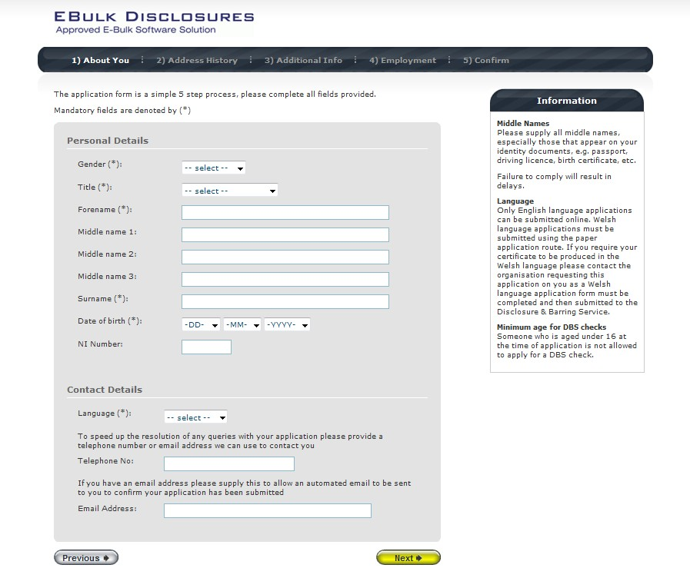

Once you have completed this section click ‘Next’.

SECTION 2 – ADDRESS HISTORY

Please enter your current address. If you have not lived at this property for more than five years, you will be taken to another screen. Here you will be required to add any additional addresses to ensure your address history goes back the required five years. Please note if you do not provide a minimum of five years address history, you will not be able to proceed to the next stage of the application process.

Address Dates

There cannot be any gaps/overlaps in your address history. Please ensure that the month and year of each address follows that of the previous address. Students who switch between their permanent residence and education establishments must enter each address with dates consecutively, e.g. parents’ address Dec 2009 – Jan 2010, university address Jan 2010 – March 2010, parents’ address March 2010 – April 2010 etc. Do not run addresses/dates simultaneously as your application form will be rejected by the DBS. Once an address has been entered, you can edit any information by clicking on the ‘Edit’ button.

Postcode

Please ensure that all UK addresses have a full postcode; if you cannot remember your postcode please use the
Royal Mail UK Postcode Finder link provided within the address information box.

No Fixed Abode UK

If you were of no fixed abode within the UK please enter the nearest hostel address to the location you were based.

Foreign Addresses/Travelling Overseas

If you have travelled overseas and cannot supply the address for a foreign country then please enter ‘no fixed abode’ for Address Line 1. Please then enter the Town/City and Country of where you were residing within this period.
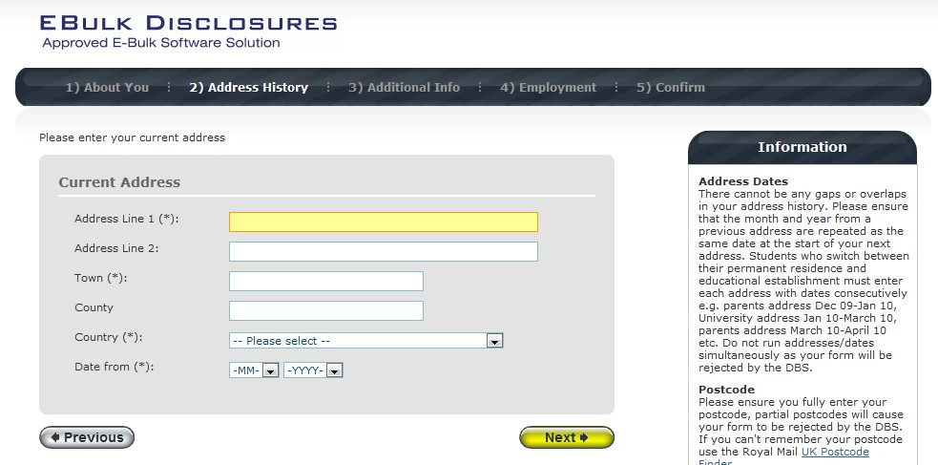

Once you have completed this section click ‘Next’.

a

SECTION 3 – ADDITIONAL INFO

Place of Birth

Please enter details of your place of birth.

Nationality at Birth

Please enter your Nationality at birth and state YES or NO as to whether this has changed since you were born. If this has changed, you will be required to enter your current nationality.

Changed Surname

If you have changed your surname please provide your birth surname and the year you changed it. Please ensure that where names change they run in date order and with no gaps.

Other Names

Please provide details of any other names used at any time during your lifetime and the dates during which the names were used. Please enter each forename, middle name(s) and surname separately using the 'Add Name' button below. If you have used any aliases, e.g. William known as Bill, please also supply these details.

Failure to supply any additional information may cause your application to be delayed.
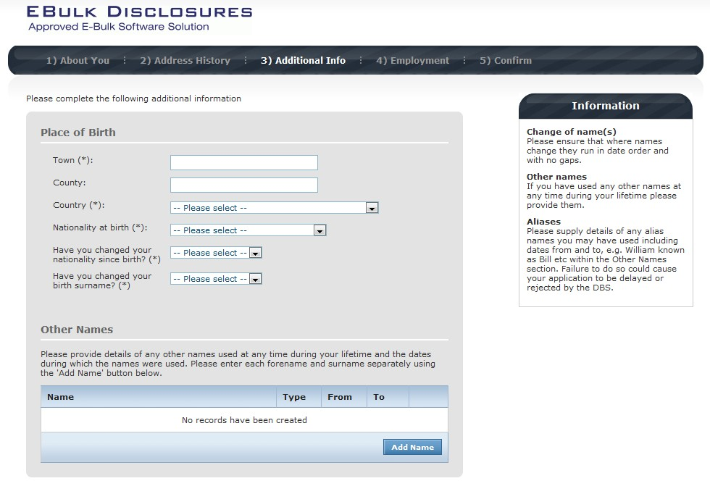

Once you have completed this section click ‘Next’.

SECTION 4 – EMPLOYMENT DETAILS

Position Applied For

Please insert the correct job role as supplied to you by your current/new employer. You will either be required to select your job role from the dropdown list provided or enter this manually. No abbreviations are permissible, e.g. Admin Asst should read Administrative Assistant. If you are a volunteer do not enter just volunteer, please enter in which capacity your job role is, e.g. Coach.

Failure to enter the correct job role may cause your application to be delayed. Employer Name
This has been defaulted to the organisation you are applying through and should not be amended.
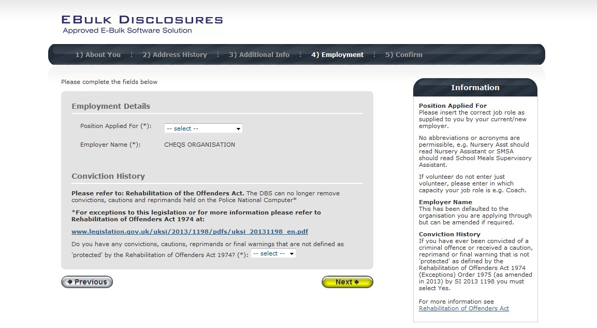

Conviction History

If you have never been convicted of a criminal offence or never received a caution, reprimand or warning then please select ‘No’. If you have been convicted of a criminal offence, or received a caution, reprimand or warning that is ‘protected’ as defined by the Rehabilitation of Offenders Act then please also select ‘No’.

If you have ever been convicted of a criminal offence, caution, reprimand or warning that is not ‘protected’ as
defined by the Rehabilitation of Offenders Act then please select ‘Yes’.

For more information, please refer to Rehabilitation of Offenders Act 1974 at:

http://www.justice.gov.uk/guidance/docs/rehabilitation-offenders.pdf

Once you have completed this section click ‘Next’.

SECTION 5 – CONFIRMATION AND CONSENT

Now please read through your application to ensure that there are no omissions/errors before you submit your application. If you wish to edit a section of your application click on ‘edit’ next to the section of the form that requires changes.

At the end of the application please make sure that you complete the Applicant Consent section.
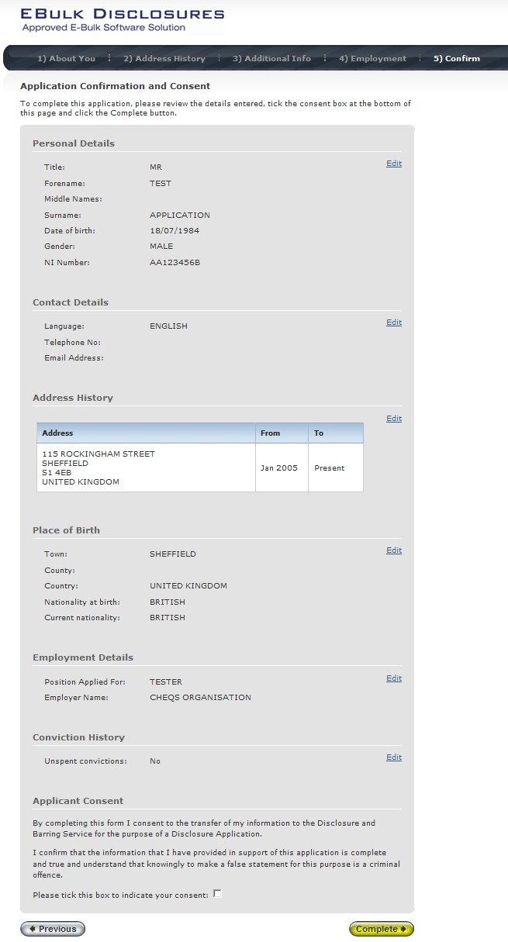

Now click ‘Complete’.

You have now completed your application form and you will be given a submission reference number. Please make a note of this number for reference purposes. If you entered an email address onto your application form you will receive a confirmation email containing these details.
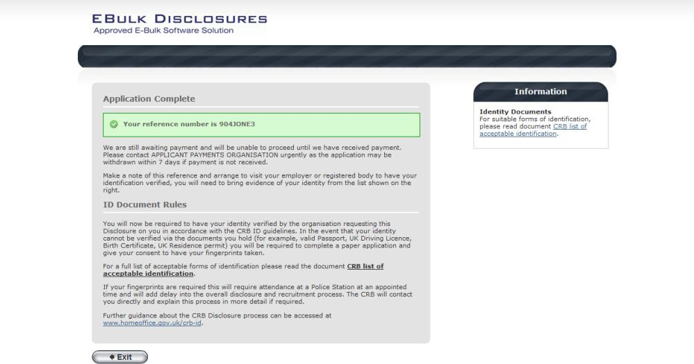

Your application form will be processed by your employer once they have verified your identity. Please see below for guidance on identity verification.

Next step - identity verification

In line with the DBS code of practice all applicants requiring a DBS check must have their identity verified.

How do I have my identity verified?

Please provide original identification to your Company’s Nominated Person (usually Recruitment or HR Manager) and provide identification as listed in the acceptable ID table (see table below). Your application form will be processed by your employer once they have verified your identity, and then sent onto the DBS.

Tracking the progress of your application with the DBS

If you supplied an email address whilst entering your application, as soon as your application has been received at the DBS and is assigned a DBS Application Reference number you will receive a second email detailing this information. This email will also include details and links to the DBS website to enable you to track the progress of your application from the moment the disclosure process commences.

CONTACT DETAILS

Please contact the NWSSP – Primary Care Services department if you have any queries in regards to the DBS application process. If you experience any technical issues with the online system, please contact the CRVS Client Relations Team on 0870 850 2516 (Option 1). Lines open 9.00am-5.30pm Monday to Friday. Alternatively you can contact us by e-mail at dbs.enquiries@capita.co.uk.

ANNEX 2

Annex 2

DBS Applications - Identity Documents for UK and EEA Nationals

What identity documents can be used?
You must supply 3 documents in total; 1 document from Group 1 and 2 further documents from Group 1, 2a or 2b; at least one of which must verify your current address. If you are unable to produce these documents please contact the NHS Wales Shared Service Partnership for advice. I should make you aware that if you are unable to produce a Group 1 document then an external ID validation service will need to be accessed. This may delay the processing of your application.

Group 1: Primary Identity Documents

Document | Notes
Passport | Any current and valid passport
Biometric residence permit | UK
Current driving licence photocard – (full or provisional) | UK, Isle of Man, Channel Islands and EEA. From 8 June 2015, the paper counterpart to the photocard driving licence will not be valid and will no longer be issued by DVLA
Birth certificate – must be issued within 12 months of date of birth | UK, Isle of Man and Channel Islands – including those issued by UK authorities overseas, for example embassies, High Commissions and HM Forces
Adoption certificate | UK and Channel Islands

Group 2a: Trusted Government Documents

Document | Notes
Current driving licence photocard – (full or provisional) | All countries outside the EEA (excluding Isle of Man and Channel Islands)
Current driving licence (full or provisional) – paper version (if issued before 1998) | UK, Isle of Man, Channel Islands and EEA
Birth certificate – issued after time of birth | UK, Isle of Man and Channel Islands
Marriage/civil partnership certificate | UK and Channel Islands
Immigration document, visa or work permit | Issued by a country outside the EEA. Valid only for roles whereby the applicant is living and working outside of the UK. Visa/permit must relate to the non EEA country in which the role is based
HM Forces ID card | UK
Firearms licence | UK, Channel Islands and Isle of Man

Group 2b: Financial and social history documents

Document | Notes | Issue date and validity
Mortgage statement | UK or EEA | Issued in last 12 months
Bank or building society statement | UK and Channel Islands or EEA | Issued in last 3 months
Bank or building society statement | Countries outside the EEA | Issued in last 3 months – branch must be in the country where the applicant lives and works
Bank or building society account opening confirmation letter | UK | Issued in last 3 months
Credit card statement | UK or EEA | Issued in last 3 months
Financial statement, for example pension or endowment | UK | Issued in last 12 months
P45 or P60 statement | UK and Channel Islands | Issued in last 12 months
Council tax statement | UK and Channel Islands | Issued in last 12 months
Letter of sponsorship from future employment provider | Non UK or non EEA only – valid only for applicants residing outside of the UK at time of application | Must still be valid
Utility bill | UK – not mobile telephone bill | Issued in last 3 months
Benefit statement, for example, Child Benefit, Pension | UK | Issued in last 3 months
Central or local government, government agency, or local council document giving entitlement, for example from the Department for Work and Pensions, the Employment Service, HMRC | UK and Channel Islands | Issued in last 3 months
EEA National ID card |  | Must still be valid
Irish Passport card | Cannot be used with an Irish passport | Must still be valid
Cards carrying the PASS accreditation logo | UK, Isle of Mann and Channel Islands | Must still be valid
Letter from head teacher or college principal | UK – for 16 to 19 year olds in full time education – only used in exceptional circumstances if other documents cannot be provided | Must still be valid

ANNEX 3

DBS Applications - Identity Documents (for non UK and non EEA Nationals)

What identity documents can be used?
If you want to undertake paid work and you are not a national of the UK or EEA you must be able to supply 1 original ‘Primary Document’ and 2 original supporting documents from Groups 1, 2a or 2b, one of which must verify your current address. If you are not able to produce these documents you will be unable to undergo a DBS check.

Primary Documents

Document
A Permanent Residence Card issued by the Home Office to the family member of a national of a European Economic Area country or Switzerland.

A current Biometric Immigration Document (Biometric Residence Permit) issued by the Home Office to the holder indicating that the person named is allowed to stay indefinitely in the UK, or has no time limit on their stay in the UK.

A current passport endorsed to show that the holder is exempt from immigration control, is allowed to stay indefinitely in the UK, has the right of abode in the UK, or has no time limit on their stay in the UK.

A current Immigration Status Document issued by the Home Office to the holder with an endorsement indicating that the named person is allowed to stay indefinitely in the UK or has no time limit on their stay in the UK, together with an official document giving the person’s permanent National Insurance number and their name issued by a Government agency or a previous employer.

A current passport endorsed to show that the holder is allowed to stay in the UK and is currently allowed to do the type of work in question.

A current Biometric Immigration Document (Biometric Residence Permit) issued by the Home Office to the holder which indicates that the named person can currently stay in the UK and is allowed to do the work in question.

A current Residence Card (including an Accession Residence Card or a Derivative Residence Card) issued by the Home Office to a non-European Economic Area national who is a family member of a national of a European Economic Area country or Switzerland or who has a derivative right of residence.

A current Immigration Status Document containing a photograph issued by the Home Office to the holder with a valid endorsement indicating that the named person may stay in the UK, and is allowed to do the type of work in question, together with an official document giving the person’s permanent National Insurance number and their name issued by a Government agency or a previous employer.

A Certificate of Application issued by the Home Office under regulation 17(3) or 18A (2) of the Immigration (European Economic Area) Regulations 2006, to a family member of a national of a European Economic Area country or Switzerland stating that the holder is permitted to take employment which is less than 6 months old together with a Positive Verification Notice from the Home Office Employer Checking Service.

An Application Registration Card issued by the Home Office stating that the holder is permitted to take the employment in question, together with a Positive Verification Notice from the Home Office Employer Checking Service.

A Positive Verification Notice issued by the Home Office Employer Checking Service to the employer or prospective employer, which indicates that the named person may stay in the UK and is permitted to do the work in question.

Group 1: Primary Identity Documents

Document | Notes
Passport | Any current and valid passport
Biometric residence permit | UK
Current driving licence photocard – (full or provisional) | UK, Isle of Man, Channel Islands and EEA. From 8 June 2015, the paper counterpart to the photocard driving licence will not be valid and will no longer be issued by DVLA
Birth certificate – must be issued within 12 months of date of birth | UK, Isle of Man and Channel Islands – including those issued by UK authorities overseas, for example embassies, High Commissions and HM Forces
Adoption certificate | UK and Channel Islands

A passport or biometric residence permit can only be used as a supporting document if it is not already been used as a primary document.

Group 2a: Trusted Government Documents

Document | Notes
Current driving licence photocard – (full or provisional) | All countries outside the EEA (excluding Isle of Man and Channel Islands)
Current driving licence (full or provisional) – paper version (if issued before 1998) | UK, Isle of Man, Channel Islands and EEA
Birth certificate – issued after time of birth | UK, Isle of Man and Channel Islands
Marriage/civil partnership certificate | UK and Channel Islands
Immigration document, visa or work permit | Issued by a country outside the EEA. Valid only for roles whereby the applicant is living and working outside of the UK. Visa/permit must relate to the non EEA country in which the role is based
HM Forces ID card | UK
Firearms licence | UK, Channel Islands and Isle of Man

Group 2b: Financial and social history documents

Document | Notes | Issue date and validity
Mortgage statement | UK or EEA | Issued in last 12 months
Bank or building society statement | UK and Channel Islands or EEA | Issued in last 3 months
Bank or building society statement (for applicants living and working outside the UK) | Countries outside the EEA | Issued in last 3 months – branch must be in the country where the applicant lives and works
Bank or building society account opening confirmation letter | UK | Issued in last 3 months
Credit card statement | UK or EEA | Issued in last 3 months
Financial statement, for example pension or endowment | UK | Issued in last 12 months
P45 or P60 statement | UK and Channel Islands | Issued in last 12 months
Council tax statement | UK and Channel Islands | Issued in last 12 months
Letter of sponsorship from future employment provider | Non UK or non EEA only – valid only for applicants residing outside of the UK at time of application | Must still be valid
Utility bill | UK – not mobile telephone bill | Issued in last 3 months
Benefit statement, for example, Child Benefit, Pension | UK | Issued in last 3 months
Central or local government, government agency, or local council document giving entitlement, for example from the Department for Work and Pensions, the Employment Service, HMRC | UK and Channel Islands | Issued in last 3 months
EEA National ID card |  | Must still be valid
Irish Passport card | Cannot be used with an Irish passport | Must still be valid
Cards carrying the PASS accreditation logo | UK, Isle of Mann and Channel Islands | Must still be valid
Letter from head teacher or college principal | UK – for 16 to 19 year olds in full time education – only used in exceptional circumstances if other documents cannot be provided | Must still be valid

Annex 4

Undertaking a Skype for Business ID Check

If you have submitted a new Disclosure and Barring Service (DBS) application, as well as scanning your 3 ID documents to nwssp-primarycareservices@wales.nhs.uk, you must also arrange to show your original ID documents via a video check. You are required to:

- Complete the on-line DBS Application Form;

- Send scanned copies of your ID documents to nwssp-primarycareservices@wales.nhs.uk together with your MPL application form.

- This office will then contact you to book a Video Check appointment and send you an email inviting you to attend a Skype for Business video appointment;

- You must download the Skype for Business App;

- You must attend the video check appointment with your original ID documents to show to the camera.

How to Download the Skype for Business App and Participate in the Video ID Check

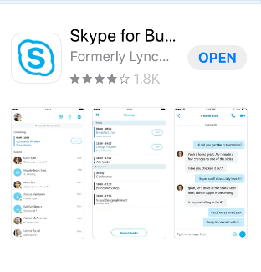
In your iOS or Android app store, search for “Skype for Business” and download the app above, which is free. You do not have to sign in or set a password in the app.

You will have been sent an email scheduling your appointment. On the scheduled date and time open the e-mail you have been sent and click the link “Join Skype Meeting”.

Your device will seek confirmation to “Open this page in the Business app”, select “Open”.

Select “Join as Guest” then enter your name.

At this point you will be in a virtual lobby. An Officer will open the meeting shortly.

Click the video icon to accept video call.

Click the microphone icon to unmute the microphone when video call begins.

You will be required to confirm your full name, date of birth and current address and will be required to show the original ID documents to the camera that you had previously submitted copies of to the office.

Please note: If you fail to join the call by clicking on the link in the email sent you within 10 minutes of the time of your appointment, the appointment will be cancelled and will need to be re-scheduled.

