
WP34A
Part 1 - Contractor Details and Authorisation
PLEASE RETURN TO:

Document Scanning Team
Primary Care Services
Cwmbran House
Mamhilad Park Estate
Mamhilad
Pontypool
NP4 0XS

CONTRACTOR’S STAMP
Submission document relating to drugs and approved appliances ordered by medical and dental practitioners supplied under Part II of the National Health Service Act 1997.

I hereby claim payment in accordance with the relevant provisions of my Terms of Service.
SIGNATURE OF CONTRACTOR OR AUTHORISED AGENT -
PRINT NAME -

Date:

D | D

© NHS Shared Services Partnership
M | M

Y | Y | Y | Y

Account No.

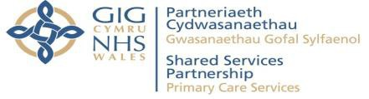
www.wales.nhs.uk/prescribing
Part 2 - Submissions
Forms
Items
Group 1 (Exempt
from patient charge)
Group 2 (Patient
charge paid)
Total
(Sum of groups 1 & 2)
Please complete all fields inserting a zero if not applicable
6 | 0 |  |  |  |  | Z

Effective from: April 2024 - Version 0.2

