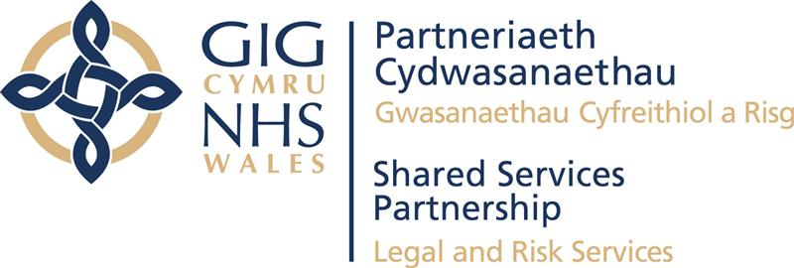
Our fees
Our fees are based on hourly rates which are reviewed annually. The current rates are £104.70 for work done by a solicitor or legal executive and £81.40 per hour for work done by a trainee or paralegal. All fees are subject to VAT at a rate of 20%. A detailed costs estimate will be provided in each case.
The average cost range for advice in a case of unfair dismissal or wrongful dismissal
- Simple Case: £8,000 – £12,000 plus VAT
- Medium Complexity Case: £12,000 – £15,000 plus VAT
- High Complexity Case: £15,000 – £20,000 plus VAT.
These are an indication of the fees based in the typical stages involved in a claim for unfair or wrongful dismissal as set out below. If some of these stages aren’t required, our fees could be lower.
Factors which could increase the complexity and cost of a case include; complex factual background, numbers of witnesses, numbers of documents, interim applications and defending claims bought by litigants in person. We will inform you if there are any factors which are likely to increase the cost.
We do not offer conditional fee or damage based agreements known as “no win, no fee.”
Key stages of an unfair or wrongful dismissal claim included in the cost.
- Initial call to discuss the claim.
- Review the Tribunal claim.
- Review the documents.
- Drafting the defence to the claim.
- Preparing the Tribunal paperwork.
- Submitting the response to the Tribunal (within 28 days of receiving the claim).
- Providing advice on the strengths and weaknesses of the claim at multiple key stages. of the case. The strengths and weaknesses can change throughout the life of the case. as the case progresses through each stage of the process and as more evidence comes to light.
- Providing an estimate of what compensation or remedy could be awarded in the event the claim is not successfully defended.
- Drafting a list of all documents that are relevant to the case.
- Exchange the list of documents and copies with the other party.
- Reviewing the other parties list of documents and document disclosure.
- Agreeing a joint bundle of documents with the other party for use at the Tribunal.
- Preparing the joint bundle for use at the Tribunal hearing.
- Liaising with you to agree a barrister for representation at the final hearing (please refer to section on disbursements below).
- Preparing instructions to the barrister which includes providing all the relevant documents.
- Meeting with each witness to get their version of the events that are the subject matter of the claim.
- Drafting the witness statements.
- Liaising with witnesses to agree the wording of the statements and any changes to the wording.
- Exchanging witness statements with the other side.
- Reviewing the other parties witness statements.
- Drafting a list of issues setting out the key issues of dispute.
- Drafting a chronology of key events.
- Drafting a cast list of key people involved in the case.
- Attendance at the final hearing.
- Discussing the outcome of the case and if there are any next steps.
- At any stage in the process, you may wish to engage the services of Advisory Conciliation and Arbitration Service (ACAS) which is a free service. We can act on your behalf and explore a possible settlement and negotiate and draft terms of settlement prior to a Tribunal hearing.
What our fee bandings do not include

The fee bandings above cover the typical stages of an unfair or wrongful dismissal claim. Not all cases follow the same stages of the process. As a result, not all types of employment tribunal claim or stages in the employment tribunal process are covered.
The following are not included:
- Other types of employment tribunal claims, for example discrimination claims, whistleblowing, holiday pay, unlawful deduction from wages or equal pay claims.
- Substantive preliminary hearings which are typically 1-2 days in addition to any final hearing.
- Group claims.
- Appealing the decision to the Employment Appeal Tribunal.
- Related claims in other areas, such as, injunctions, a breach of contract claim in a civil court or a personal injury claim.
- Disbursements.

We can assist you with these claims and provide you with a specific fee estimate.
Disbursements
Disbursements are expenses in connection with your case that are payable to third parties. Disbursements in your case are likely to include barrister’s costs for a conference and for representation at a final hearing. In some case travel expenses to where the hearing takes place.
The cost of disbursements can vary, a barrister’s fees will depend on their level of seniority. Typically, barristers fees for representing you at a hearing for unfair or wrongful dismissal would be £1200 - £2000 for the first day (known as the brief fee) and £750 -£1500 for each day thereafter (know as refreshers fees).
Disbursements attract VAT at the rate of 20%.
We will speak to you to agree the cost with you in advance before we incur any disbursements and you will receive a separate quote of these costs, which will be payable directly to the barrister.
Timescales
The time it takes for a case to conclude will vary.
A settlement via ACAS where the parties reach early resolution without recourse to the Tribunal for a final hearing will usually mean a shorter timescale.
If a case proceeds to a full hearing this will usually take between 6 to 12 months. Factors which may impact on when a case can be heard and therefore how long it will take can include availability of a Tribunal venue, length of hearing and availability of parties and witnesses.
Who will be dealing with my case?
The employment team at legal and risk comprises of 15 lawyers (from trainee solicitor, paralegal, legal executives, solicitors to senior solicitor level) who are experienced in employment law. Collectively as a team we have over 170 years experience.
You will be notified of the lawyer who is responsible for the conduct of your case plus details of their supervisor.
Complaints
In the event you are dissatisfied with any element of our service in the first instance please contact Sioned Eurig, Senior Solicitor and Employment Team Manager.
You have the right to make a complaint to the Legal Ombudsman and the Solicitors Regulation Authority.

