Skilled Worker Visa Guidance

Contents

Sponsorship Requirements 3
Certificate of Sponsorship (CoS) 3
UK visa process 3
Entry Clearance 4
What your visa will look like 4
BRP December 2024 expiry 5
Application App 5
Lost or stolen BRPs 5
Visa conditions, permissions, and restrictions 5
Work conditions 5
Other work restrictions 6
Visa cancellation provisions 6
If your employer no longer has a Sponsor Licence 6
Unpaid Leave 7
Evidencing your Right to work 7
Updating the Home Office (for employees) 7
Visa information 8
Visa length 8
Other conditions (main worker) 8
Right to rent 8
Opening a bank account in the UK 8
The National Health Service (NHS) & Immigration Health Surcharge (IHS) 9
Driving in the UK 9
Studying in the UK 9
Voting in the UK 10
UK Taxation 10
Family member dependants of a Skilled Worker 10
Eligibility 10
Relationship requirement for a dependant partner 11
Relationship requirement for a dependant child 11
Visa process 11
Visa conditions & restrictions for dependants 11
Children born in the UK 12
Indefinite Leave to Remain (ILR) 12
British Citizenship requirements 13
Indefinite Leave to Remain (ILR) requirements for dependants 13
British Citizenship requirements for dependants 13
Glossary 14

Sponsorship Requirements

- Your employer will require a Home Office sponsor licence. The licence is valid for a period of 4 years and it can be used to employ any number of overseas workers.
- Your employer will, as a result of having a sponsor licence, be given access to a portal with the Home Office called the Sponsor Management System (SMS). Through its SMS, your employer can apply to the Home Office for a Certificate of Sponsorship (CoS) to support your Skilled Worker visa application.
- A Health and Care visa is a sub-category within Skilled Worker visa category - If you are eligible for a Health and Care visa, this will be specified within your CoS. A Health and Care Worker visa allows workers to enter or stay in the UK to do an eligible job with the National Health Service (NHS), an NHS supplier or in adult social care

Certificate of Sponsorship (CoS)

- The CoS is populated with your personal information and details of your proposed job role. You will need your unique CoS number including your employer’s sponsor licence registration number since you must refer to this information in your visa application.
- When applying for Leave to Remain (LTR) under the Skilled Worker visa route, if you are staying with the same employer in the same job role, your employer can apply to extend your current CoS through its SMS.

UK visa process

The steps below explain the Leave to Remain visa application process.
- Review the eligibility requirements to ensure you qualify for a Skilled Worker visa
- Ensure you meet the English language requirement and/or obtain ATAS approval
- Gather your supporting documents including your Certificate of Sponsorship
- Complete and submit your visa application online and pay the application fee either using the app (see below) or using the online application links.
- Book your biometrics appointment at a visa application centre where you will have your photo and fingerprints taken. Alternatively, you may be able to verify your identity online via the UKVI app, meaning you will not have to attend an appointment (see below).
- You will normally receive your visa decision within 8 weeks of your biometrics appointment. You may have the opportunity to pay an additional fee to receive a quicker decision.

Entry Clearance

*This section is applicable only to those entering the UK for the first time
- You will receive a three-month visa vignette initially which will be placed inside your passport. In the meantime, a Biometric Resident Permit (BRP) covering the entire duration of your visa will be sent to a UK address that you will nominate in your online visa application form.
- On entering the UK, you must show a border officer your three-month vignette which will be stamped. This vignette is used to show that you have entered the UK on the Skilled Worker visa and it will be proof that you are allowed in the country whilst your BRP is being issued.
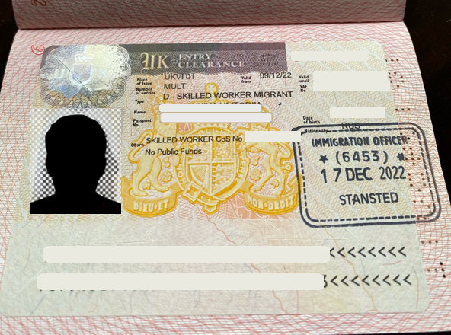

Example Entry Clearance vignette stamp

What your visa will look like

A BRP will be issued once the Home Office has approved your visa application. It is an identity card which shows your current immigration status, and it includes an issue date and an expiry date. It will also include your photograph and other personal information. You have 10 days to inform the Home Office of any errors on your BRP. You will need to refer to your BRP at any time you leave and re-enter the UK, for example if you go on holiday abroad.
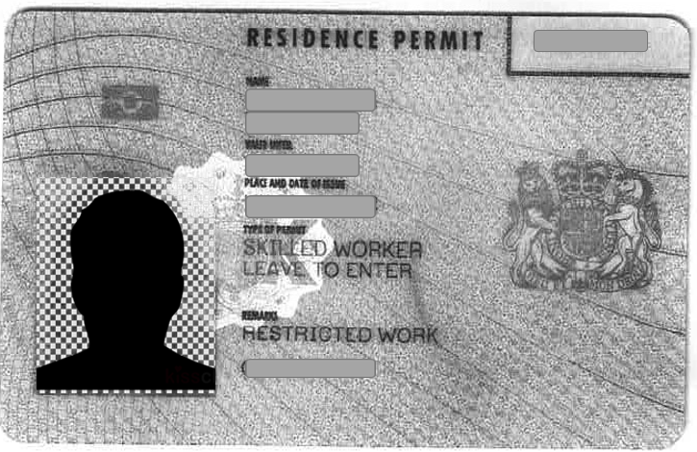
Example BRP

BRP December 2024 expiry

Regardless of your visa length, all BRPs now expire on or before 31 December 2024. The Home Office will tell you what you need to do in 2024 to evidence the duration of your visa. You do not need to do anything now.

Application App

The Home Office has an app which allows you to confirm your identity before submitting your Skilled Worker visa application. This means that you are not required to attend a biometrics appointment in the country you are applying from, potentially saving you time and extra cost.
Once you have confirmed your identity, you can complete the rest of the application either on your smartphone, tablet, laptop or computer.
On completing your visa application, you do not need to keep the app downloaded on your phone. If your application is successful, you can prove your permission to stay in the UK using your digital immigration status.

Lost or stolen BRPs

If you think your BRP is lost or stolen, you can report it and apply for a replacement using the link here.
If your BRP is lost or stolen outside the UK, you will not be able to apply for a replacement BRP from outside the UK. Once you have returned to the UK, you will need to apply for a replacement BRP card within three months of reporting it lost or stolen.
If you find your BRP but have already reported it lost or stolen, you will not be able to use it.
When your replacement BRP arrives, you should cut your old BRP into pieces (cut through your personal details, the royal coat of arms and the gold biometric chip, if your card has one) and post it to the Home Office: Returns Unit, PO Box 195, Bristol, BS20 1BT.

Visa conditions, permissions, and restrictions

Work conditions

Anyone granted Leave to Remain on a Skilled Worker visa is subject to the following conditions:
- no access to public funds – this means you cannot claim most state benefits, tax credits or housing assistance.
- restrictions on the employment you can take (please see below for further information).
- study is permitted, subject to certain restrictions.

Other work restrictions

You can do additional paid work on the Skilled Worker visa as long as you are still doing the job you are being sponsored for. You can also do unpaid voluntary work.
You can specifically work up to 20 hours a week (outside of your normal working hours stated in your Certificate of Sponsorship) in a job that is either:
- in the same occupation code and at the same level as your main job for which you are being sponsored; or
- in a shortage occupation
You will generally be in breach of your conditions of stay if you undertake additional employment that does not meet the above conditions.
You may however be allowed to work a second job which does not meet the above criteria by:
- applying to update your visa so that you are being sponsored to do both jobs; and
- including a letter with your application explaining that you want to change your current permission to stay; and
- getting a new Certificate of Sponsorship from your second employer.

Visa cancellation provisions

- Even if you meet all of the relevant Rules and your employer has met all of their sponsorship duties, you can still have your permission cancelled, under the grounds for refusal in Part 9 of the Immigration Rules. This could be, for example, if you have used deception in your application, have previously breached your conditions of stay, or have a criminal record.

If your employer no longer has a Sponsor Licence

- Your employer must always have a sponsor licence from the point you submit your visa application.
- You can check the status of your employer’s sponsor licence on the register of sponsors at any point. Your employer will not be listed if they no longer have a licence or it is suspended.
- If your employer loses their sponsor licence whilst you are in the UK, your sponsorship will be cancelled, and your visa will be curtailed to 60 days (or less if it expires sooner than 60 days’ time). You will need to leave your job and leave the UK unless you make a new visa application within that time check your eligibility for visas.

Unpaid Leave

- As a worker with a Skilled Worker visa, you can take short periods of unpaid leave.
- However, unless a specific Home Office exception applies, your employer will normally need to stop sponsoring you if you are absent from work without pay for more than 4 weeks in total in any calendar year.

Evidencing your Right to work

- All employers in the UK have a responsibility to prevent illegal working. Your employer will do this by conducting simple right to work checks before employing you. You will need to evidence your right to work by applying for a share code online and passing it onto your employer. This allows your employer to access your documentation digitally to complete its checks.
- Your employer must ask the Home Office to check your immigration status if you cannot show your documents or online immigration status.

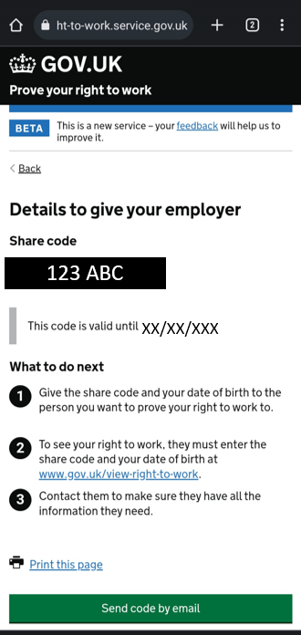

Example Share Code

Updating the Home Office (for employees)

- You should update UK Visas and Immigration (UKVI) if you have changed any of the following:

- name
- mobile phone number
- email address
- gender
- identity document, such as your passport or national identity card
- criminal convictions
- home address
- postal address

- Your details must be up to date so that you can:
- view and prove your rights to others, for example employers or landlords
- be contacted by the Home Office, for example if you are waiting for a decision or to have documents returned
- To update UKVI with any of the above information, use the link here.

Visa information

Visa length

- You must apply for your visa online within 3 months of your Certificate of Sponsorship issue date.
- You can apply for a Skilled Worker visa for up to 5 years. On completing a period of five continuous years in this visa category, you may be eligible to apply for Indefinite Leave to Remain (see below).

Other conditions (main worker)

Right to rent

- Before you enter into a tenancy agreement to rent a property in the UK, the landlord of the property you wish to rent from may conduct a right to rent check on you as the potential tenant. The checks are currently only mandatory in England, but it is important to note that right to rent checks may still be carried out in Wales, Scotland and Northern Ireland. More information can be found here.
- Guidance to assist landlords, letting agents and tenants on carrying out right to rent checks can be found in the following links: Code of practice on right to rent: civil penalty scheme for landlords and their agents and the Landlord’s guide to right to rent checks, where the list of acceptable documents can be found.

Opening a bank account in the UK

- You can open a bank account when you come to the UK. The bank will require proof of your immigration status such as your BRP and a document showing your proof of address.
- Banks and building societies are required to carry out immigration status checks on people applying for current accounts. Under the Immigration Act 2014 they must refuse your application for a new current account (or an application to add you as a signatory or identified beneficiary to a new or existing current account) if you are a disqualified person.

The National Health Service (NHS) & Immigration Health Surcharge (IHS)

- The National Health Service (NHS) is a publicly funded healthcare system in the UK. The NHS provides healthcare to all residents lawfully in the UK, with most services free at the point of use.
- If you are eligible for a Health and Care visa, you and your family members will not have to pay the Immigration Healthcare Surcharge (IHS)
- If you are required to pay the IHS, you can calculate the amount
- You can start using the NHS as soon as your visa application is granted, however you might still need to pay for certain types of services, such as prescriptions, dental treatment, eye tests and assisted conception.
- When you access healthcare in the UK, you may need to:
- provide your biometric residence permit, if you have one
- prove your status online using a share code if you have a digital immigration status

Driving in the UK

- If you passed your driving test outside of the EU, EEA, Jersey, Guernsey or the Isle of Man, you can drive any type of small vehicle (for example cars or motorcycles) listed on your full and valid licence for 12 months from when you last entered Great Britain. If you have held a bus or lorry licence, you can only drive buses or lorries that are registered outside Great Britain if you have actually driven the vehicle into Great Britain yourself.
- If you passed your test in the EU or EEA, you can drive any type of vehicle listed on your full and valid licence.
- Use this link for further information on driving in Great Britain with your non-GB driving licence.

Studying in the UK

- If you are granted Leave to Remain on the Skilled Worker visa route, you can study, with no limit on the number of study hours, provided it does not interfere with the job you have been sponsored to do.
- You must obtain an Academic Technology Approval Scheme (ATAS) certificate for certain courses before the start of study. Check if you need to get approval for your course here. You are not required to obtain an ATAS certificate if you are a national of one of these countries.

Voting in the UK

- Only once you have secured British Citizenship can you register to vote in the UK for general elections. You must also be 16 or over, or 14 or over in Scotland and Wales.
- Guidance and further information on your right to vote can be found here.

UK Taxation

- You have to pay tax on your income if you come to live in the UK. Income includes:
- Wages
- Benefits
- Your pension
- Savings interest
- You will pay Income Tax on income above your Personal Allowance
- You will usually need to pay National Insurance when you work in the UK. This is normally automatically deducted from your salary by your employer and you must apply for a National Insurance number if you want to work
- Apply to claim back tax if you are a foreign national assigned to the UK and you think you have paid too much

Family member dependants of a Skilled Worker

Dependant partners and children can apply for visas to accompany or to later join you, as the main worker:
- Extend or switch to a Skilled Worker visa as your partner or child

Each family member will need to complete a separate application and pay the appropriate visa fee. Their eligibility requirements are explained below.
If you extend or switch your visa, your partner or child’s current visa will still be valid until its original end date. Your partner or child need to apply to extend or switch their visa, either:
- at the same time as you
- at any time before their current visa expires

Eligibility

Your family member dependant must be your partner or child and the Immigration Rules require you to:
(a) have permission on the Skilled Worker route already; or
(b) be applying for your visa at the same time as your dependant family member; or
(c) be settled or to have become a British citizen, having previously had permission on the Skilled Worker route; In this instance, your family member dependant must have had permission as your partner at that time.

Relationship requirement for a dependant partner

- Your adult dependant must normally be married to or have a civil partnership with you. If you and your partner are not married or in a civil partnership, each of the following requirements must be met:
(a) you must have been living together in a relationship similar to marriage or civil partnership for at least the two years before the date of submitting the UK visa application; and
(b) any previous relationship with another person must have permanently broken down; and
(c) you and your partner must not be so closely related that you would not be allowed to marry or form a civil partnership in the UK
(d) as a couple you must intend to live together when you arrive in the UK

Relationship requirement for a dependant child

- The child’s parents must each be either applying for entry clearance at the same time as the child under the Skilled Worker visa route. Otherwise the parents must already have permission to be in the UK (other than as a visitor).
- If the applicant is a child born in the UK to a Skilled Worker visa holder or their partner, the child can apply for a visa from within the UK, supported by a full UK birth certificate showing the names of both parents.

Visa process

- The application process for a dependant of a Skilled Worker visa applicant is the same as the main worker (as detailed above). The family member dependant will be granted a visa that expires on the same date as the main worker’s visa.
- If a family dependant therefore applies to enter the UK after the main worker’s visa has been approved, they will accrue residence towards Indefinite Leave to Remain at a different pace to the main worker.

Visa conditions & restrictions for dependants

- A partner of the main worker will be granted:
(a) a visa which ends on the same date as their partner’s visa as a Skilled Worker; or
(b) three years’ visa if the Skilled Worker was (or is being) granted settlement having previously held a Skilled Worker visa.
- A child will be granted a visa which ends on the same date as whichever of their parents’ visa ends first, unless both parents have (or are being granted) settlement or British Citizenship (in which case the child will be granted a visa for three years).
- The visa will be subject to all the following conditions:
(a) no access to public funds; and
(b) any work (including self-employment and voluntary work) is permitted, except as a professional sportsperson (including as a sports coach), doctor or dentist; and
(c) study is permitted, subject to the ATAS condition in Appendix ATAS being satisfied.

Children born in the UK

If your child is born in the UK whilst you are in the country on a Skilled Worker visa, they do not automatically have British Citizenship. You must apply for a dependant child visa for your child to legally live in and travel to and from the UK.

Indefinite Leave to Remain (ILR)

Indefinite Leave to Remain, also referred to as ‘settlement’, gives you the right to live, work and study here for as long as you like; without requiring visa permissions or sponsorships. You can also apply for benefits if you are eligible to do so. You can potentially apply for British citizenship after being granted ILR (see below).
To be eligible for ILR you must, as a Skilled Worker visa holder:
- have lived and worked in the UK for 5 years - there are rules for what counts towards your time in the UK
- have spent the majority of your time in the UK
- meet the salary requirements
- continue to be needed for your job and meet the salary requirements after you get Indefinite Leave to Remain – you will need a document from your employer to confirm this
- pass the Life in the UK Test if you are aged 18 to 64.
- meet the English language requirement. You do not need to prove you meet the English language requirements again if you had to do so for your Skilled Worker visa.

British Citizenship requirements

You may be able to apply for British citizenship after spending at least 12 months in the UK with Indefinite Leave to Remain (a shorter period might apply depending on your family circumstances). A person with British citizenship can live and work in the UK free of any immigration controls. It is important to check that acquiring a dual nationality does not affect your existing nationality/nationalities.
As at your application date, you should not have spent more than 450 days outside the UK during the preceding 5-year period, or more than 90 days outside the UK in the preceding 12 months.
If your application is successful, you will be required to book and attend a ceremony where you will be issued a certificate of British citizenship. You can apply or a first passport with this certificate.

Indefinite Leave to Remain (ILR) requirements for dependants

You can include your partner and children on your application if they are eligible. Alternatively, your partner and children can apply separately at a later date. They can continue to extend their visa as your Skilled Worker dependant, even after you are granted ILR.
Your partner may qualify for ILR if all the following apply:
- they have permission to be in the UK as your partner (as a ‘dependant’ on your visa)
- they have lived in the UK with you as your dependant for at least 5 continuous years
- your relationship is genuine and you intend to keep living together
- you are not claiming public funds and have always complied with the conditions of your visa(s).
If your partner is aged 18 to 64, they must pass the Life in the UK Test and meet the English language requirements.
You can include your child on your ILR application if:
- they have permission to be in the UK as your child (as a ‘dependant’ on your visa)
- they are not married or in a civil partnership
- they will live with you and be supported by you without using public funds
- you and your child’s other parent are both currently applying to settle, or are already settled
Further information on eligibility for dependant’s ILR can be found here.

British Citizenship requirements for dependants

Similar to you, as the main applicant, a dependant may be eligible for British Citizenship if they have lived in the UK continuously for 5 years and have held ILR status for 12 months. They do not need to wait 12 months to apply if they are married to a British citizen.
You must apply separately for your children.
You can apply to ‘register’ your child for citizenship if they were born:
- inside the UK before you were granted Indefinite Leave to Remain
you can read further guidance here.
If your application is successful, you will be required to book and attend a ceremony where you will be issued a certificate of British citizenship.

Glossary

Term | Definition
Entry Clearance | Entry Clearance is the term used by the Home Office to describe people coming into the UK on a visa for the first time.
LTR | Leave to Remain: Permission for a person to stay for a limited period of time, with restrictions, in the UK. This application can be made inside the UK.
ILR | Indefinite Leave to Remain: Allows a person to stay and work in the UK for an unlimited time. A person with this status is regarded as ‘settled’ and does not need to apply for a visa extension.
CoS | Certificate of Sponsorship: An electronic record containing an employee’s details such as name, passport details, hours of work, job description, SOC code and salary. It can be managed by your employer through its SMS.
UKVI | UK Visas and Immigration: operates the UK immigration system and manages applications to live and work in the UK.
VFS Global | Service provider which an applicant can use to book their biometrics appointment.
Sopra Steria | Service provider which an applicant can use to book their biometrics appointment
TLS | Service provider which an applicant can use to book their biometrics appointment
Dependants | Husband, wife, civil partner, unmarried partner, child
IHS | Immigration Health Surcharge: funds paid towards IHS go towards the UK government for the administration of health services.
BRP | Biometric Residence Permit: an identity card used to show a person’s immigration status and right to live in the UK.
NI Number | National Insurance number: A form of social security record in the UK which allows workers to pay tax and national insurance contributions to the government.
SMS | Sponsorship Management System: an online portal between your employer and the Home Office to keep track of and update employee details. It is also used to control an employer’s sponsor licence. The Home Office can view this information and complete compliance checks on sponsors.
SOC Code | Standard Occupational Classification: a number code for a job title used by the Office for National Statistics. A SOC code will match a salary which is identified as the minimum rate for that job title.

