ESR Manager / Supervisor Self Service Absence Data Entry

Record Sickness Absence data in ESR

Coronavirus can cause a variety of symptoms, so the most appropriate Sickness Reason should be selected based on information provided by the employee
- Absence Type: Sickness
- Level 1 Reason: ‘S15 Chest and respiratory problems’
- also enter Coronavirus (COVID-19) in the ‘Related Reason’ field
- See Table 1: Record Absence relating to Coronavirus (COVID-19) in ESR and Roster

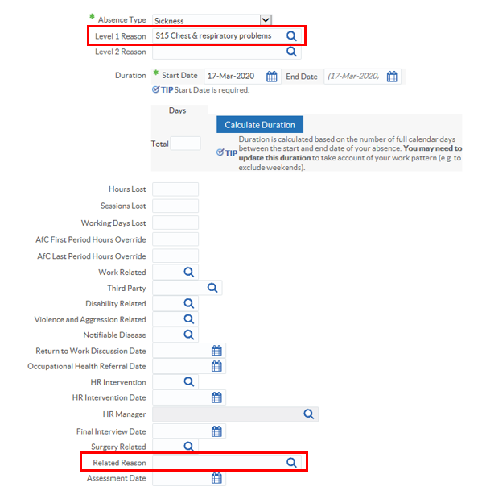
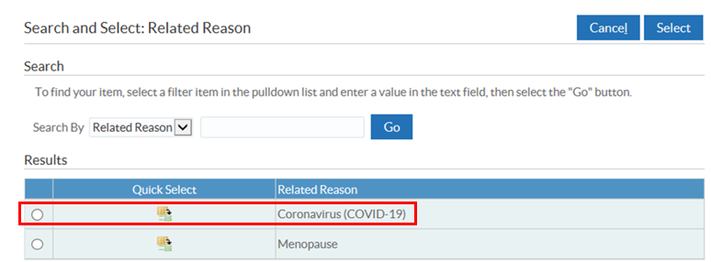
Record Non-Sickness Absence data in ESR

- Absence Type: ‘Special Leave’ (Special Increasing Bal)
- Absence Reason:
  - ‘Medical Suspension’ (Fit but Symptomatic, reported to Manager)
  - ‘Infection Precaution’ (Fit and NOT Symptomatic, eg member of the household has symptoms)
- also enter Coronavirus (COVID-19) in the ‘Related Reason’ field
- See Table 1: Record Absence relating to Coronavirus (COVID-19) in ESR and Roster

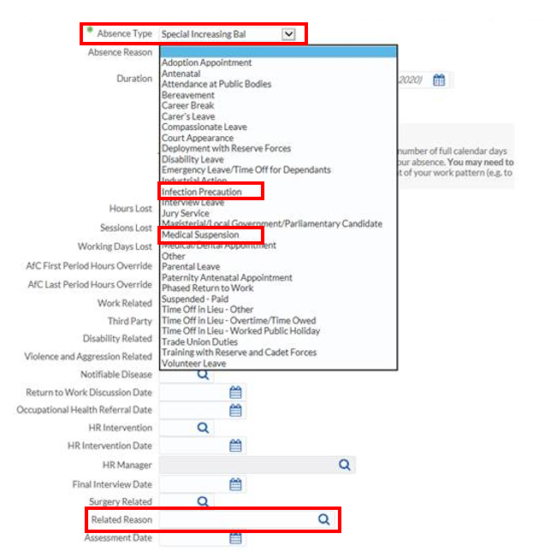

Report data from ESR Business Intelligence (BI)

Data is available to report from ESR BI - Absence Dashboard – Detail & Individual Absence Record tabs, BI is refreshed overnight
- NOTE: ‘Related Reason’ field will replace ‘DH Monitoring’ in ESR Release 45, end Mar20.
- ESR UN2864 - Absences relating to the Coronavirus (COVID-19), 13 Mar 2020
As absence data is interfaced monthly from the Roster to ESR, retrospective reporting is available from ESRBI. However, live reporting will require both BI (for non-rostered staff) plus an extract from the roster system.

Baseline Data – S15 Chest and respiratory problems Mar-Jun 2019

Recommend Health Boards and Trusts to run baseline data from 1 Mar 2019 to 30 June 2019 on ‘S15 Chest and respiratory problems’ and ‘Special Leave Increasing Balance’ – ‘Medical Suspension’ and ‘Infection Precaution’
It is reasonable to assume that reporting ‘S15 Chest and respiratory problems’ or ‘Medical Suspension’ or ‘Infection Precaution’ above the monthly 2019 baseline from 1 Mar 2020 to 30 June 2020, is related to ‘Coronavirus (COVID-19)

Roster Absence Data Entry

- Rosters interface with ESR monthly providing Level 1 Sickness Absence Reason
- Where Health Boards & Trusts interface Level 2 Sickness Absence Reasons, link these under S15 Chest & respiratory problems category add ‘*COVID-19’, linked to ESR as ‘S15998 Other chest and respiratory problems’
- Rosters do NOT interface ‘Related Reason’
  - How can this additional data be captured in ESR? At a later date
- Both Sickness Absence and Special Leave data should be interfaced to ESR
  - Sickness Absence Level 1 Reason: S15 Chest and respiratory problems
  - Sickness Absence Level 2 Reason: S15998 Other chest and respiratory problems
  - Special Leave Reason (Special Increasing Bal): ‘Medical Suspension’ or ‘Infection Precaution’
- See Table 1: Record Absence relating to Coronavirus (COVID-19) in ESR and Roster

- How to add Secondary Sickness Absence Reason to Allocate Roster – BCU guide

Table 1: Record Absence relating to Coronavirus (COVID-19) in ESR and Roster

