How to Export Sickness Absence Via Supervisor/Manager Self Service
To view and export a detail sickness absence report for your team through Supervisor/Manager Self Service complete the following steps:

- Login to ESR via your 120 ESR username and password.

- Click the My ESR link from the main navigation bar located on the left side of the screen:
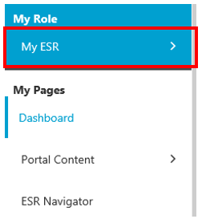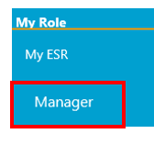
- Click Manager

- From the Team Absence portlet click the sickness percentage figure displayed on the sickness gauge:
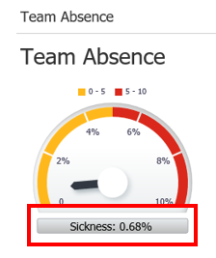
The Business Intelligence tool will launch in a new window.
- Click the Detail tab from the selection of tabs listed horizontally at the top of the screen:

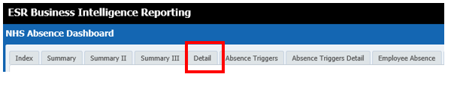

A detail sickness report will be displayed.

- Enter required date parameters and click apply:
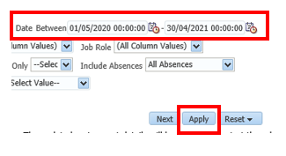
N.B. It is recommended that you set the date parameters for a 2-year period e.g. 21/05/2019 – 20/05/2021

- Click the Export link to export to Excel:
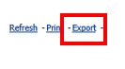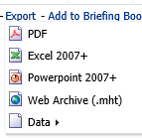

- When prompted click the drop down arrow to the right of the Save button and choose Save As and save the file where it can be accessed securely at a later date:

- Click Open to open the file in Excel
N.B. The above steps have been completed using Internet Explorer. Screens may differ if using a different web browser.

