How to Export Annual Leave from ESR Employee Self Service.

- Login to ESR with your 120 ESR username and password

- From the My Annual Leave portlet select the View My Absence Calendar button

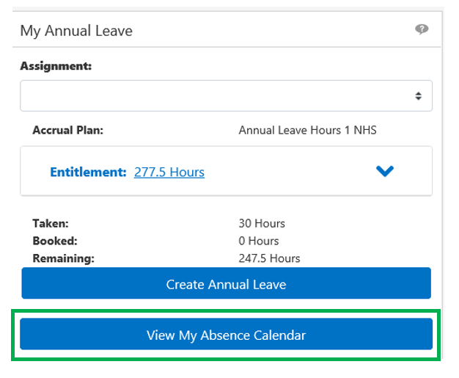
- Whilst viewing the Absence Calendar, from the top right of the screen click the Absence Summary button to be taken to the Absence Calendar Summary screen:
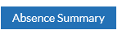

The below screen will display:

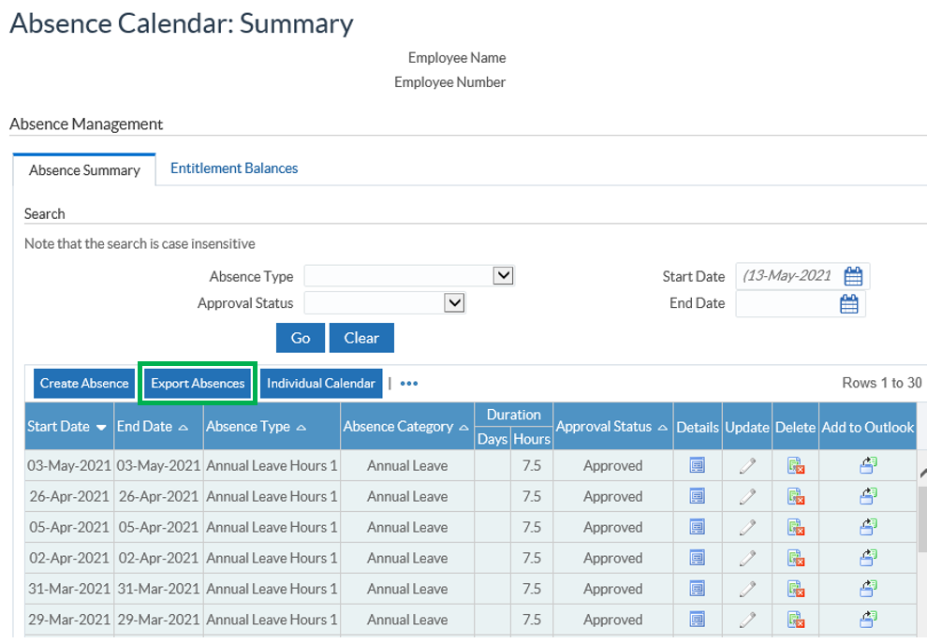

- Click the Export Absences button
- When prompted click the drop down arrow to the right of the Save button and choose Save As and save the file where it can be accessed securely at a later date:

- Click Open to open the file in Excel
N.B. The above steps have been completed using Internet Explorer. Screens may differ if using a different web browser.

