Details of the deceased
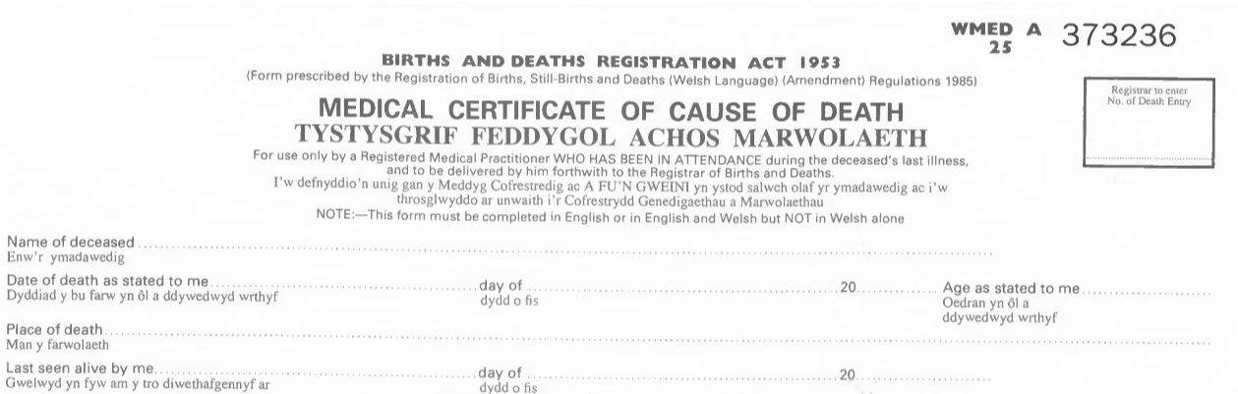

Joseph Michael Raymond Jones
1.
2.
31st
March
20
74 years

3.
The General Hospital, Pound Street, Cardiff, CF23 5TU
Dr John Gray GMC 2358964
28th March
4.
20

1. Enter the patient’s FULL name including middle names
2. Enter the date the death was verified in the medical records, along with the patient’s age
3. Enter the FULL address of the place of death
4. Strike through ‘me’ in the last seen alive by me section, and document the FULL name and GMC number of the doctor who attended the deceased within the last 28 days of life, and record the date THEY last saw the deceased

Details of coroner involvement and further information

Medical practitioners are required to certify causes of death “to the best of their knowledge and belief”. For patients who had symptoms typical of COVID-19 infection, but the test result has not been received, it is satisfactory to give ‘COVID-19’ as the cause of death. The medical practitioner can circle ‘2’ in the MCCD (“information from post-mortem may be available later”) and initial Box B on the reverse of the MCCD for ante-mortem investigations then share the test result when it becomes available. The sections 1-4 and a - c should be completed as normal.

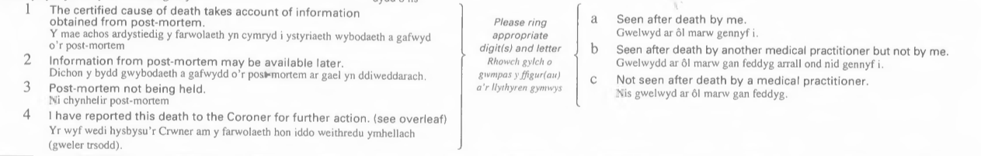

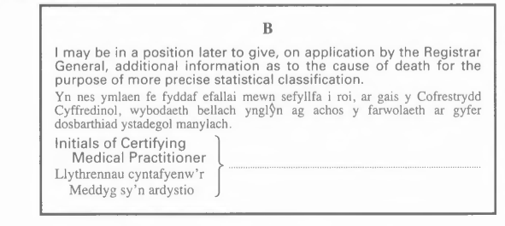

DLG

NB if the attending practitioner has not seen the deceased for >28 days, but the QDC feels able to offer a cause of death, this MUST be discussed with the coroner for form 100A endorsement

The Cause of death

The cause of death section must be completed to the ‘best of your knowledge and belief’, please refer to the advice documents on MCCD: formulating a cause of death and acceptable wording and phrases and the standard ‘how to’ guidance for completing the MCCD from the GRO – both located in the training section of the Death Certification Central Hub

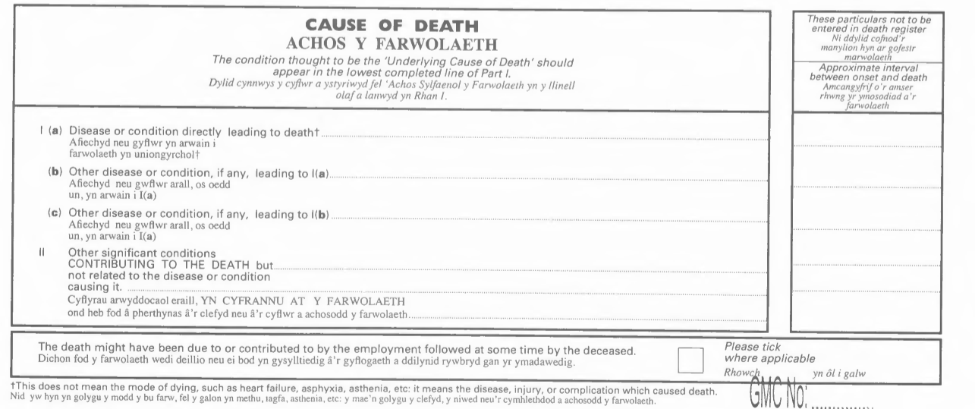

COVID-19
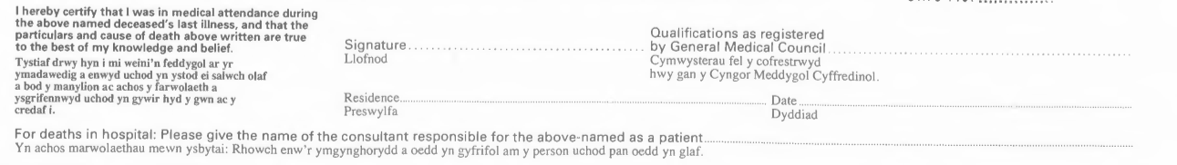
Ischaemic heart disease, chronic obstructive pulmonary disease, type two diabetes mellitus

Declaration

As you have not attended the deceased in life you must amend the declaration section of the MCCD before you sign and transmit it to the Registrar Office.

Dr Darren Leo Gove DLGover
MBChB GMC 7890564

Jamestown General Hospital
02/04/2020

Dr R G Cooper

- Strike through the wording ‘that I was in medical attendance during the above named deceased’s last illness, and’
- Sign and PRINT your name
- Record your Qualifications and your GMC number
- Record your place of work rather than your home address
- Record the Consultant responsible for the patient’s care in life

The MCCD should be completed, scanned and emailed directly to the Registrar as soon as possible, and the bereaved notified that this has been done. Please note, than in cases that have been reported to the coroner, a form A must first be agreed before the MCCD is transmitted.

Failure to amend the MCCD in the ways described above will result in rejection from the Registrar and you will be asked to correct the MCCD and resubmit it.

