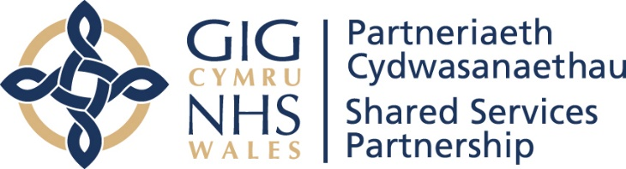
NWSSP – Who we are and what we do
May 2022

Background to NHS Wales Shared Services Partnership
In May 2009, the Minister for Health and Social Services commissioned a research study to be carried out by the School of Management at Bath University to review best practice models for shared services across the UK and internationally, and to canvas detailed feedback from stakeholders across Wales.

A consultation paper was produced to propose changes to the structure of the NHS in Wales to include provision for Shared Services Wales. The Shared Services business case focused on the need to deliver economies of scale; efficiencies and consistency of quality and process for the business and professional services that were directly managed and delivered by local NHS bodies. Consequently, NHS Wales Shared Services Partnership (NWSSP) was established in November 2010 and went live in April 2011.

Since then, NWSSP has significantly developed and continued to improve and adapt; expanding our range of services year on year.

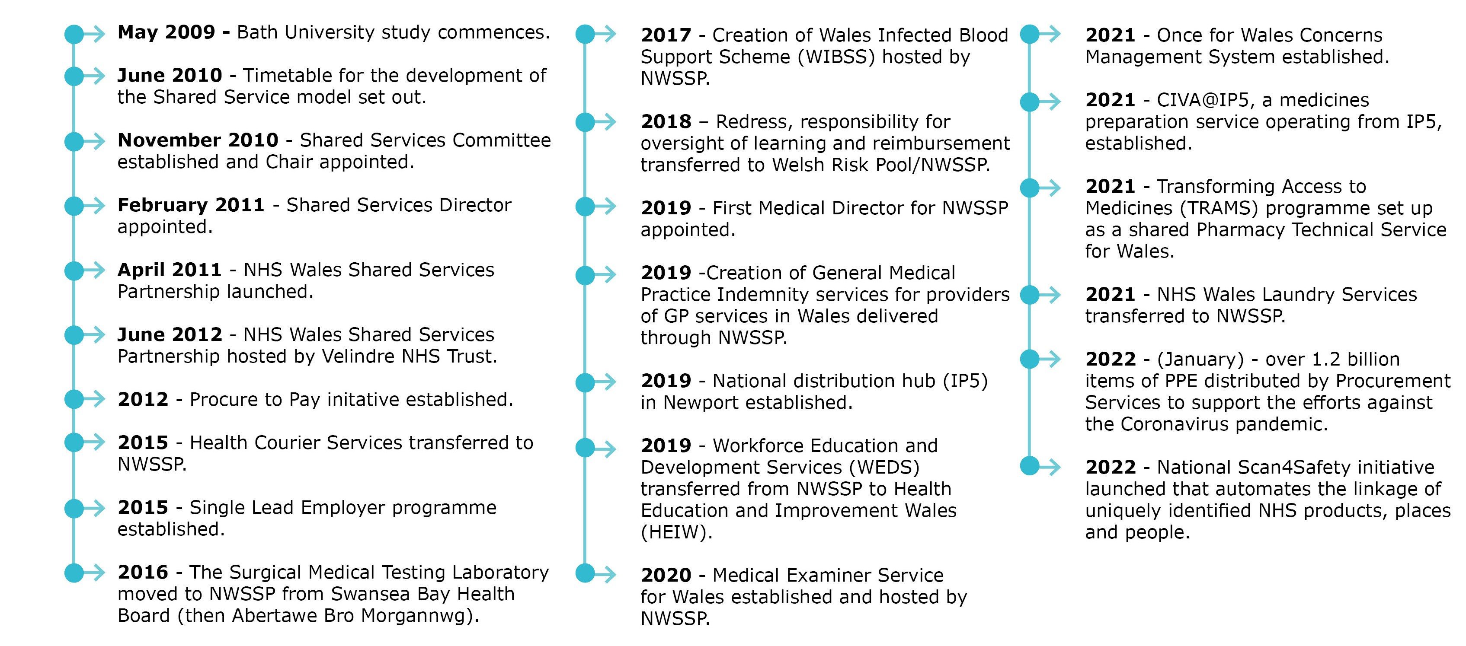

What we do
NWSSP now delivers a wide range of high quality, professional, technical, and administrative services for and on behalf of NHS Wales also working with the wider public services, including Welsh Government.

NWSSP has matured and is seen as an integral part of the NHS Wales family; supporting the staff and patients of NHS organisations across Wales. We also provide a range of services to the GP practices, dentists, opticians, and community pharmacies.

Our main customers are:

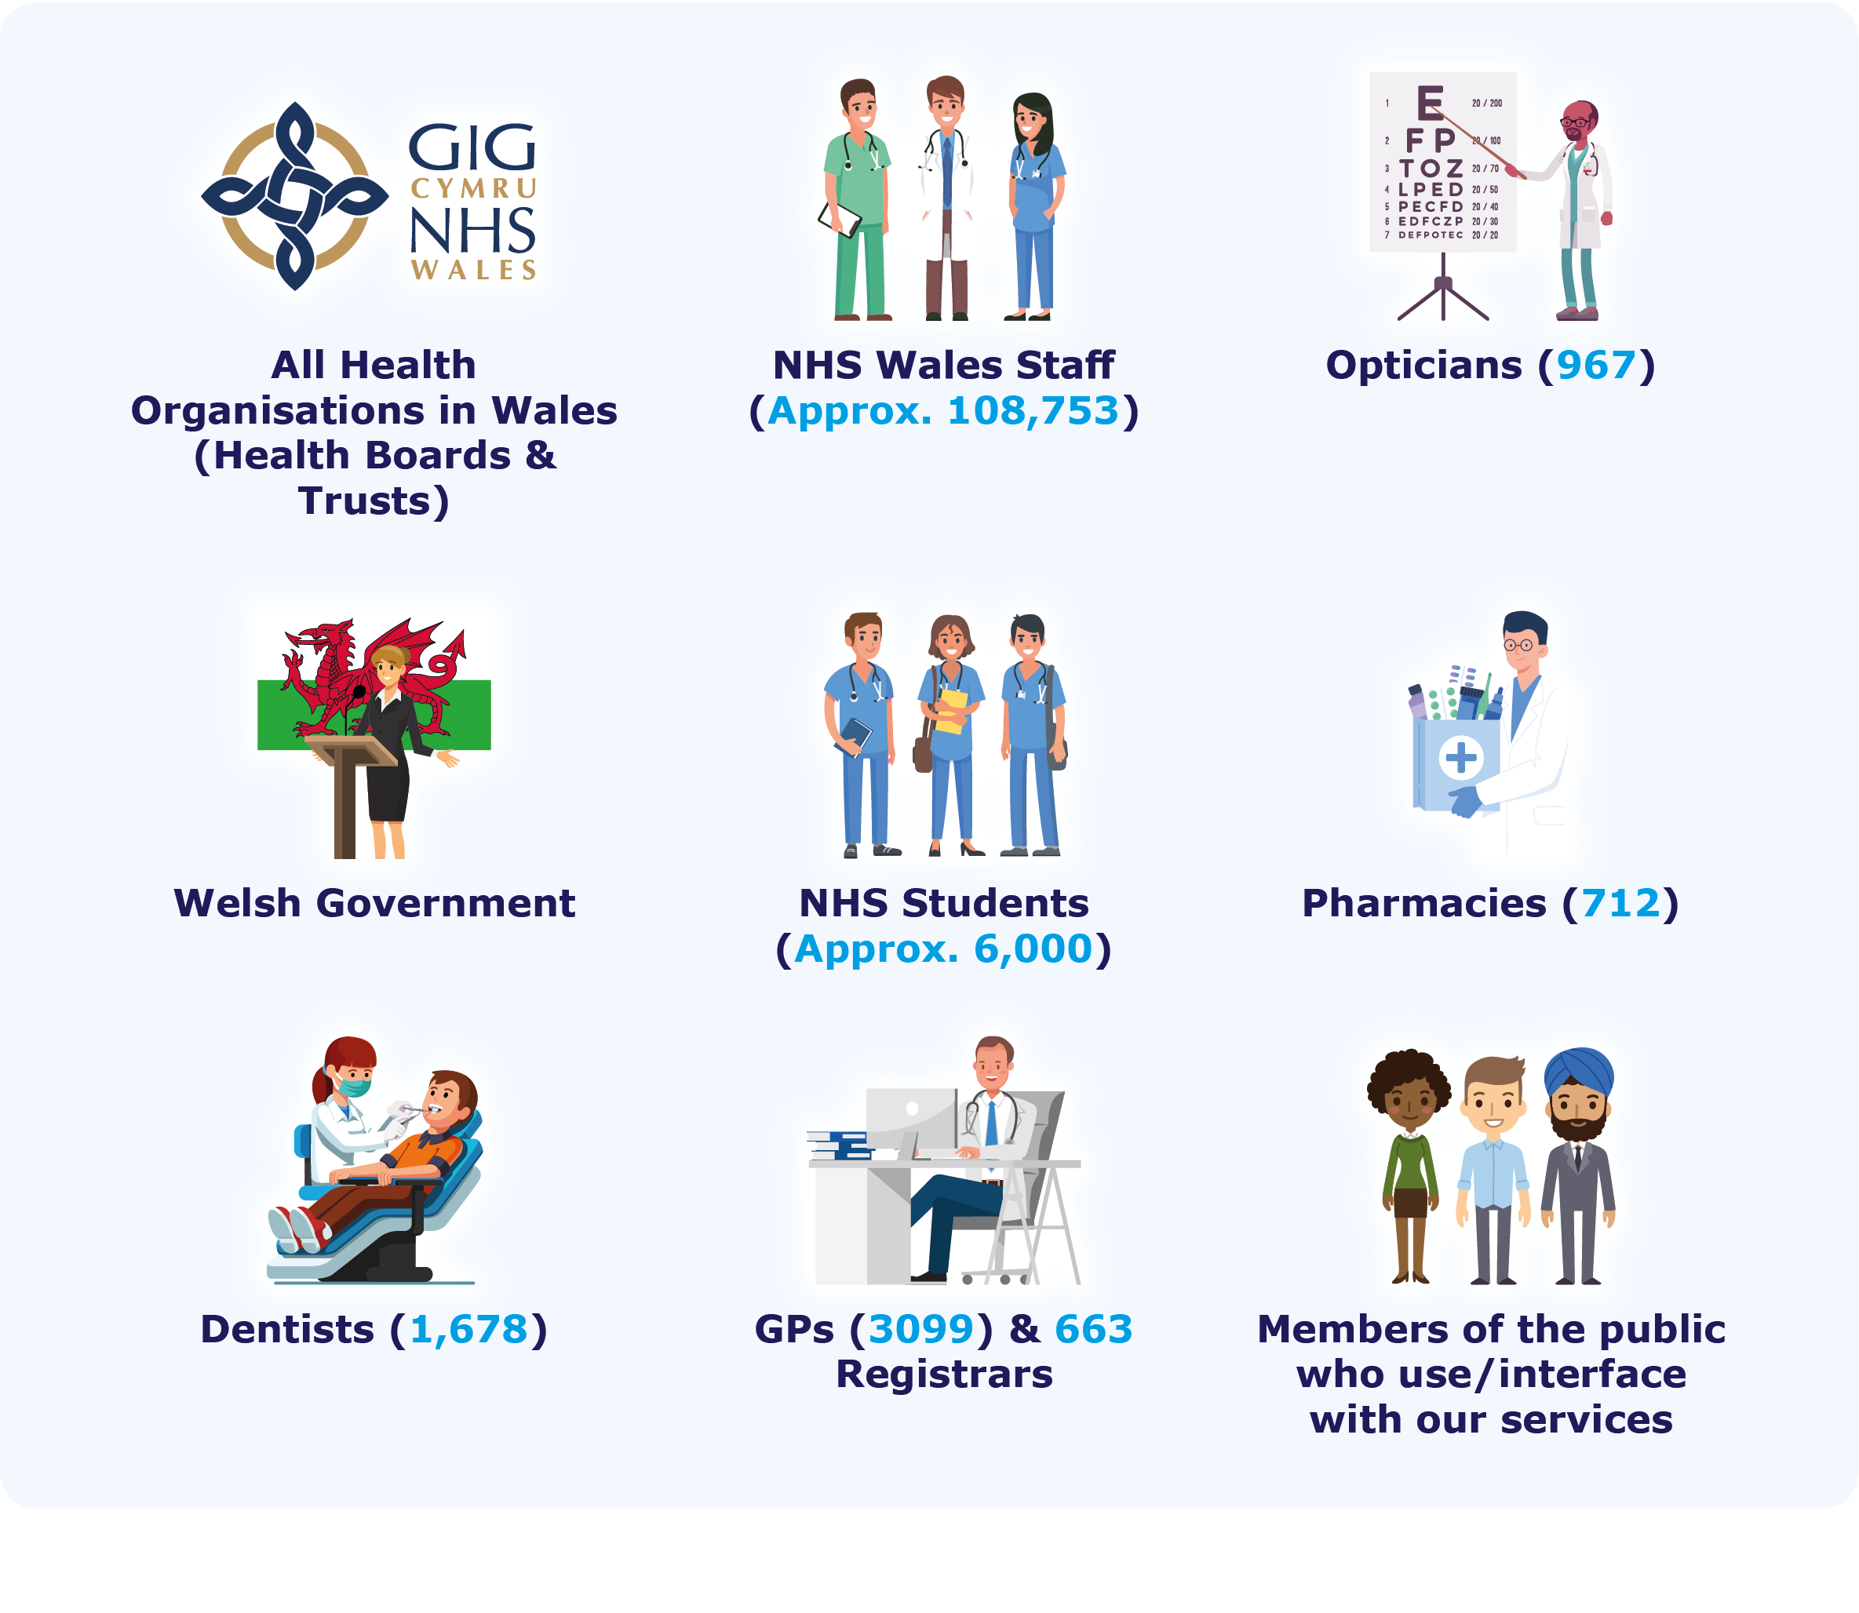
As a hosted organisation NWSSP operates under the legal framework and Establishment Order of Velindre University NHS Trust. Our Managing Director is the designated Accountable Officer for Shared Services in line with The Velindre National Health Service Trust Shared Services Committee (Wales) Regulations 2012 and is accountable to the Director General / CEO NHS Wales and Health Boards, Special Health Authorities and Trusts through the Shared Services Partnership Committee (the Partnership Committee). The Partnership Committee meets bi-monthly and is chaired by Professor Tracy Myhill OBE. The membership is comprised of representatives from each NHS organisation that use our services and from Welsh Government in an observer capacity.

The Partnership Committee and not Velindre Board is responsible for exercising the Velindre National Health Service Trust's functions in relation to shared services, including the setting of policy and strategy and the management and provision of shared services to Local Health Boards, Special Health Authorities and National Health Service Trusts. Several committees and advisory groups have been established to help support the governance arrangements that underpin how NWSSP operates.

Our Structure

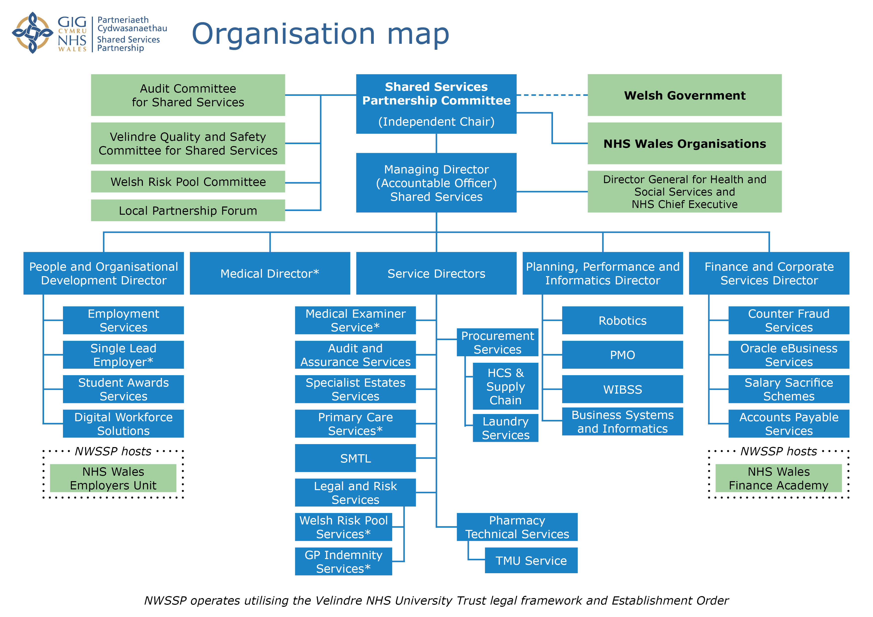

How we deliver our work

Our overarching mission is adding value through partnership, innovation, and excellence. We have aligned our five strategic objectives to Ministerial Priorities, legislation, and the priorities of our customers:

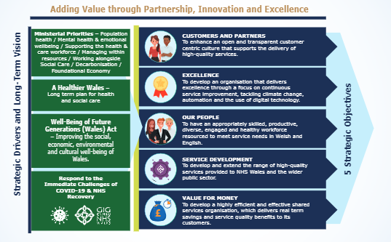

In discussion with our Partnership Committee, we identified the following key priorities for 2022-2025, with the primary focus on Year 1 (2022-2023):

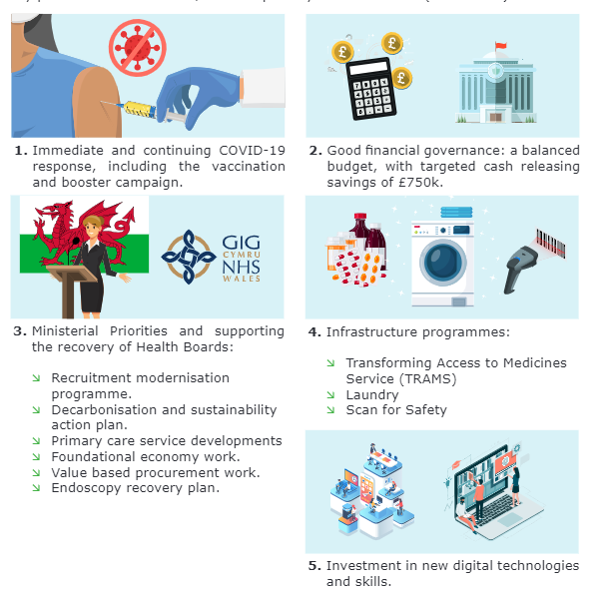

Underpinning those priorities are wider commitments to our people, customers, and partners:

- Be great on the basics: focus on continuous improvement in our core services e.g., recruitment, payroll, accounts payable, audit, legal services, and contractor payments.
- Employee Health and Wellbeing: continue to provide support for our staff. They all continue to go the extra mile and adapt and change to new ways of working.
- Adding value through partnership: continue collaborative working with HEIW and DHCW to enable success of our wider NHS and social care partners.
- Sustainability for the longer term: beyond 3 years e.g., accommodation strategy needs to be aligned to an agile workforce, greener energy in fleet management, progress in safeguarding an ethical supply chain, growth in our use of Foundational Economy, Value Based approaches, and cost savings in Procurement.
Increasingly we are developing innovative service improvements and implementing several new services to the NHS in Wales. We recognise the growing opportunity to formalise our partnerships with both further and higher education sectors across Wales as a learning organisation.

A positive track record
During 2021-22 we continued to adapt and change to meet the additional pressures that the COVID-19 pandemic placed on public services, our NHS and local communities. We supported the response to ensure continuous supply of Personal Protective Equipment, pharmaceutical and logistical support to the vaccination and booster campaigns and met the demand of additional recruitment activity and associated workforce support.

We have continued to build on our strong organisational performance and in 2021-22 distributed £2M savings back to our partners. We also made good progress on establishing the first phase of a new national NHS laundry service, securing endorsement for the Transforming Access to Medicines programme, commenced the Scan for Safety programme and implemented new payment systems for GP practices and ophthalmic contractors.

Our successful partnership model is already designed to embrace the transformational change and improvement set out in the Welsh Government’s Planning Framework. We have a positive track record of working together across organisational boundaries in the spirit of shared interests, pooling resources where appropriate and deploying the right skills to the right place across Wales.

NWSSP Growth over 10 years
 | 2011 | 2017/18 | 2018/19 | 2019/20 | 2020/21 | 2021/22
Staff | 1,240 | 2,000+* | 2,000+* | 2,148* | 3,019* | 4,606*
Estates | 50+ | 23 Sites | 23 Sites | 24 Sites | 26 sites | 27 Sites
Professional Influence Savings | - | £137M | £110M | £129M | £165M | Forecast >£120M

*Figure includes Single Lead Employer personnel.

Note: The 2020/21 increase was as a result of COVID-19 income and the start of the Single Lead Employer expansion from August 2020.

Original “Ministerial Directed” Services - 2011
Transactional | Professional / Technical
Employment Services | Audit & Assurance
Legal and Risk Services | Specialist Estates services
Primary Care Services | Counter Fraud Wales
Procurement and Supply Chain Services | Accounts Payable
Welsh Risk Pool

Additional Services Transferred to NWSSP
Health Courier Services* | Salary Sacrifice
Surgical Materials Testing Laboratory | Medical Examiner
Central eBusiness Team | e-Enablement
Student Award Service | All Wales Laundry Services
Digital Workforce Solutions | Lead employer for medical, dental & pharmacy trainees
Finance Academy (hosted) | Pharmacy Technical Services
Welsh Infected Blood Support Scheme | General Medical Practice Indemnity
*Now called Supply Chain Logistics and Transport

Internal Support Services
Finance and Corporate services
People and Organisational Development
Planning Performance and Informatics

Our Services

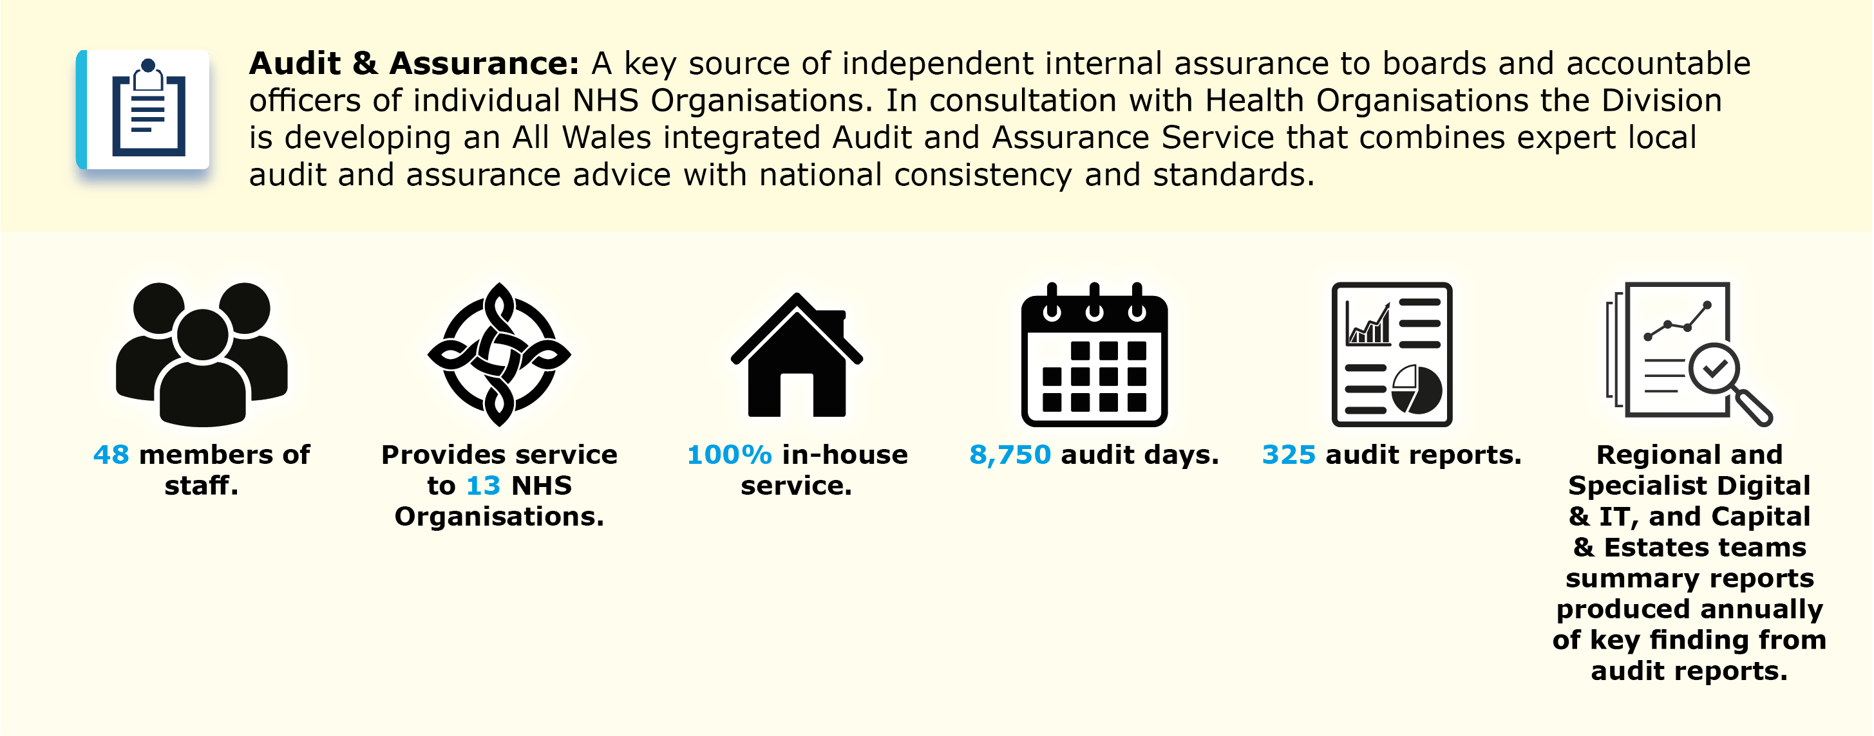

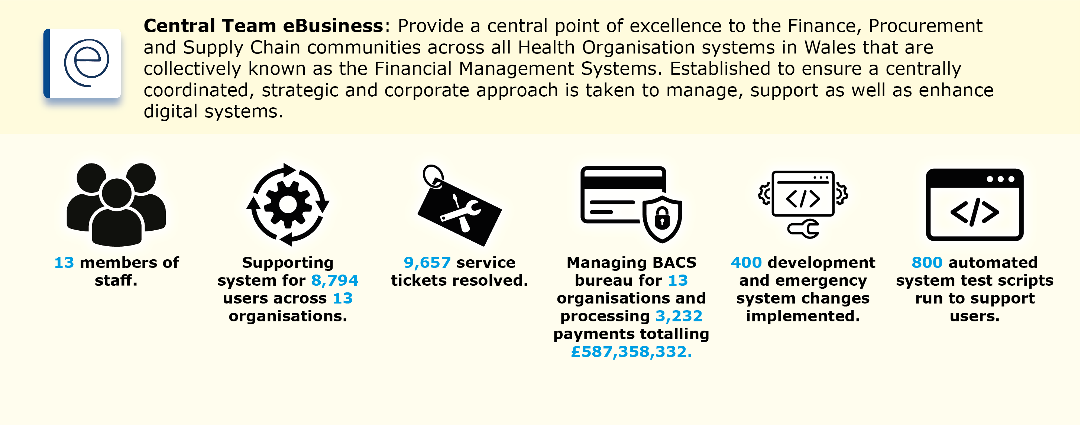

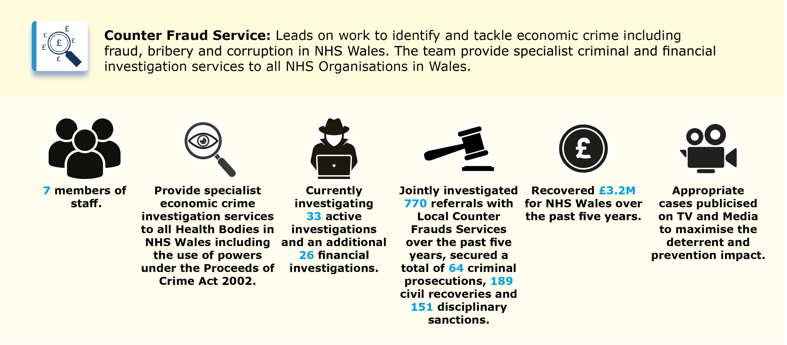

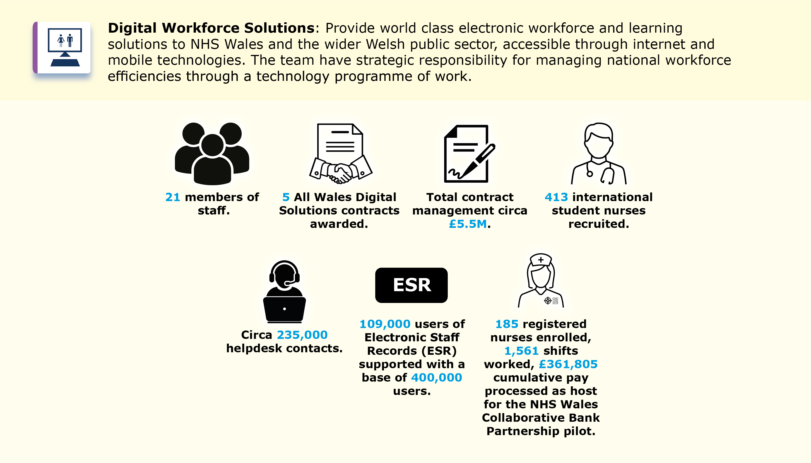

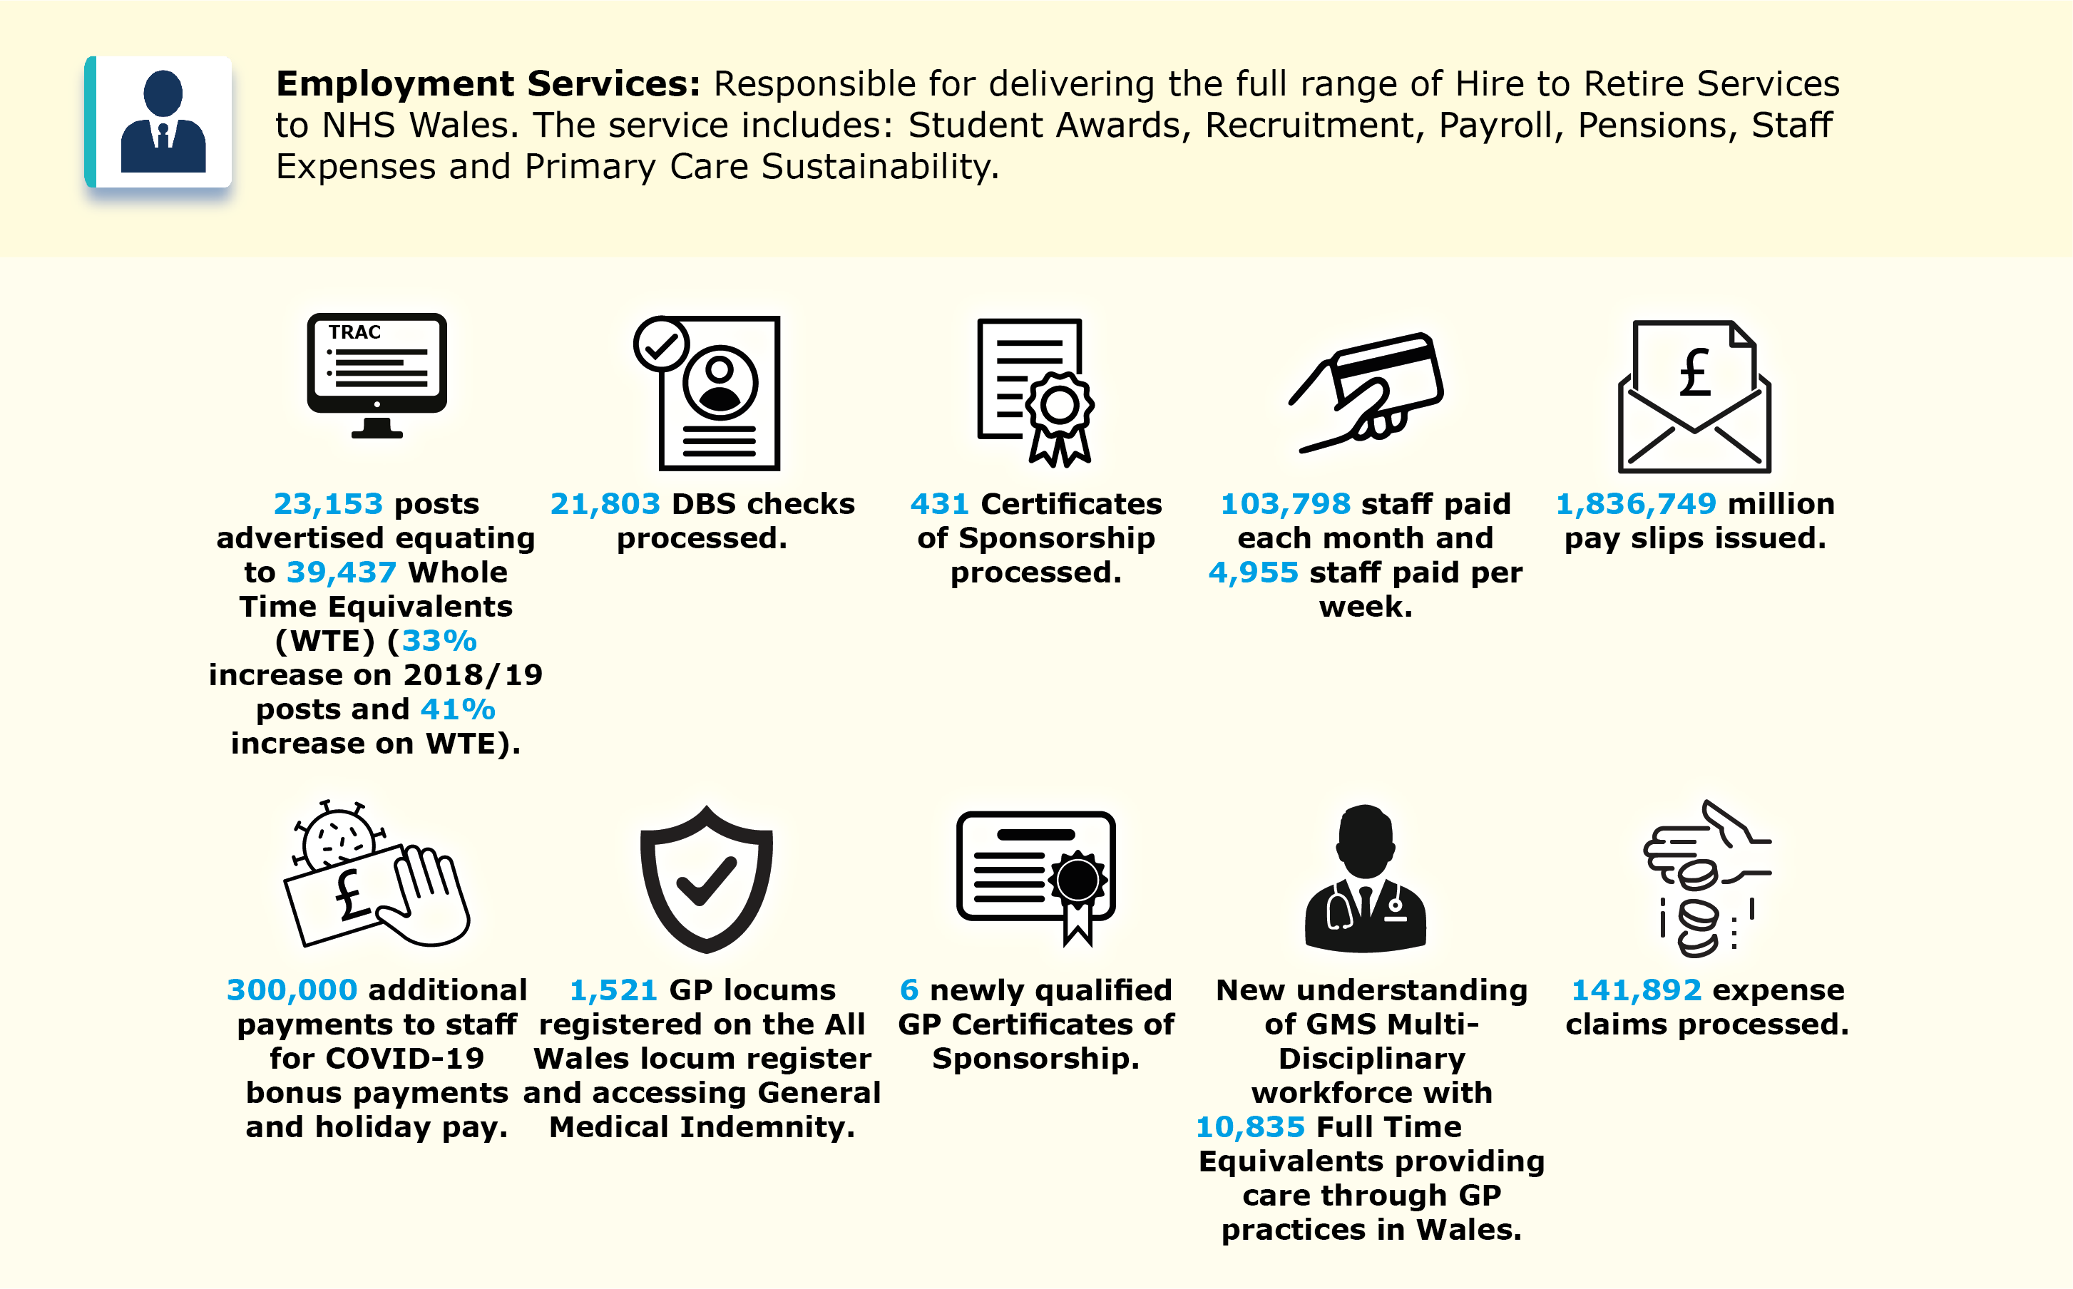

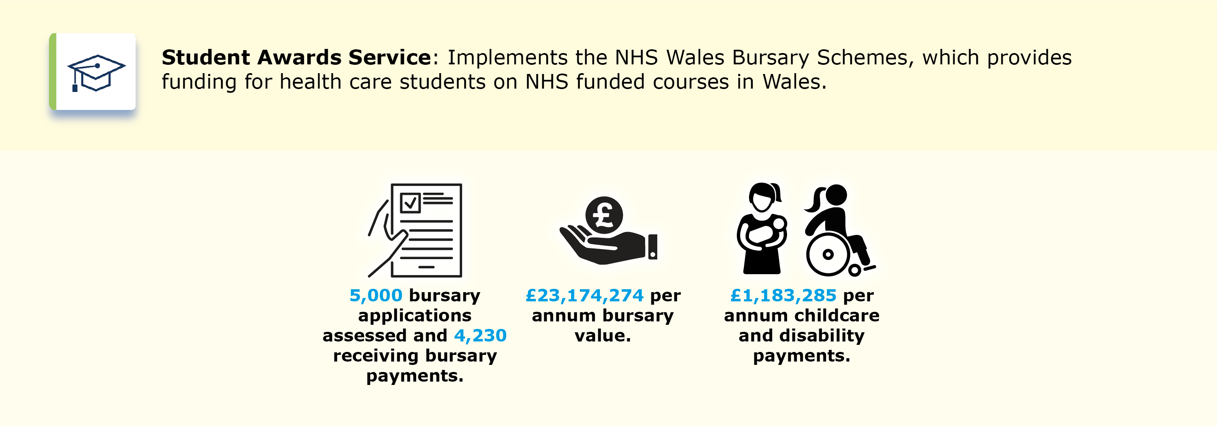

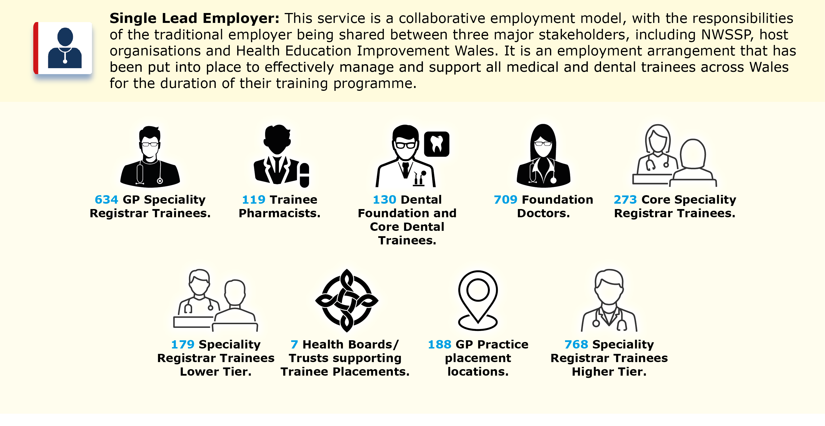
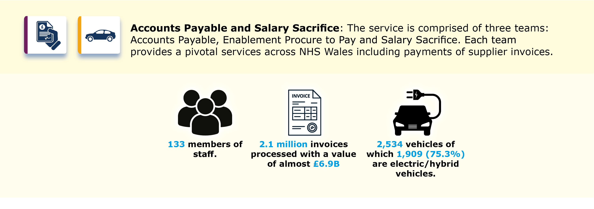
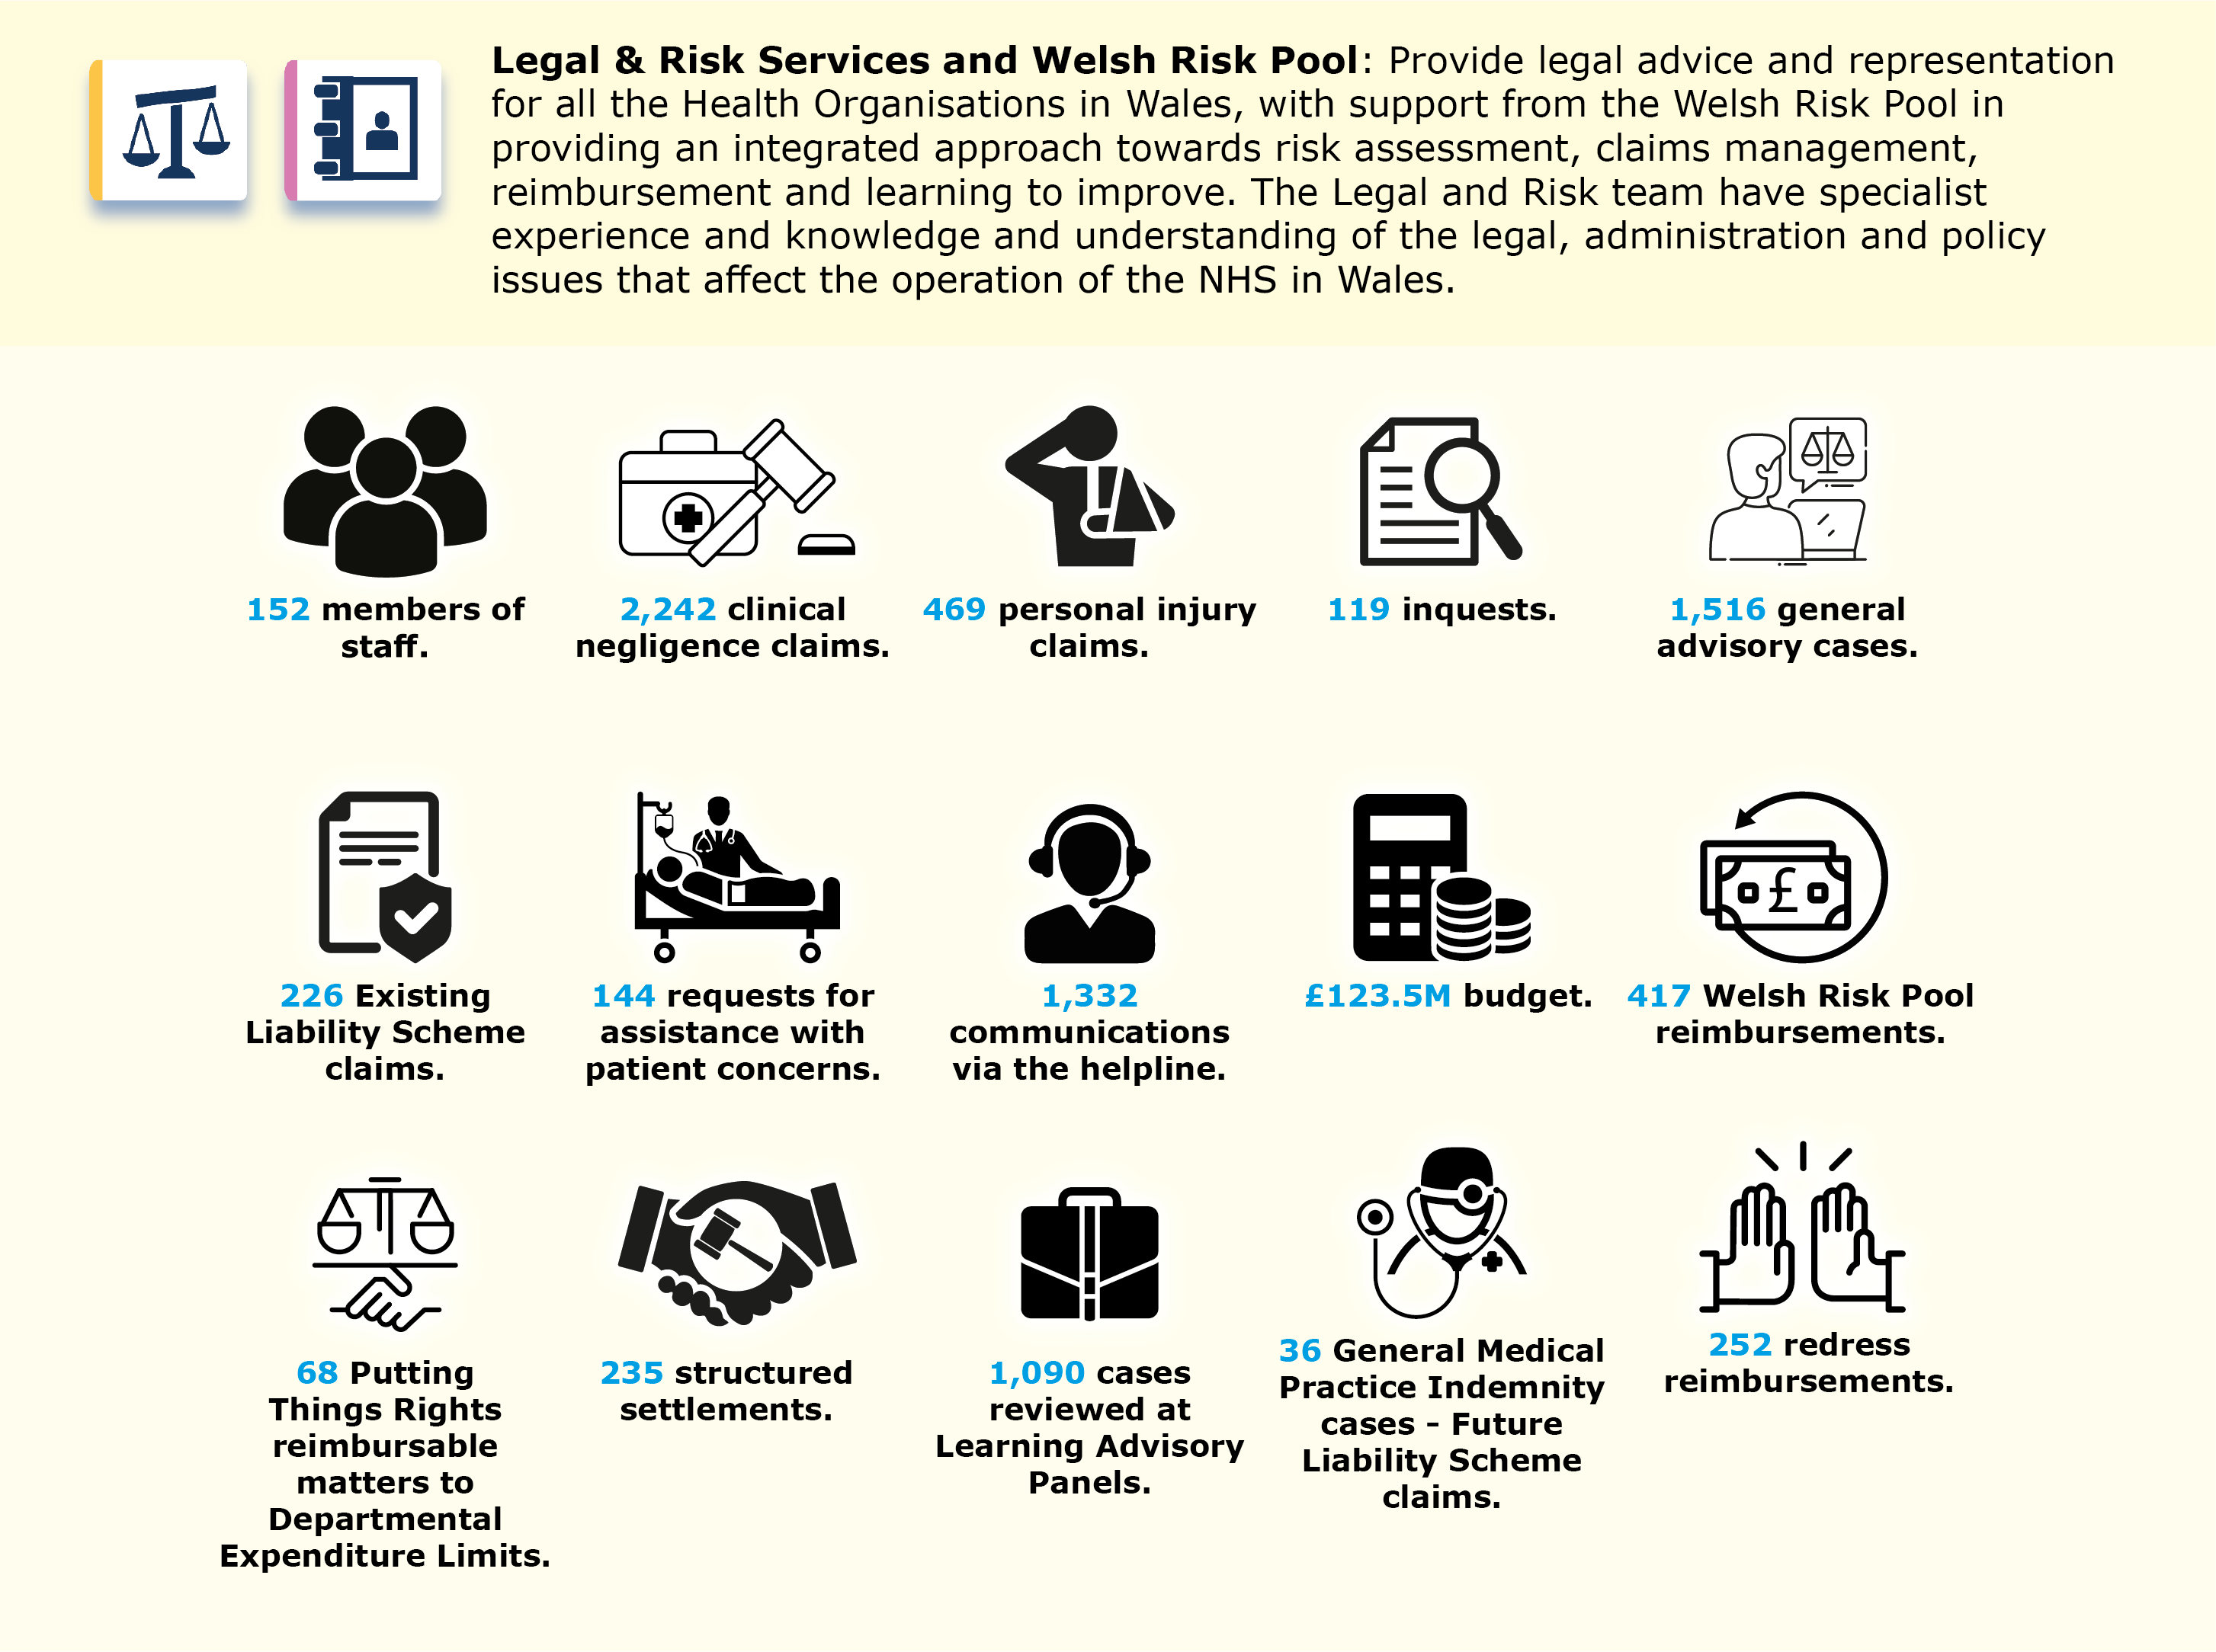

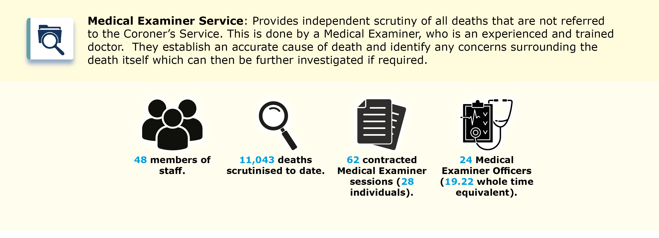

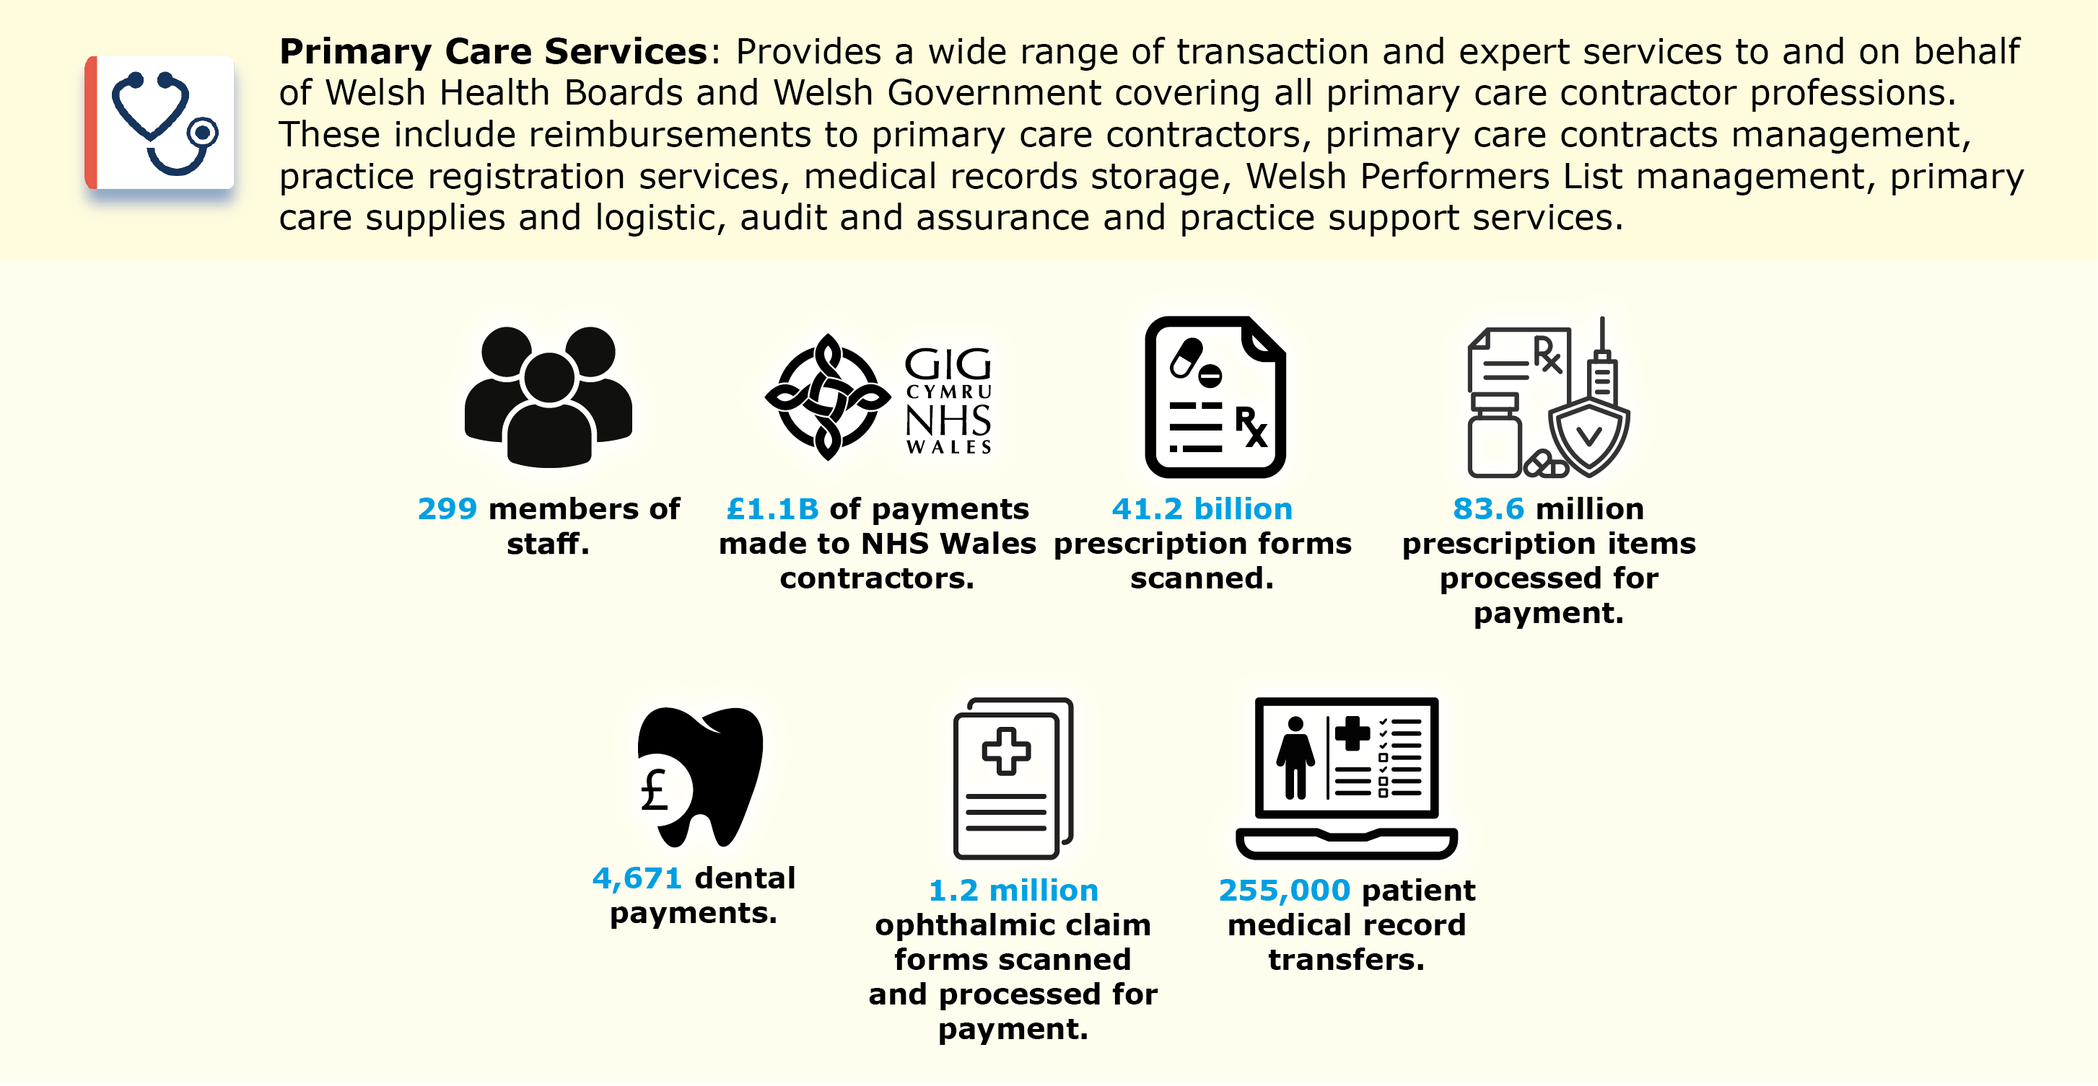

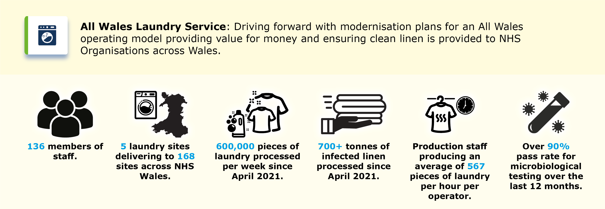

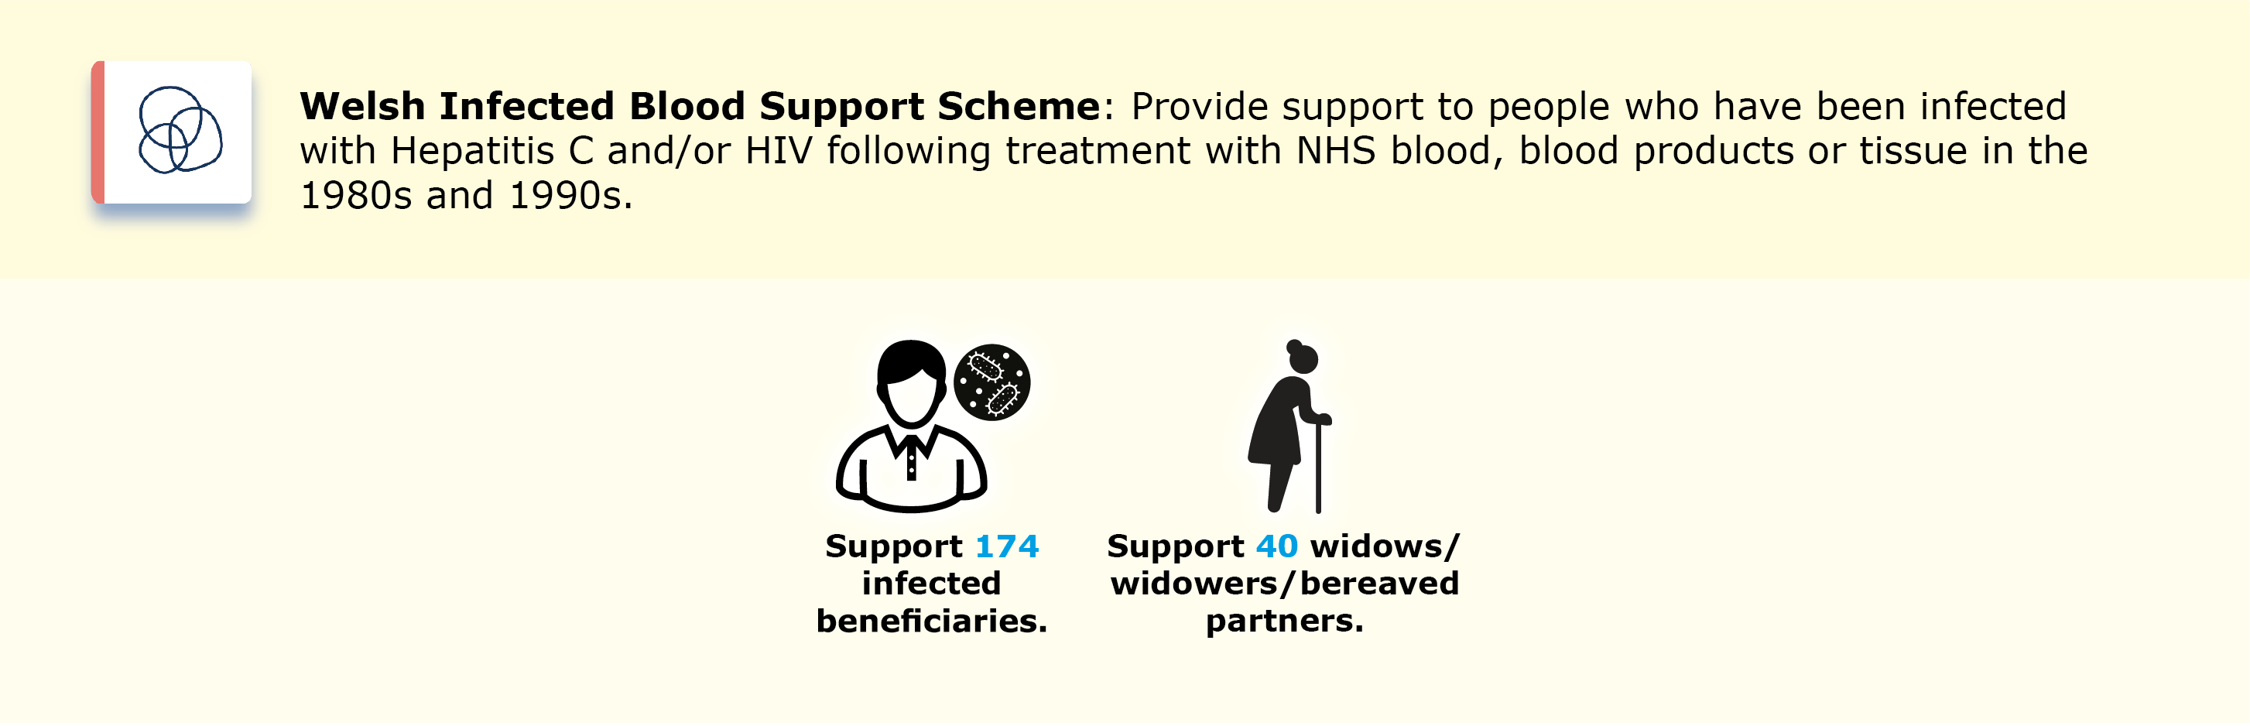
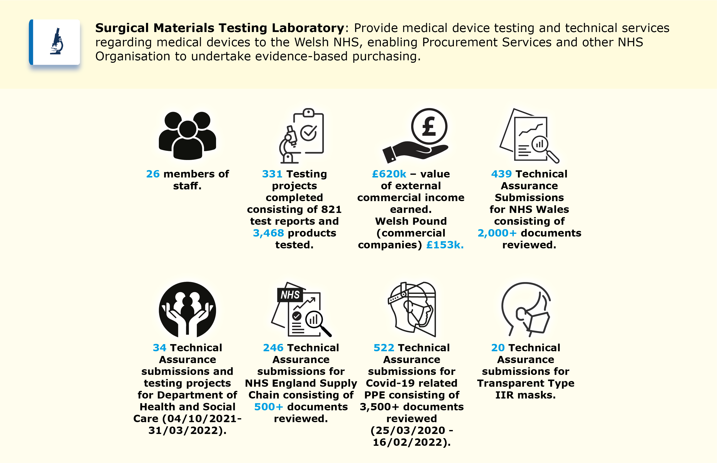

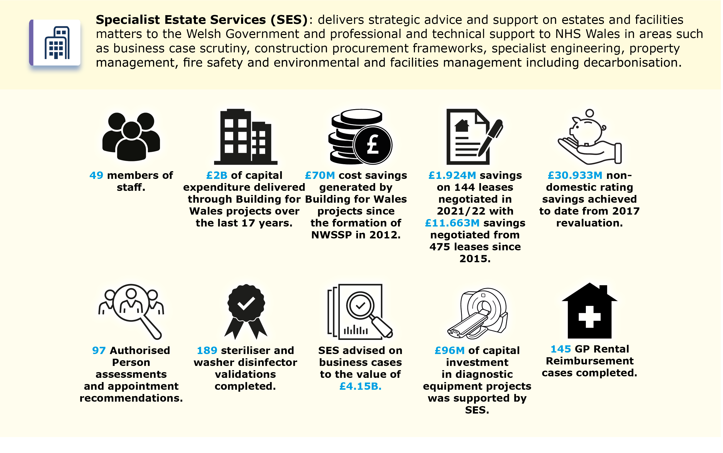

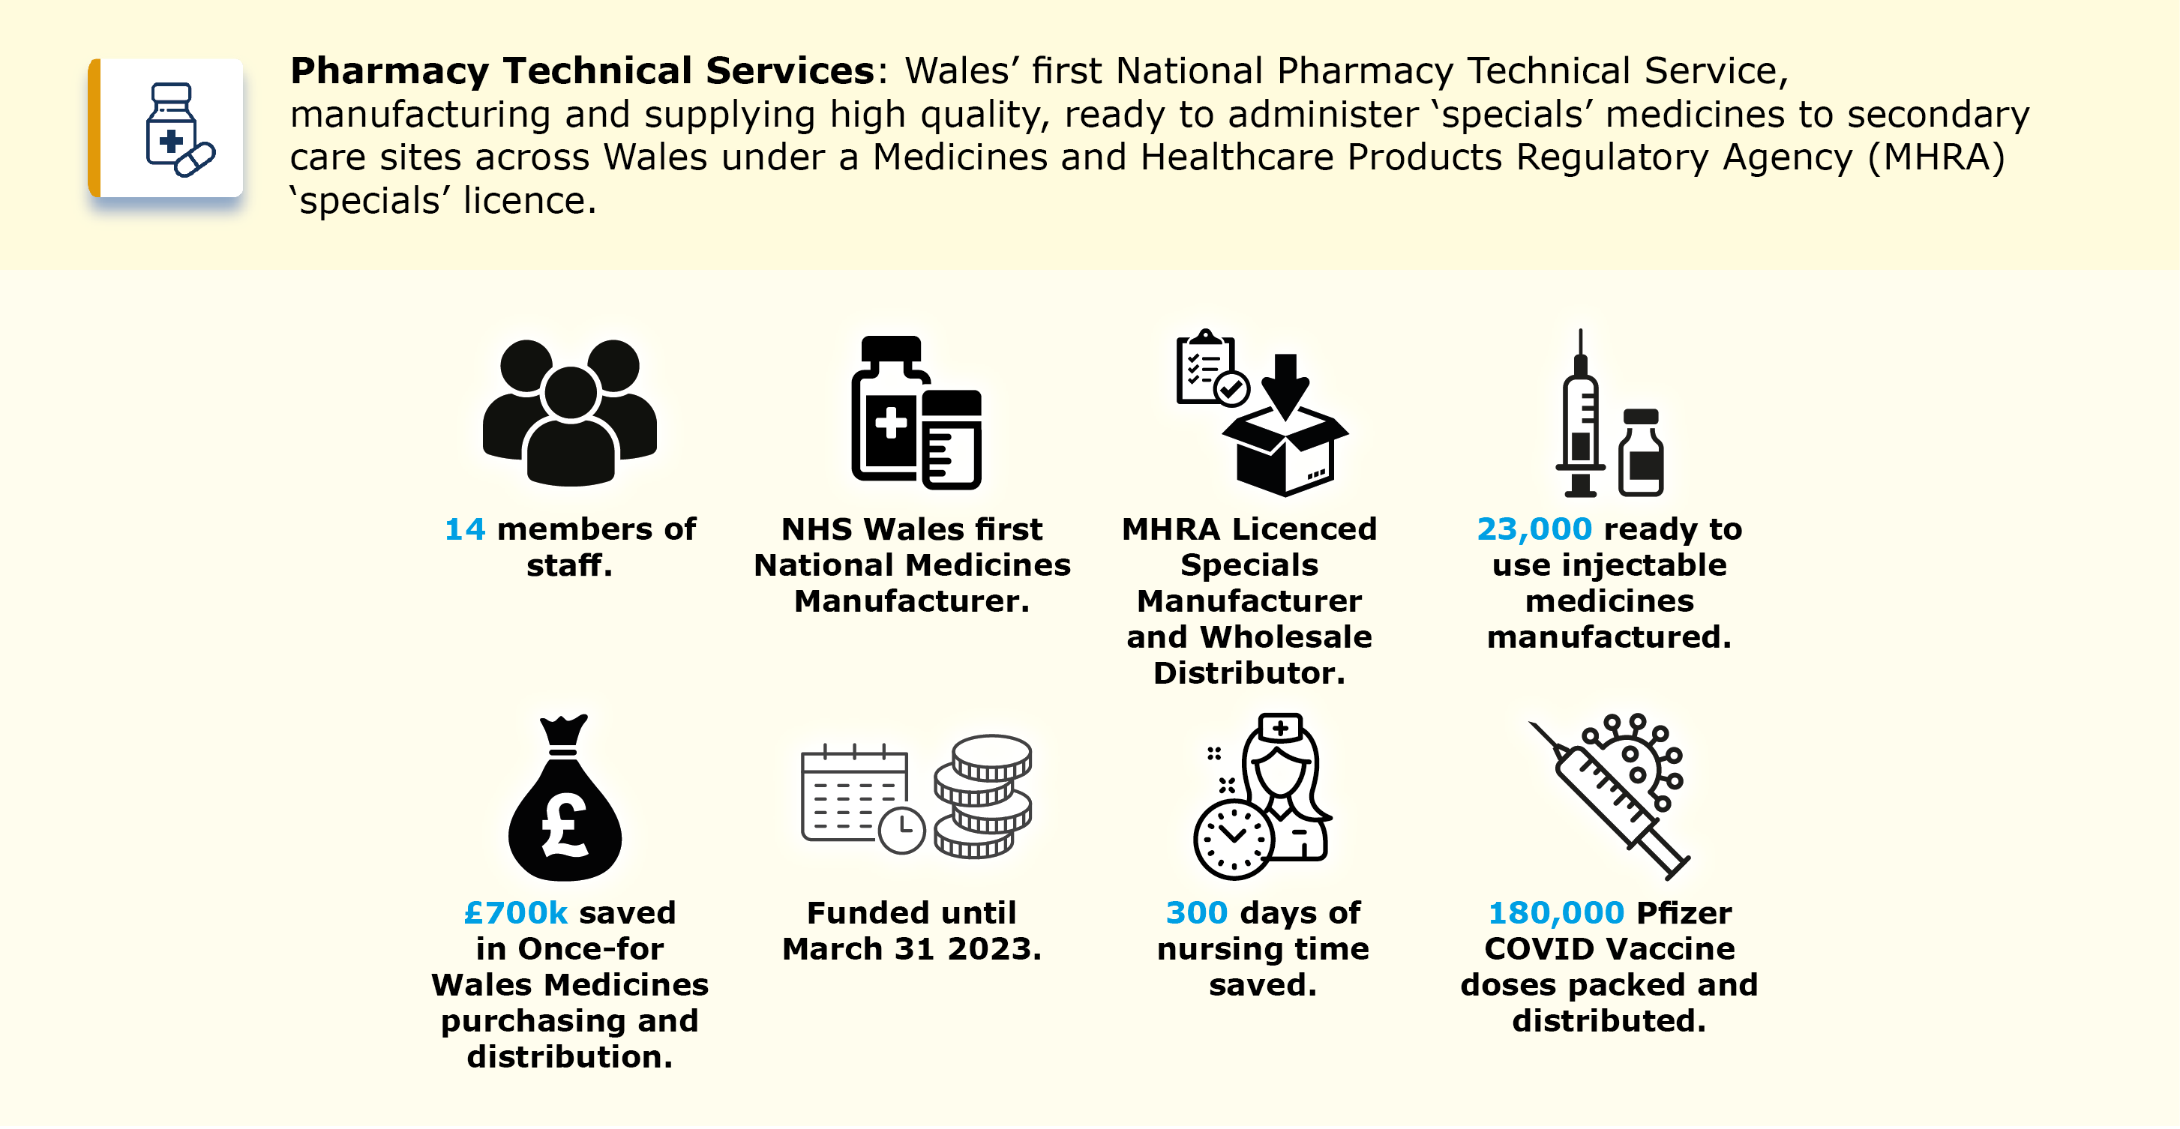

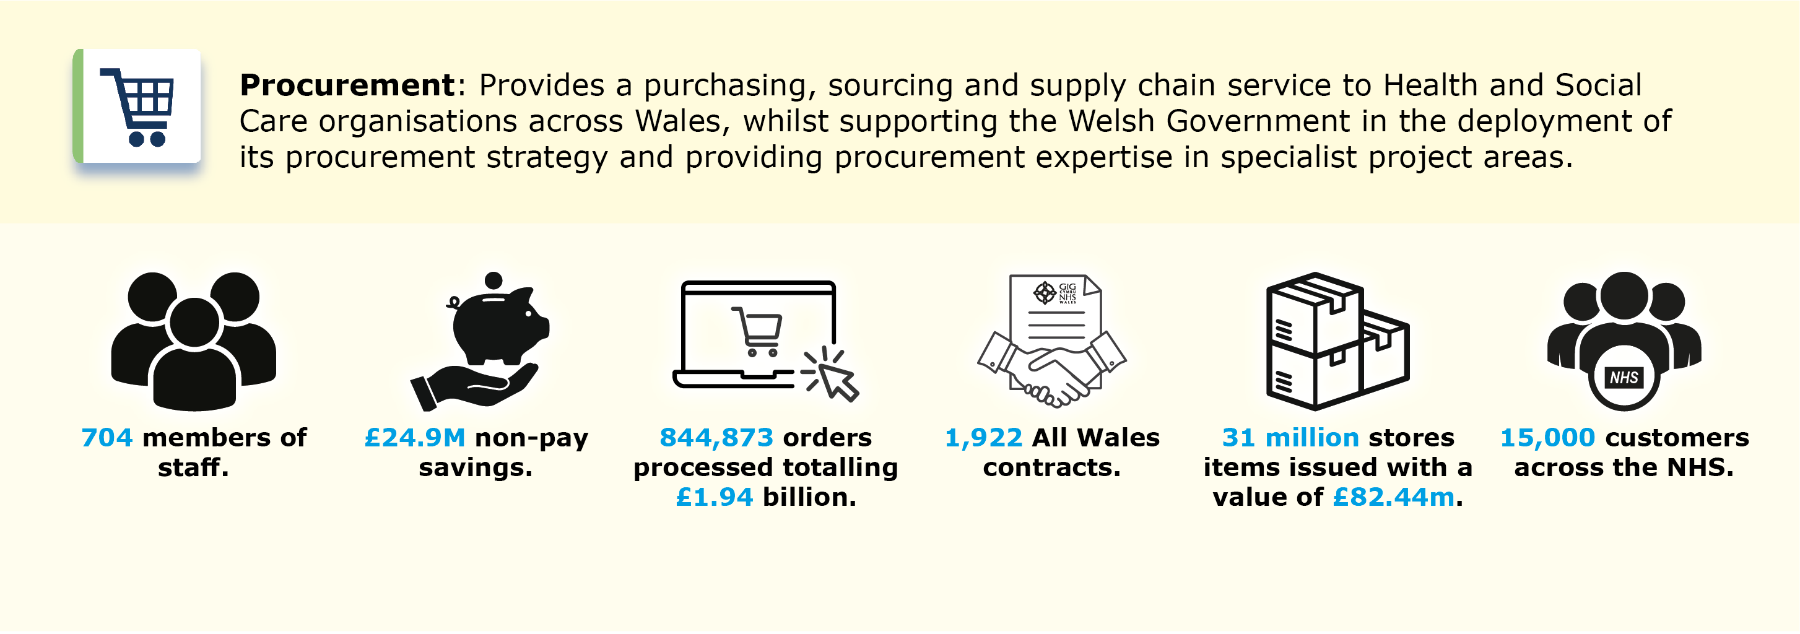

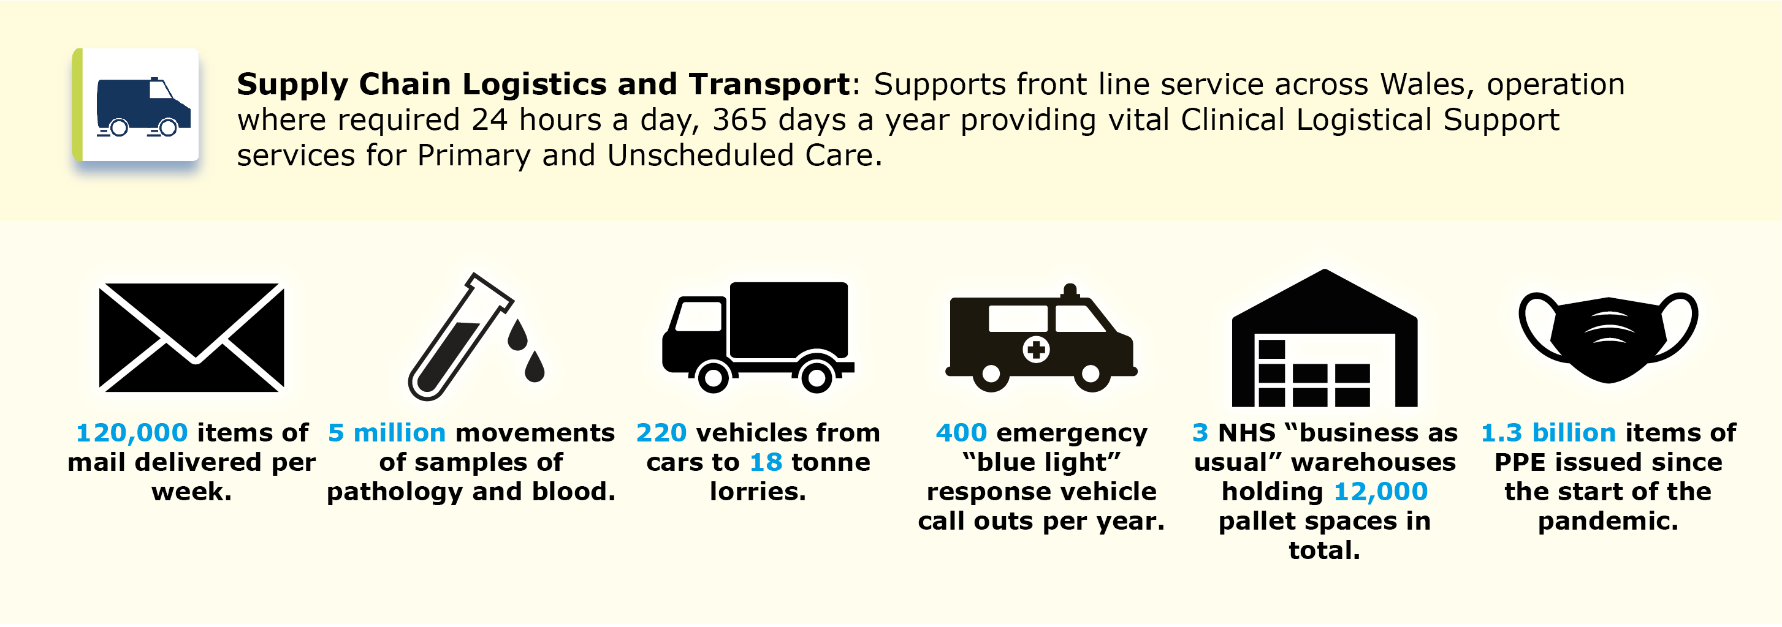

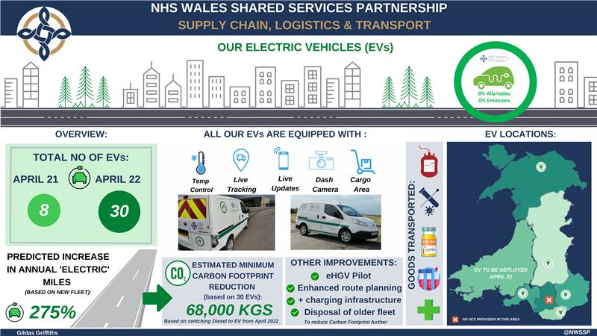

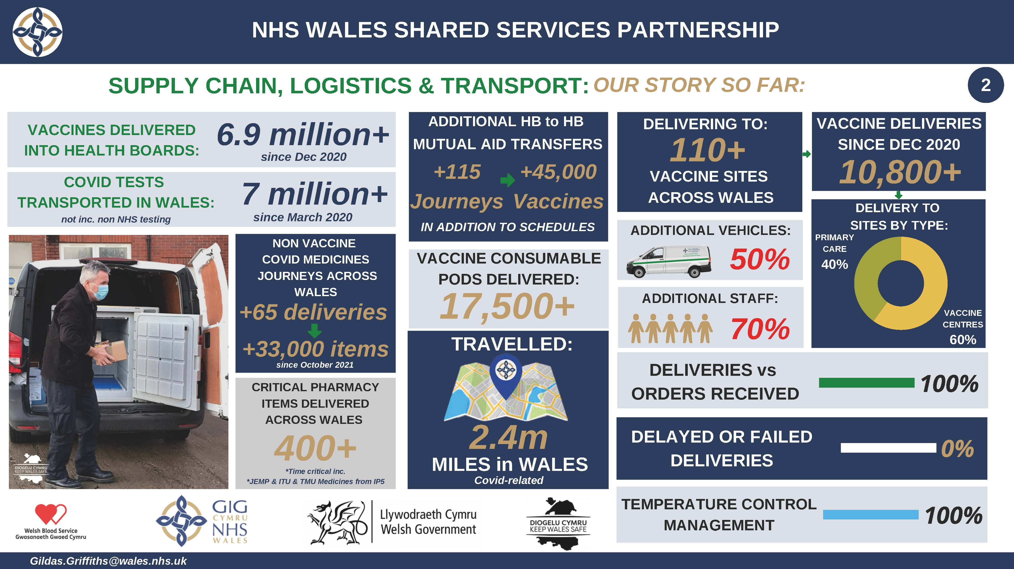

Civil Contingency Functions: NWSSP Procurement Services and Supply Chain, Logistics & Transport (Supply Chain & Health Courier Services), has a critical national role in planning for and responding to major emergencies. Its civil contingency role is undertaken through direction from Welsh Government and in accordance with NWSSP obligations under the Civil Contingency Act 2004. NWSSP civil contingency responsibilities broadly cover the following emergency functions:

- The storage, management, and distribution of Wales’ pandemic stockpiles, including pharmaceutical items, medical consumables, and PPE.
- Management of the contents and replenishment process for the mass casualty bags held across Wales by Welsh Ambulance Service NHS Trust for use by medical teams in the event of a major incident.
- Maintaining contingency plans for the distribution of health countermeasures in the event of an accident or deliberate release of hazardous materials, including:
  - In emergency life threatening situation under ‘Blue Light’ conditions.
  - Urgent response for ‘Rising Tide’ incidents.
- Maintaining logistical support arrangements for Mobilisation of NHS Medical Teams (MERIT) to respond to major incidents.
- Active participation in emergency planning fora and exercises, supporting Welsh Government and partner health boards and trusts across a range of scenarios.
- Flexible response and support to NHS Wales during time of ‘business continuity’ declaration by partners and increased pressures e.g., blood, pathology, centralised sterile services department (CSSD), pharmaceutical or medical consumable requirements.

Our leadership team

Our leadership team is made up of a range of experience from within the NHS, wider public sector, and private sector.



Our Locations
We are a national organisation with a physical presence across Wales.

Our largely positive experience of adapting to remote working during the pandemic does mean that agile working will form part of our future workforce model; increasing our ability to recruit from all parts of Wales.

