

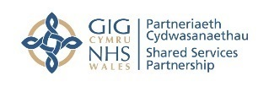
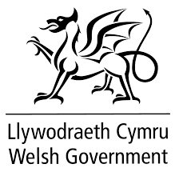
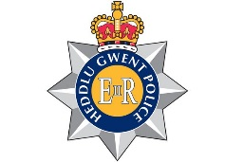
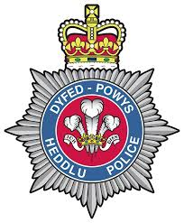
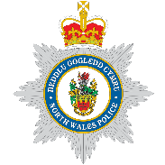

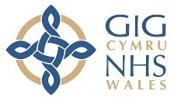

Official Press Release
EMBARGOED xxxx
National agreement document launched to protect violence against staff in NHS Wales
An updated agreement entitled ‘Obligatory Responses to Violence in Healthcare’ with regards to violence and aggression towards NHS Wales staff, has been launched.
The Obligatory Responses to Violence in Healthcare document between NHS Wales, the Police and Crown Prosecution Service (CPS) has been updated from a previous agreement in terms of criminal procedure and sentencing legislation. This includes references to the assaults against Emergency Workers Act 2018, which increases the penalties available to the courts, recognises the aggravating features of such assaults and has been shortened to make it digestible with operational guidance. The document also contains fully revised appendices and will be hosted by NHS Wales Shared Services Partnership (NWSSP).
Cabinet Secretary for Health and Social Services, Vaughan Gething;
“We all deserve to feel safe and supported in our working environments and our hardworking staff should not have to feel fear and apprehension about attending work. This is not a privilege; it is a fundamental right. With this in mind, there is a real sense that NHS Wales staff are front and centre within the ‘Obligatory Reponses to Violence in Healthcare’ agreement. I would also like to take this opportunity to thank the Anti-Violence Collaborative for their immense efforts to bring this agreement to fruition.”
All parties to this agreement will encourage individual Police services, CPS areas and NHS bodies to seek the strongest possible action in appropriate cases. All NHS staff are also strongly encouraged to actively report violent incidents at all times.
Dr Andrew Goodall, Director General of Health and Social Services/Chief Executive, NHS Wales;
“NHS victims are expressed as central to this document and in addition, the name ‘Obligatory Responses to Violence in Healthcare’ has been deliberately adopted to confirm the intent of this agreement. This agreement also recognises that staff should feel safe and secure in their working environment. To ensure this is the case, this document also encourages incident reporting and that the reporting of violent incidents is worthwhile and that violence is never accepted as part of the job.”

Dr David Bailey, Chair of BMA’s Welsh Council;
“BMA Cymru Wales welcomes this important document. Everybody has the right to feel safe and secure at work and it is especially important that assaults on NHS staff, who are working in pressurized environments to the best of their ability, receive as much support as possible when they are deliberately assaulted – be it physically or verbally. This document, alongside the Assaults on Emergency Workers Act 2018, will provide the necessary support to NHS staff who are victims of deliberate verbal of physical assaults at work and ensure those who attack staff deliberately face the full force of the law.”
Andrew Hynes, NHS Wales Anti Violence Collaborative Chair and Senior Solicitor, Legal & Risk Services, NHS Wales Shared Services Partnership;
“I am delighted to launch the ‘Obligatory Reponses to Violence in Healthcare’ document in partnership with our key stakeholders. It fully sets out the responsibilities of partners when dealing with violent or aggressive incidents relating to NHS staff, improves the reporting of violent incidents and strengthens the investigation and prosecution process by improving the quality and timeliness of shared information. It will also help to improve victim and witness care and confidence and raises the issues of violence and aggression against NHS staff and the action that will be taken by all parties.”
ENDS
Notes to Editor

- NHS Wales Anti Violence Collaborative (AVC)
NHS Wales Anti Violence Collaborative is an all-Wales cross party working group that aims to reduce violence and aggression against NHS staff in Wales through the Obligatory Reponses to Violence in Healthcare document. The AVC works with key stakeholders across NHS Wales, Welsh Government, CPS, the Police and Trade Unions. This updated document aims to bring effective and efficient communication across partners, including the exchange of information at all levels; a clear understanding of the respective roles, responsibilities, processes and legal constraints; and a clear statement on prosecution policy which will help NHS staff to understand the criminal justice system, and have confidence in it.

- NHS Wales Shared Services Partnership (NWSSP)
NWSSP is an independent organisation, owned and directed by NHS Wales. NWSSP supports NHS Wales through the provision of a comprehensive range of high quality, customer focused support functions and services.

- Legal and Risk Services
Legal and Risk Services is provide legal advice and representation for all of the health bodies in Wales. They have specialist experience, knowledge and understanding of the legal, administrative and policy issues that affect the operation of the NHS in Wales. Legal and Risk Services is a division of the NHS Wales Shared Services Partnership.

Hard copies of the Obligatory Reponses to Violence in Healthcare document are available on request. Electronic copies can be downloaded via:
http://www.nwssp.wales.nhs.uk/nhs-wales-anti-violence-collaborative
Further Information
Darren Davies
Communications Manager,
NHS Wales Shared Services Partnership

Email: darren.davies@wales.nhs.uk
Tel: 01443 848534

Website: http://www.nwssp.wales.nhs.uk/nhs-wales-anti-violence-collaborative

Twitter: @NHSAntiViolence

