Blank Letterhead Template[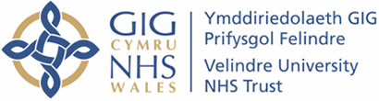](http://www.google.co.uk/url?sa=i&rct=j&q=&esrc=s&frm=1&source=images&cd=&cad=rja&uact=8&ved=0CAcQjRw&url=http://www.velindre-tr.wales.nhs.uk/&ei=2IufVa_JDOO07ga864v4Dw&bvm=bv.96952980,d.ZGU&psig=AFQjCNEsVIexARj9MR_9VyMTfXMgjFElvw&ust=1436605779246665)

**Velindre University NHS Trust Audit Committee for NHS Wales Shared Services Partnership**

**Annual Report 2020-2021**

1. **FOREWORD**

I am pleased to present the Annual Report of the Velindre University NHS Trust Audit Committee for NHS Wales Shared Services Partnership. It outlines the coverage and results of the Committee’s work for the year ending 31March 2021.

During the year, I was supported by Independent Members, Mr Gareth Jones, and Mrs Jan Pickles, who offered considerable knowledge and wide-ranging experience to the Committee. I would like to take this opportunity to put on record my sincere thanks for the significant contribution made by both during the year.

I would like to express my thanks to all the Officers of the Committee who have supported and contributed to the work carried out and for their commitment in meeting important targets and deadlines. I also wish to record my appreciation for the support and contribution given by Internal Audit at NWSSP, Local Counter Fraud Services and by Audit Wales.

Despite a very challenging year due to the pandemic, meetings have been well attended, and there was constructive dialogue and challenge throughout. All meetings have been held virtually and have generally worked well. A characteristic of the Committee’s work and its related meetings has been the willingness of all parties to raise issues, acknowledge shortcomings and put forward positive suggestions to help bring about meaningful improvements to services, systems, and day-to-day working practices. This approach is to be welcomed and is very much appreciated by the Committee.

I am keen to foster and promote a culture of continual improvement and, as a Committee, we continued to conduct a brief effectiveness review session at the end of each meeting and introduced topical service presentations to the agenda in order to strengthen and engage in a meaningful way with this process. The issuing of electronic Committee papers has contributed to effective sustainable development and has helped to reduce our environmental impact.

Going forward, the Committee intends to continue to pursue a full programme of work covering a wide range of topics and subject areas as part of its long-term aim to help further strengthen the governance arrangements of NWSSP, in order to achieve better value for money and high quality, sustainable outcomes for NHS Wales.

**Mr Martin Veale JP**

**Chair of the Velindre University NHS Trust Audit Committee for NWSSP**

**2. INTRODUCTION**

The Committee’s business cycle runs from the closure of the Annual Accounts in one financial year to the next. This reflects its key role in the development and monitoring of the Governance and Assurance framework for NWSSP, which culminates in the production of the Annual Governance Statement.

This report sets out the role and functions of the Audit Committee and summarises the key areas of business undertaken during the year. In addition, the report sets out some of the key issues, which the Committee will be focussing on over the next few years.

1. **ROLE, MEMBERSHIP, ATTENDEES AND COMMITTEE ATTENDANCES**

**3.1 Role**

The Audit Committee advises and assures the Shared Services Partnership Committee (SSPC) on whether effective governance arrangements are in place through the design and operation of the SSPC Assurance Framework. This framework supports the SSPC in its decision-making and in discharging its accountabilities for securing the achievement of NWSSP’s objectives in accordance with the standards of good governance determined for the NHS in Wales.

The organisation’s system of internal control has been designed to identify the potential risks that could prevent NWSSP achieving its aims and objectives. It evaluates the likelihood of the risks being realised, considers the impact should they occur and seeks to manage them efficiently, effectively, and economically. Where appropriate, the Committee will advise the SSPC (and Velindre University NHS Trust, where appropriate) and the Accountable Officer(s) on where and how the Assurance Framework may be strengthened and developed further.

The Committee’s Terms of Reference are reviewed annually and are included within the Standing Orders for the SSPC and Velindre University NHS Trust.

Detail of the overall Assurance Framework is set out in **Figure 1** overleaf:

**Figure 1: Overall Assurance Framework**

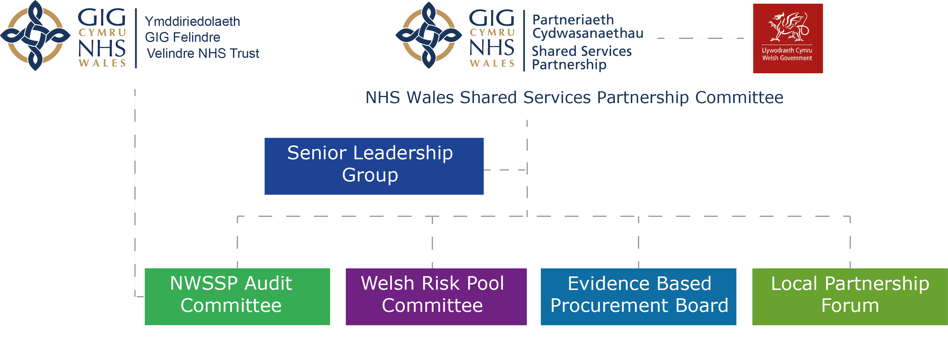

***Underpinned through the overarching Velindre University NHS Trust legal and assurance framework***

The above framework is to be strengthened in 2021/22 with the addition of a Quality & Safety Committee.

**3.2 Membership**

Given the hosting and specific governance responsibilities of Velindre in relation to NWSSP, Velindre University NHS Trust’s Audit Committee also acts as the Audit Committee for NWSSP. As such, the same three Independent Members sit on both Audit Committees.

**3.3 Attendees**

The Committee’s work is informed by reports provided by Audit Wales, Internal Audit, Local Counter Fraud Services and NWSSP personnel. Although they are not members of the Committee, auditors, and other key personnel from both Velindre University NHS Trust and NWSSP are invited to attend each meeting of the Audit Committee. Invitations to attend the Committee meeting are also extended where appropriate to staff where reports relating to their specific area of responsibility are discussed.

**3.4 Attendance at Audit Committee 2020-21**

During the year, the Committee met on four occasions. All meetings were quorate and were well attended as shown in **Figure 2** overleaf:

**Figure 2: Meetings and Member Attendance 2020-21**

| **In Attendance** | **April 2020** | **June 2020** | **Oct 2020** | **Jan 2021** | **Total** |
| --- | --- | --- | --- | --- | --- |
| **Committee Members** | | | | | |
| Martin Veale, Chair & Independent Member | ✓ | ✓ | ✓ | ✓ | **4/4** |
| Gareth Jones, Independent Member | ✓ | ✓ | ✓ | ✓ | **4/4** |
| Janet Pickles, Independent Member | ✓ | ✓ | ✓ | x | **3/4** |
| **Audit Wales** | | | | | |
| Audit Team Representative | ✓ | ✓ | ✓ | ✓ | **4/4** |
| **NWSSP Audit Service** | | | | | |
| Director of Audit & Assurance | ✓ | ✓ | ✓ | ✓ | **4/4** |
| Head of Internal Audit | ✓ | ✓ | ✓ | ✓ | **4/4** |
| **Counter Fraud Services** | | | | | |
| Local Counter Fraud Specialist | x | ✓ | ✓ | ✓ | **3/4** |
| **NWSSP** | | | | | |
| Margaret Foster,  Chair NWSSP | ✓ | ✓ | ✓ | ✓ | **4/4** |
| Neil Frow,  Managing Director | ✓ | ✓ | ✓ | ✓ | **4/4** |
| Andy Butler,  Director of Finance & Corporate Services | ✓ | ✓ | ✓ | ✓ | **4/4** |
| Peter Stephenson,  Head of Finance & Business Development | ✓ | ✓ | ✓ | ✓ | **4/4** |
| Roxann Davies/Carly Wilce  Corporate Services Manager | ✓ | ✓ | ✓ | ✓ | **4/4** |
| NWSSP Secretariat | ✓ | ✓ | ✓ | ✓ | **4/4** |
| **Velindre University NHS Trust** | | | | | |
| Mark Osland,  Director of Finance | ✓ | ✓ | ✓ | ✓ | **4/4** |
| Lauren Fear,  Director of Corporate Governance | ✓ | ✓ | ✓ | ✓ | **4/4** |

 

1. **AUDIT COMMITTEE BUSINESS**

The Audit Committee provides an essential element of the organisation’s overall assurance framework. It has operated within its Terms of Reference in accordance with the guidance contained within the NHS Wales Audit Committee Handbook.

The Audit Committee agenda broadly follows a standard format, comprising four key sections; External Audit, Internal Audit, Counter Fraud Services and ‘Internal Control and Risk Management’. These are discussed further below.

**4.1 External Audit (Audit Wales)**

Audit Wales provides an Audit Position Statement at each meeting, summarising progress against its planned audit work. The following additional reports were presented during the year:

* Management Letter 2019/20
* Audit Wales Nationally Hosted NHS IT Systems Assurance Report
* Audit Wales “Raising our Game” on tackling fraud in Wales
* Audit Wales Audit Assurance Arrangements 2021
* Audit Wales Procuring and supplying of PPE during Covid-19
* Audit Wales Data Analytics
* Audit Wales Maintaining Good Governance in the NHS during the Covid-19 crisis

Audit Wales have stated that the findings of their work enable them to place reliance on the services provided by NWSSP.

Unfortunately, the Committee was not provided with any notice of the decision made by Audit Wales not to undertake on-site stocktakes due to the Covid pandemic, and so did not have the opportunity to discuss the consequences of this upon the accounts of Velindre University NHS Trust for year ended 2020/21.

**4.2 Internal Audit**

Internal Audit have continued to support the organisation in the development and improvement of its governance framework by providing proactive advice and support on new developments and ensuring that the existing systems and processes of control are reviewed, weaknesses identified, and suggestions for improvement made.

15 Internal Audit reports were generated during 2020-21 and they achieved assurances as follows:

* 3 reports achieved Substantial assurance
* 5 reports achieved a Reasonable assurance
* 7Advisoryreports were generated (where assurance is not applicable)

**Figure 3: Internal Audit Reports 2020-21** **by Assurance Rating**

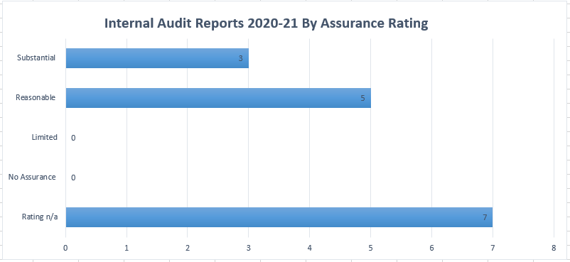

During 2020-21, the reports to Committee on Internal Audit’s programme of work included:

* Internal Audit Position Statement at each meeting;
* Head of Internal Audit Opinion and Annual Report;
* Quality Assurance and Improvement Programme Report;
* Internal Audit Operational Plan; and
* 15 Internal Audit Reports, as detailed in Appendix A.

Head of Internal Audit Opinion and Annual Report

**Figure 4: Head of Internal Audit Opinion: Reasonable Assurance**

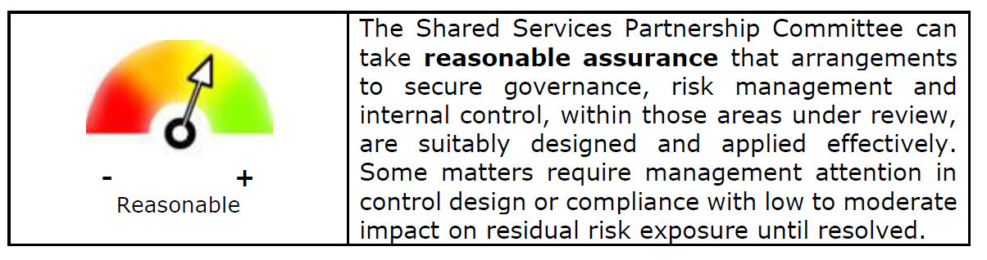

**4.3 Local Counter Fraud Services**

The work of the Local Counter Fraud Services is undertaken to help reduce and maintain the incidence of fraud (and/or corruption) within NWSSP to an absolute minimum. Regular reports were received by the Committee to monitor progress against the agreed Counter Fraud Plan, including the following:

* Counter Fraud Progress Update at each meeting;
* Counter Fraud Annual Report 2019/20;
* Counter Fraud Work Plan 2020/21; and
* Counter Fraud Newsletter.

As part of its work, there is a regular annual programme of raising fraud awareness, for which a number of days are allocated and included as part of a Counter Fraud Work Plan which is approved annually by the Audit Committee. In addition to this a quarterly newsletter is produced which is available to all staff on NWSSP’s intranet; all successful prosecution cases are publicised to obtain the maximum deterrent effect.

The pandemic did significantly affect the provision of the Counter Fraud service during 2020-21. In the early months of the pandemic, staff from the Cardiff & Vale UHB team, who supply services to NWSSP, were re-deployed onto front-line duties. In recent months, the designated Local Counter Fraud Specialist (LCFS) has been on long-term sickness absence due to a very serious COVID illness. At the same time, the fraud risk profile for NWSSP has increased, not least due to the substantial sums of money passing through the organisation to procure and store Personal Protective Equipment (PPE) and other medical consumables and equipment. I am aware that meetings have been held between the Finance Directors of NWSSP and Cardiff & Vale UHB, and that NWSSP are looking to invest to increase resource in this area, and I am therefore hopeful that there will be a resolution to this issue shortly.

**4.4 Internal Control and Risk Management**

In addition to the audit reports dealt with by the Committee during the reporting period, a wide range of internally generated governance reports/papers were produced for consideration by the Audit Committee including:

***Annual Governance Statement*:** During 2020-21, the NWSSP produced its Annual Governance Statement which explains the processes and procedures in place to enable NWSSP to carry out its functions effectively. The Statement was produced following a review of NWSSP’s governance arrangements undertaken by the NWSSP Senior Management Team and the Head of Finance and Business Development. The Statement brings together all disclosures relating to governance, risk, and control for the organisation.

***Tracking of Audit Recommendations*:** The Committee has continued focus on the timely implementation of audit recommendations. The overall position with this is very positive but occasionally requests are made to extend the date of an agreed action due to a change in circumstance. All such requests have to be approved by the Committee and an action can only be extended once.

***Audit Committee Effectiveness Survey:*** An anonymised Committee Effectiveness Survey was undertaken to obtain feedback from Committee members on performance and potential areas for development. The statements used in the survey were devised in accordance with the guidance outlined within the NHS Audit Committee Handbook and aligned with the statements used by Velindre University NHS Trust for its Effectiveness Survey.

The results of the survey were very positive and highlighted that 80% of respondents agree that their experience of remote meetings have been effective and that 100% agree that the content of the organisations system of assurance are robust. Operating an e-board software system has allowed us to significantly reduce our paper/printing usage reducing our carbon footprint and impact on the Environment, supporting our commitments to ISO 14001 certification and Wellbeing of Future Generations goals.

A full list of the internal reports/papers considered by the Audit Committee in 2020-21 is attached at **Appendix B** for information.

* 1. **Private Meeting with Auditors**

In line with recognised good practice, a private meeting was held in January 2021 between Audit Committee members, Internal Audit, External Audit, and the Local Counter Fraud Specialist. This provided an opportunity for any matters of concern to be raised without the involvement of Executives. No issues of concern arose from the meeting. All auditors are also aware that they can directly approach the Chair at any time with any matters that concerns them.

1. **REPORTING AND COMMUNICATION OF THE COMMITTEE’S WORK**

The Committee reports a summary of the key issues discussed at each of its meetings to the SLG, SSPC and to Velindre University NHS Trust Board by way of an Assurance Report. In addition, this Annual Report seeks to bring together details of the work carried out during the reporting period, to review and test NWSSP’s Governance and Assurance Framework. The outcome of this work has helped to demonstrate the effectiveness of NWSSP’s governance arrangements and underpins the assurance the Committee was able to provide to both the SLG, SSPC and Velindre University NHS Trust.

1. **CONCLUSION AND FORWARD LOOK**

The work of the Audit Committee in 2020-21 has been varied and wide-ranging. The Committee has sought to play its part in helping to develop and maintain a more effective assurance framework and improvements have been evidenced by the findings of internal and external audit.

The COVID-19 pandemic had a significant impact on NWSSP throughout the year and initially rapid changes to systems and processes were required to respond to the pandemic and to continue to deliver existing services. The establishment of the Finance Governance Group helped to maintain control over very large financial commitments on PPE and other medical equipment, whilst giving Procurement colleagues the agility to respond quickly in a very competitive and challenging marketplace. Reports have been provided to each Committee on NWSSP’s response to COVID and these include not only detail on the financial commitments, but also assurance over the measures put into place to both protect the health and well-being of NWSSP staff, whilst continuing to maintain services to its existing (and new) customer base. The Audit Committee will continue to review the increased challenges facing NWSSP in response to the pandemic.

In addition, the Audit Committee will continue to adopt the following priorities for 2021-22:

* A higher standard of assurance, through strengthening existing governance processes, particularly in relation to corporate risk management and assurance mapping;
* A continued focus on the timely implementation of audit recommendations; and
* Capturing lessons learned and reviewing how we develop as a Committee, considering better value for money and service improvement. Whilst we all hope that some normality may return as we emerge from the pandemic, we also do not want to lose the benefits that have accrued over the last year. Virtual meetings are likely to remain in some form as they offer opportunity to reduce travelling time and costs, and generally make the meetings more accessible to all.

**APPENDIX A**

**List of Internal Audits Undertaken and Assurance Ratings**

|  |  |  |
| --- | --- | --- |
| **Internal Audit Assignment** | **Assurance Rating**  **2020-21** | **Date Presented**  **To Audit Committee** |
| Credit Card Expenditure | Substantial | October 2020 |
| Primary Care Contractor Payments (All Wales) | Substantial | June 2021 |
| Welsh Risk Pool Services | Substantial | June 2021 |
| Covid-19 Premises Safety | Reasonable | April 2021 |
| Student Awards Services | Reasonable | April 2021 |
| Payroll Services | Reasonable | April 2021 |
| Procure to Pay (P2P) | Reasonable | June 2021 |
| Head of Internal Audit Opinion & Annual Report | Reasonable | June 2021 |
| Financial Governance Arrangements During Covid-19 Pandemic | Advisory Report | October 2020 |
| Declarations of Interest | Advisory Report | January 2021 |
| Covid-19 Divisional Preparedness and Resilience review | Advisory Report | January 2021 |
| PCS Payment System Data Migration | Advisory Report | April 2021 |
| PCS Payment System Project Management | Advisory Report | April 2021 |
| Brexit Preparations | Advisory Report | June 2021 |
| Single Lead Employer (SLE) | Advisory Report | June 2021 |
| *Substantial Assurance Rating* | *3* |  |
| *Reasonable Assurance Rating* | *5* |  |
| *Limited Assurance Rating* | *0* |  |
| *No Assurance Rating* | *0* |  |
| *Assurance Not Applicable* | *7* |  |
| **Total** | **15** |  |

**APPENDIX B**

**Internally Generated Assurance Reports/Papers**

|  |  |  |  |
| --- | --- | --- | --- |
| **Report/Paper** | **Every Meeting** | **Annually** | **As**  **Appropriate** |
| Tracking of Audit Recommendations | ✓ |  |  |
| Governance Matters | ✓ |  |  |
| Corporate Risk Register | ✓ |  |  |
| Audit Committee Forward Plan | ✓ |  |  |
| Annual Governance Statement |  | ✓ |  |
| Audit Committee Effectiveness Review and Results |  | ✓ |  |
| Audit Committee Annual Report |  | ✓ |  |
| Audit Committee Terms of Reference |  | ✓ |  |
| Assurance Mapping |  | ✓ |  |
| Freedom of Information (FOI) Annual Report |  | ✓ |  |
| NWSSP Integrated Medium Term Plan (IMTP) |  | ✓ |  |
| NWSSP Annual Review |  | ✓ |  |
| Welsh Language Annual Report |  | ✓ |  |
| Review of Stores Write-Offs |  | ✓ |  |
| Review of the Shared Services Partnership Committee’s Standing Orders (SSPC SOs) |  |  | ✓ |