Tuesday 24 January 2023 - NWSSP Audit Committee (Part A)
Tue 24 January 2023, 14:00 - 16:00
By Microsoft Teams

Agenda

14:00 - 14:15
15 min

14:15 - 14:25
10 min

14:25 - 14:35
10 min

14:35 - 15:00
25 min
- Standard Business
Martin Veale

  - Welcome and Opening Remarks (verbal)

Martin Veale

  - Apologies

Martin Veale

  - Declarations of Interest

Martin Veale

  - Minutes of Meeting Held on 11 October 2022

Martin Veale
 1.4 Approved Minutes 11102022.pdf (7 pages)

  - Matters Arising

Martin Veale
 1.5 Matters Arising.pdf (3 pages)

- NWSSP Update
Neil Frow
 2 MD Update January 23.pdf (7 pages)

- External Audit
Steve Wyndham

  - Audit Wales Update

Steve Wyndham
 3.1 Audit Wales update paper - NWSSP January 2023 AC meeting.pdf (3 pages)

- Internal Audit

  - Progress Report

James Johns
 4.1 A&A NWSSP Audit Cttee Progress Report January 23.pdf (7 pages)

  - Audit Reports

James John/Sophie Corbett

    - Recruitment Services

James Johns/Sophie Corbett
 4.2.1 NWSSP-2223-02 Recruitment Services Final IA Report.pdf (11 pages)

    - Laundry Services - Glan Clwyd

James Johns/Sophie Corbett
 4.2.2 NWSSP-2223-05b Laundry Service - Glan Clwyd - Final Report.pdf (13 pages)

    - Accounts Payable

James Johns/Sophie Corbett
 4.2.3 NWSSP-2223-12 Accounts Payable Final Internal Audit Report.pdf (16 pages)

15:00 - 15:15
15 min

15:15 - 15:45
30 min
- Counter Fraud
Mark Weston

  - Progress Update

 5.1 NWSSP Period 3 draft 2022 LCFS Progress Report (002).pdf (8 pages)

    - Fraud Awareness Week Summary

Mark Weston
 5.1.1 Fraud awareness week summary.pdf (1 pages)

    - NWSSP Staff Fraud Survey Results

Mark Weston
 5.1.2 NWSSP Staff Fraud Survey Results.pdf (5 pages)

- Governance, Assurance & Risk

  - Update on Surplus Beds

Andy butler
 6.1 Audit Committee - update on surplus beds January 2023.pdf (5 pages)

  - Risk Management

Peter Stephenson

    - Risk Appetite Statement

Peter Stephenson
 6.2.1 Risk Appetite Statement cover paper.pdf (1 pages)

 6.2.1 NWSSP Risk Appetite Statement November 2022.pdf (4 pages)

    - Risk Register

Peter Stephenson
 6.2.2 Corporate Risk Register.pdf (3 pages)
 6.2.2 Corporate Risk Register 20230113.pdf (4 pages)

    - Assurance Mapping

Peter Stephenson
 6.2.3 Assurance Mapping Jan 23.pdf (23 pages)

  - Health and Care Standards

Peter Stephenson
 6.3 Audit Committee NWSSP Health and Care Standards.pdf (3 pages)

  - Governance Matters

Andy Butler
 6.4 Final Governance Matters January 2023.pdf (12 pages)

  - Tracking of Audit Recommendations

Peter Stephenson
 6.5 Tracking of Audit recommendations report January 2023.pdf (3 pages)
 6.5 11012023 Appendix A progress of recommendations.pdf (6 pages)

15:45 - 16:00
15 min

16:00 - 16:00
0 min

16:00 - 16:00
0 min
- Items for Information

  - IMTP Plan on a Page

 7.1 NWSSP Year 1 plan on a page .pdf (1 pages)

  - Welsh Language Annual Report 2021-22

 7.2 .FINAL Welsh Language Performance Report 2021.202.pdf (15 pages)
 7.2 FINAL Welsh Language Performance Report 2021.2022 Cymru.pdf (15 pages)

  - Forward Plan

 7.3 Audit Committee Forward Plan.pdf (3 pages)

- Any Other Business (By Prior Approval Only)

- Time and Date of Next Meeting, Wednesday 19 April 2023



MINUTES OF THE MEETING HELD ON TUESDAY 11 OCTOBER 2022 / 14:00 – 16:00 BY TEAMS
VELINDRE UNIVERSITY NHS TRUST AUDIT COMMITTEE FOR NHS WALES SHARED SERVICES PARTNERSHIP

EXPECTED ATTENDEES:
ATTENDANCE | DESIGNATION
INDEPENDENT MEMBERS:
Martin Veale (Chair) | Chair & Independent Member
Gareth Jones (GJ) | Independent Member
Vicky Morris (VM) | Independent member
ATTENDANCE | DESIGNATION | ORGANISATION
Neil Frow (NF) | Managing Director | NWSSP
Tracy Myhill (TM) | NWSSP Chair | NWSSP
Andy Butler (AB) | Director of Finance & Corporate Services | NWSSP
Peter Stephenson (PS) | Head of Finance & Business Improvement | NWSSP
Carly Wilce (CW) | Corporate Services Manager | NWSSP
Simon Cookson (SC) | Director of Audit & Assurance | NWSSP
James John (JJ) | Head of Internal Audit | NWSSP
Sophie Corbett (SCo) | Deputy Head of Internal Audit | NWSSP
Mark Weston (MW) | Local Counter Fraud Specialist | NWSSP
Linsay Payne (LP) | Deputy Director of Finance & Corporate Services | NWSSP
Murray Gard (item 4.2 only) | Audit Manager | NWSSP
Steve Ham (SH) | Chief Executive | Velindre
Lauren Fear (LF) | Director of Corporate Governance | Velindre
Matthew Bunce (MB) | Velindre NHS Trust Director of Finance | Velindre
Steve Wyndham (SW) | Audit Lead | Audit Wales

Item |  | Action
1. STANDARD BUSINESS
1.1 | Welcome and Opening Remarks  Welcome was given to Murray Gard, Audit Manager for NWSSP Internal Audit who was attending the meeting to present two Advisory Reports to the Audit Committee.
1.2 | Apologies  No apologies were received.
1.3 | Declarations of Interest  None received.
1.4 | Minutes of Meeting held on 13 July 2022  The minutes of the meeting held in July 2022 were AGREED as a true and accurate record of the meeting.

NWSSP Audit Committee
11 October 2022 1

Item |  | Action
1.5 | Matters Arising from Meeting on 13 July 2022  All matters arising are complete, in progress or on the agenda.  - VM queried as to when the Health & Care Standards would be brought to the Velindre Quality and Safety Committee. It was confirmed that the standards are currently being finalised and would be taken to the next Quality and Safety Committee meeting in November and would also come to the next Audit Committee in January 2023. | PS
2.0 | NWSSP Update  NF provided an update to the Committee as to recent developments within NWSSP since the last meeting:  - The Integrated Medium-Term Plan (IMTP) acceptance letter from Judith Paget had been received and was on the agenda for information. The letter confirmed acceptance of the NWSSP IMTP which was described as robust and ambitious, and identified that NWSSP needs to become the catalyst for change in leading on the transformation agenda.  - The Financial position is on track and the forecast outturn remains at a break-even position. The 2022-23 Welsh Risk Pool Risk Sharing Agreement will be invoked in line with the IMTP. Capital continues to be a challenge, as the allocation of capital funding was not increased following the transfer of the All Wales Laundries. However, funding for the Welsh Healthcare Student Hub (Student Bursary and streamlining) was approved by Welsh Government in September.  - Technology is being introduced from the 1st of October in line with Home Office guidance which allows NWSSP to continue to undertake virtual pre-employment checks for successful applicants with a UK or Irish passport. All other new staff will now have to attend a face-to-face check.  - 198 surplus critical care beds have been sent to a hospital in Moldova to support Ukrainian refugees following a request from a Charity which was authorised by Welsh Government.  - A recruitment exercise had recently taken place for the role of Director of Specialist Estates Services, where the current Director, Neil Davies, has announced his intention to retire at the end of this financial year. Interviews took place recently and from a strong field, the current Deputy Director, Stuart Douglas, has been appointed.  The Committee NOTED the Update Report.
3. EXTERNAL AUDIT

NWSSP Audit Committee
11 October 2022 2

Item |  | Action
3.1 | Audit Wales Update  SW presented the latest position statement detailing current and planned work. He confirmed that the audit work for NWSSP would commence in January, and when questioned as to whether this was rather late, answered that unfortunately completing the 2021/22 Local Authority audits are currently the priority, resulting in the 2022/23 NHS audits being unable to start earlier.  MV queried if responses to the recent fee consultation would be shared. SW agreed to provide members with the responses once available.  The Committee NOTED the Update. | SW
4. INTERNAL AUDIT
4.1 | Internal Audit Position Statement  JJ presented the latest Internal Audit Position Statement together with an overview of other activity undertaken since the previous meeting. Four audits from the 2022-23 audit plan are complete and are on the agenda, together with the one remaining report from 2021-22. Fieldwork on the Recruitment services audit is complete, and the report would be brought to the next Audit Committee.  The Committee NOTED the Position Statement.
4.2 | Internal Audit Reports  The following Internal Audit Reports were presented to the Committee:  Capital Governance Arrangements  Murray Gard presented this advisory report and stated that the scope of the review was to assess the governance arrangements over two major investment programmes, Transforming Access to Medicine (TrAMS) and the All-Wales Laundry service. The review of the programmes generally was positive, but it was noted in both cases that the initial estimated costs had been revised significantly upwards. The report contains a number of recommendations which management had agreed to act on. However as this is an advisory report there is no detailed action plan with names and dates for completion so the question was asked as to how the Audit Committee should monitor this report. TM stated that the actions will be monitored at the relevant Programme Governance Boards and suggested that a progress report from the Governance Boards be brought back to the Committee to demonstrate progress, rather than the detail of each recommendation being added to the Audit Tracker. This approach was agreed, and CW will add to the agenda for the January Committee meeting.  Health Courier Service  SCo presented the report to the Audit Committee, which had been awarded reasonable assurance. There was one high priority recommendation relating to the reporting, recording and investigation | CW
NWSSP Audit Committee
11 October 2022 3

Item |  | Action
of road traffic incidents, where inconsistencies were noted in current practice at the time of the audit, but which have now been addressed.

Laundry Services
The objective of the review was to establish a baseline position for Green Vale Laundry following the transfer of services to NWSSP. The audit report achieved a rating of reasonable assurance with five medium recommendations for action. The audit was in line with last year’s review of the Llansamlet Laundry and management are aware of the issues identified in the report, which will be addressed as part of the Laundry Modernisation Programme.

Surgical Materials Testing Laboratory
SCo presented the Surgical Materials Testing Laboratory report to the Committee, which assessed the governance, financial and risk management arrangements. The audit achieved substantial assurance and no recommendations were raised. The Committee were pleased to note such a positive audit report.

Decarbonisation Advisory report
MG presented the report, which is intended to be undertaken at all NHS Wales organisations. To date five reviews, including NWSSP, have been concluded. The audit was an early-stage review intended to provide advice and share best practice. The report included both overall national recommendations and a set of NWSSP-specific recommendations. SC confirmed that the summary report would be shared with all NHS Wales organisations and that the team would be linking in with Chief Executives and Audit Committee chairs to ensure messages are fully communicated. Of the specific recommendations raised in the report, it was noted that NWSSP need to ensure that sufficient resource is in place to undertake the work detailed in the NWSSP Decarbonisation Action Plan.

The Committee NOTED the Internal Audit Reports.
5. COUNTER FRAUD
5.1 | Counter Fraud Position Statement  MW presented the Counter Fraud Position Statement with an overview of activity since the last meeting. A fraud awareness survey was sent to all staff together with an informative video, and over 300 responses have been received to date. This will provide a useful benchmark to monitor how effective MW’s appointment will be in terms of helping to raise fraud awareness amongst NWSSP staff.  MW gave an update regarding the Counter Fraud national e-learning training module which is almost complete, and discussions are continuing to assess whether this training can be made mandatory, at least for certain groups of staff, by the end of the financial year. Bank Mandate fraud is still prevalent across the NHS, but NWSSP have robust controls in place and there have been no recent successful fraud
NWSSP Audit Committee
11 October 2022 4

Item |  | Action
attempts for over 18 months. Salary overpayments are a concern, and this is a particular are of focus at present.

The Committee NOTED the Position Statement.
6. GOVERNANCE, ASSURANCE AND RISK
6.1 | NWSSP Audit Committee Annual Report 2021-22  MV presented the 2021-22 Audit Committee Annual Report, which outlines the areas reviewed by the committee during the year including the results of all internal audit activity. The majority of audits were positive achieving a rating of reasonable or substantial assurance, with exception of one audit, which was rated as limited. No audits were given no assurance and the vast majority of audit actions were implemented within agreed timescales. The Head of Internal Audit Opinion provided a rating of reasonable assurance.  The Committee NOTED the 2021/22 Audit Committee Annual Report.
6.2 | Audit Committee Effectiveness Survey Results 2022  CW presented the results of the recent 2022 Audit Committee Effectiveness Survey. The anonymised survey was undertaken to obtain feedback from Committee members on performance and potential areas of development and was issued to all members in August 2022. The number of responses received was up from the previous year and were very positive with no significant areas to address. Some members are keen for a face-to-face meeting and therefore CW would arrange a physical meeting for one of the four meetings planned for 2023.  The Committee NOTED the Report. | CW
6.3 | Governance Matters  AB presented the paper, which provides the Committee with the contracting activity from 21 June to 20 September 2022. The report summarises that:  - There were no departures from the Standing Orders;  - NWSSP have let 21 contracts during the reporting period;  - In addition 22 All-Wales contracts were let for the period;  - There were three declarations of gifts, hospitality, and sponsorship during the reporting period;  - 77% of NWSSP have now completed a Declaration of Interest – the first time that all NWSSP staff have been asked to participate in this exercise; and  - NWSSP have submitted a nil return to Welsh Government in respect of the quarterly update on limited and no assurance Internal Audit reports.  The Committee NOTED the Report.
6.4 | Utilisation of Surplus Beds
NWSSP Audit Committee
11 October 2022 5

Item |  | Action
LP presented the report to the Audit Committee providing members with an update on the utilisation of surplus bed stock that resulted from the NHS Wales Covid response. In 2021 the Audit Committee was asked to approve on behalf of Welsh Government the write-off of £5.7 million for surplus beds. 2,328 beds were held in storage, and Welsh Government was recently approached by a Charity who wanted to repurpose 198 critical care beds and transport them to Moldova for Ukrainian refugees. Welsh Government agreed to the donation and all governance documentation was completed in conjunction with the Shared Services Partnership Legal and Risk team. To date, there has been two collections and one further collection date has been scheduled to take place week commencing 24 October 2022. NWSSP staff are working with local authorises to see whether the remaining beds could be utilised elsewhere.

The Committee NOTED the Report.
6.5 | Corporate Risk Register  PS presented the Corporate Risk Register which contains one red risk concerning the inflationary impact on goods and services, particularly relating to energy. This continues to be mitigated as far as possible through the actions of the Energy Price Risk Management Group.  There have been three new risks added to the register since the last Audit Committee meeting. These are as follows:  - The threat of industrial action and the resulting impact on delivery of services;  - A current dispute with the supplier of the new Legal & Risk Case Management system which may have both a financial and service delivery impact; and  - Difficulties in obtaining sufficient financial and staff resource to take forward the agreed plans for the Clinical Pharmacy service.  In addition to the above, one risk relating to Covid-19 Pandemic has been re-escalated from monitoring to a risk for action and relates to the temporary fixed term posts of staff recruited through the Pandemic. At present there is lack of uncertainly as to whether the Welsh Government would continue to fund the additional posts appointed pre-covid, despite the roles still being needed.  The Committee NOTED the Report.
6.6 | Tracking of Audit Recommendations  PS presented the paper and noted that there were currently no outstanding recommendations although there are four recommendations where the agreed date has passed but completion of the actions is dependent upon third parties. It was agreed that these would be shared with the Shared Services Partnership Committee to obtain appropriate updates.  The Committee NOTED the Report. | PS
NWSSP Audit Committee
11 October 2022 6

Item |  | Action
7. ITEMS FOR INFORMATION
The following items were provided for information:

- NWSSP Annual Review 2021-22;
- Information Governance Annual Report 2021-22;
- IMTP Outcome letter; and
- Audit Committee Forward Plan.
8. ANY OTHER BUSINESS
8.1 | Any Other Business  No issues were raised.
DATE OF NEXT MEETING:
Tuesday, 24 January from 14:00-16:00 via Teams

NWSSP Audit Committee
11 October 2022 7


Velindre University NHS Trust Audit Committee for NHS Wales Shared Services Partnership
Matters Arising

Actions arising from the meeting held on 11 October 2022
1. | SW | External Audit - Nationally Hosted NHS IT Systems Report  To review the Audit Wales risk category priority risk ratings and bring back an update to the October 2022 Committee meeting, for clarity on the matter. | In progress  Audit Wales priority ratings are a judgement based on significance and time (i.e. based on urgency) however it is something they are reviewing (as relates to both our performance audit and financial audit work) however no significant progress has yet been made.
2. | MW | Counter Fraud Annual Plan 2022-23  MW to bring details of the new e-learning package back to the Committee, once complete. | In progress  The e-learning package is complete and was presented to the Finance Academy Governance Steering Group on 7th November, members provided very positive and constructive feedback. Additional feedback has also been obtained from other stakeholders and amendments are currently being made to conclude the package in the next few weeks. Planned meeting with ESR team to facilitate amendments and therefore a verbal update will be given at the meeting.
3. | PS | To take the Health and Care Standards to the next Velindre UNHT Quality | Complete and on agenda

 |  | and Safety Committee meeting in November and bring them back to the next Audit Committee in January 2023.
4. | SW | Audit Wales to share responses to the recent fee consultation once available. | In progress  SW is unaware of any consultation responses from either Velindre Trust of NWSSP, Audit Wales have summarised their consultation responses in the draft Fee Scheme that was included within our Estimate for 2023-24 that was reported to the Senedd Finance Committee in November 2022 – (Public Pack)Agenda Document for Finance Committee, 09/11/2022 09:30 (senedd.wales). In response to the consultation – and also to reflect the reduction in NI rates announced in the ‘mini-budget’ the expected increase in fee rates was reduced to 4.8%. (note the initial consultation proposed 5.5%). Finance Committee are considering Audit Wales final fee scheme for 2023-24 today (12th January) and once approved this will be published on their website and a communication sent to all audited bodies to advise.
5. | CW | To obtain an update on progress from the Programme Governance Board regarding the action plan being monitored by the Group. A progress report from the Governance Boards would be brought back to the January Committee to demonstrate progress.  CW to add the progress update to the January Committee meeting agenda. | In progress  The action plan has been prepared and is due to be taken to the next meeting of the two Governance Boards.

6. | CW | To arrange a face-to-face Audit Committee meeting in 2023. | In progress  Audit Committee Chair to consult with members on options at the January meeting.

MEETING | Velindre University NHS Trust Audit Committee for NHS Wales Shared Services Partnership
DATE | 24 January 2023
AGENDA ITEM | 2.0
PREPARED BY | Peter Stephenson, Head of Finance and Business Development
PRESENTED BY | Neil Frow, Managing Director
RESPONSIBLE HEAD OF SERVICE | Neil Frow, Managing Director
TITLE OF REPORT | NWSSP Update

PURPOSE
To update the Committee on recent developments within NWSSP.

Introduction

This paper provides an update into the key issues that have impacted upon, and the activities undertaken by, NWSSP, since the date of the last meeting in September.

COVID Response Funding

NWSSP continues to provide products and services to support the ongoing NHS Wales and Social Care response to the COVID pandemic. The additional operational services being provided across NWSSP above our business-as- usual funded baseline include:

- COVID PPE: procurement, purchase, storage, pick & pack, and distribution to Healthcare settings (Secondary care);

- COVID PPE: procurement, purchase, storage, pick & pack, and distribution to Healthcare settings (Primary Care contractors: GPs / Dentists / Opticians / Community Pharmacies);

- COVID PPE: procurement, purchase, storage, pick & pack, and distribution to Social care settings;

- Lateral Flow Devices: storage, pick & pack, and distribution, primarily to Healthcare settings but have provided cross public sector;

- Vaccination support - provision of consumable packs: procurement, purchase, storage, pick & pack, and distribution to vaccination sites;

- Vaccination support - provision of vaccines to vaccination sites: distribution service;

- Vaccination support – part funding of Senior Manager to work with Welsh Government to plan vaccination distribution;

- COVID Medicines: storage, pick & pack, and distribution to Health care settings (Secondary care);

- COVID Field Hospital equipment: storage of surplus field hospital equipment, and distribution where required;

- COVID pathology sample transport;

- Surgical Material Testing Laboratory PPE testing support – date life management of PPE stocks, ongoing stockpile management and further PPE procurement;

- Medicines Unit support to mass vaccination – bulk delivery, storage and repackaging of vaccines ready for distribution; and

- Management of the feeder entries for the Primary & Social care stores issues and recharge of issues to Welsh Government. Cash management related to additional stock balances.

Surplus Beds

Throughout Quarter 3 we have been working closely with Welsh Government officials to arrange the distribution of surplus COVID Field Hospital beds to Social Care Homes and Joint Equipment Stores Services throughout Wales. Through that period, roughly 1600 beds have been allocated out across various parts of Wales, and the programme continues into the next quarter.

Recruitment

Trust ID was implemented on 30th Sept across NHS Wales in line with legislative changes from the Home Office. The system removes the need to face to face pre-employment checks for those with an in-date UK or Irish Passport or Share Code.

The majority of organisation in NHS Wales are live with the following process changes, with others having agreed go live dates:

  - Include a proposed start date in the offer letter

  - Reduction of Mandatory Pre-employment checks prior to start date (references and qualifications can be completed after start).
  - More streamlined internal employment checks process where dates from ESR are used to evidence some existing pre-employment checks.
  - Removal of the unconditional offer letter.

Although data is limited currently due to the short time the changes have been live in some organisations, improvements can be seen already in relation to reducing the time to hire.

CIVAS

In light of the national Penicillin V shortage for treatment of Strep A infections the CIVAS@IP5 Medicines Unit, utilising its national portfolio and MHRA Wholesale Dealer licence, procured direct from the manufacture significant numbers of the Penicillin V liquid (11000 bottles in total). This stock was received and processed for distribution to primary and secondary care sites across all UHBs in collaboration with HCS within 48 hours to provide resilience in stock to health boards. The service subsequently took delivery of a further 8000 bottles of Clarithromycin and these were distributed to UHBs and primary care sites in the week leading to Christmas provided further resilience of supply.

Emergency planning / pandemic medicines storage of Welsh Government owned stock in Wales

From April 1st, 2023, the management of the above stock will transfer to NWSSP. This includes:

  - CBRN (Chemical, Biological, Radiological and Nuclear) stock, including antidotes for use against specific chemical, biological, radiological, and nuclear threats as determined at UK level.

  - PIPP (Pandemic influenza) - NWSSP will take over the responsibility for the Wholesale Dealing Authorisation from Cardiff and Vale UHB.

  - Medicines Buffer Stock programme will commence within NWSSP which will include medicines previously included in the COVID Medicines Stockpile. NWSSP will take over the responsibility for the Wholesale Dealing Authorisation from Cardiff and Vale UHB. This new programme will avoid unnecessary waste as these medicines will be distributed routinely across Wales and replenished with longer dated stock.

  - New COVID-19 treatment medicines - NWSSP will take over the responsibility for the Wholesale Dealing Authorisation from Cardiff and Vale UHB.

Low Vision Service

On 22nd December 2022 Welsh Government confirmed that, subject to full consultation, all aspects of the Low Vision Service Wales (LVSW), currently undertaken through the hosting arrangement with Hywel Dda University Health Board (HDuHB) will transfer to NWSSP.

Welsh Government requested that HDuHB in collaboration with NWSSP, commence detailed discussion as part of the Transfer of Undertakings/Protection of Employment process from December 2022 with an expected completion date of 31st March 2023.

NWSSP have contacted HDuHB to confirm that we are supportive of these arrangements and will work in partnership with the Health Board to ensure a smooth transition to the new arrangements. HDuHB now need to commence a consultation process with the LVSW team, so that they can advise NWSSP on next steps regarding all TUPE transfer requirements.

TrAMS

The first meeting of the All-Wales TrAMS Finance representatives is taking place on the 20th of January. The intention is for the Group to meet every few months. It is important that Health Boards/Trusts are appropriately represented as we move through the programme completing business cases for the South East, South West and North Hubs and ultimately identifying budgets to be transferred on the opening of the hubs.

Citizens’ Voice Body (CVB)

Work is progressing on the establishment of the CVB, and a separate Virtual Private Database (VPD) code has been set up. The Audit & Assurance Team are undertaking analysis of the consultation exercise by Welsh Government that is due to end on 5th March and will produce a report summarising the findings.

Laundry Services

Following submission of the Outline Business Case to Welsh Government we are currently working through a number of queries that they have raised. However, given the challenging position with regards to availability of capital, we are also currently working up alternative options to provide a different approach for the next five years which allows us to push ahead with the consolidation of laundry sites and meet the required minimum standards in terms of hygiene regulations. However, this will not deliver the significant changes planned to support the decarbonisation agenda.

Decarbonisation

We are working with Welsh Government on decarbonisation following the allocation of funding to support the programme. A number of positions have already been appointed to, and plans are in place with Welsh Government to fill the remaining vacancies.

Premises

Issues with Reinforced Autoclaved Aerated Concrete (RAAC) have been noted at Brecon House in Mamhilad affecting our Primary Care Directorate. RAAC was used between the 1960s and 1990s in schools and hospitals to speed up the construction process, but there is a high volume of air within RAAC, making it vulnerable to moisture ingress and losing strength. This is particularly affecting the roof of Brecon House where there are regular leaks and some falls of concrete. Immediate safety measures have been put in place to protect staff, and we are in discussion with the Landlord to move out of this building at the end of the current financial year, and to relocate in a building that is not affected by RAAC. RAAC has also been identified in Companies House but currently the state of that building does not give any cause for concern.

Oracle Upgrade and reporting tool

NWSSP run all Wales Oracle Procurement and Finance system. Following on from the decision made in September 2022 to migrate the All-Wales Oracle system into the cloud, there is requirement to also replace the current reporting tool (Qlikview).

Considerable work has been undertaken in recent months by the NWSSP Central team, working in collaboration with Health Board and Trust colleagues, to identify a replacement. This work has identified two potential solutions, both of which will offer a significant improvement over the current Qlikview system. NHS bodies have not as yet been able to reach a consensus on selecting the replacement. As a consequence a sub-group of the All-Wales STRAD group, working with Procurement colleagues, have developed a robust evaluation model to select the replacement.

Health Organisations and Procurement have been heavily engaged in the assessments and discussions at all levels, and more recently, a presentation was made to the Deputy Directors of Finance on the 13th January. It is expected STRAD will review the outcomes of the task finish group on the 17th January and further soundings will be taken at the All-Wales Directors of Finance group.

It is vital that a decision is made promptly to avoid introducing significant risk to the Oracle cloud migration, by removing the safety net of a contingency date prior to the expiry of the warranty on the FMS Hardware.

Energy Arrangements Update

Procurement for All Wales Energy contracts is undertaken by NWSSP and purchasing decisions are made through the Energy Price Management Risk Group (EPMRG). The EPMRG arrangements have been in place since 2005 and pre-date the current NHS organisational structure.

In June 2022 our Energy supplier announced that they were not taking any more business in the industrial and commercial exceptional energy price increases. This announcement alongside the volatility in energy markets experienced during 2022/23, resulted in a review being undertaken by the All Wales Directors of Finance group to consider current arrangements and how they may be strengthened and made more sustainable for the future. The review has identified a number of proposals for consideration including the introduction of new management arrangements and establishing a new and compliant procurement arrangement with a new energy provider. These proposals are to be considered by the All Wales Directors of Finance group and if implemented will have implications on NWSSP. A further update will be provided at the next Committee meeting in March 2022.

Corporate Risk Register

Following a detailed review of the Corporate Risk Register at the November SLG, a number of risks have been escalated to red and some new red risks added.

- The existing red risk relating to the inflationary consequences of the situation in Ukraine and the resultant impact on energy prices remains red. This is currently being mitigated through the role of the Energy Price Risk Management Group (EPRMG), but energy prices remain very volatile.
- The above risk has also been articulated into a second risk which considers the role that NWSSP plays as the lead energy purchaser for the whole of NHS Wales, and the reputational risk that is associated with that role.
- The existing risk of the impact of potential industrial action has been escalated from amber to red as strike action has now been confirmed. While the strikes currently called by the RCN are not likely to have a significant impact on NWSSP, the likely industrial action from other Trade Unions will have a greater impact.
- Similarly the existing risk of having insufficient staff resource to meet demand has also been escalated from amber to red. NWSSP have a lot of staff on bank contracts who help to deliver essential services but for whom we are unable to guarantee security of employment due to Welsh Government not confirming whether these posts will be funded into 2023/24.
- The contractual dispute affecting the replacement for the Legal & Risk Case Management system has also been escalated from amber to red.

While there are contingency arrangements in place to maintain services, the potential financial loss could be significant.
- The Laundry Transformation Programme has been added as a red risk due to uncertainty over whether the required capital funding for the scheme will be available to complete it.
- The Brecon House roof at Mamhilad has also been added as a red risk due to serious issues with water ingress and falling masonry, making the building unsafe for staff.

Senior Staff Changes

Neil Davies, Director, Specialist Estates Services is retiring in March and following a comprehensive recruitment process, Stuart Douglas, the current Deputy Director, will take on this role with effect from 1st of February. This allows an appropriate handover period between Neil and Stuart.

Neil Frow,
Managing Director, NWSSP, January 2023



Date issued: January 2023

Audit Wales update for the NWSSP Audit Committee – January 2023

Introduction
- This document provides the NWSSP Audit Committee with an update on current and planned Audit Wales work, together with information on the Auditor General’s planned programme of studies and publications together with the work of our Good Practice Exchange (GPX).

2022-23 Audit Progress update
- At the equivalent Shared Services Audit Committee meeting during January 2022 we presented a paper setting out our planned programme of work at NWSSP for 2022. We are unable, at this stage, to produce a similar paper for our 2023 programme of work.
- This is due to the fact that 2021-22 audit work is continuing at many of our client sites, particularly in the local government sector, and in addition we are working through the impact of a new significant auditing standard (ISA 315) that requires external auditors to fundamentally review their approach to audit risk at audited bodies. ISA315 will therefore influence the scope of our work at NWSSP that we undertake on behalf of the various auditors of NHS Wales bodies. Both of these factors could result in a delay to our 2022-23 audit work at all client sites including NWSSP.

General Audit Wales Update
- Other areas of Audit Wales activity of potential interest are outlined below for your information.
- For latest news and updates you can also subscribe to our newsletter.

Good practice events and products
- We continue to seek opportunities for finding and sharing good practice from all- Wales audit work through our forward planning, programme design and good practice research. Up to date details of future events are available on our GPX webpages.
Page 1 of 3 - Audit Wales update for the NWSSP Audit Committee – January 2023

Recent Audit Wales Publications
- A summary is provided below of the NHS-related or other relevant national studies published in the last twelve months:

Title | Publication Date
Flood risk management | December 2022
‘A missed opportunity’ – Social Enterprises | November 2022
Time for change – Poverty in Wales | November 2022
Cyber Resilience Follow-up | October 2022
National Fraud Initiative 2020-21 | October 2022
Equality impact assessments | September 2022
Welsh Government workforce planning | September 2022
NHS Wales Finances Data Tool - up to March 2022 | August 2022
Public Sector Readiness for Net Zero Carbon by 2030: Evidence Report | July 2022
Public Sector Readiness for Net Zero Carbon by 2030 | July 2022

Page 2 of 3 - Audit Wales update for the NWSSP Audit Committee – January 2023

Title | Publication Date
The Welsh Community Care Information System update | July 2022
Tackling the Planned Care Backlog in Wales | May 2022
Unscheduled Care in Wales | April 2022
Joint working between Emergency Services | January 2022

- Other NHS-related work is in progress as outlined below.

Title | Indicative publication date
Orthopaedic services | 2023
NHS quality governance | 2023
Collaborative arrangements for managing local public health resources | 2023

Page 3 of 3 - Audit Wales update for the NWSSP Audit Committee – January 2023



NHS WALES SHARED SERVICES PARTNERSHIP

Audit Committee

January 2023

Audit & Assurance Services Internal Audit Progress Report




Audit Committee Progress Report January 2023

CONTENTS Page
- Introduction 2
- Outcomes from Finalised Audits 2
- Planning & Delivery Update 2
- Other Internal Audit Activity and Engagement 2
- Recommendation 3
Appendix A - Assignment Status Schedule 2022-23 4
Appendix B – Key Performance Indicators 5

Audit Committee Progress Report January 2023

- Introduction
The purpose of this report is to highlight the progress of the Internal Audit Plan to the Audit Committee and provide an overview of other activity undertaken since the previous meeting.

- Outcomes from Finalised Audits
The Internal Audit reports from the 2022/23 plan that have been finalised since the previous meeting of the committee are highlighted in the table below along with the allocated assurance ratings where applicable. The full versions of these reports are included on the agenda as separate items.

ASSIGNMENT | ASSURANCE RATING
Accounts Payable |   Reasonable
Recruitment Services | Reasonable
Laundry Service (North Wales Site) | Reasonable

Audit Committee Progress Report January 2023

- Planning and Delivery Update
The work to progress the delivery of the Internal Audit Plan for 2022/23 has been continuing broadly to plan at this stage of the year. The assignment status schedule at Appendix A sets out the planned audit work for the year along with current progress. Key Performance Indicators are reported at Appendix B.
In addition to the finalised audits in the table above, audit fieldwork is progressing on all remaining audits within the current year plan, including the main transactional systems Payroll, Procurement and Primary Care.
Following discussions with management regarding the implementation of a new system for Student Awards the main audit will be undertaken in the 23/24 audit year, however a further follow up of recommendations requiring full implementation form the previous audit will be undertaken in Q4 of 22/23.
The planning process to develop the Internal audit Plan for 23/24 has commenced. Preliminary discussions have taken place with Management and Audit Committee Chair, with the timeline to take the draft plan to the NWSSP Senior Leadership Group, together with further discussions with the Audit Committee Chair in March and to Audit Committee for formal review and approval in April.
- Other Internal Audit Activity & Engagement
Ongoing liaison and planning meetings have continued to take place in this period including with Head of Finance & Business Development, Director of Finance and Corporate Services, Local Counter Fraud Specialist and Audit Committee Chair. Meetings with other Directors and senior managers have taken place as part of the planning and delivery of individual audits.

- Recommendation
The Audit Committee is invited to note the progress with the delivery of the Internal Audit Plan.

Audit Committee Progress Report January 2023

Appendix A: Assignment Status - 2022/23 Internal Audit Plan

Status

Assurance Rating
Matters Arising Anticipated

Primary Care Contractor Payments
Audit
Committee1
Low
Medium
High
Review
Work in Progress

April 23

April 23
Payroll | Work in Progress |  |  |  |  | April 23
Accounts Payable | FINAL | Reasonable | - | 3 | 1 | Jan 23
Procurement – National | Work in
Sourcing – Integrated Progress
Health Courier Service FINAL |  | Reasonable | 1 | 1 | - | Oct 22
Surgical Materials Testing FINAL |  | Substantial | - | - | - | Oct 22
Laundry Service FINAL |  | Reasonable | - | 5 | - | Oct 22
Laundry Service FINAL |  | Reasonable | 1 | 1 | 1 | Jan 23
Recruitment Services FINAL |  | Reasonable | - | 2 | - | Jan 23

Teams

Laboratory (Green Vale) (North Wales)

Cyber Security Work in Progress

Jan 23

Decarbonisation (Advisory) FINAL n/a Oct 22

Operational ICT Infrastructure Follow up
Student Awards (2nd Follow up)
Risk Management and Assurance Mapping
Work in Progress
Work in Progress
Work in Progress
April 23

April 23

Jan 23

1 May be subject to change

Audit Committee Progress Report January 2023

APPENDIX B – KEY PERFORMANCE INDICTORS

Indicator Reported to NWSSP Audit Committee | Status | Actual
Operational Audit Plan agreed for 2022/23 | G | April
Audit opinions/annual reports on track 2022/23 | G | Yes
Total assignments reported, to at least draft stage, against adjusted plan to date for 2022/223 | A | 78%  7 of 9
Audits at work in progress stage | --- | 50% (7of14)
Report turnaround: time from fieldwork completion to draft reporting [10 working days] | A | 71%  (5of7)
Report turnaround: time taken for management response to draft report [15 working days] | G | 100%  (7of7)
Report turnaround: time from management response to issue of final report [10 working days] | G | 100%  (7of7)

Audit Committee Progress Report January 2023

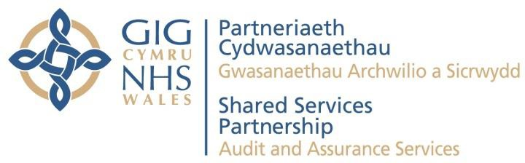

Office details:

Contact details: james.johns@wales.nhs.uk
Webpage: Audit & Assurance Services - NHS Wales Shared Services Partnership



Recruitment Services Final Internal Audit Report
October 2022

NHS Wales Shared Services Partnership

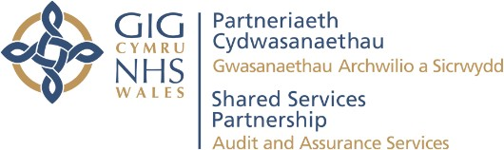
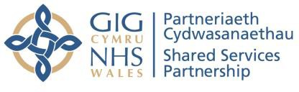

Recruitment Services Final Internal Audit Report

Contents
Executive Summary 3
- Introduction 4
- Detailed Audit Findings 5
Appendix A: Management Action Plan 8
Appendix B: Assurance opinion and action plan risk rating 10

Review reference:
Report status:
Fieldwork commencement: Fieldwork completion: Debrief meeting:
Draft report issued: Management response received: Final report issued:
Auditors:
NWSSP-2223-02
Final
22nd August 2022
10th October 2022
6th
October 2022
Executive sign-off: Distribution:
Committee:
12th October 2022
24th October 2022
25th October 2022
Gareth Heaven, Audit Manager Henry Wellesley, Audit Manager
Gareth Hardacre, Director of People, Organisation Development and Employment Services
Darren Rees, Interim Deputy Director of Employment Services Kelly Skene, Assistant Director of Employment Services
Velindre University NHS Trust Audit Committee for NWSSP


Audit and Assurance Services conform with all Public Sector Internal Audit Standards as validated through the external quality assessment undertaken by the Institute of Internal Auditors

Acknowledgement
NHS Wales Audit and Assurance Services would like to acknowledge the time and co-operation given by management and staff during the course of this review.

Disclaimer notice - please note
This audit report has been prepared for internal use only. Audit and Assurance Services reports are prepared, in accordance with the agreed audit brief, and the Audit Charter as approved by the Audit Committee.
Audit reports are prepared by the staff of the NHS Wales Audit and Assurance Services, and addressed to Independent Members or officers including those designated as Accountable Officer. They are prepared for the sole use of NHS Wales Shared Services Partnership and no responsibility is taken by the Audit and Assurance Services Internal Auditors to any director or officer in their individual capacity, or to any third party.

NWSSP Audit and Assurance Services 2

Recruitment Services Final Internal Audit Report

Executive Summary

Report Opinion
Purpose
The overall objective of this audit was to assess the adequacy and effectiveness of systems and controls for the management of Recruitment Services.
Overview
The Recruitment Service has in place a service level agreement (SLA) that sets out key responsibilities and timescales, a robust system ensuring compliance with the NHS Employment Check Standards and regular monitoring of performance.
Two medium priority matters arising were identified relating to:
- the Employment Services risk register reflects the risk associated with new starters commencing employment before the completion of pre-employment checks however, the potential impact of this risk affects the recruiting body rather than NWSSP. The real risk to NWSSP (if any) is not clear and therefore requires reassessment; and
- analysis of customer service surveys has not taken place since February 2022.
Accordingly, we have concluded
Reasonable assurance overall.

Reasonable Some matters require

management attention in control design or compliance.
Low to moderate impact on residual risk exposure until resolved.

Trend

N/A

Assurance summary1
Objectives Assurance
The recruitment process is managed  1 and delivered in accordance with the SLA | Substantial
2 Pre-employment checks comply with the NHS Employment Checks Standards | Reasonable
Performance, including customer  3 satisfaction, is monitored and any issues resolved | Reasonable
¹The objectives and associated assurance ratings are not necessarily given equal weighting when formulating the overall audit opinion.

Key Matters Arising Objective
Control Design or Operation

Recommendation Priority

1 | Risk Register | 2 | Design | Medium
2 | Customer Satisfaction Analysis | 3 | Operation | Medium

NWSSP Audit and Assurance Services 3

Recruitment Services Final Internal Audit Report

Introduction
  - Recruitment Services is a function of Employment Services within NHS Wales Shared Services Partnership (NWSSP) that provides a standardised approach to recruitment across NHS Wales. The function is split across three teams in Cardiff, Swansea and St Asaph.
  - TRAC application management software facilitates the end-to-end recruitment process from vacancy approval to the completion of recruitment checks. NHS Employment Check Standards outline the type and level of checks employers must carry out before recruiting staff into NHS positions.
  - The risks considered in this review were:
    - insufficient resources to cope with the sustained increase in recruitment activity, potentially impacting on staff wellbeing and the quality of service provided to NHS Wales organisations;
    - inefficient recruitment processes impact the ability to recruit and appoint suitable candidates within NHS Wales, potentially resulting in service disruption causing harm to patients, increased agency staff costs and reputational damage; and
    - NHS staff do not have the appropriate qualifications or experience for their role potentially resulting in harm to patients, staff or the general public.
  - The scope of this review was restricted to the systems, responsibilities and controls within NWSSP only.

Recruitment Services Final Internal Audit Report

Detailed Audit Findings
Objective 1: The end-to-end recruitment process is managed and delivered in accordance with the responsibilities and timescales set out within the SLA (April 2022)
  - The Employment Services SLA sets out the requirement to provide a comprehensive recruitment and selection service including key responsibilities for both NWSSP Recruitment Services and Health Boards/Trusts. These responsibilities are aligned against quality standards and key performance indicators (KPIs) – see Table A on page 7.
  - The Employment Services intranet page provides recruiting managers with a suite of bespoke standard operating procedures (SOPs) for each Health Board/Trust and training videos that provides a step-by-step guide through the recruitment and selection process.
Conclusion:
  - Noting the above, we have concluded Substantial assurance of this objective.

Objective 2: Pre-employment checks are completed in line with the NHS Employment Checks Standards
  - In line with the NHS Employment Checks Standards, Recruitment Services are required to check the following information for both internal and external new starters.
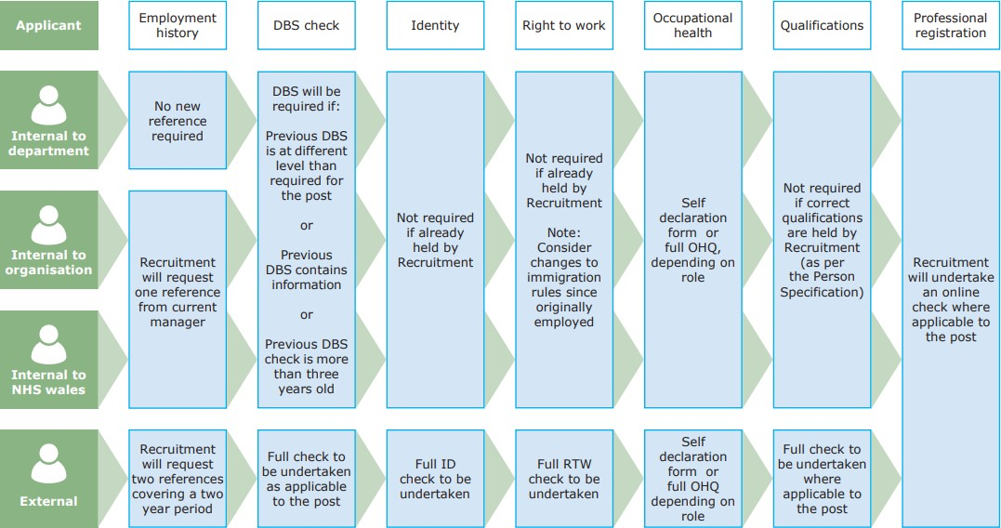
NWSSP Recruitment – Internal Employment Check Process (Passport)

Recruitment Services Final Internal Audit Report

  - A sample of 40 new starters on the payroll for health bodies across Wales was reviewed to establish whether pre-employment checks (PECs) had been undertaken.
  - One instance was identified where a second reference had not been acquired due to an administrative error by Recruitment Services – this was an isolated instance raised with the Head of Recruitment during fieldwork.
  - Five instances were identified where new starters had commenced employment up to two weeks prior to receipt of the criminal record check, although all other checks had been completed. Whilst the criminal record checks had been instigated promptly by Recruitment Services, delays were noted in obtaining the required supporting documentation from the candidate, subsequently delaying submission of the application to the Disclosure & Barring Service. The SLA states that recruiting managers should not agree a start date until all PECs have been completed. Where health bodies choose to start a new employee prior to the completion of the PECs this is outside of the control of NWSSP.
  - The risks associated with new starters commencing employment prior to the completion of PECs is reflected on the Employment Services risk register, albeit the potential impact of this (patient harm, financial penalty) affects the recruiting body rather than NWSSP. The New Appointment Form (NAF) is identified as a mitigating control however, this does not prevent new starters commencing in post before completion of PECs as stated in the register. [Matter Arising 1]
Conclusion:
  - Noting the above, we have concluded Reasonable assurance for this objective.

Objective 3: Performance, including customer satisfaction, is monitored and any issues or complaints are resolved promptly
  - Recruitment Services produce an All-Wales Performance & Volumes Report providing a breakdown of performance against KPI targets (see Table A below) and is issued to health bodies on a monthly basis. We confirmed that the All-Wales performance figures for August 2022 reconciled to source data in TRAC.
  - Recruitment Services are consistently meeting targets with the exception of ‘Completion of pre-employment checks within 25 days’. We were advised that this is due to delays in obtaining evidence from external sources such as references and criminal record checks, and our testing identified examples supporting this (see para 2.7). Recruitment Services also cited difficulty in completing PECs where the new starter has already commenced in post.
  - Two of the four Health Board/Trusts KPIs identified in Table A were consistently not met, in particular significant delays were identified between the time from resignation to submitting vacancy for approval on TRAC.

Recruitment Services Final Internal Audit Report

Table A
AGREED KPI | RESPONSIBILITY & TARGET | AVERAGE WORKING DAYS PER MONTH 2022/23
AGREED KPI | RESPONSIBILITY & TARGET | MAY | JUNE | JULY | AUGUST
Time from resignation to submitting vacancy for approval on TRAC | Health Board/ Trust  (5 Days) | 52.4 | 57.2 | 44.0 | 49.4
Time to approve/authorise a vacancy | Health Board/ Trust  (10 Days) | 8.1 | 8.7 | 8.0 | 7.8
Time to place adverts live | NWSSP  (2 Days) | 1.4 | 1.4 | 1.6 | 1.6
Time to send applications to a manager after the post closes | NWSSP  (2 Days) | 1.1 | 1.1 | 1.0 | 1.0
Time to shortlist by manager | Health Board/ Trust  (3 Days) | 7.4 | 6.9 | 6.1 | 7.3
Time to invite candidates to interview | NWSSP  (3 Days) | 2.3 | 2.4 | 2.9 | 1.9
Time to notify Recruitment of interview outcome | Health Board/ Trust  (3 Days) | 2.3 | 2.4 | 2.9 | 1.9
Time to send conditional offer letter | NWSSP  (4 Days) | 3.7 | 3.4 | 3.4 | 3.6
Completion of pre-employment checks | NWSSP  (25 Days) | 37.4 | 46.2 | 37.0 | 32.9
Time to send unconditional offer letter | NWSSP  (2 Days) | 1.8 | 1.9 | 1.8 | 2.1
  - Employment Services has a SOP for dealing with complaints, issues and compliments. Complaints, compliments and issues statistics are reported at the Employment Services quarterly review. No formal complaints were reported for Recruitment Services in quarter one of 2022/23.
  - Customer satisfaction surveys are issued to applicants and recruiting managers via an automated email from the TRAC system at various stages of the recruitment and selection process. Whilst the current response rate is low, the survey will be reviewed as part of the Contact Centre Project with a view to improving the response rate. We were informed that due to recent work pressures, feedback from the customer satisfaction surveys has not been reviewed since February 2022. [Matter Arising 2]
Conclusion:
  - Noting the above, we have concluded Reasonable assurance of this objective.

Recruitment Services Final Internal Audit Report
Appendix A

Appendix A: Management Action Plan
Matter Arising 1: Risk Register (Design) |  |  | Impact
The risk relating to new starters commencing employment prior to completion of PECs is reflected on the Employment Services risk register, albeit the potential impact (patient harm, financial penalty) would affect the recruiting body rather than NWSSP. The New Appointment Form (NAF) is identified as a mitigating control, however this does not prevent new starters commencing in post before completion of PECs as stated in the register. |  |  | Risks relating to the recruitment service are not identified and mitigated, potentially impacting on the quality of service provided to health bodies.  Risks are not accurately assessed resulting in inefficient use of resources to manage and mitigate.
Recommendation |  |  | Priority
1.1 | Re-assess the risk relating to new starters commencing in post before completion of PECs to ensure it reflects the potential risk to NWSSP rather than the recruiting body. If there is deemed to be a risk to NWSSP, actions should be identified to effectively mitigate the risk, and should be within the gift of NWSSP. |  | Medium
Agreed Management Action |  | Target Date | Responsible Officer
1.1 | The risk will be removed from NWSSP Employment Services Risk Register.  The risk is a risk to Health Bodies, as the appointees are their employees. The decision to start people with incomplete pre-employment checks sits with the Health Bodies and not with NWSSP. The managers have access to the TRAC Recruitment System to review the pre-employment checks for their appointees 24 hours a day, 7 days a week. Please note though that significant engagement has been undertaken in this area with HBs to ensure they understand the risk. The final decision though is not within NWSSPs gift. | 24th October 2022 | Assistant Director of Employment Services

Recruitment Services Final Internal Audit Report
Appendix A

Matter Arising 2: Customer Survey Analysis (Operation) |  |  | Impact
We were informed that due to recent work pressures, a review of customer satisfaction surveys have not taken place since February 2022. |  |  | Inefficient recruitment processes impact the ability to recruit and appoint suitable candidates within NHS Wales, potentially resulting in service disruption causing harm to patients, increased agency staff costs and reputational damage.
Recommendation |  |  | Priority
2.1 | Feedback received via the customer satisfaction surveys should be reviewed and analysed on a regular basis to identify and address areas requiring improvement. |  | Medium
Agreed Management Action |  | Target Date | Responsible Officer
2.1 | Due to service pressures and significant change programmes running in the department the survey analysis has not been completed as regularly as required. Once the Recruitment Modernisation process changes are implemented for all Health Bodies, and the Trust ID system is embedded across Wales, the Recruitment Service will analyse survey responses quarterly. | 31st January 2023 | Assistant Director of Employment Services

Recruitment Services Final Internal Audit Report Appendix B

Appendix B: Assurance opinion and action plan risk rating

Audit Assurance Ratings
We define the following levels of assurance that governance, risk management and internal control within the area under review are suitable designed and applied effectively:

Substantial assurance

Reasonable assurance
Few matters require attention and are compliance or advisory in nature.
Low impact on residual risk exposure.
Some matters require management attention in control design or compliance.
Low to moderate impact on residual risk exposure until resolved.

Limited assurance
More significant matters require management attention.
Moderate impact on residual risk exposure until resolved.

No assurance


Assurance not applicable
Action is required to address the whole control framework in this area.
High impact on residual risk exposure until resolved.
Given to reviews and support provided to management which form part of the internal audit plan, to which the assurance definitions are not appropriate.
These reviews are still relevant to the evidence base upon which the overall opinion is formed.

Prioritisation of Recommendations
We categorise our recommendations according to their level of priority as follows:

Priority level | Explanation | Management action
High | Poor system design OR widespread non-compliance.  Significant risk to achievement of a system objective OR evidence present of material loss, error or misstatement. | Immediate*
Medium | Minor weakness in system design OR limited non-compliance. Within one month* Some risk to achievement of a system objective.
Low | Potential to enhance system design to improve efficiency or effectiveness of controls.  Generally issues of good practice for management consideration. | Within three months*
* Unless a more appropriate timescale is identified/agreed at the assignment.

NWSSP Audit and Assurance Services 10


Partneriaeth Cydwasanaethau
Gwasan.aethau Archwilio a Sim-vydd
Shared Services
Partners.hip
Audit and Assurance Services

NHS Wales Shared Services Partnership 4-5 Charnwood Court
Heol Billingsley Parc Nantgarw Cardiff
CF15 7QZ

Website: Audit & Assurance Services - NHS Wales Shared Services Partnership

Laundry Service – Glan Clwyd Final Internal Audit Report
December 2022

NHS Wales Shared Services Partnership NWSSP Audit and Assurance

Laundry Service – Glan Clwyd Final Internal Audit Report

Contents
Executive Summary 3
- Introduction 4
- Detailed Audit Findings 5
Appendix A: Management Action Plan 9
Appendix B: Assurance opinion and action plan risk rating 12
Review reference: NWSSP-2223-05b
Report status: Final
Fieldwork commencement: 23 September 2022
Fieldwork completion: 10 November 2022
Draft report issued: 14 November 2022
Management response received: 16 November 2022
Executive sign-off: 5 December 2022
Final report issued: 12 December 2022
Auditors: James Johns, Head of Internal Audit
Sophie Corbett, Deputy Head of Internal Audit Pat Williams, Principal Auditor
Executive sign-off: Jonathan Irvine, Director of Procurement Services Distribution: Anthony Hayward, Assistant Director of Laundry & Operations
Oliver Rix, Business Manager, Laundry Services
Peter White, Laundry Operations Manager Nigel Higgins, Laundry Assistant Manager
Committee: Velindre University NHS Trust Audit Committee for NWSSP

Audit and Assurance Services conform with all Public Sector Internal Audit Standards as validated through the external quality assessment undertaken by the Institute of Internal Auditors
Acknowledgement
NHS Wales Audit & Assurance Services would like to acknowledge the time and co-operation given by management and staff during the course of this review.

Disclaimer notice - please note
This audit report has been prepared for internal use only. Audit & Assurance Services reports are prepared, in accordance with the Service Strategy and Terms of Reference, approved by the Audit Committee.
Audit reports are prepared by the staff of the NHS Wales Shared Services Partnership – Audit and Assurance Services and addressed to Independent Members or officers including those designated as Accountable Officer. They are prepared for the sole use of the NHS Wales Shared Services Partnership and no responsibility is taken by the Audit and Assurance Services Internal Auditors to any director or officer in their individual capacity, or to any third party.

NWSSP Audit and Assurance Services 2

Laundry Service – Glan Clwyd Final Internal Audit Report

Executive Summary

Report Classification

Purpose
The overall objective of the review was to provide a baseline for the new national Laundry Service hosted by NWSSP since April 2021, and a high-level overview of existing governance and management arrangements.
Overview
We have concluded Reasonable assurance overall with one high priority matter arising relating to the physical condition and security of the Glan Clwyd site.
We also identified one medium priority matters arising relating to:
- Lack of ICT asset register.
Full details are provided in Appendix A.

Reasonable Some matters require
management attention in
control design or compliance.
Low to moderate impact on residual risk exposure until resolved.

Assurance summary1

Trend

N/A
First Review (Glan Clwyd)

Assurance objectives Assurance
1 Business Continuity | Substantial
2 Physical Security | Limited
3 Plant & Equipment Records | Reasonable
4 Stock Traceability | Reasonable
5 Recording Laundry Activity | Reasonable
6 Non-NHS Activity n/a

7 | Time & Attendance |  | Substantial
8 | Sickness | Absence | Reasonable
9 | PADRs |  | Reasonable

Key Matters Arising
Assurance Objective
Control Design or Operation
Recommendation Priority

1 | Site Security | 2 | Design | High
2 | ICT Asset Register | 3 | Design | Medium

¹ The objectives and associated assurance ratings are not necessarily given equal weighting when formulating the overall audit opinion.

NWSSP Audit and Assurance Services 3

Laundry Service – Glan Clwyd Final Internal Audit Report

Introduction
  - The All-Wales Laundry Service was established in April 2021 with the transfer of laundry service provision from Health Boards to NHS Wales Shared Services Partnership (NWSSP) as agreed by the Shared Services Partnership Committee in May 2016.
  - The availability of clean, decontaminated linen is fundamental to the operation of core NHS services and the delivery of high quality, safe patient care. There are currently five laundry production units servicing NHS Wales:

Transferred April 2021 | Transferred October 2021
Ysbyty Glan Clwyd Laundry (North Wales) | Glangwili Laundry (Carmarthen)
Llansamlet Laundry (Swansea) | Church Village Laundry (Rhondda Cynon Taf)
Green Vale Laundry (Cwmbran)
  - The first audit of the All-Wales Laundry Service was undertaken in 2021/22 at Llansamlet Laundry, to provide a high-level overview of existing governance and management arrangements with a view to providing a baseline for the new national service. We concluded Reasonable assurance overall, with a number of actions identified to improve the existing control environment at Llansamlet Laundry, although some were applicable to the wider All-Wales Laundry Service. This audit has adopted the same approach for consistency.
  - The potential risk considered in the review is that the laundry service is not operating efficiently or effectively, potentially resulting in:
    - detrimental impact on the continuity of hospital services and patient safety; and
    - financial loss.

Laundry Service – Glan Clwyd Final Internal Audit Report

Detailed Audit Findings
Objective 1: Service continuity arrangements have been developed, documented and tested
  - The Standard Operating Procedure for Laundry Production Unit (LPU) Loss of Production (December 2021) sets out the process for the NWSSP Laundry Service to continue to provide services in the event of a shutdown of an LPU due to equipment failure or staffing levels.
  - Each LPU has a nominated back up site for the transfer of activity in the event of loss of production, with a flowchart setting out the procedure to be followed. Optimum and minimum staffing levels have been identified for each site.
  - Buffer stock is held at each laundry site, sufficient to serve production needs for one day due to limited storage capacity. An emergency linen stock has been established at IP5 in Newport equivalent to 3-5 days of production at each LPU. Senior management approval is required to release stock.
  - The SOP was tested in December 2021, with the total shutdown of Glan Clwyd Laundry and transfer of activity to Green Vale (week 1) and reduced production at Greenvale, testing a new process, extended working hours and transfer of staff from Swansea Laundry (week 2). An Operations Update Report to the Transformational Programme Board reported that these exercises were successful with no impact to customers.
Conclusion:
  - Business continuity arrangements have been documented in a standard operating procedure and successfully tested. Accordingly, we have concluded Substantial assurance for this objective.
Objective 2: Appropriate physical controls are in operation at laundry sites
  - During a site visit at the Glan Clwyd Laundry we noted that the building is in a poor state of repair with fire exit doors in poor condition providing opportunity for unauthorised access. Unlike Llansamlet and Green Vale Laundries, there is no alarm system or CCTV in place, no perimeter fencing and a record of building key holders is not maintained. We also observed fire exit doors propped open to allow ventilation.
[Matter Arising 1]
Conclusion:
  - Whilst we acknowledge the longer terms plan to move to a new site as part of the all-Wales Laundry Service Transformation Programme, the existing facility is in a poor state of repair. Accordingly, we have concluded Limited assurance for this objective.

Laundry Service – Glan Clwyd Final Internal Audit Report

Objective 3: Records of plant and equipment are maintained and up to date
  - A record of production and engineering assets is maintained with the serial number and purchase date of each item. Sample testing of 10 assets from the physical items to the register and vice versa found no issues.
  - We observed a small number of ICT assets on site however a record of these assets is not maintained. [Matter Arising 2]
Conclusion:
  - The asset register records production and engineering assets but excludes ICT assets. Accordingly, we have concluded Reasonable assurance for this objective.

Objective 4: Appropriate systems are in place to ensure that linen stocks are traceable, with movement between laundry and hospital sites recorded
  - Linen items are not separately identifiable and movements are not traceable. We were informed that Green Vale Laundry previously trialled a sensor system to enable the tracking of individual linen items however this was unsuccessful.
  - Items are collected, processed and reissued in a continuous cycle. Linen stocks are owned by the Laundry. New linen orders are infrequent and based on the Laundry’s ability to fulfil requests for additional items.
  - Dirty linen is not recorded at the point of collection or processing due to infection control implications of handling and counting items. Consequently, it is not possible to identify or quantify missing items. A record of ‘rejected’ items (i.e. condemned following washing and rewashing) is maintained. This is consistent with the arrangements observed during the 2021 audit of Llansamlet Laundry.
  - The cost of missing linen stock is currently absorbed by the Laundry in terms of replacement costs. We were advised that a standard pricing model will be implemented following completion of the All-Wales Laundry Transformational Programme which will incorporate all operating costs including replacement linen stock. A recommendation relating to this has been raised in the Laundry Service - Green Vale audit report (NWSSP-2223-05a) so no further recommendations are raised here.
Conclusion:
  - It is not feasible to record dirty linen items collected and processed by the Laundry, so it is difficult to identify and quantify missing items. The cost of missing stock is currently absorbed by the Laundry; however, this will be addressed with the implementation of a standard pricing model. Consequently, we have concluded Reasonable assurance for this objective.

Laundry Service – Glan Clwyd Final Internal Audit Report

Objective 5: Systems and processes are in place to record both NHS and non- NHS activity (where applicable), ensuring that associated income is invoiced and received
  - Linen is issued based on the agreed stock levels as per the service level agreement and physical stock levels at each site. Items processed and issued are manually recorded on a spreadsheet for each site and total activity for the laundry is manually calculated and entered onto the Laundry Services Weekly Production Dashboard. For other sites this information can be extracted from the Benchmarker system. We understand that the Benchmarker system used in Green Vale and Llansamlet laundries is due to be implemented but the timescales for this are not clear. [Matter Arising 3]
  - Current prices are based on 2019/20 prices plus 2% inflation, although prices and billing vary across Wales due to legacy arrangements. The Health Board and Trust serviced by Glan Clwyd Laundry are invoiced quarterly based on a fixed rate agreement and agreed annual activity set out in the Service Level Agreement (SLA).
  - Review of production data for Q1-3 noted that this is generally in line with the agreed activity levels. The SLA includes agreed tolerances which, if exceeded, will trigger a review of the annual fee as part of the quarterly review process.
Conclusion:
  - The arrangements for recording activity are satisfactory, albeit there is opportunity to improve efficiency and consistency with the planned implementation of Benchmarker system at Glan Clwyd Laundry. Prices charged reflect legacy arrangements prior to the transfer to NWSSP and this will be addressed following completion of the Transformational Programme. Accordingly, we have concluded Reasonable assurance for this objective.

Objective 6: Non-NHS activity represents value for money and any cash income is recorded, securely stored and banked regularly
  - Management advised that there is no non-NHS activity or cash income at Glan Clwyd Laundry.
Conclusion:
  - Noting the above, an assurance rating is not applicable for this objective.

Objective 7: Time and attendance recording systems are in place
  - Time and attendance is recorded using sign in/out sheets, which are checked against the Health Roster system to ensure it is up to date as it feeds into the Payroll system. An electronic clock in system is in the process of being installed.
  - Overtime to cover staff absence and vacancies is available to staff on the request of the Laundry Manager and is recorded and approved on Health Roster.

Laundry Service – Glan Clwyd Final Internal Audit Report

  - Annual leave is recorded on Health Roster which updates the ESR system on the 8th of each month. We were advised that issues have been experienced with staff absence not correctly updating on ESR, although Workforce assured that balances were manually corrected and the issue has now been resolved.
Conclusion:
  - We have concluded Substantial assurance for this objective.

Objective 8: Sickness absence is managed in accordance with the All Wales Managing Attendance at Work Policy
  - A central record of sickness absence is maintained and used to update the Health Roster system, which in turn updates ESR.
  - Workforce have recently completed a deep dive review of sickness absence at Glan Clwyd Laundry. The review included an analysis of sickness patterns and a sickness file audit, so we have not undertaken further testing in this area. A number of recommendations were identified in relation to compliance with key requirements of the Managing Attendance at Work (MAAW) Policy, including sickness absence review meetings and return to work interviews. Workforce continue to support Glan Clwyd Laundry in understanding the requirements of the MAAW Policy and addressing the issues identified.
Conclusion:
  - Noting the above, we have concluded Reasonable assurance for this objective.

Objective 9: Personal Appraisal & Development Reviews (PADRs) are undertaken in line with the NWSSP Appraisal Procedure
  - Workforce have been working closely with Laundry Services to deliver training and support improved PADR compliance, which has increased from 10.69% in May 2022 to 73.48% in July 2022. At the time of our review Glan Clwyd Laundry compliance was 71.74%.
  - Sample testing of employees with a PADR date recorded in ESR confirmed that PADRs had been completed and evidenced on the employees personal file, with the date accurately recorded in ESR.
Conclusion:
  - Whilst the PADR compliance rate for Glan Clwyd is improving it remains below NWSSP target of 85%. Accordingly, we have concluded Reasonable assurance for this objective.

Final Internal Audit Report Appendix A

Appendix A: Management Action Plan
Matter Arising 1: Site Security (Design) |  | Impact
During a site visit at the Glan Clwyd Laundry we noted that the building is in a poor state of repair with fire exit doors in poor condition providing opportunity for unauthorised access. Unlike Llansamlet and Green Vale Laundries, there is no alarm system or CCTV in place, no perimeter fencing and a record of building key holders is not maintained. We also observed fire exit doors propped open to allow ventilation. |  | Potential risk of:  - malicious damage / theft resulting in service disruption.
Recommendations |  | Priority
1.1 Perform a risk assessment of the existing site to identify and prioritise any significant issues with the physical site condition/security that need to be addressed in the interim period until the facility is moved to a new site as part of the transformation programme. |  | High
Agreed Management Action | Target Date | Responsible Officer
1.1 Management accept the recommendation and will conduct a security review, the recommendations will then be implemented in collaboration with BCUHB who own and maintain the building. | 31 March 23 | Peter White, Laundry Operations Manager

Final Internal Audit Report Appendix A

Matter Arising 2: ICT Asset Register (Design) |  | Impact
A record of ICT assets is not maintained. |  | Potential risk of:  - assets are not identifiable or traceable  - loss/theft resulting in service disruption
Recommendations |  | Priority
2.1 Management should maintain a record of ICT assets identifying the make/model, serial/asset numbers and location. |  | Medium
Agreed Management Action | Target Date | Responsible Officer
2.1 Management agree and will develop an asset register containing all ICT assets including the make/model, serial/asset numbers and location. | 28 February 23 | Peter White, Laundry Operations Manager

Final Internal Audit Report Appendix A

Matter Arising 3: Record of Activity (Design) |  | Impact
Items processed and issued are manually recorded on a spreadsheet for each site and total activity for the laundry is manually calculated and entered onto the Laundry Services Weekly Production Dashboard. For other sites this information can be extracted from the Benchmarker system. We understand that the Benchmarker system used in Green Vale and Llansamlet laundries is due to be implemented but the timescales for this are not clear. |  | Potential risk of:  - financial loss.
Recommendations |  | Priority
3.1 We concur with the plans to implement the Benchmarker system at Glan Clwyd Laundry and a timescale for completion of this should be determined. This will achieve consistency across the service, improve efficiency and reduce the risk of human error by reducing manual intervention, and also provide a more robust audit trail of production activity. |  | Low
Agreed Management Action | Target Date | Responsible Officer
3.1 The North Wales LPU is included in the Benchmarker rollout programme achieving consistency in data collection for the group | 31 March 23 | Ollie Rix, Business Manager

Final Internal Audit Report Appendix B

Appendix B: Assurance opinion and action plan risk rating

Audit Assurance Ratings
We define the following levels of assurance that governance, risk management and internal control within the area under review are suitable designed and applied effectively:

Substantial assurance

Reasonable assurance
Few matters require attention and are compliance or advisory in nature.
Low impact on residual risk exposure.
Some matters require management attention in control design or compliance.
Low to moderate impact on residual risk exposure until resolved.

Limited assurance
More significant matters require management attention.
Moderate impact on residual risk exposure until resolved.

No assurance

Assurance not applicable
Action is required to address the whole control framework in this area.
High impact on residual risk exposure until resolved.
Given to reviews and support provided to management which form part of the internal audit plan, to which the assurance definitions are not appropriate.
These reviews are still relevant to the evidence base upon which the overall opinion is formed.

Prioritisation of Recommendations
We categorise our recommendations according to their level of priority as follows:

Priority level | Explanation | Management action
High | Poor system design OR widespread non-compliance.  Significant risk to achievement of a system objective OR evidence present of material loss, error or misstatement. | Immediate*
Medium | Minor weakness in system design OR limited non-compliance. Some risk to achievement of a system objective. | Within one month*
Low | Potential to enhance system design to improve efficiency or effectiveness of controls.  Generally issues of good practice for management consideration. | Within three months*
* Unless a more appropriate timescale is identified/agreed at the assignment.

NWSSP Audit and Assurance Services 12


Partneriaeth Cydwasanaethau
GVw 1san.>elhau Arch-.villO ,1 Sicrw,,dd
Shared Services
Partnership
Audit and Assurance Services
NHS Wales Shared Services Partnership 4-5 Charnwood Court
Heol Billingsley Parc Nantgarw Cardiff
CF15 7QZ

Website: Audit & Assurance Services - NHS Wales Shared Services Partnership

Accounts Payable
Final Internal Audit Report
January 2023

NHS Wales Shared Services Partnership

Accounts Payable Final Internal Audit Report

Contents
Executive Summary 3
- Introduction 4
- Detailed Audit Findings 5
Appendix A: Management Action Plan 11
Appendix B: Assurance opinion and action plan risk rating 15

Review reference:
Report status:
Fieldwork commencement: Mid-audit review meeting: Fieldwork completion:
Draft report issued: Management response received: Final report issued:
Auditors: Executive sign-off: Distribution:

Committee:
NWSSP-2223-12
Final
24 August 2022
17 November 2022
20 December 2022
9 January 2023
11 January 2023
13 January 2023
Jennifer Usher, Principal Auditor
Andrew Butler, Director of Finance & Corporate Services Russell Ward, Head of Accounts Payable and Enablement Alison Ruckley, AP Regional Manager
Rowena Bines, AP Regional Manager
Dawn Butterworth, AP Regional Manager
Velindre University NHS Trust Audit Committee for NWSSP

Audit and Assurance Services conform with all Public Sector Internal Audit Standards as validated through the external quality assessment undertaken by the Institute of Internal Auditors

Acknowledgement
NHS Wales Audit and Assurance Services would like to acknowledge the time and co-operation given by management and staff during the course of this review.

Disclaimer notice - please note
This audit report has been prepared for internal use only. Audit and Assurance Services reports are prepared, in accordance with the agreed audit brief, and the Audit Charter as approved by the Audit Committee.
Audit reports are prepared by the staff of the NHS Wales Audit and Assurance Services, and addressed to Independent Members or officers including those designated as Accountable Officer. They are prepared for the sole use of NHS Wales Shared Services Partnership and no responsibility is taken by the Audit and Assurance Services Internal Auditors to any director or officer in their individual capacity, or to any third party.

NWSSP Audit and Assurance Services 2

Accounts Payable Final Internal Audit Report

Executive Summary

Report Opinion

Purpose
The purpose of the audit review was to evaluate and determine the adequacy of the systems and controls in place over the management of the NWSSP Accounts Payable service.
Overview
We have concluded Reasonable assurance overall, with three medium priority matters arising relating to:
- clarification and application of the verification and review /approval process for supplier bank additions/amendments;
- authorisation of non-PO invoices in line with organisation approval hierarchies; and
- exploring use of the Oracle Invoice Approval Workflow to facilitate more efficient and robust approval of non- PO invoices.
One low priority matter arising has also been identified relating to minor non- compliance with regards to disputed invoices.
Full details of all matters arising and associated recommendations are provided at Appendix A on page 13.
Some matters require management attention in

Trend

Reasonable
control design or compliance.
Low to moderate impact on residual risk exposure until resolved
2021/22

Assurance summary1
Objectives Assurance
1 | Amendments and additions to the Supplier Masterfile | Reasonable
2 | Invoices are supported by a purchase order (PO) in line with the No PO No Pay Policy | Reasonable
3 | Non-PO invoices are appropriately authorised and accurately processed | Reasonable
4 | Invoices on hold are monitored and cleared on a regular basis to ensure compliance with PSPP | Reasonable
5 | COVID-19 revised payment arrangements are complied with | Reasonable
6 | Mechanisms are in place to ensure that duplicate payments are avoided or detected | Substantial
7 | Previous audit recommendations | Reasonable
¹The objectives and associated assurance ratings are not necessarily given equal weighting when formulating the overall audit opinion.

Key Matters Arising Objective Control Design
or Operation
Recommendation Priority

1 Supplier Bank Account Additions and  Amendments | 1 | Operation | Medium
2.1 Authorisation of Non-PO Invoices (1) | 3 | Operation | Medium
2.2 Oracle Invoice Approval Workflow | 3 | Design / Operation | Medium

NWSSP Audit and Assurance Services 3

Accounts Payable Final Internal Audit Report

Introduction
  - NHS Wales Shared Services Partnership (NWSSP) provides a complete Procure to Pay (P2P) service to NHS Wales through sourcing, frontline local procurement, supply chain, accounts payable and eEnablement functions.
  - The Accounts Payable (AP) team comprises 117.2 full time equivalent (FTE) which includes 3.8 FTE responsible for supplier masterfile maintenance. During 2021/22, the AP Team processed 2.06 million invoices, for approximately 16,000 active suppliers with a value of £6.9 billion.
  - In line with the Public Sector Payment Policy (PSPP), NHS Wales has an obligation to pay its suppliers within 30 days of receipt of invoice. NHS bodies report compliance to Welsh Government in the monthly monitoring returns. To facilitate this, the AP Team report against key performance indicators to customer organisations on a monthly basis. At November 2022:

Invoice Volumes
13% increase compared to 2021/22 35.9% increase compared to 2020/21 Forecast to exceed 2.3m for 2022/23

PSPP Compliance
9 organisations have achieved the target 95% compliance (cumulative ytd)

Invoices on Hold (IOH)
37,145 IOH >30 days

Duplicate Payments
£7.8m prevented
£1.56m cost avoidance re: recovery audit fees @20%

  - The potential risks considered in the review were as follows:
    - purchases and payments are made without due authority;
    - payments are made for goods/services not received;
    - payments are made to the wrong supplier or for the wrong amount;
    - duplicate payments are not prevented or detected;
    - late payments resulting in breach of Public Sector Payment Policy;
    - failure to achieve value for money; and
    - fraud.

Accounts Payable Final Internal Audit Report

Detailed Audit Findings
Objective 1: There is adequate control over the creation and amendments of creditor masterfile data
  - Access to the supplier masterfile is restricted to the Supplier Maintenance Team (SMT) and reviewed on a quarterly basis.
  - Additions and amendments to the supplier masterfile are processed and independently checked within the SMT to ensure accuracy.
  - In response to the heightened fraud risk due to an increase in the number of attempted bank mandate frauds, controls around the processing of supplier bank changes were enhanced during 2021:
improved verification checks with the supplier
implementation of a bank account mandate checklist
independent review and approval of bank account amendments by the Head of Finance & Business Development
use of Experian bank account verification service

  - These enhanced controls have not been formally documented or reflected in SMT procedural guidance documents. We noted ambiguity around the requirements for Experian checks and escalation to the Head of Finance & Business Development for approval. The SMT advised that checks are not completed for schools or one- off payments but the rationale for this was not clear, and the Head of Finance & Business Development was not aware. [See Matter Arising 1 in Appendix A]
  - The Experian check is a two-step process, firstly validating account number and sort code then matching to the payee details. Where the Experian check has resulted in a no match (for which there is no fee), additional verification checks are undertaken by the SMT Leader or Head of Finance & Business Development using a personal banking application, with documented justification for approved additions/amendments where there is still no match (e.g., due to banks not participating in verification schemes).
  - Sample testing of supplier bank additions/amendments noted an Experian match rate of only 53%. The previous audit recommended that management consider the effectiveness of the Experian service to assess whether it is delivering expected benefits. NWSSP have escalated low matching rates to Experian whilst exploring alternative options and we understand that discussions are ongoing with an alternative supplier.
  - We reviewed a sample of 70 additions / amendments to the supplier bank details processed during the period March 2022 to November 2022. All were verified to available source documentation and confirmed to have been promptly and accurately processed. One instance was identified where a bank amendment had not been escalated to the Head of Finance & Business Development for review and approval.
[See Matter Arising 1 in Appendix A]

Accounts Payable Final Internal Audit Report

Conclusion:
  - Controls for additions/amendments to the supplier masterfile have been significantly enhanced albeit not documented, and an isolated instance of non- compliance with independent review/approval requirements for bank amendments was identified (as detailed at paragraph 2.7). Nevertheless, sample testing confirmed all additions/amendments reviewed had been promptly and accurately processed. We have therefore concluded Reasonable assurance for this objective.
Objective 2: Invoices are supported by a purchase order (PO) in line with the No PO No Pay Policy and systems ensure that invoice values paid are in accordance with agreed prices
  - Invoice matching arrangements are determined at supplier set-up, with the default setting requiring a 3-way match between the invoice, PO and order receipt. If a PO invoice does not fully match the PO details (within agreed tolerances) or has not been receipted on Oracle it is automatically placed on hold by the system. Invoice matching tolerances are set within Oracle and are generally standardised for all NHS Wales organisations.
  - In line with the all-Wales No PO No Pay Policy, invoices without a purchase order (PO) that are not on the agreed all-Wales exceptions list should be placed on hold and payment withheld until the supplier provides a valid PO number. Performance data for November 2022 reported No PO No Pay holds continues to remain high, with a new initiative currently being explored utilising retrospective PO data to identify which cost centres are contributing to this.
  - Whilst the volume of No PO No Pay holds has reduced since April 2021, it remains high with 7,493 invoices on hold as at November 2022. No PO No Pay holds is included on the workplan for the internal NWSSP P2P Group1. Following the All- Wales P2P group meeting in November, a No PO No Pay Communication plan setting out the escalation arrangements for non-compliance with PO requirements has been circulated to all members for review and feedback at the next meeting in January 2023.
  - Sample testing of 110 non-PO invoices identified 17 invoices/payments that were not covered by the exceptions list but had not been placed on hold to obtain a valid PO number. However, based on the invoice description/supplier type we were satisfied that a PO may not be appropriate for these and instead the exceptions list requires updating to incorporate examples such as postage stamps, payments to consultants and Welsh Health Specialist Services Committee invoices which are all non-PO. We understand that review of the exceptions list is included on the work plan of the Finance Academy P2P Group and is ongoing.
Conclusion:
  - Management is aware of the need to agree an escalation process with sanctions for non-compliance with the No PO No Pay Policy and update the all-Wales exceptions list which is fundamental to the operation of the policy. These actions

¹ Internal Audit has representation on these Groups

Accounts Payable Final Internal Audit Report

require collective input from all NHS Wales organisations and are reflected on the work plans of the NWSSP P2P and Finance Academy P2P Groups for 2022/23 with action ongoing. Accordingly, we have concluded Reasonable assurance for this objective with no further recommendations raised.

Objective 3: Non-PO invoices and manual payments are appropriately authorised for payment and accurately processed
  - Sample testing of 110 non-purchase order invoices/payments confirmed that all were supported by an official invoice/request for payment, recorded against the correct supplier and for the correct amount. The following exceptions were identified in relation to authorisation to pay:
    - three occasions where the approver was not identified on the respective authorised signatory list; and
    - in four cases the invoice value exceeded the approvers financial limit.
  - The AP Team are reliant on health bodies maintaining their authorised signatory lists, which vary significantly in terms of accessibility for AP, format and level of detail. Oracle has an invoice approval workflow which would enable non-PO invoices to be subject to the same authorisation system controls as POs, in line with the organisations Oracle hierarchy. This function offers efficiency and a more robust approval mechanism through system automation and application of the organisations approval hierarchy. Following an initial pilot exercise, it was adopted by Digital Health & Care Wales (DHCW) in 2020. Further implementation across NHS Wales requires agreement from the participating organisations and should be explored at the Finance Academy P2P Group.
[See Matter Arising 2 in Appendix A]
Conclusion:
  - Testing identified a small number of invoices which did not have evidence of appropriate approval on the basis that the approver did not have sufficient delegated authority or was not located on the organisations authorised signatory listing/Oracle hierarchy. Accordingly, we have concluded Reasonable assurance for this objective.

Objective 4: Invoices on hold are monitored and cleared on a regular basis to ensure compliance with PSPP
  - In January 2022 an IOH Guide was developed and circulated to all Procurement and AP staff. The guide covers all IOH processes, explains the roles and responsibilities, rules for disputed invoices and individual working instructions with scenarios.
  - Sample testing of invoices on hold identified evidence to demonstrate action taken/ongoing to actively investigate, follow up and resolve invoice holds. However, the volume of purchase orders, invoices and invoice holds continue to

Accounts Payable Final Internal Audit Report

rise, with the November 2022 position (37,145 invoices on hold) representing a 20% increase in invoice holds since January 2022. Less than 30% of these are marked as in dispute with the supplier. Figure 1 illustrates the volume of invoices on hold for more than 30 days, over a four-year period:
Invoices on hold older than 30 days
40000
35000
30000
25000
20000
15000
10000
5000
0
Apr
May
Jun
Jul
Aug
Sep
Oct
Nov
Dec
Jan
Feb
Mar
2019/20
2020/21
2021/22
2022/23
  - The 2021/22 internal audit recommended that a deep dive review is undertaken to establish the root cause of key invoice holds (e.g. price holds) and identify corrective action to prevent recurrence. An exercise is underway focusing on invoices on hold prior to 1 April 2021.
  - In addition, the NWSSP P2P Group requested that the eEnablement team review the top ten suppliers with price holds. The aim of the review is to develop ways of identifying issues / root causes in order to reduce the volume of IOH; release as many holds as possible; and develop a process and guidance for teams. This process is ongoing and will take time to impact on invoice hold volumes. Recognising this, no further recommendations are raised in respect of invoice holds.
  - The AP Team are responsible for releasing and in some cases resolving many of the invoice holds. However, addressing the root cause of the hold predominantly rests with Procurement and health bodies, for example:

Hold | Volume | Value | Cause
Quantity Received | 27,111 | £58.4m | Order not receipted by health body
Price | 8,398 | £5.9m | Discrepancy between item price on PO and invoice
Awaiting Authorisation | 5,248 | £38.1m | Manual authorisation to pay required in the absence of a PO from the health body
  - Whilst the volume of invoices on hold inevitably impacts on Public Sector Payment Performance (PSPP), year to date cumulative performance remains on target for most organisations. This is partly attributable to an increase in the number of

Accounts Payable Final Internal Audit Report

disputed invoices (which stops the clock for PSPP purposes) under the No PO No Pay policy.
  - Sample testing identified three instances where we considered an invoice to have been inappropriately marked as ‘in dispute’ based on the criteria set out within both the IOH Guide and AP’s month end procedure. Evidence was provided to demonstrate the ongoing investigation and resolution of these. [See Matter Arising 3 in Appendix A]
Conclusion:
  - We recognise the positive steps taken to improve the management of IOH through the All-Wales P2P Group and the focus on aged IOH. However, this does not address the root cause of invoice holds, which continue to increase year on year. Failure to pay suppliers in accordance with agreed terms could pose a risk to service continuity and patient safety. Consequently, we have concluded Reasonable assurance for this objective.

Objective 5: The COVID-19 revised payment arrangements are complied with
  - It was agreed at the NHS Wales Directors of Finance Forum in March 2020 that NHS Wales would support business during COVID-19 with the aim of paying suppliers quicker to improve their cash flow. A two-way matching process was introduced to allow purchase order invoices up to a value of £500 (excel VAT) to be paid without requirement for confirmation of receipt of the order, providing the invoice matches the purchase order and was supported by retrospective checks being undertaken by local procurement teams.
  - As at November 2022, 20,386 invoices with a cumulative value of £3.2m have been paid under this arrangement during 2022/23. Sample testing of released holds for invoices over £500, to ensure that the COVID-19 payment arrangements were only being applied to invoices within the agreed threshold, identified no issues.
  - At the July 2022 All-Wales P2P Group meeting all but one organisation agreed to the permanent adoption of the two-way matching process subject to a transparent retrospective checking process by local Procurement Teams.
  - The requirements for retrospective checks have not been formally communicated to local Procurement Teams, resulting inconsistent checking processes and in some cases no checking at all. This was discussed at the All-Wales P2P Group meeting in November, where it was agreed a small task and finish group would be established to consider retrospective checking requirements and propose a process for agreement at the all-Wales P2P Group.
Conclusion:
  - Proactive steps have been taken through the establishment of the task and finish group in order to clarify the requirements and ownership of the retrospective checking process. Consequently, we have concluded Reasonable assurance for this objective, although no further recommendations are raised.

Accounts Payable Final Internal Audit Report

Objective 6: Mechanisms are in place to ensure that duplicate payments are avoided or detected
  - The Oracle system will not allow an invoice to be entered more than once against the same organisation and supplier site. However, duplicates can occur if an invoice is entered incorrectly.
  - FiscalTec forensic software is used to identify duplicate invoices prior to payment. Potential duplicates are placed on hold in Oracle to prevent payment until investigation is complete, and those confirmed to be a duplicate are cancelled.
  - A review of the duplicate logs for the period February to November 2022 noted nine duplicate payments totalling £10,292.56, eight of which have been recovered. Performance data for November 2022 reported that FiscalTec has prevented £7.8m of duplicate payments during the year.
Conclusion:
  - Noting the above, we have concluded Substantial assurance for this objective

Objective 7: Progress in addressing the issues identified in the previous internal audit (report NWSSP-2122-15 refers)
  - Progress in implementing recommendations arising from the previous internal audit (report NWSSP-2122-15) has been assessed under the objectives above and recommendations raised where appropriate.

Ref | Finding | Priority | Status
1 | Supplier Bank Account Additions and Amendments | Medium | Partially Implemented / Ongoing – see para. 2.4 & 2.7 and Matter Arising 1
1 | Supplier Bank Account Additions and Amendments | Low | Ongoing - see para. 2.5 and Matter Arising 1
2 | Authorisation of Non-PO Invoices | Medium | Ongoing - action taken but issue not addressed See para. 2.14 and Matter Arising 2
3 | Invoices on Hold | High | Ongoing – see para. 2.18  No further recommendations raised
4 | Finance Academy P2P Group | Low | Implemented
5 | Invoices in Dispute | Low | Ongoing – action taken but issue not addressed See para. 2.23 and Matter Arising 3
Conclusion:
  - Action has been taken in respect of all previous recommendations although in some cases the issue/risk has not been fully addressed so further action is required. New recommendations have been raised where appropriate, these are detailed within Appendix A. Accordingly, we have concluded Reasonable assurance for this objective.

Accounts Payable Final Internal Audit Report
Appendix A

Appendix A: Management Action Plan
Matter Arising 1: Supplier Bank Account Additions and Amendments (Operation) |  |  | Impact
The process for the review and approval by the Head of Finance & Business Development of bank amendments |  |  | Potential risk of:
and additions are not currently documented. We noted ambiguity around the requirements for Experian checks and escalation to the Head of Finance & Business Development for approval. The SMT advised that checks are not completed for schools or one-off payments but the rationale for this was not clear, and the Head of Finance & Business Development was not aware. |  |  | - Payments are made to the wrong supplier or the wrong amount; and  - Fraud
We reviewed a sample of 70 additions / amendments to supplier bank details processed during the period
March to November 2022. Whilst all were verified to available source documentation and confirmed to have
been promptly and accurately processed, one instance was identified where a bank amendment had not been
escalated to the Head of Finance & Business Development for review and approval.
Recommendations |  |  | Priority
1.1 | The verification and review/approval process for supplier bank additions/amendments should be clarified, documented and consistently applied. |  | Medium
Agreed Management Action |  | Target Date | Responsible Officer
1.1 | Agreed. The verification and review process will be documented as suggested, including the requirement for bank validation checks to be carried out for schools and one-off payments. | 31 January 2023 | Head of Finance & Business Development

Accounts Payable Final Internal Audit Report
Appendix A

Matter Arising 2: Authorisation of Non-PO Invoices (Design / Operation) |  |  | Impact
Sample testing of 110 non-purchase order invoices/payments confirmed that all were supported by an official invoice/request for payment, recorded against the correct supplier and for the correct amount. The following exceptions were identified in relation to authorisation to pay, although we recognise that Accounts Payable are reliant on health bodies to maintain their authorised signatory lists:  - three occasions where the approver was not identified on the respective authorised signatory list; and  - in four cases the invoice value exceeded the approvers financial limit.  The AP Team are reliant on health bodies maintaining their authorised signatory lists, which vary significantly in terms of accessibility for AP, format and level of detail. Oracle has an invoice approval workflow which offers efficiency and a more robust approval mechanism through system automation and application of the organisations approval hierarchy. Following an initial pilot exercise, it was adopted by Digital Health & Care Wales (DHCW) in 2020. Further implementation across NHS Wales requires agreement from the participating organisations and should be explored at the Finance Academy P2P Group. |  |  | Potential risk of:  - Payments are made to the wrong supplier or the wrong amount paid;  - Payments are made without due authority; and  - Fraud.
Recommendations |  |  | Priority
2.1 | Reiterated from 2021/22 audit:  Invoices or requests for payment that have not been approved in accordance with the organisations purchase order hierarchy / authorised signatory list must be placed on hold and returned to the organisation for appropriate authorisation. |  | Medium
2.2 | Management should propose that All-Wales P2P Group explore Oracle Invoice Approval Workflow as a potentially more efficient and robust option for the approval of non-PO invoices. |  | Medium
Agreed Management Action |  | Target Date | Responsible Officer

Accounts Payable Final Internal Audit Report
Appendix A

2.1 | Agreed – Staff will be reminded of the process to ensure that invoices or requests for payment that have not been approved in accordance with the organisations purchase order hierarchy / authorised signatory list must be placed on hold and returned to the organisation for appropriate authorisation. | 31 March 2023 | Head of Accounts Payable & eEnablement
2.2 | Agreed – This will be raised at the next All Wales P2P Group. | At the next All Wales P2P Group – no date confirmed as yet. | Head of Accounts Payable & eEnablement

Accounts Payable Final Internal Audit Report
Appendix A

Matter Arising 3: Invoices in Dispute (Operation) |  |  | Impact
Sample testing identified two instances where we considered an invoice to have been inappropriately marked as ‘in dispute’ (which stops the clock for PSPP purposes), based on the criteria set out within both the IOH Guide and Accounts Payables month-end procedure. |  |  | Potential risk of:  - Late payments resulting in breach of Public Sector Payment Policy.
Recommendations |  |  | Priority
3.1 | Reiterated from 2021/22 audit:  Invoices should only be placed as in dispute as in line with the prescribed criteria within both the Invoice on Hold guide and the Accounts Payable month-end procedure. |  | Low
Agreed Management Action |  | Target Date | Responsible Officer
3.1 | Agreed – All AP & eEnablement Staff involved in placing invoices in dispute will be reminded that they should only be placed as in dispute in line with the prescribed criteria within both the Invoice on Hold guide and the Accounts Payable month-end procedure. | 31 March 2023 | Head of Accounts Payable & eEnablement

Accounts Payable Final Internal Audit Report Appendix B

Appendix B: Assurance opinion and action plan risk rating

Audit Assurance Ratings
We define the following levels of assurance that governance, risk management and internal control within the area under review are suitable designed and applied effectively:

Substantial assurance

Reasonable assurance
Few matters require attention and are compliance or advisory in nature.
Low impact on residual risk exposure.
Some matters require management attention in control design or compliance.
Low to moderate impact on residual risk exposure until resolved.

Limited assurance
More significant matters require management attention.
Moderate impact on residual risk exposure until resolved.

No assurance

Assurance not applicable
Action is required to address the whole control framework in this area.
High impact on residual risk exposure until resolved.
Given to reviews and support provided to management which form part of the internal audit plan, to which the assurance definitions are not appropriate.
These reviews are still relevant to the evidence base upon which the overall opinion is formed.

Prioritisation of Recommendations
We categorise our recommendations according to their level of priority as follows:

Priority level | Explanation | Management action
High | Poor system design OR widespread non-compliance.  Significant risk to achievement of a system objective OR evidence present of material loss, error or misstatement. | Immediate*
Medium | Minor weakness in system design OR limited non-compliance. Within one month* Some risk to achievement of a system objective.
Low | Potential to enhance system design to improve efficiency or effectiveness of controls.  Generally issues of good practice for management consideration. | Within three months*
* Unless a more appropriate timescale is identified/agreed at the assignment.

NWSSP Audit and Assurance Services 15

Partneriaeth Cydwasanaethau
Gwasan.aethau Archwilio a Sim-vydd
Shared Services
Partners.hip
Audit and Assurance Services

NHS Wales Shared Services Partnership 4-5 Charnwood Court
Heol Billingsley Parc Nantgarw Cardiff
CF15 7QZ
Website: Audit & Assurance Services - NHS Wales Shared Services Partnership

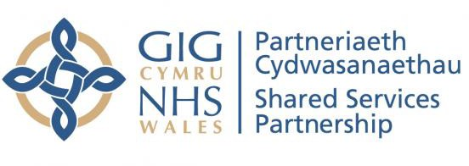NHS WALES
Shared Services Partnership (NWSSP)

Counter Fraud Progress Report 01/10/2022 – 31/12/2022

Mark Weston
Local Counter Fraud Manager
NHS Wales Shared Services Partnership

TABLE OF CONTENTS

- Introduction

- Progress Staffing Activity -
Infrastructure/Annual Plan Awareness sessions Fraud Survey
Newsletters

Fraud Alerts and Bulletins (FPN/IBURN) Referrals/Enquiries/Investigations
Local Proactive Exercises Fraud Risk Assessments Other
- Appendices

- Introduction
In compliance with the Secretary of State for Health’s Directions on Countering Fraud in the NHS, this report provides details of the work carried out by the NHS Wales Shared Service Partnership (NWSSP) Local Counter Fraud Manager supported by Cardiff and Vale University Health Board’s (CAVUHB) Local Counter Fraud Specialists for NWSSP from the 1st October 2022 to the 31st December 2022.

The report’s format has been adopted, in consultation with the Director of Finance and Corporate Services, to update the Audit and Assurance Committee about counter fraud referrals, investigations, activity and operational issues.

At 31st December 2022, 148 days of Counter Fraud work have been completed against the agreed 242 days in the Counter Fraud Annual Work-Plan for the 2022/23 financial year. In summary the days have been used concluding ongoing fraud investigations and two new fraud referrals; Fraud Awareness activity was mainly focussed on Fraud Awareness Week and development of fraud awareness material, responses to NHS CFA Fraud Prevention Notices, and Local Proactive Exercises.

The breakdown of these days is as follows:

TYPE | Days
Proactive | 120.75
Reactive | 27.25

- Progress

The Counter Fraud Annual Plan 2022/2023 and the Annual Counter Fraud report 2021/2022 were completed and approved by the Director of Finance and Corporate Services and the Audit Committee.

Staffing

Previous reports this financial year have outlined recent changes in personnel. The NWSSP LCFS service will continue to be supported by the LCFS team at CAVUHB. CAVUHB team have now appointed a new LCFS with previous experience from the NHS CFS Wales team, the new LCFS will commence early January 2023.

Activity- Infrastructure/Annual Plan

The Counter Fraud Plan for 2022-2023. is aligned fully to the NHSCFA requirements as stipulated in Government Standard 13. The plan states proposed actions throughout the year. In tandem with investigation work

required, the main focus of the NWSSP Local Counter Fraud Manager during the last quarter was as follows:

  - Review of the Counter Fraud Bribery and Corruption Policy – review and update is currently being undertaken by NWSSP LCFS Manager and will be concluded during Quarter 4.
  - The NWSSP Local Counter Fraud Service intranet page has been frequently updated with assistance from the Communications team. It will be continuously reviewed and kept up to date with news and relevant topics.
  - Joint working protocol with Internal Audit has been updated with the Head of Internal Audit.
  - E-learning Module – The NWSSP LCFS Manager has been involved with NHS CFS Wales in the development of the All-Wales Counter Fraud Awareness E-learning module. The module is currently being updated following review by the Finance Academy Steering Group and other stakeholders and will be implemented by the start of the new financial year. NWSSP staff will initially be encouraged to complete this module which will be recorded against the Staff Learning and Development Record.
  - The NWSSP LCFS Manager has liaised with a number of divisions to deliver bespoke and general awareness sessions to staff in order to refresh knowledge of fraud in the NHS, this includes the People and Organisational Development (POD) Division, liaison is ongoing with meetings planned during the next quarter.
  - Main focus for fraud awareness was International Fraud Awareness week as detailed further below.
  - Liaison has taken place with the NWSSP POD Learning and Development team to arrange to include reference to fraud awareness on staff induction as the current content does not include a message from Counter Fraud. In general induction has now moved to a virtual delivery and not individual face to face sessions, further meetings are planned next quarter.
  - Work is ongoing to develop the communications strategy for the Counter Fraud Team. A Counter Fraud App has been developed in conjunction with the NWSSP Communications Team and is ready to be launched in the next few weeks. Microsoft Sway was used as an interactive tool to communicate fraud awareness material. The Social Media Platform Twitter was used to promote new fraud awareness videos on YouTube. With these new methods we are able to collect data on the numbers who engage with the material, this has been fed back to CFS Wales who will look to collate similar data on an all-Wales basis.

Awareness Sessions

During this reporting period three fraud awareness sessions have been delivered to NWSSP staff.

Group | No of attendees / Participants
Electronic Sway Newsletter | 146
Matrix House site | 8
Nantgarw Site | 10
Total | 164

A feedback form has been devised and will be issued retrospectively following future sessions, however instant feedback from each session was very positive and instigated much discussion.

Further arrangements have been made to deliver sessions to POD Teams and Accounts Payable Teams on Mandate Fraud Risk Update.

Fraud Survey

On 22nd July 2022 an email was issued to all NWSSP staff inviting them to complete a fraud awareness survey. The survey included a short video to measure staff awareness before and after the video. A further request was made in the newsletter to complete the survey by 31st October 2022.

As at 31st December 2022, 304 staff participated and awareness increased from
6.96 (before the video) to 8.56 (after the video) (Ratings of 1-10). Further details are included (Appendix 1). This survey will now assist in identifying which divisions and or locations require further fraud awareness training.

Newsletters / International Fraud Awareness Week.

The last newsletter was issued at the end of the previous reporting period on 28th September 2022. A significant focus was given to fraud awareness during International Fraud Awareness Week (13th Nov – 20th Nov 2022.) All NWSSP staff received an email with a link to a Microsoft SWAY newsletter, this allowed for a more interactive communication and collection of metrics to measure staff engagement. The newsletter included fraud awareness videos, which were produced in collaboration with the communications team, the videos were bilingual and made available to support all Health Bodies in Wales. Additional communication was issued via Twitter which resulted in reaching a wider audience. Face to face PowerPoint presentations were provided to staff based at Nantgarw HQ and Matrix House, they were also made available for staff to

join via TEAMS. The metrics showing engagement are produced in Appendix 2.

Fraud Prevention Notices (FPN’S) and IBURN’s (Intelligence Bulletins)

During this reporting period one FPN has been issued by the NHS CFA.

FPN issued on 19/12/2022 to raise awareness as to the possible fraud risks in relation to fraudulent attempts with false invoices relating to payment of office supplies/consumables concentrating mainly on printer toners and printer drums. In most cases the items have not been ordered or received. It should be noted that the fraud not only applies to office supplies but could apply to supplies in general. The risk was mainly with Primary Care Contractors. The methodology of the fraudster is to impersonate a company that may do business with the NHS, therefore adding plausibility that the invoice request is legitimate. The information was disseminated to Finance Leads and Accounts Payable Managers who assessed that the risk to NWSSP and HB’s was minimal. The information was also circulated to all NHS Wales Primary Care contractors.

The IBURN issued on 22/12/22 related to Mandate Fraud against Health Bodies in NHS England where a supplier’s bank account had been hacked and fake emails issued in an attempt to request a change of their bank account details. Checks carried out with NWSSP Supplier Maintenance Team show no attempts made by the parties involved to NWSSP and that NHS Wales does not pay this company. Checks also made with DCHW show no emails received from the email domains reported and they were subsequently blocked to mitigate the risk.

Changes to supplier bank accounts are limited to the Supplier Maintenance Team to conduct checks. Further checks are made independently at a senior level by the Head of Finance and Business Development. A bespoke fraud awareness session will be delivered to the Supplier Maintenance Team in February 2023.

Both the FPN and IBURNs were recorded and actioned on the CLUE 2 database in accordance with NHS CFA requirements, they were also disseminated to all Lead LCFS in NHS Wales to avoid duplication which previously existed in verifying similar alerts.

Referrals/Enquiries/Investigations

During this reporting period the NWSSP Counter Fraud Team received two new referrals for investigation.

Case 1 related to working whilst on sick leave. The most appropriate action for that case was for Managers and POD to liaise with the individual on their future conduct and the case closed. However, the LCFS met with Senior Managers who discussed such allegations and agreed on the importance of early liaison with Counter Fraud.

Case 2 related to an overpayment of Salary of £22k received over a nine-month period. Initial enquiries concluded that the case would not have been suitable for further criminal investigation. An agreement was made to recover the amount overpaid in one lump sum payment of £10k and four instalments of £3k. There was a delay in the recovery process and discussions with Payroll and Finance have since taken place to speed up the process.

The case from the previous quarter concerning the owner of a domiciliary care service provider selling boxes of PPE items on social media remains open. The LCFS liaised with the NWSSP National Clinical Logistics Manager to ensure that all related documentation includes a notice to stipulate that PPE should not be resold and is for use only by the NHS and Health and Social Care only.

The amount saved due to this intervention was valued at £2,700 as the subject was prevented from selling the PPE items and warned of her future conduct. LCFS also liaised with Care Inspectorate Wales on this matter.

Local Proactive Exercises

As part or the Government Functional Standards LCFS are required to conduct Local Proactive Exercises (LPE’s) and Fraud Risk Assessments and record them on the CLUE case management system. LPE’s should be conducted on a local risk-based approach or can be directed by NHS CFA or as a result of an action point e.g. from an investigation, a Fraud Prevention Notice (FPN) or a wider nationally driven proactive exercise.

LPE’s were conducted following the issue of the FPN on mandate fraud risks and the IBURN invoice fraud which were detailed above and also on the following:

Salary Overpayments - As reported in the previous quarter a current common theme which result in investigations throughout most NHS Wales Health Bodies is overpayment of salary where staff receive an overpayment in error and are aware of it but do not report it to their Manager or Payroll. Where unreported overpayments are subsequently identified, the Payroll Department or Manager should refer relevant cases to Counter Fraud to be assessed for investigation. If it is discovered that the employee or former employee has spent the money, appropriate action will be taken on a case-by-case basis as it represents theft. No such referrals have currently been made to Counter Fraud for NWSSP staff.

The NWSSP LCFS Manager has liaised with Internal Audit to obtain details of a recent audit of salary overpayments and have also obtained new data to conduct a LPE. The LCFS Manager has liaised further with the POD Single Lead Employer Team on ongoing cases and due to meet Finance leads to discuss referrals to LCFS and the existing Salary Overpayment Policy.

Risk Assessments

The NWSSP LCFS is currently:

- liaising with SBUHB LCFS to conduct a risk measurement exercise on pre-Employment checks undertaken by NWSSP Recruitment and Health Board Departmental Managers;
- Liaising with C&VUHB /HEIW LCFS to conduct a risk measurement exercise on Bursary Fraud;
- Conducting a risk assessment on Mandate Fraud; and
- Discussing the methodology of recording fraud risk assessments with the Head of Finance and Business Development.

National Fraud Initiative

National Fraud (NFI) data privacy notices were issued to staff during the last quarter. Data has now been collected and processed by the Cabinet Office NFI Team, and the results will be made available for analysis in January 2023.

The NWSSP Lead LCFS has now obtained access to historic NFI data and has commenced a review of checks made on Accounts Payable matches. This will be used to consider the best use of resources for checking the forthcoming NFI data output.

Other

Work is ongoing on relevant projects with NHS CFS Wales to ensure continuity, which will also benefit NWSSP Local Counter Fraud as follows:

- Development of the All-Wales Fraud Awareness E-Learning module as detailed earlier in this report.
- Community Pharmacy Data Analytics Exercise - a long-term data analytical exercise with NHS CFS Wales and Audit Wales to analyse Primary Care Services Community Pharmacy Services claims data for expensive items to identify and assess unusual claiming trends. The exercise is still in a pilot stage with two Health Board’s data used to test analyse the data and collaborate with the Pharmacy Teams. The NWSSP LCFS Manager will continue to engage with the project with CFS Wales, Audit Wales and the Health Boards involved.
- The NWSSP Lead LCFS also met with CFS Wales, Audit Wales, NWSSP Primary Care Services and others to consider a further data analytical exercise to provide assurance on General Medical Services Patient Registration and Capitation Fees. Further meetings have taken place with Audit Wales, NWSSP, and the BCUHB Lead LCFS’.

Summary of NWSP International Fraud Awareness Week interactions

Type of media
5%
1%
1% 16%
77%
Sway Intranet youtube Twitter
In person presentations
Media | Total
Sway | 146
Intranet | 34
YouTube | 476
Twitter | 2274
In person presentations | 18
Total | 2948

Intranet Video views
Intranet | Page views | Average Time
English | 36 | 1.36
Welsh | 5 | 23s
Total | 41

Total Video Views
English | Welsh
712 | 118

YouTube

YouTube Videos | English | Welsh | Average Time
What is Fraud? | 116 | 17 | 1.44
Who pays? | 54 | 9 | 1.08
Procurement Fraud | 65 | 8 | 1.03
Mandate Fraud | 122 | 12 | 1.08
Theft of Overpayment | 66 | 6 | 1.3
Total | 423 | 52 | 475

Twitter

Tweets - English | Likes | Retweets | Video Views | Impressions
Mon (Who Pays for Fraud) | 5 | 5 | 138 | 703
Tues (What is Fraud?) | 7 | 6 | 116 (YouTube) | 318
Wed (Salary Overpayment) | 5 | 4 | 67 | 280
Thurs (Procurement Fraud) | 2 | 3 | 39 | 195
Fri (Mandate Fraud) | 7 | 7 | 45 | 235
 |  |  | Total | 1731
Tweets - Welsh | Likes | Retweets | Video Views | Impressions
Mon (Who Pays for Fraud) | 3 | 1 | 18 | 143
Tues (What is Fraud?) | 2 | 0 | 17 (YouTube) | 117
Wed (Salary Overpayment) | 1 | 1 | 20 | 115
Thurs (Procurement Fraud) | 1 | 0 | 13 | 86
Fri (Mandate Fraud) | 1 | 0 | 14 | 82
 |  |  | Total | 543

NHS Wales Shared Services Partnership (NWSSP) Staff Fraud Awareness Survey

304 03:52
Responses Average time to complete
Active
Status

- Are you aware that NWSSP employs Local Counter Fraud Specialists ( LCFS ), specifically trained to address all matters of Fraud, bribery and Corruption?

 Yes


No
272

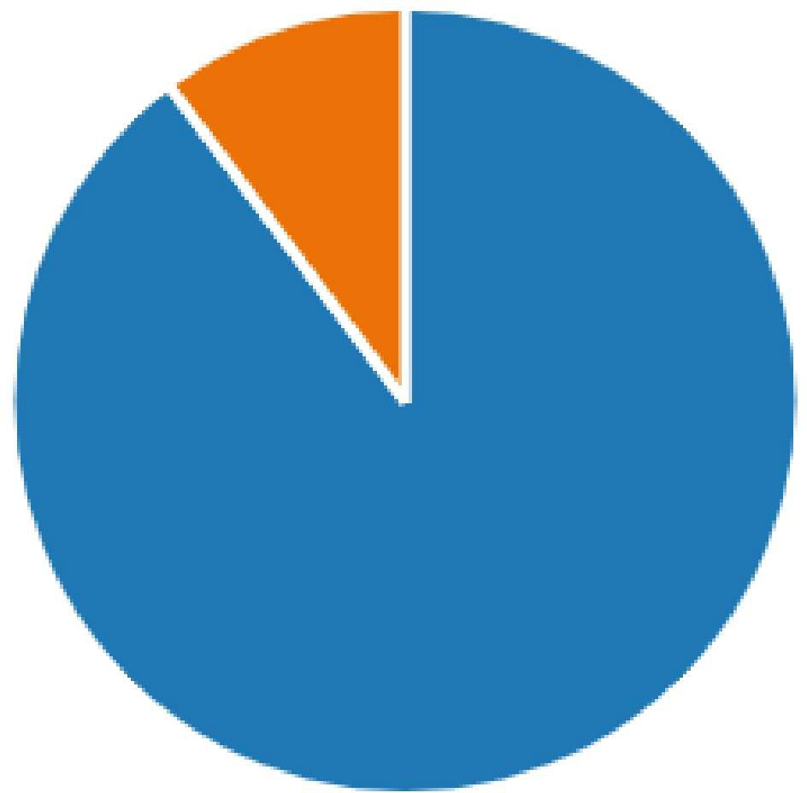
31

- Did you know that NWSSP has a Counter Fraud, Bribery and Corruption Policy to support all staff in dealing with matters of fraud, bribery and corruption?

 Yes

 No


Maybe
242

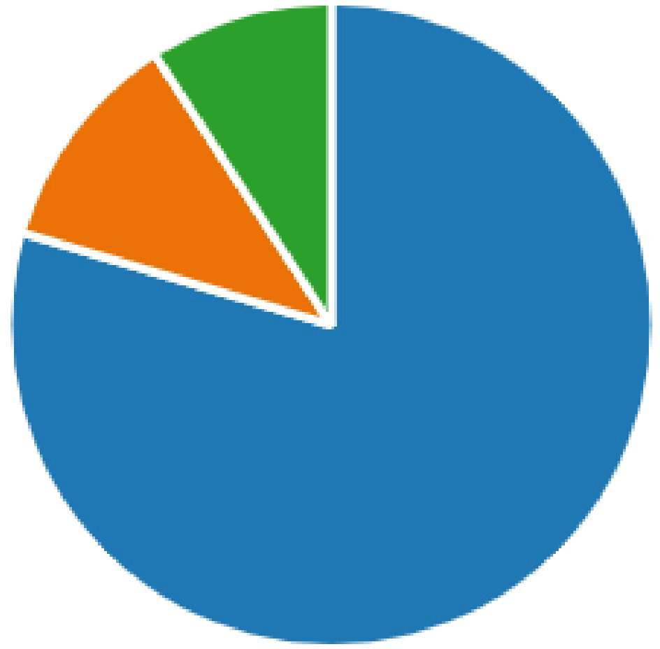
34

28

- Have you ever needed to consult the NWSSP Counter Fraud, Bribery and Corruption Policy?


 Yes No

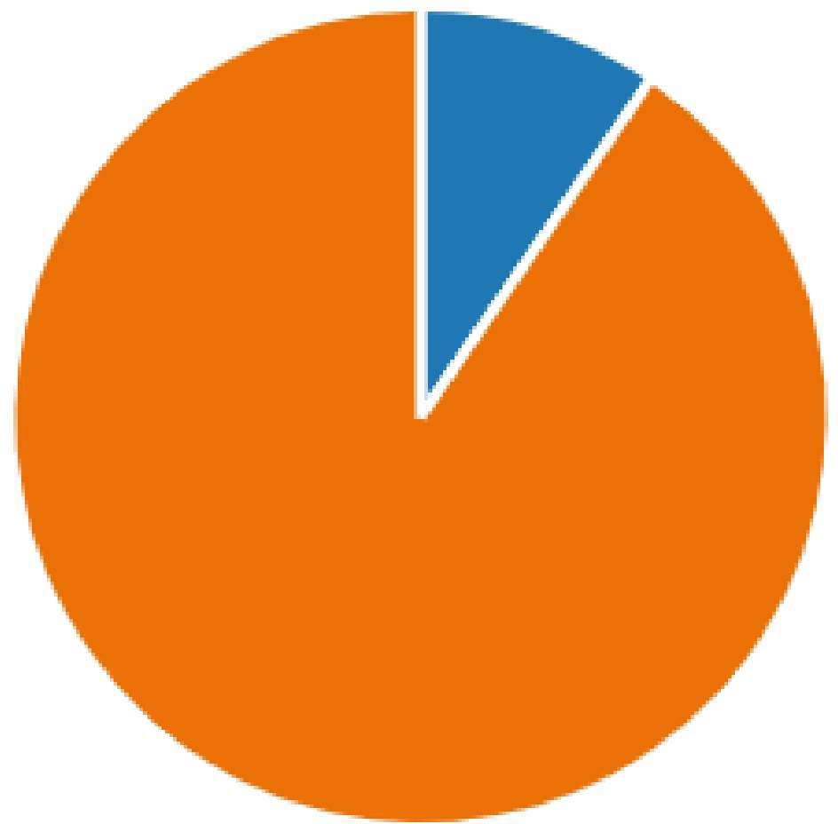
29

275

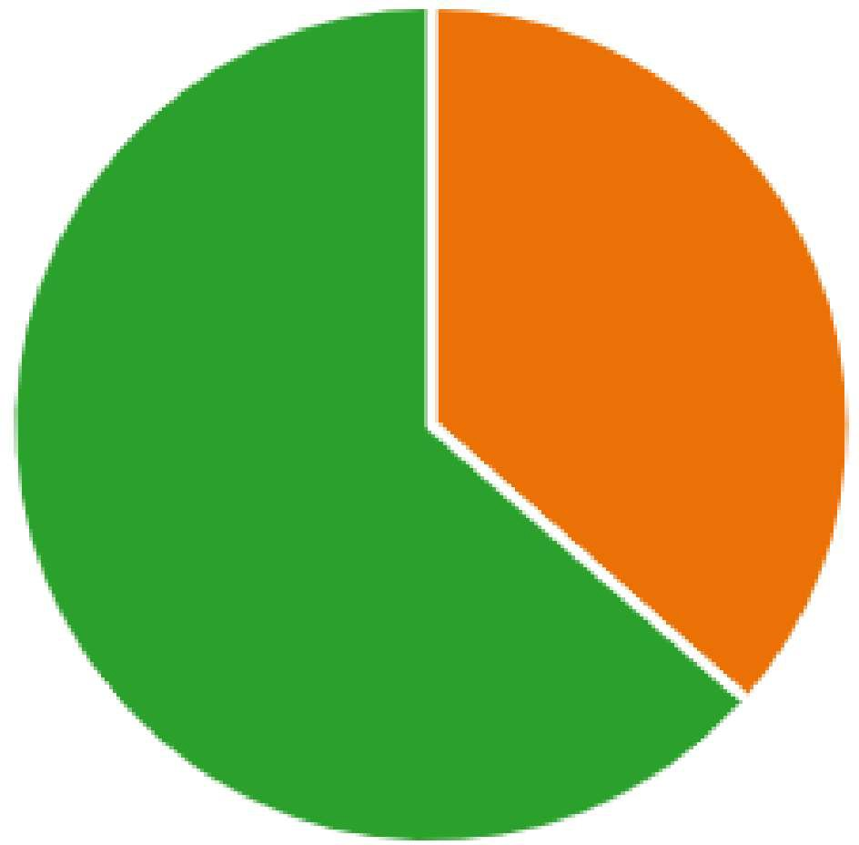
- If you suspect a concern of fraud, bribery or corruption, then what action should you take?

Gather evidence yourself and ta... 0  Report to line manager to consi... 110  Report to the LCFS for review an... 192

- Please score your current level of awareness of fraud against the NHS.

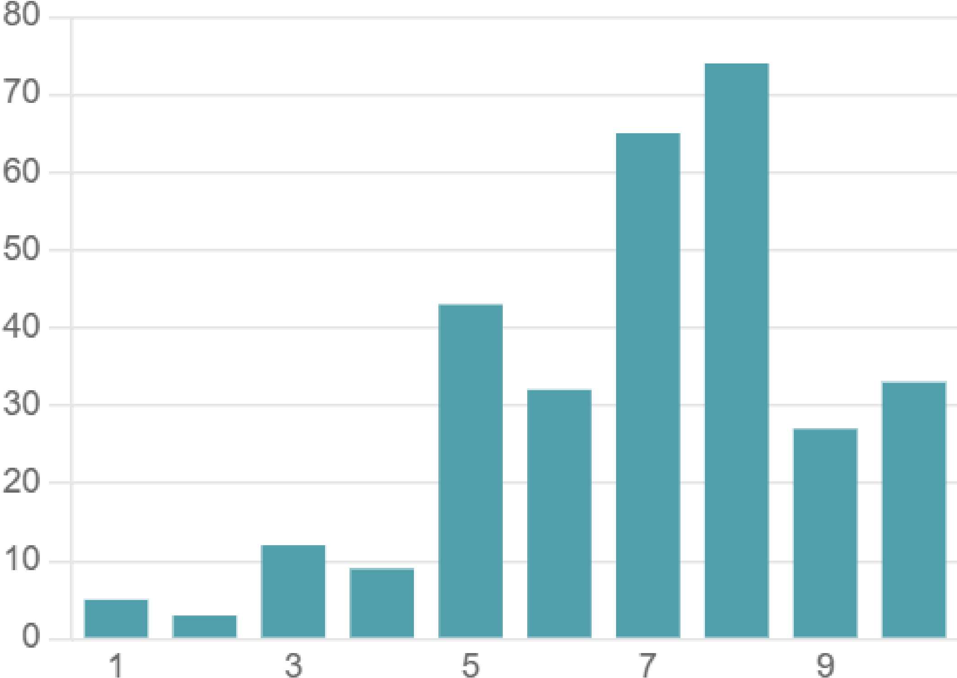
1 = Low 10=High

6.96
Average Rating

- Please watch the following video and proceed to Q7 when finished

- Now you have watched the video please score your fraud awareness on the examples shown.

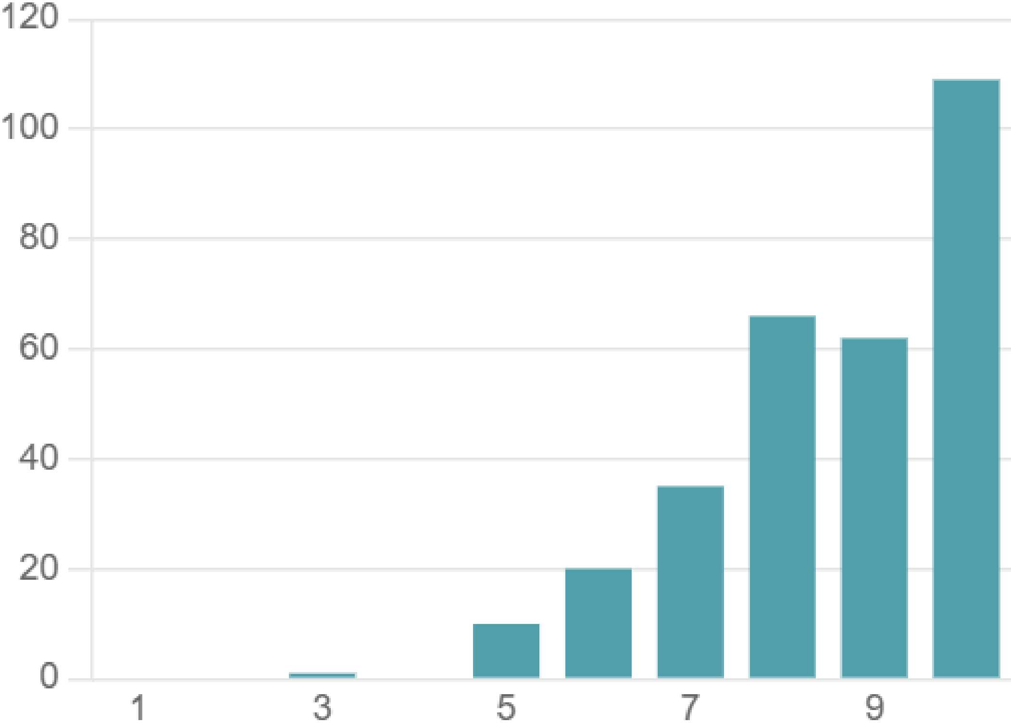
1 = Low 10=High

8.56
Average Rating














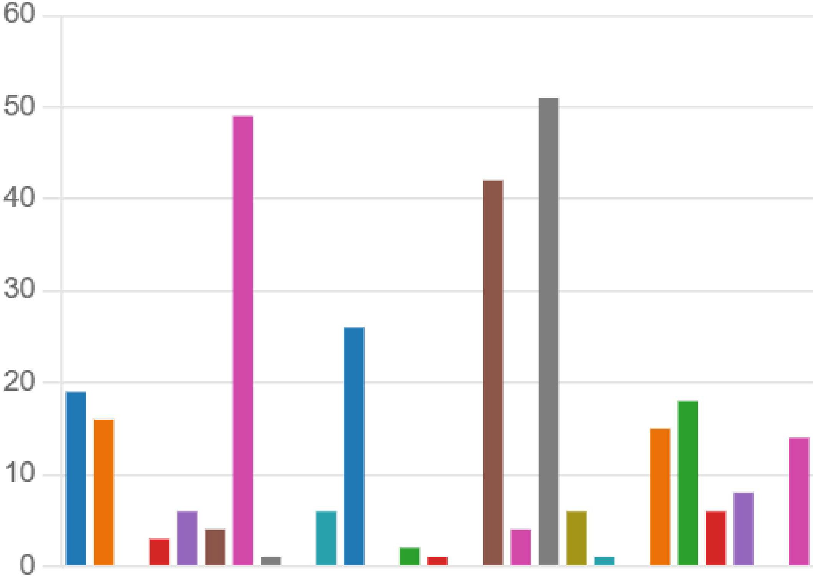
- What department/ division do you currently work for?

Accounts Payable | 19
Audit and Assurance Services | 16
Central E Business Team | 0
Counter Fraud Wales | 3
Digital Wrokforce Solutions | 6
e-Enablement | 4
Employment Services | 49
Finance Academy (hosted)
Laundry Services | 0
Health Courier Services | 6
Legal and Risk Services | 26
Lead Employer for Medical, Den... | 0
Medical Examiner | 2
Pharmacy Technical Services
Student Awards Services | 0
Primary Care Services | 42
SMTL | 4
Procurement and Supply Chain ... | 51
Welsh Risk Pool | 6
Salary Sacrifice
Wales Infected Blood Support S... | 0
Specialist Estates Services | 15
Finance and Corporate Services | 18
People and Organisational Deve... | 6




 Planning, Performance and lnfor... 8

 PROMPT Wales 0 Other 14

- Workplace Location

301
Responses

Latest Responses
"Alder House"

"Nantgarw Head office - currently work from home" "companies house"

0 Update
108 respondents (36%) answered Companies House for this question.
Home/Companies
Cardiff companies Remote / Companies
House/Home Cwmbran House
wor mg rom
k" f
h
1
houseandwork Companies House Talbc
House-UHW
•
st Asa
Woodlands House HOUSE CARDIFF Matrix House
Alder House ho,
House Surgery House - 4th House is base



MEETING | Velindre University NHS Trust Audit Committee for NHS Wales Shared Services Partnership
DATE | 24th January 2023
AGENDA ITEM | 6.1
PRESENTED BY | Andy Butler, Director of Finance and Corporate Services, NWSSP
PREPARED BY | Linsay Payne - Deputy Director of Finance & Corporate Services
TITLE OF REPORT | Update on utilisation of surplus beds

PURPOSE
The purpose of this paper is to provide the Audit Committee with an update on the utilisation of surplus bed stock as at January 2023.

BACKGROUND

At the commencement of the NHS Wales response to the Covid pandemic in early March 2020, NWSSP Procurement Services were requested by Welsh Government to co-ordinate the central purchase of beds and mattresses for NHS Wales to equip the field hospitals being established.
NWSSP was provided with the quantities of beds/mattresses required by each UHB to meet their identified demand for additional bed capacity. At that point in time, demand for beds was high and NHS Wales was competing with other nations, both within the UK and internationally who were also equipping field hospitals and aiming to secure orders and timely deliveries. Where the models of beds currently in use and requested were not available, alternative models were sourced. It was identified that the products available were not of hospital grade, however, due to the field hospitals envisaged as being used as step-down facilities, the supply of community beds was not considered an issue, and at that point in time the ability to secure any bed was deemed preferrable to not being able to fully equip the field hospitals to the forecast demand for beds required. In addition, at this point with the early peak of the pandemic across European states, and reports and footage of patients in Italy and France laying in hospital corridors and being turned away from healthcare facilities, prime importance was placed on securing sufficient volumes of beds to avoid a repeat of the European experience in Wales.
NWSSP Audit Committee
1

As the pandemic progressed and it became evident that the first wave in Wales was not going to realise the forecast demand for field hospital beds, NWSSP Procurement Services worked with suppliers of beds and mattresses to cancel a number of large orders for beds that had been placed and at that point had not yet been delivered. There were however a large number of beds that had been delivered to field hospitals that were in the process of being dis-established and were subsequently placed in storage provided by Welsh Government.

At 31st March 2021, the bulk of the surplus stock of these beds remained despite numerous attempts for the items to be provided to UHBs as part of any bed replacement programme. UHBs deemed these beds as not being of hospital grade and therefore unsuitable for use within NHS Wales. Due to this, Audit Committee and Welsh Government approval was sought to write off the value of these beds in 2020/21 totalling £5.7million which was funded by Welsh Government.

UPDATE
At September 2022 we reported 2,328 surplus beds remained in stock with 198 of these being provided during the month to Communication Workers Union Humanitarian Aid for transport to hospitals in Moldova supporting the Ukraine war response.
At that time it was reported that options were being explored with Welsh Government to repurpose the remaining 2,130 beds and mattresses.
At the beginning of January 2023, an additional 1,805 beds and 1,667 mattresses have been repurposed, with only 325 beds and 463 mattresses remaining to be allocated. The table in Appendix A summarises the distribution of the beds and mattresses.

ACTION
The Committee is asked to NOTE the report.

NWSSP Audit Committee
2

APPENDIX 1

Make/Model | Beds | Mattresses
Medstrom Critical Care Bed - Guess 301 ICU Bed | 198 | 0
CWUHA | -198 | 0
Balance Medstrom Critical Care Bed - Guess 301 ICU Bed | 0 | 0
Medstrom Electric (with foam mattress) - Xpress | 944 | 944
Pembrokeshire CES | -60 | 0
North East Wales Community Equipment Service - Flintshire County Council - CAR1000 (Low Height) | -30 | -30
North West Wales Community Equipment Services - Betsi - CAR1000 (Low Height) | -150 | -150
North West Wales Community Equipment Services - Betsi - CAR1000 (Low Height) | -100 | -100
Ael-Y-Bryn Emergency Accommodation Bridgend | -1 | -1
Various Care Homes - Newport | -57 | -59
Camarthenshire Council | -80 | 0
Swansea Council | -35 | -35
Torfaen Council | -35 | -35
Monmouthshire Council | -61 | -61
Ynys Mon | -10 | -10
Balance Medstrom Electric (with foam mattress) - Xpress | 325 | 463

Medstrom Profiling beds with alerta mattress Opera - eco | 907 | 907
Awel Tywi Care Home , Y Plas, Dol Y Felin | -14 | -14
North East Wales Community Equipment Service - Flintshire County Council - CAR1000 (Low Height) | -35 | -35
North West Wales Community Equipment Services - Betsi - CAR1000 (Low Height) | -35 | -35
North East Wales Community Equipment Service - Flintshire County Council | -20 | -20
Gwynedd Council for our Internal Care Homes | -30 | -30
Denbighshire Community Equipment | -20 | -20
Denbighshire Community Equipment | -20 | -20
Various Care Homes - Newport | -167 | -167
Swansea Council | -290 | -290
Torfaen Council | -136 | -136
Monmouthshire Council | -47 | -47
Monmouthshire Council | -40 | -40
Ynys Mon | -10 | -10
Caerphilly CBC | -43 | -43
Balance Medstrom Profiling beds with alerta mattress Opera - eco | 0 | 0
Medstrom Opera Signature 4 | 80 | 80
Swansea Council | -80 | -80
Balance Medstrom Opera Signature 4 | 0 | 0

Renray Profiling Beds with mattress | 199 | 199
North East Wales Community Equipment Services - Flintshire County Council - CAR1000 (Low Height) | -35 | -35
North West Wales Community Equipment Services - Betsi - CAR1000 (Low Height) | -35 | -35
Cardiff and Vale Joint Equipment Services | -50 | -50
Various Care Homes - Newport | -79 | -79
Balance Renray Profiling Beds with mattress | 0 | 0
Available units September 2022 | 2,328 | 2,130
Allocated | 2,003 | 1,667
Remaining units January 2023 | 325 | 463

MEETING | Velindre University NHS Trust Audit Committee for NHS Wales Shared Services Partnership
DATE | 24 January 2023
AGENDA ITEM
PREPARED BY | Peter Stephenson, Head of Finance and Business Development
PRESENTED BY | Peter Stephenson, Head of Finance and Business Development
RESPONSIBLE HEAD OF SERVICE | Andy Butler, Director of Finance and Corporate Services
TITLE OF REPORT | NWSSP Risk Appetite Statement
PURPOSE

To request the Audit Committee to note the Risk Appetite Statement.

INTRODUCTION

The Risk Appetite Statement is presented at Appendix 1 for information. This requires annual review by the Committee and was last presented at the June 2021 meeting.

The statement was informally reviewed at the Shared Services Partnership Committee (SSPC) Development Day on 11 November 2022 and the Informal Senior Leadership Group on the 10th of November. It is due to be formally approved at the SSPC being held on 19th November.

Following the two reviews in November 2022 referred to above, the statement has been significantly amended, both in terms of content and format. The format has been updated to reflect the latest guidance from the Good Governance Institute and the content has been updated to reflect a bolder approach to taking risk, which was encouraged by both members of the SLG and SSPC.

RECOMMENDATION

The Audit Committee is asked to:

  - NOTE the Risk Appetite Statement.

NWSSP Audit Committee
24 January 2023 1



NHS Wales Shared Service Partnership Risk Appetite Statement.

Introduction.

NWSSP is committed to achieving and maintaining the highest standards of managerial practices that maximise and progress service benefits. NWSSP recognises that effective risk management is a key component of corporate governance and is critical to achieving the strategic objectives of the organisation.
NWSSP’s Risk Management Protocol seeks to ensure that there is an effective process in place to manage risk across the organisation. Risk management is part of management decision-making and is the responsibility of all staff. Risks are identified, assessed, and managed at a corporate level (‘top-down’) and operational level (‘bottom-up’). Managers have a responsibility to evaluate their risk environment, to put in place appropriate controls and monitor the effectiveness of these controls.

An organisation’s risk appetite is defined as the amount and type of risk that the organisation is willing to take in the pursuit of its strategic objectives. The risk appetite can help NWSSP by enabling the organisation to take decisions based on an understanding of the risks involved and communicating expectations for risk-taking to managers.

NWSSP has undertaken a review to identify the most commonly used framework for NHS organisations and confirmed that this is one developed by the Good Governance Institute (Annex 1).

The risk appetite has been communicated to staff to embed it throughout the organisation and it is also a key reference document in discussions regarding the risks on the NWSSP risk register, ensuring these are in line with NWSSP's risk appetite.

The Risk Appetite Statement is presented to the SSPC for approval on an annual basis, or sooner if circumstances require. The statement was informally reviewed at the SSPC Development Day on 11 November 2022 and the Informal Senior Leadership Group on the 10th of November.

.

General Statement of Appetite.
NWSSP faces a broad range of risks reflecting its responsibilities. The risks arising from our responsibilities can be significant. These risks are managed through detailed processes that emphasise the importance of integrity, intelligent inquiry, maintaining high quality staff and public accountability.

NWSSP make resources available to control operational risks at acceptable levels and recognises that it is not possible or indeed necessarily desirable to eliminate some of the risks inherent in our activities. Acceptance of some risk is often necessary to foster innovation within the services for which we are responsible.

This statement considers the most significant risks to which NWSSP is exposed and provides an outline of the approach to managing these risks. All strategic and business plans for operational areas must be consistent with this Statement. Given the range of our activities and responsibilities, it is not appropriate to make a single overarching statement of our attitude to risk. Instead, a range of risk appetite statements arising from the different areas of our work are set out below.

- Financial
We are prepared to accept some financial risk as long as appropriate controls are in place. We have a holistic understanding of VFM with price not the overriding factor.
- Regulatory
We are prepared to accept the possibility of some regulatory challenge as long as we can be reasonably confident that we would be able to challenge this successfully.
- Quality
We will pursue innovation wherever appropriate. We are willing to take decisions on quality where there may be high inherent risks but the potential for significant longer-term gains.
- Reputational
We are prepared to accept the possibility of some reputational risk as long as there is the potential for improved outcomes for stakeholders.
- People

We will pursue workforce innovation. We are willing to take risks which may have implications for our workforce but could improve the skills and capabilities of our staff. We recognise that innovation is likely to be disruptive in the short-term but with the possibility of long-term gains.
Conclusion
This statement has acknowledged that NWSSP faces a broad range of risks reflecting its responsibilities and that some of these can be significant.
It has also asserted that risk management is part of management decision-making and is the responsibility of all staff. It has reaffirmed that Managers have a responsibility to evaluate their risk environment, to put in place appropriate controls and monitor the effectiveness of these controls.

NWSSP’s risk appetite levels are communicated to staff through the practical adoption of these risk appetite levels in the way that the Directorate and Corporate Risk Registers function. Directorate Senior Management meetings and the NWSSP Senior Leadership Group are the conduit through which this process is led.

This statement will be reviewed annually, unless circumstances dictate that an earlier review is necessary


Good Governance Institute
Applying risk appetite matrix

RISK APPETITE LEVEL►

0 NONE

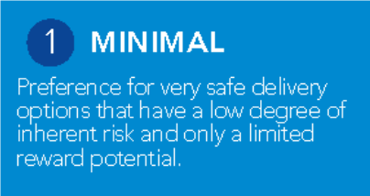
2 CAUTIOUS
potent"I
nsk and only a Imted reward
that have a bw degree of residual
Preference fcr safe delivery opt1ors

3 OPEN

4 SEEK
Eager to be 1nnovat1ve and to
choose opt1ors offering h1gi'1er
bJs1ness re\11/ards (despite geater
inherent nsk)

5 SIGNIFICANT
Confident 1n setting h gh levels of nsk appetite because controls,
forward scanning and resp:wis1ve
systems are robust

Avoidance of risk 1s a key organ1sat1onal object1Ve
and choose while
'Mll1ng to consider all potent"I
dehveryopt1ors

RISK TYPES T
►
How will we use
FINANCIAL
our resources?

►
perceived by our
How will we be
REGULATORY
QUALITY
How will we deliver safe services?
regulator?
►

We have no appetite for We are only willing to accept decisions or actions that may the possibility of very limited result in financial loss. financial risk.

We have no appetite for We will avoid any decisions decisions that may that may result in heightened compromise compliance regulatory challenge unless with statutory, regulatory of absolutely essential.
policy requirements.

We have no appetite for We wilI avoid anything that decisions that may have an may impact on quality uncertain impact on quality outcomes unless absolutely

We are prepared to accept We are prepared to accept the possibility of limited some financial risk as long as financial risk. However, VFM is appropriate controls are in our primary concern. place. We have a holistic
understanding of VFM with price not the overriding factor.

We are prepared to accept We are prepared to accept the possibility of limited the possibility of some regulatory challenge. We regulatory challenge as long would seek to understand as we can be reasonably where similar actions had confident we would be able been successful elsewhere to challenge this successfully. before taking any decision.

Our preference is for risk We are prepared to accept avoidance. However, if the possibility of a short-term necessary we will take impact on quality outcomes

We will invest for the best possible return and accept the possibility of increased financial risk.
of reward
also prov1d1ng an acceptable level

We are willing to take decisions that will likely result in regulatory intervention if we can justify these and where the potential benefits outweigh the risks.

We will pursue innovation wherever appropriate. We are willing to take decisions

We will consistently invest for the best possible return for stakeholders, recognising that the potentia I for substantial gain outweighs inherent risks.

We are comfortable challenging regulatory practice. We have a significant appetite for challenging the status quo in order to improve outcomes for stakeholders.

We seek to lead the way and will prioritize new innovations, even in

outcomes. essential. We will avoid decisions on quality where with potential for on quality where there may emerging fields. We innovation unless established there is a low degree of longer-term rewards. We be higher inherent risks but consistently challenge
and proven to be effective in inherent risk and the support innovation. the potential for significant current working practices in a variety of settings. possibility of improved longer-term gains. order to drive quality
outcomes, and appropriate improvement.
►
perceived by the
How will we be
REPUTATIONA
controls are in place.

We have no appetite for Our appetite for risk taking is We are prepared to accep: the We are prepared to accept We are willing to take We are comfortable to take decisions that could lead to limited to those events possibility of limted reputafonal the possibility of some decisions that are likely to decisions that may expose additional scrutiny or where there is no chance of r-.;k if appropriate controls are in reputational risk as long as bring scrutiny of the the organisation to attention on the significant repercussions. pace to limt any fallout. there is the potential for organisation. We outwardly significant scrutiny or organisation. improved outcomes for our promote new ideas and criticism as long as there is a
L
partners?
public and our
stakeholders. innovations where potential commensurate opportunity benefits outweigh the risks. for improved outcomes for
►
perceived by the
How will we be
PEOPLE
our stakeholders.

We have no appetite for decisions that could have a negative impact on our workforce development, recruitment and retention. Sustainability is our primary interest.
partners?
public and our

© 2020 GGI Development and Research LLP, London
We will avoid all risks relating to our workforce unless absolutely essential.
Innovative approaches to workforce recruitment and retention are not a priority and will only be adopted if established and proven to be effective elsewhere.
We are prepared to take limited r-.;ks with regards to our workforce. Where attempting to innovate, we would seek to understand where similar actions had been successful elsewhere before taking any decision.
We are prepared to accept the possibility of some workforce risk, as a direct result from innovation as long as there is the potential for improved recruitment and retention, and developmental opportunities for staff.
We will pursue workforce innovation. We are willing to take risks which may have implications for our workforce but could improve the skills and capabilities of our staff. We recognize that innovation is likely to be disruptive in the short term but with the possibility of long term gains.
We seek to lead the way in terms of workforce innovation. We accept that innovation can be disruptive and are happy to use it as a catalyst to drive a positive chan.


WWW.GOOD-GOVERNPJ\JCE.ORG.UK

MEETING | Velindre University NHS Trust Audit Committee for NHS Wales Shared Services Partnership
DATE | 24 January 2023
AGENDA ITEM | 6.5
PREPARED BY | Peter Stephenson, Head of Finance and Business Development
PRESENTED BY | Peter Stephenson, Head of Finance and Business Development
RESPONSIBLE HEAD OF SERVICE | Andy Butler, Director of Finance and Corporate Services
TITLE OF REPORT | NWSSP Corporate Risk Register
PURPOSE

To provide the Audit Committee with an update as to the progress made against the organisation’s Corporate Risk Register.

INTRODUCTION

The Corporate Register is presented at Appendix 1 for information.

RISKS FOR ACTION

The ratings are summarised below in relation to the Risks for Action:

Current Risk Rating | January 2023
Red Risk | 7
Amber Risk | 9
Yellow Risk | 2
Green Risk | 0
Total | 18

  - Red-rated Risks

Following a detailed review of the Corporate Risk Register at the November SLG, a number of risks have been escalated to red and some new red risks added.

    - The existing red risk relating to the inflationary consequences of the situation in Ukraine and the resultant impact on energy prices

remains red. This is currently being mitigated through the role of the Energy Price Risk Management Group (EPRMG), but energy prices remain very volatile.
    - The above risk has also been articulated into a second risk which considers the role that NWSSP plays as the lead energy purchaser for the whole of NHS Wales, and the reputational risk that is associated with that role.
    - The existing risk of the impact of potential industrial action has been escalated from amber to red as strike action has now been confirmed. While the strikes currently called by the RCN are not likely to have a significant impact on NWSSP, the likely industrial action from other Trade Unions will have a greater impact.
    - Similarly the existing risk of having insufficient staff resource to meet demand has also been escalated from amber to red. NWSSP have a lot of staff on bank contracts who help to deliver essential services but for whom we are unable to guarantee security of employment due to Welsh Government not confirming whether these posts will be funded into 2023/24.
    - The contractual dispute affecting the replacement for the Legal & Risk Case Management system has also been escalated from amber to red. While there are contingency arrangements in place to maintain services, the potential financial loss could be significant.
    - The Laundry Transformation Programme has been added as a red risk due to uncertainty over whether the required capital funding for the scheme will be available to complete it.
    - The Brecon House roof at Mamhilad has also been added as a red risk due to serious issues with water ingress and falling masonry, making the building unsafe for staff.

  - New/Deleted Risks

In addition to the Laundry Transformation Programme and Brecon House risks referred to above, the following risks have been added to the register since the last meeting of the SLG:

    - Difficulties in recruiting staff leave us unable to meet the expectations of Welsh Government in playing a leading role in delivering the decarbonisation agenda; and
    - The move to agile working, and the relatively imminent expiry of a number of our property leases, require urgent agreement of an Accommodation Strategy.

Two risks were also removed from the Register as follows:

    - The failure to engage with appropriate specialists (e.g. H&S/Fire Safety, Information Security/IG) sufficiently early enough when considering major developments may result in actions being taken that do not consider all relevant potential issues; and

    - The introduction of new technology and the promotion of the digitisation agenda may impact NWSSP staff in terms of their current roles and responsibilities.

It was considered in both cases that appropriate action had been taken to mitigate the risk.

RISKS FOR MONITORING

There are eight risks that have reached their target score, and which are rated as follows:

Current Risk Rating | January 2023
Red Risk | 0
Amber Risk | 0
Yellow Risk | 2
Green Risk | 6
Total | 8

RECOMMENDATION

The Audit Committee is asked to:

  - NOTE the Corporate Risk Register.

NWSSP Audit Committee
24 January 2023 3

Corporate Risk Register
Ref | Risk Summary | Inherent Risk |  |  | Existing Controls & Mitigations | Current Risk |  |  | Further Action Required | Progress | Trend since last review | Target & Date
Ref | Risk Summary | Likelihood | Impact | Total Score | Existing Controls & Mitigations | Likelihood | impact | Total Score
Risks for Action
A1 | Lack of storage space across NWSSP due to increased demands on space linked to COVID and specific requirements for IP5 (added April 2021) | 4 | 4 | 16 | IP5 Board  Additional facilities secured at Picketston | 2 | 4 | 8 | PCS reviewing options for medical records storage - additional space is available from Johnseys on Mamhilad site. Business Case prepared and approved at June SLG and July SSPC. Awaiting formal Welsh Government approval. | Business Case approved at June SLG and July SSPC. Currently with Welsh Government for final approval.  There is now also a problem wth Brecon House that may impact on current capacity. | ↓ | 31-Mar-23
A1 | Strategic Objective - Service Development |  |  |  |  |  |  |  |  | Risk Lead: Programme Director | ↓ | 31-Mar-23
A2 | Suppliers, Staff or the general public committing fraud against NWSSP. (added April 2019) | 5 | 3 | 15 | Dedicated NWSSP LCFS Counter Fraud Service Internal Audit  WAO PPV  National Fraud Initiative Counter Fraud Steering Group Policies & Procedures  Fraud Awareness Training  Fighting Fraud Strategy & Action Plan | 3 | 3 | 9 | Develop work plan for dedicated LCFS resource (PS 31/10/2022) | C&V have recruited an additional Band 6 LCFS and an 8A. Dedicated LCFS commenced in post for NWSSP with effect from 6/6/22. Fraud Awareness session held on 16/11/2022. | ↓ | 31-Mar-23
A2 | Strategic Objective - Value For Money |  |  |  |  |  |  |  |  | Risk Lead: Director of Finance & Corporate Services | ↓ | 31-Mar-23
A3 | Risk of cyber attack exacerbated if NWSSP, or other NHS Wales organisations, run unsupported versions of software. (added Apr 2019) | 5 | 5 | 25 | Cyber Security Action Plan BCP Champions Meeting  Information Governance training Mandatory cyber security e-learn Internal Audit review  Band 6 IT Security Officer appointed Sept 21 BCP Action Cards (updated March 22)  CAF completed and report received from CRU CAF remediation project established with support from PMO.  ‘Exercise in a box’ launch event held with SLG (face to face) on 12 May.  Phishing testing has been running since February 2022 alongside proactive communications on cyber awareness. | 2 | 5 | 10 | Initial phase of work to review and update the service catalogue and make assessment of risk on existing systems has commenced (w/c 20th June). IT security team attended BCP meeting on 16 June to explain the process and requirements of All Divisions.  Given the heightened level of risk promotion of good practice to staff and phishing testing continues.  Progress against the CAF will be reported to SLG on a quarterly basis.  CRU held a workshop with SIRO and Director of Informatics on 29 June.  Agreement for further resource achieved - recruitment underway. | Team was strengthened in Sept 21 with additional member of staff. Following war in Ukraine staff have been reminded of good housekeeping procedures and guidance reissued. All directorates have completed or updated their action cards relating to the potential loss of IT systems and networks. Focus on this topic at May SLG. | ↓ | 31-Mar-23
A3 | Strategic Objective - Service Development |  |  |  |  |  |  |  |  | Risk Lead: Director of Planning, Performance &  Informatics | ↓ | 31-Mar-23
A4 | The demand on services within Employment Services as a result of Health Boards taking on substantial numbers of staff to respond to and recover from the pandemic, is unsustainable, leading to poor levels of performance. (added  November 2021) | 4 | 4 | 16 | Established working practices governed by Service Level Agreements and measured by reporting of KPIs on monthly basis. | 3 | 4 | 12 | Additional staff being recruited  Use of students from Cardiff Univeristy Temporary support from other Directorates Modernisation Programme being implemented Accessing KickStart scheme | Focus on training staff on pinch points rather than whole process  Backlog in applications in Student Awards reduced from 1800 to <800.  Significant reduction in complaints as at March 2022  Deep Dive Presentation to SSPC March 2022 | ↓ | 31-Mar-23
A4 | Strategic Objective - Customers |  |  |  |  |  |  |  |  | Risk Lead: Director of People and OD | ↓ | 31-Mar-23
A5 | The level of stock that we are being asked to hold is likely to mean that some items go out-of- date before being issued for use and need to be written off causing a loss to public funds and possible reputational damage to NWSSP. (added January 2022) | 5 | 5 | 25 | Internal Audit Review of Stores Stock Rotation - based on FIFO Donations to India and Namibia | 2 | 3 | 6 | SMTL are meeting Procurement management on the 5th of December to review whether the shelf life of any items can be safely extended. | Wales On-Line FoI request robustly responded to on 31/1.  SMTL working with DHSC to investigate whether expiry dates can be extended on some PPE equipment Schedules produced and discussed with senior finance officials in WG and Velindre.  There is a need to write off significant values of PPE | ↓ | 31/03/2023
 |  |  |  |  |  |  |  |  |  | Risk Lead: Director of Finance & Corporate Services | ↓ | 31/03/2023
A6 | The increase in energy prices, exacerbated by the war in Ukraine, is likely to lead to significant price increases across the whole range of goods and services resulting in severe cost pressures for NWSSP. (added March 2022) | 5 | 5 | 25 | Energy Price Risk Management Group Forward purchase of energy  Briefings to Welsh Government | 4 | 5 | 20 | Assess impact of UK Govt announcement on subsidies for energy prices (EPRMG 31/10/22) | Paper on energy costs to March SSPC, and update provided to August Informal SLG. Daily monitoring of prices and buying ahead at fixed price where possible. Presentation to September SSPC. WG are funding first six months of actual additional costs. | ↓ | 31/03/2023

 | Strategic Objective - Value For Money |  |  | 25  16  25  16 |  |  |  |  |  | Risk Lead: Director of Finance & Corporate Services
A7 | The volatility in the energy market, due to the war in Ukraine, increases the reputational risk to NWSSP in its role in securing energy on behalf  of NHS Wales. | 5 | 5 | 25  16  25  16 | Energy Price Risk Management Group Forward purchase of energy  Briefings to Welsh Government | 4 | 5 | 20 | EPMRG considering an alternative energy partner and supplier. | Risk has been increased due to the withdrawal of British Gas from the market. |  | 31/03/2023
A7 | Strategic Objective - Value For Money |  |  |  |  |  |  |  |  | Risk Lead: Director of Finance & Corporate Services |  | 31/03/2023
A8 | The threat of industrial action (both within the NHS and across other sectors) is likely to lead to staff shortages in both NWSSP and across NHS Wales impacting delivery of services  (added August 22) | 4 | 4 | 25  16  25  16 | Good working relationship with Trade Union colleagues - presence on and updates to SLG. Business Continuity Plans and Arrangements. | 5 | 4 | 20 | L&R providing Industrial Action training. BCP Action Cards being updated. | Difficult to assess impact and possible contingencies until details of industrial action known. |  | 31/03/2023
A8 | Strategic Objective - Staff |  |  |  |  |  |  |  |  | Risk Lead: Director of People and OD |  | 31/03/2023
A9 | The Student Awards software is at end of life and needs replacement without which delays to student bursary payments could be significantly affected. (added May 2022) | 5 | 5 | 25  16  25  16 | Formal project management in place | 2 | 4 | 8 | Phase 1 to be delivered by April 2023. | SAS contract support agreement with Kainos in place to end of March 2023.  FBC approved by Welsh Govt 5/9/22 and funding agreed. | ↓ | 31/03/2023
A9 | Strategic Objective - Customers |  |  |  |  |  |  |  |  | Risk Lead: Director of People and OD | ↓ | 31/03/2023
A10 | There is a reputational risk associated with the establishment of the Citizens' Voice Body (added July 2022) | 4 | 4 | 25  16  25  16 | Experienced Programme Director Appointment of (Agency) Governance Lead | 2 | 4 | 8 | Provide options for financial systems (PB) | Role is to assist Welsh Government in determining how CVB will operate. Governance advice provided initially by PS but an Agency Governance Lead has now been  appointed. |  | 31/03/2023
A10 | Strategic Objective - Service Development |  |  |  |  |  |  |  |  | Risk Lead: Director of Finance & Corporate Services |  | 31/03/2023
A11 | NWSSP are unable to continue to provide business-critical services due to having insufficient numbers of staff available and able to undertake the work. This is particularly an issue with staff on bank or fixed term contracts  where funding from WG is uncertain e.g. COVID- realted activity and SLE. (added back Sept | 5 | 5 | 25 | Identification of all business-critical services Redeployment of staff to business-critical services  Increased provision of laptops and VPN Roll-out of Office 365  Use of Bomgar service for PCS  Daily monitoring and reporting of absence figures. IT Update also given to weekly COVID-19 Planning & Response Group. | 4 | 5 | 20 | Need to get WG to confirm funding arrangements for 2023/24 and beyond. Staff on bank contracts to given fixed term contracts until end March 2023. | Action agreed at September SLG to move bank staff onto fixed term contracts for this financial year until funding arrangements from WG are clarified. AB is meeting with Steve Elliott and Matt Denham-Jones to get clarity on their funding intentions. |  | 31-Mar-23
A11 | Strategic Objective - Customers |  |  |  |  |  |  |  |  | Risk Lead: Senior Leadership Group |  | 31-Mar-23
A12 | An issue with the supplier of the replacement Legal & Risk Case Management System threatens financial loss and the delivery of the  service (added Sept 22) | 4 | 4 | 16 | Formal project managed through PMO | 4 | 4 | 16 | While working with the supplier Management team to resolve the current open issues, it was agreed that all work from the supplier's perspective will pause from 07 July 2022 until  all issues have been resolved. | There is currently a significant issue about the scope, duration and cost of the project. |  | 31/03/2023
A12 | Esclalated Divisional Risk |  |  |  |  |  |  |  |  | Risk Lead: Director, Legal & Risk Services |  | 31/03/2023
A13 | The planned development of the Clinical Pharmacy Service is adversely impacted due to financial and staffing challenges (added Sept  22) | 4 | 4 | 16 | CIVAS Board  National QA Pharmacist | 3 | 4 | 12 | On-going discussion regarding funding and TUPE of staff from Health Boards. | Update on SSPC Agenda | ↓ | 31/03/2023
A13 | Esclalated Divisional Risk |  |  |  |  |  |  |  |  | Risk Lead: Service Director | ↓ | 31/03/2023
A14 | The lack of available capital threatens the successful implementation of the Laundry Transformation programme, resulting in required service improvements not being achieved. | 5 | 5 | 25 | Business Case signed off at SSPC and Trust Board | 5 | 5 | 25 | Develop alternative plans that do not rely on substantial capital investment. | Welsh Government have confirmed that the required capital funding is not available for the forseeable future. |  | 30/06/2023
A14 | Strategic Objective - Service Development |  |  |  |  |  |  |  |  | Risk Lead: Director, Procurement Services |  | 30/06/2023
A15 | Difficulties in recruiting staff leave us unable to meet the expectations of Welsh Government in playing a leading role in delivering the  decarbonisation agenda. | 5 | 5 | 25 | Decarbonisation Programme Board Project Execution Plan  PMO Support | 3 | 4 | 12 | Continue to recruit to fill vacant posts. | Anticipated that the full team will not be in place until the summer of 2023. |  | 31/08/2023
A15 | Strategic Objective - Service Development |  |  |  |  |  |  |  |  | Director, Specialist Estates Services |  | 31/08/2023
A16 | The move to agile working, and the relatively imminent expiry of a number of our property leases, require urgent agreement of an  Accommodation Strategy. | 5 | 4 | 20  25 |  | 3 | 4 | 12 | Work ongoing to re-negotiate leases that are coming up for renewal and/or look for alternative accommodation given the numbers still working from home. | Nantgarw lease currently being negotiated. |  | 30/04/2023
A16 | Strategic Objective - Staff |  |  |  |  |  |  |  |  | Director, Specialist Estates Services |  | 30/04/2023
A17 | The presence of Reinforced Autoclaved Aerated Concrete in the Brecon House building in Mamhilad has contributed to the unsafe state of repair of the roof, making the building unsafe for  staff. (added January 2023) | 5 | 5 | 20  25 | Majority of staff working from home. Health & Safety Reviews | 3 | 5 | 15 | Structural Engineers appointed  Immediate work being undertaken to make building safe for staff.  Plan to vacate Brecon House, ideally at end of 2022/23 financial year. | Negotiations being undertaken for alternative accommodation. |  | 30/06/2023
A17 | Esclalated Divisional Risk |  |  |  |  |  |  |  |  | Director, Primary Care Services |  | 30/06/2023

A18 | The transfer of the laundries to NWSSP expose a number of risks including concerns over health and safety and formality of customer relationships. (added April 2021) | 4 | 4 | 16 | All-Wales Programme Business Case Programme Board  Regular updates to SLG on progress with Action Plan  Draft SLAs approved by SSPC  Appointment of Assistant Director for Laundry Services  H&S Audits of Laundry Sites | 2 | 3 | 6 | Arrange internal audit review of Laundry service (AB/PS - complete)  Prioritised report to be submitted to SLGs to monitor progress. (on-going) - good progress now being made with majority of required actions completed. | Transfer has now taken place for all of the 5 laundries, although arrangements are different for Hywel Dda and Cwm Taf. Updates provided to SLG.  IA review focused on Swansea Laundry provides reasonable assurance.  Report to Sept 22 H&S Group showed good progress in completing actions. | ↓ | 31-Dec-22
A18 | Strategic Objective - Service Development |  |  |  |  |  |  |  |  | Risk Lead: Director of Procurement Services | ↓ | 31-Dec-22
Risks for Monitoring
M1 | Disruption to services and threats to staff due to unauthorised access to NWSSP sites. | 5 | 4 | 20 | Manned Security at Matrix CCTV  Locked Gates installed at Matrix.  Security Review Undertaken (reported Dec 18) Increased Security Patrols at Matrix.  CTSA underake annual reviews of high risk  buildings e.g. IP5, Picketston | 1 | 4 | 4 | Review results from security checklists (PS - 31/07/22 - complete)  Review any gaps in security arrangements and address where possible (PS 31/12/2022) | Security Review undertaken and reported to SMT in Dec 2018. No major findings and all agreed actions implemented or superceded. | ↓
 |  |  |  |  |  |  |  |  |  | Risk Lead; Director Specialist Estates  Services/Director of Finance and Corporate Services | ↓
M2 | There is an increased fire risk with a consequence for protection of buildings at Alder House, Brecon House and Matrix House due to a lack of compartmentation in the roof space. | 2 | 5 | 10 | Fire Safety Officer Risk Assessment - assessed risk to life as low - Update Paper to Feb, May and November SMTs. | 1 | 5 | 5 | Discrete fire risk assessments to be undertaken for each site at the recommended intervals. Risk to remain on Corporate Risk Register to ensure sufficient monitoring. . | Landlords consider any work on compartmentation to be our responsibility. SES reported to Nov 2020 SLT where it was agreed that the risk to life is very low. Further discrete risk assessments to be undertaken and reported  back to Feb 2021 SLT. | ↓
 |  |  |  |  |  |  |  |  |  | Risk Lead: Director of People and OD | ↓
M3 | The total quantum for funding for addressing Covid-19 across Wales remains fluid and uncertain. There is a risk that the organisation’s operational cost of addressing the pandemic cannot be contained within available funding resulting in a potential breach of the planned outturn for 2021-22. | 3 | 3 | 9 | Financial modelling and forecasting is co- ordinated on a regular basis;  Financial reporting to Welsh Government on local costs incurred as a result of Covid-19 to inform central and local scrutiny, feedback and decision- making;  Oversight arrangements in place at SMT level, and through the command structure.  Financial Governance Committee considers VFM in all expenditure | 1 | 3 | 3 | Ensure that the costs directly associated with COVID-19 are identified and accurately captured.  Provide regular updates to Welsh Government. | WG issued letter on 24/3/21 setting out funding allocations for 2021/22. The sum of £170m is available but this is being distributed only to HBs in the first instance. | ↓
 |  |  |  |  |  |  |  |  |  | Risk Lead: Director of Finance & Corporate Services | ↓
M4 | NWSSP are unable to procure sufficient orders of PPE, medical consumables and equipment resulting in clinical staff being able to treat patients safely and effectively. | 5 | 5 | 25 | PPE Winter Plan  Finance Governance Committee  Streamlined arrangements for Trust Board and WG approvals  Increased limits approved for Scheme of Delegation.  Regular meetings with UK and Welsh Government.  Active involvement in UK Mutual Aid Schemes. Deloitte undertook consultancy work on behalf of WG to assist in this area.  Internal Audit Review (Sept 2020) | 1 | 3 | 3 | Audit Wales published their findings on 14 April 2021 and report largely positive but action plan developed to respond to their findings. | The PPE plan has been developed in consultation with key stakeholders. Some pressure from Chief Medical Officers that may lead to Type IIR masks being totally replaced by FFP3 masks. £5m COVID expenditure authorisation limit reinstated. | ↓
 |  |  |  |  |  |  |  |  |  | Risk Lead: Director of Procurement Services | ↓
M5 | By requiring our staff to continue working we expose them to a greater risk of being infected with COVID-19 which may cause them significant health problems. | 5 | 5 | 25 | Vaccination Programme  All staff encouraged to work from home where possible.  Risk Assessments undertaken for all staff. Social Distancing measures in place in each office.  Any staff displaying any symptoms told not to come into office or go home immediately.  Testing for front-line staff  Weekly Site Leads' meetings to assess position in each office. | 1 | 3 | 3 | Following the updated guidance issued by Welsh Government on 22 Dec additional  communications have been issued to all staff. This provide information regarding access to lateral flow tests as well as signposting to the requirements for self-isolation. SLG agreed to reinforce the key message to work from home unless there is a requirement to attend site. | Current measures seem to be effective, but need to be closely monitored in view of Omnicrom variant. Large numbers of staff are working from home and social distancing measures are in place for those staff who need to continue to come into work. Daily reporting of absences shows that the numbers of staff reporting COVID-19 like symptoms continues to be low, but are increasing. | ↓
 |  |  |  |  |  |  |  |  |  | Risk Lead: Senior Leadership Group | ↓
M6 | Staff wellbeing is adversely affected through concerns arising from COVID-19 either directly in terms of their health and that of their families, or financially from loss of income of a family  member. This includes the risk of "burn-out" for | 5 | 5 | 25 | Regular communications to all staff Reminders of how to access Employee Assistance schemes  Mental Health First Aiders  Formal Peer Group with phone surgery times | 1 | 3 | 3 | Implement action plan to respond to findings from staff surveys - monitored and managed through Adapt and Future Change Group. | As previously stated, absence rates are very low. Communications are regularly issued and all Directors and Managers are tasked with regularly checking the  health and well-being of their staff. | ↓
 |  |  |  |  |  |  |  |  |  | Risk Lead: Director of People and OD | ↓
M7 | GP Trainees, who are employed by NWSSP, are exposed to a level of risk of risk of catching COVID-19 but are outside the direct control and influence of NWSSP. | 5 | 5 | 25 | Risk Assessments by Education Supervisor - leads to decision on what PPE is to be provided. Tripartite Agreement | 1 | 3 | 3 | Confirming vaccination rates with staff individually as Health Board reports to total numbers vaccinated suggest under-reporting. | The tripartite agreement was agreed by the Project Board on 7/9/2020 and sets out the general duties of the host organisation for all trainees employed by NWSSP including the general duty to provide a safe working environment. Vaccination of front-line staff further mitigates this risk. | ↓

 |  |  |  |  |  |  |  |  |  | Risk Lead: Director of People and OD
M8 | Specific fraud risk relating to amendment of banking details for suppliers due to hacking of supplier e-mail accounts leading to payments being made to fraudsters | 5 | 3 | 15 | Documented process for bank mandate changes Role of Supplier Maintenance Team Authorisation by Senior Finance Staff  Internal Audit Reviews  Experian Bank Mandate Checker | 1 | 3 | 3 | Recent spate of attacks (Apr 22) reinforces need to maintain current controls.  Review results of further Internal Audit (Sept 2022) | Further spate of attempted frauds in April/May 2022 (4) but all stopped by team. This has reinforced the need to maintain and possibly even strengthen existing controls. Meeting held with Nat West on 22/9/22 to review their  payee verification software. | ↓
 |  |  |  |  |  |  |  |  |  | Risk Lead: Director of Finance & Corporate Services | ↓

NWSSP
Assurance Mapping

24 January 2023 Audit Committee

Introduction

An assurance map sets out pictorially the level of assurance against risks using the HM Treasury Three Lines of Defence Model. The benefit of this approach is that it both introduces a qualitative assessment to the assurance and provides an informative overview of whether the level of assurance for each risk is appropriate.

The map is produced using the following criteria to rate the required level of assurance, the individual assurance providers, and the overall current level of assurance:
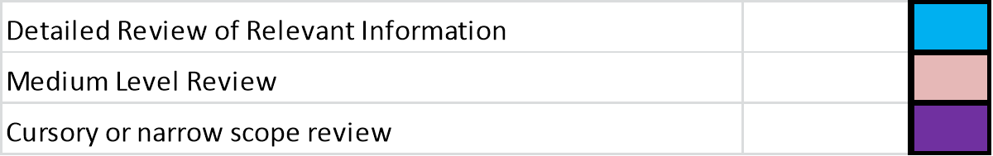

While the detailed review of relevant information obviously provides the most assurance, there is a place for each of the three categories in gaining assurance over a specific risk. For instance, a risk where there are multiple levels of detailed assurance may well indicate over-control with possible duplication of effort. Generally, there is likely to be more detailed assurance in the 1st line of Defence, with the other two categories being more prevalent in the 2nd and 3rd lines.
Assurance can be both positive and negative (i.e. just because a risk is well-assured, it does not necessarily mean that there isn’t a problem with it. However, if there is a problem, good assurance means that the organisation should know about it at an early stage).

2022/23 Update



The Assurance Maps for NWSSP were first presented to the Audit Committee in November 2017, with an annual update provided since to ensure that they remain current.



The last update, to the October 2021 Committee, demonstrated that the vast majority of risks had adequate assurance in place. In general, all previous assurances remain in place and the maps now include assurance over the Laundry Service which transferred, at least in part, to NWSSP responsibility with effect from 1 April 2021.



An Assurance Map has now also been produced for other recently acquired or introduced services such as the Medical Examiner and CIVAS services.

NWSSP Board Assurance Map

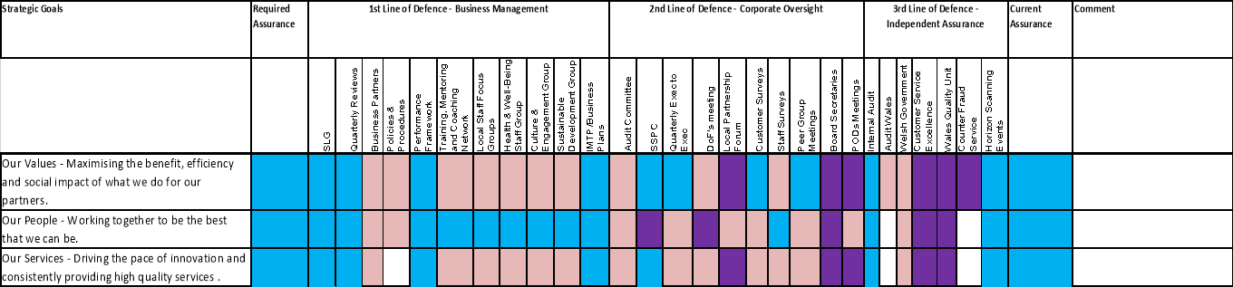

Accounts Payable

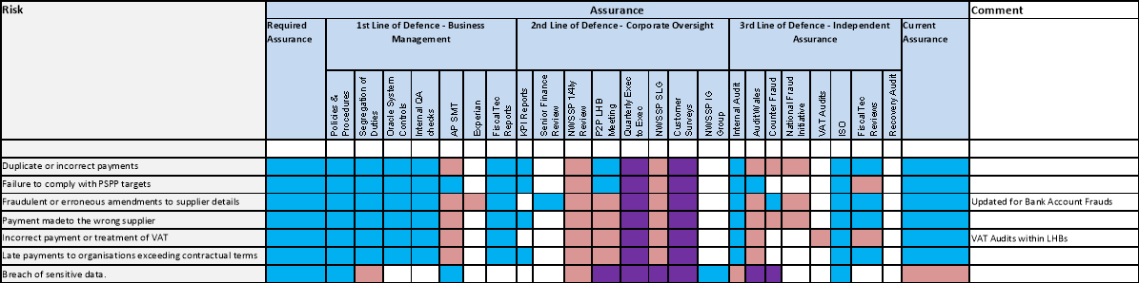

Audit & Assurance

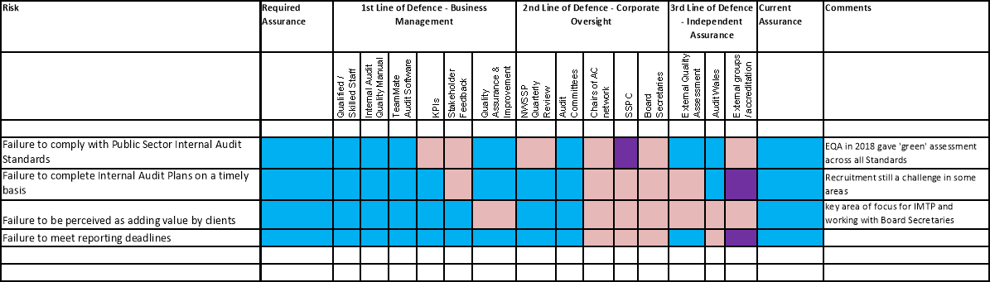

Business Systems and Information

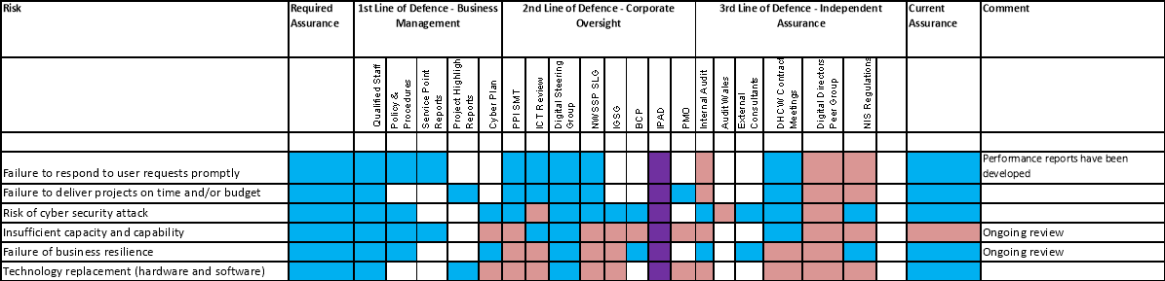

CIVAS

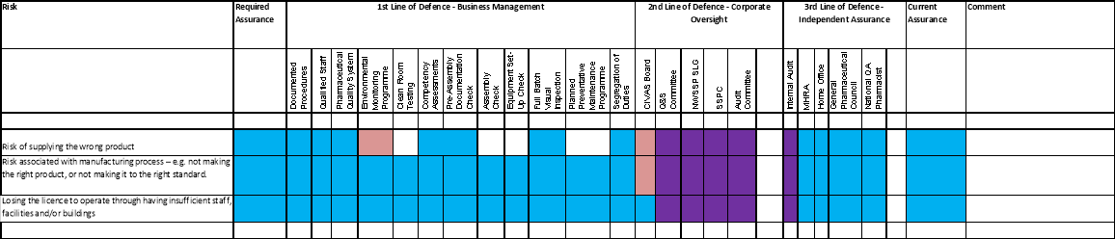

Corporate Services

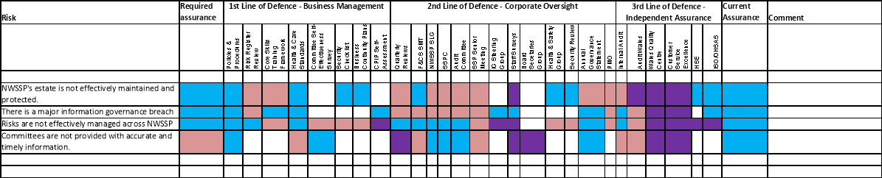

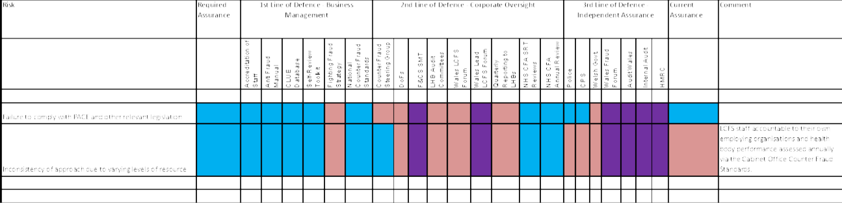

Counter Fraud

Finance

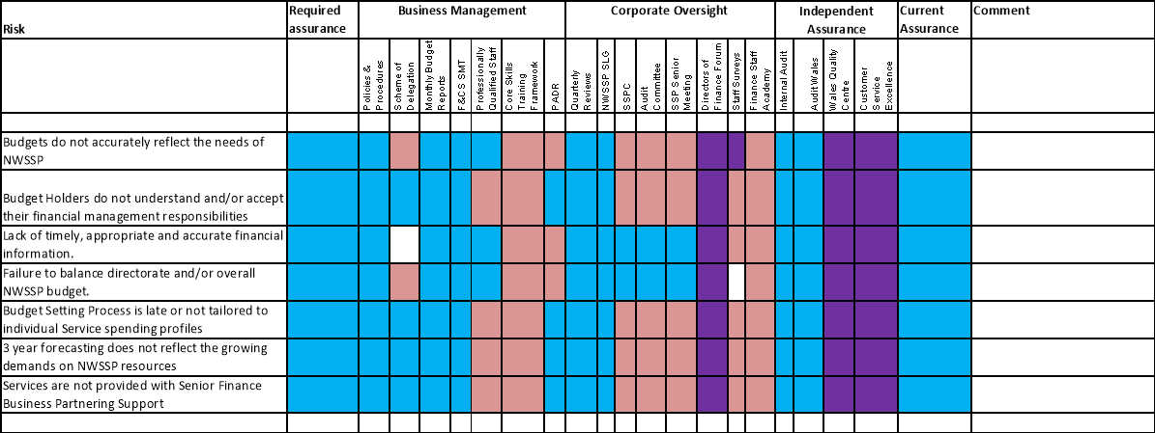

Health & Safety

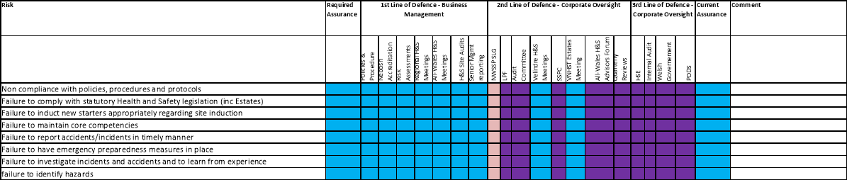

Laundry Services

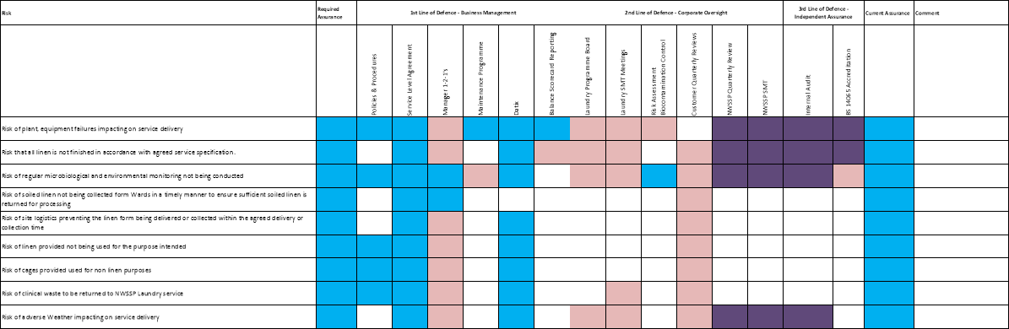

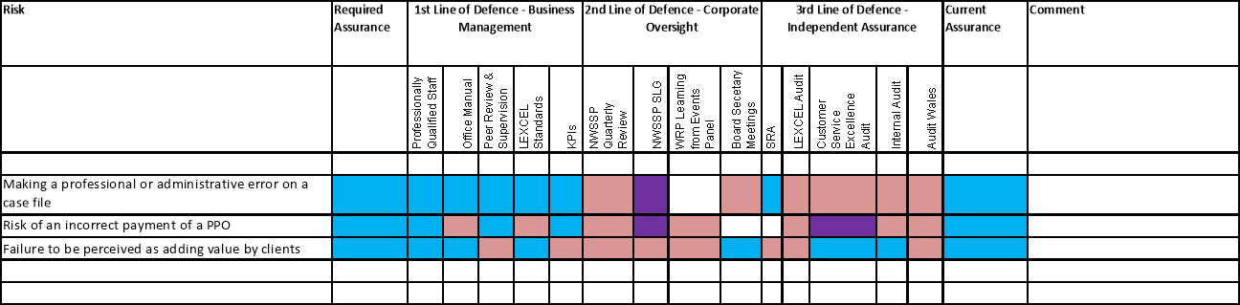

Legal & Risk Services

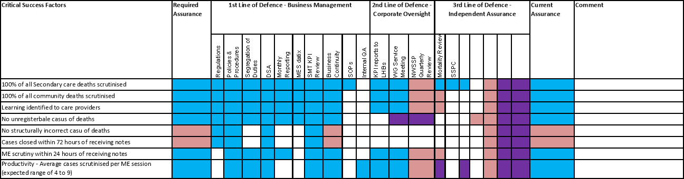

Medical Examiner Service (draft)

Payroll

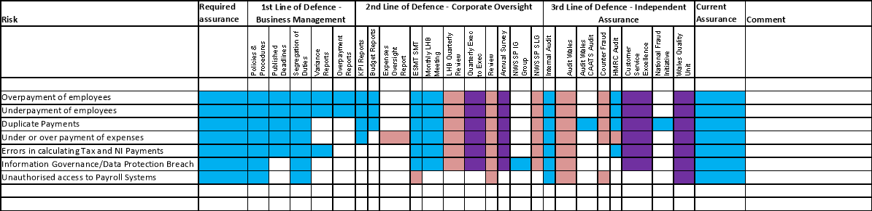

People & OD - Organisation

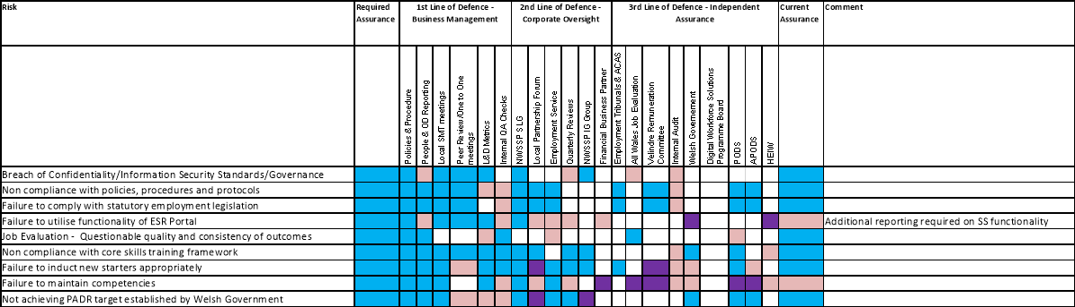

People & OD - Team

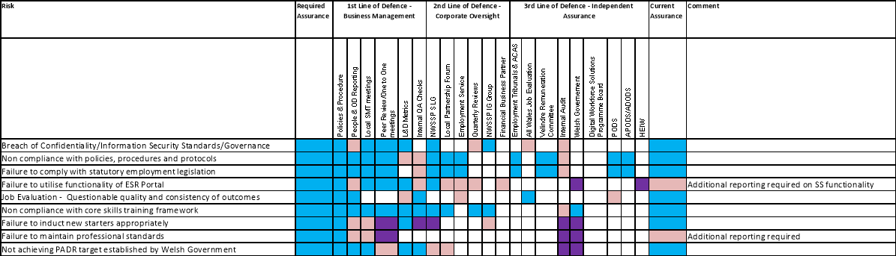

Primary Care Services

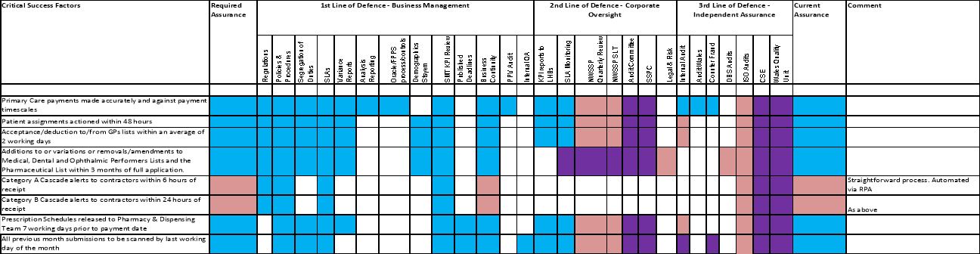

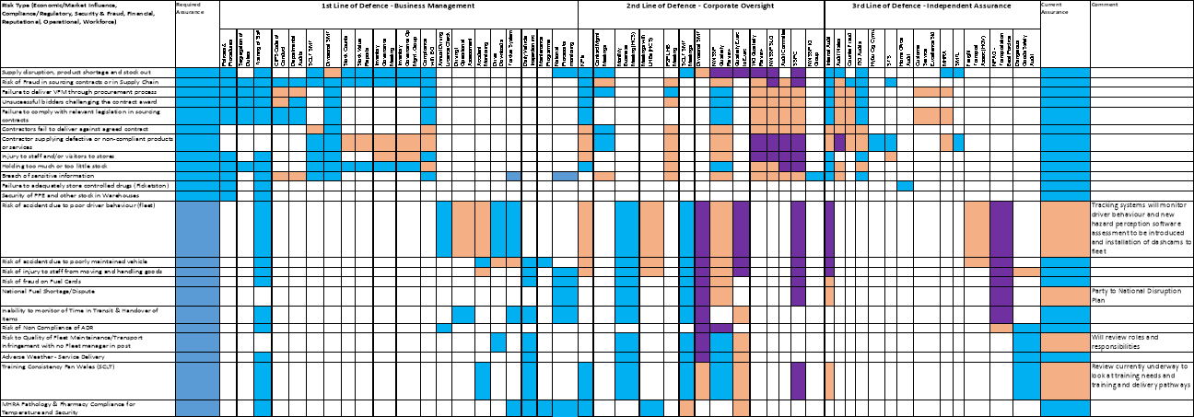

Procurement

Recruitment

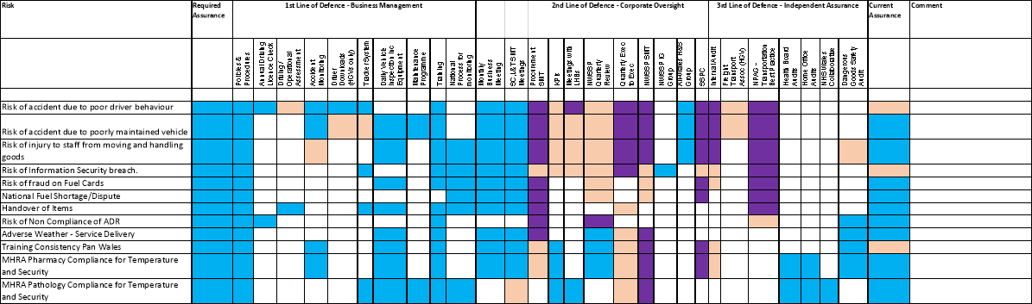

Specialist Estates Services

Welsh Infected Blood Support Scheme

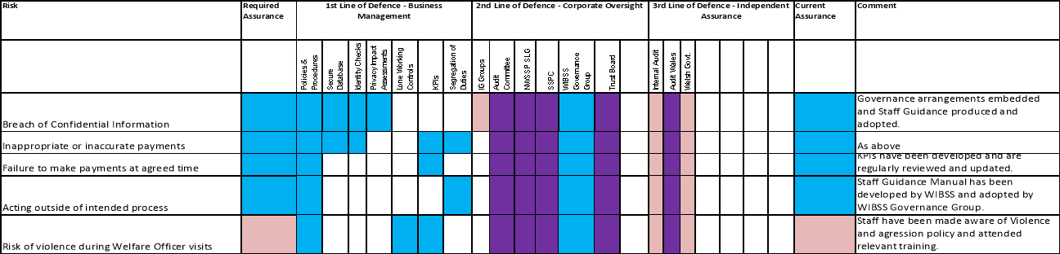



MEETING | Velindre University NHS Trust Audit Committee for NHS Wales Shared Services Partnership
DATE | 24 January 2023
PREPARED BY | Roxann Davies, Corporate Services Project Manager
PRESENTED BY | Peter Stephenson, Head of Finance & Business Development
RESPONSIBLE HEAD OF SERVICE | Andy Butler, Director of Finance and Corporate Services
TITLE OF REPORT | NWSSP Health and Care Standards Self- Assessment
PURPOSE

The purpose of this report is to provide the Committee with an update as to the Health and Care Standards Self-Assessment.

- INTRODUCTION
The paper is to provide the Committee with an update as to the Health and Care Standards Self-Assessment within NWSSP.

- BACKGROUND
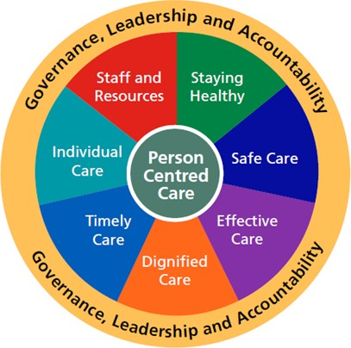
The Standards for Health Service in Wales provide a framework for consistent standards of practice and delivery across NHS Wales and for continuous improvement. In accordance with the programme of Internal Audits, the process is tested and is an integral part of the organisation’s assurance framework process. The Framework comprises seven main themes and sub criteria against which NHS bodies need to demonstrate compliance:

  - Governance, Leadership & Accountability
  - Staying Healthy
  - Safe Care
  - Effective Care
  - Dignified Care
  - Timely Care
  - Individual Care
  - Staff and Resources

Process for Completion
The process for undertaking the annual self-assessment is that NWSSP Corporate Services undertake an evaluation against the Standards, which is presented to the Senior Leadership Group (SLG) for discussion and consultation at Directorate level, where appropriate. Any feedback provided from Directorates is then reviewed and

24 January 2023
NWSSP Audit Committee 1

incorporated into the Self-Assessment and then this is reviewed by the NWSSP Medical Director.

Following completion of the Self-Assessment, an Action Plan to manage and monitor areas whereby we may develop and strengthen our compliance against the Standards has been developed, in consultation with Services, linked to the wider well-being agenda and is presented at a future SLG meeting, for discussion and approval.

In addition, once approved by the SLG, the Self-Assessment and Action Plan is presented to the Partnership Committee, Audit Committee and the Velindre University NHS Trust Quality and Safety Committee, for endorsement and assurance.

- ASSESSMENT / SUMMARY OF MATTERS FOR CONSIDERATION
Assessment of Ratings
Each theme is assessed and given an overall rating of between 1 and 5. As a largely non-clinical service provider, not all of the sub-criteria are applicable to NWSSP. A summary of the self-assessment ratings is outlined below:

Theme | Rating
Governance, Leadership & Accountability | 4
Staying Healthy | 4
Safe Care | 4
Effective Care | 4
Dignified Care | Not applicable
Timely Care | Not applicable
Individual Care | 4
Staff and Resources | 4

Appendices 1 to 8 contain the detailed criteria and assurances provided against each theme of the Standards.

The overall rating against the mandatory Governance, Leadership and Accountability module and the seven themes reflects NWSSP’s overall compliance against the Health and Care Standards and has been rated as a 4, as outlined below. This rating is based on the work undertaken to address staff well-being across the organisation, in line with A Healthier Wales and as a result of the recovery and response work undertaken in relation to the pandemic. An assessment level rating of 4 sets out that “we have well-developed plans and processes can demonstrate sustainable improvement throughout the organisation”.

The actions identified in the Action Plan will be monitored by the NWSSP SLG and we are working towards achieving a self-assessment rating of 5, which sets out that “we can demonstrate sustained good practice and innovation that is shared throughout the organisation, and which others can learn from”.

Developments
In light of the commencement of the Health and Social Care (Quality and Engagement) (Wales) Act 2020 and the associated duty that this brings upon the organisation, this is likely to alter the way in which we report and approach this

Self-Assessment, going forward. It is hoped that the Duty will lend itself better to NWSSP and the Services that we provide to NHS Wales.

The approach supports the five ways of working (Sustainable Development Principle) in the Well-being of Future Generations (Wales) act 2015, to achieve a Healthier Wales. The Duty will see active consideration of whether decisions will improve service quality and secure improvement in outcomes and applies to all health services functions (not just clinical), requiring health services to demonstrate that quality is at the heart of all we do. There will be a system-wide approach to achieving quality of care in a way that secures continuous improvement and in addressing this, we will consider the domains of quality and how these apply to NWSSP:

- Safe: Avoiding harm to patients from the care that is intended to help them;
- Effective: Providing services based on scientific knowledge to all who could benefit and refraining from providing services to those not likely to benefit (avoiding underuse and misuse, respectively);
- Patient-centred: Providing care that is respectful of and responsive to individual patient preferences, needs, and values and ensuring that patient values guide all clinical decisions;
- Timely: Reducing waits and sometimes harmful delays for both those who receive and those who give care;
- Efficient: Avoiding waste, including waste of equipment, supplies, ideas, and energy; and
- Equitable: Providing care that does not vary in quality because of personal characteristics such as gender, ethnicity, geographic location, and socioeconomic status.

In recognising the role that NWSSP plays in terms of the Services that we deliver within NHS Wales and our contributions through these Services (both directly and indirectly) towards the well-being of the wider population of Wales, we have chosen to include links to case studies within this year’s Self-Assessment, to help to tell the story of the organisation’s impact.

- RECOMMENDATION
The Committee is asked to ENDORSE the NWSSP Health and Care Standards Self- Assessment.

MEETING | Velindre University NHS Trust Audit Committee for NHS Wales Shared Services Partnership
DATE | 24 January 2023
PREPARED BY | Carly Wilce, Corporate Services Manager
PRESENTED BY | Andy Butler, Director of Finance and Corporate Services
RESPONSIBLE HEAD OF SERVICE | Andy Butler, Director of Finance and Corporate Services
TITLE OF REPORT | Governance Matters
PURPOSE
The purpose of this paper is to provide the Audit Committee with a brief update on governance developments within NWSSP.

- STANDING ORDERS AND FINANCIAL INSTRUCTIONS (SOs and SFIs)

There have been no departures from the Standing Orders and financial regulations during the period.

- CONTRACTS FOR NWSSP

The table overleaf summarises contracting activity undertaken during the period 21 September 2022 to 20 December 2022. A summary of activity for the period is set out in Appendix A.

Description | No.
File Note | 5
Invitation to competitive quote of value between £5,000 and  £25,000 (exclusive of VAT) | 16
Invitation to competitive tender of value between £25,000 and the prevailing OJEU threshold (exclusive of VAT) | 1
Single Tender Actions | 5
Single Quotation Actions | 4
Direct Call Off against National Framework Agreement | 6
Invitation to competitive tender of value exceeding prevailing OJEU threshold (exclusive of VAT) | 1
Contract Extensions | 0
Total | 38

- NWSSP PROCUREMENT SERVICES ALL WALES CONTRACTING ACTIVITY

During the period 19 September 2022 to 28 December 2022, activity against 22 contracts have been completed. This includes 10 contracts at the briefing stage and 7 contracts at the ratification stage. In addition to this activity, 5 extensions have been actioned against contracts. A summary of activity for the period is set out in Appendix B.

- AUDIT COMMITTEE APPROVAL FOR THE SUBMISSION OF LOSSES FORMS TO WELSH GOVERNMENT

As we progress towards the close of the 2022/23 financial year, we are reviewing both our fixed and current assets and making assessments of any impairments and/or write off’s
required. This includes both capital assets and stock holding. Per the Scheme of Delegation, we may need to seek Audit Committee approval to submit losses forms to Welsh Government during Quarter 4, noting that our next Audit Committee meeting is not until the final stages of the account’s completion on 19th April 2023.

- GIFTS, HOSPITALITY & SPONSORSHIP

There have been three declarations as to Gifts, Hospitality or Sponsorship made since the last Audit Committee meeting. These are as follows:

  - Evening awards dinner linked to BIP Procurex. Offer made to NWSSP’s Programme Director as chief Judge for the awards event. funded by BIP Solutions. Total value of £40 – Accepted and Approved;
  - Evening awards dinner linked to the HCSA event. Approximate value of £350 - this offer was Accepted and Approved; and
  - PROMPT Wales Celebratory Event, funded by RLDatix Ltd. Total costs of £250. Accepted and Approved.

- WELSH GOVERNMENT QUARTERLY UPDATE

On a quarterly basis, we issue a letter to Judith Paget at Welsh Government to confirm any Audit Reports which have achieved limited or no assurance. This was a nil return for the last quarter.

6. RECOMMENDATIONS

The Committee is asked to NOTE the report.

Appendix A - NWSSP Contracting Activity Undertaken (21/09/2022 to 20/12/2022)

No. | Trust | Division | Procurement Ref No | Date | SFI  Reference | Agreement Title/Descrip tion | Supplier | Anticipated Agreement Value (ex VAT) | Reason/Circumstance and Issue | Compliance Comment | Procurement Action Required
1. | VEL | NWSSP | NWSSP-OJEU- 50121 | 01/12/2022 | Above Threshold Tender | Provision of Laundry Chemicals & Detergent | Ecolab | £2,117,414.73 | Laundry Chemicals, Detergent, Dosing pumps and Management information systems for all 5 NWSSP Laundries | Endorsed | No Action Required
2. | VEL | NWSSP | NWSSP-DCO- 51124 | 01/11/2022 | Direct Call Off | Welsh Language Translation | Atebol | £50,000 | Welsh Language translation | Endorsed | No Action Required
3. | VEL | NWSSP | NWSSP-DCO- 51124 | 01/11/2022 | Direct Call Off | Welsh Language Translation | Clear Translations | £50,000 | Welsh Language translation | Endorsed | No Action Required
4. | VEL | NWSSP | NWSSP-DCO- 51124 | 01/11/2022 | Direct Call Off | Welsh Language Translation | Testun Cyf | £50,000 | Welsh Language translation | Endorsed | No Action Required
5. | VEL | NWSSP | NWSSP-ITT- 51444 | 12/12/2022 | Under Threshold Tender | Provision of an Audit of All- Wales NHS Workforce Policies through an Anti-racist Lens | Diverse Cymru | £20,000.00 | An audit of workforce policies through an anti- racist lens | Endorsed | No Action Required
6. | VEL | NWSSP | NWSSP-DCO- 822 | 31/10/2022 | Direct Call Off | Eprescribing Temporary Staff | ROC Search Ltd | £44,800.00 | Provision of a temporary member of staff to assist with the implementation of Eprescribing within PCS | Endorsed | No Action Required
7. | VEL | NWSSP | NWSSP-DCO- 823 | 28/11/2022 | Direct Call Off | BA Campus - Due Diligence Services | Ove Arup and Partners (Arup) | £46,600.43 | Technical Due Diligence Report concerning a potential site purchase | Endorsed | No Action Required
8. | VEL | NWSSP | SCLT-DCO-001 | 28/11/2022 | Direct Call Off | IP5 Racking | Whittan Industrial Ltd | £199,401.00 | Racking for IP5 warehouse | Endorsed | No Action Required

9. | VEL | NWSSP | NWSSP-MQ- RA322610 | 01/09/2022 | Multiquote | Material testing and associated services | Minton, Treharne and Davies Limited | Up to £25,000 | MEAT evaluation utilised | Endorsed | No Action Required
10. | VEL | NWSSP | NWSSP-MQ- RA322906 | 17/10/2022 | Multiquote | The provision of Mobile Phones for NWSSP | Specialist Computer Centres PLC | £10,022.40 | MEAT evaluation utilised | Endorsed | No Action Required
11. | VEL | NWSSP | NWSSP-MQ- RA322973 | 10/10/2022 | Multiquote | ISO20000-1  Certification | BSI  Assurance Group | £7,010.00 | MEAT evaluation utilised | Endorsed | No Action Required
12. | VEL | NWSSP | NWSSP-MQ- RA323768 | 01/11/2022 | Multiquote | Culture Assessment of The Citizen Voice Body for Health and Social Care in Wales | Human Synergistics | £14,143.26 | MEAT evaluation utilised | Endorsed | No Action Required
13. | VEL | NWSSP | NWSSP-MQ- RA323925 | 12/12/2022 | Multiquote | External Quality Assesment for NHS Wales Audit and Assurance | CIPFA | £4,785.00 | MEAT evaluation utilised | Endorsed | No Action Required
14. | VEL | NWSSP | NWSSP-MQ- RA324540 | 05/12/2022 | Multiquote | Microbiological Incubators | Scientific laboratory supplies | £12,713.50 | MEAT evaluation utilised | Endorsed | No Action Required
15. | VEL | NWSSP | NWSSP-MQ- RA325500 | 01/01/2023 | Multiquote | Prince2 Foundation and Practitioner Training | NILC LTD | £14,043.60 | MEAT evaluation utilised | Endorsed | No Action Required
16. | VEL | NWSSP | NWSSP-RFQ- (22-23)-3 | 14/10/2022 | Request for Quote | Generator Hire for Picketston | POWER ELECTRICS (BRISTOL) LTD | £8,898.00 | Awarded to lowest price quotation | Endorsed | No Action Required
17. | VEL | NWSSP | NWSSP-RFQ- (22-23)-4 | 14/10/2022 | Request for Quote | Trainee Solicitors Practical Skills Course | Barbri Altior | £5,100.00 | Awarded to lowest price quotation | Endorsed | No Action Required
18. | VEL | NWSSP | NWSSP-RFQ- (22-23)-5 | 07/11/2022 | Request for Quote | Rental of refrigerated Vans | Petit Forestier Uk Ltd | £17,120.00 | Awarded to lowest price quotation | Endorsed | No Action Required

19. | VEL | NWSSP | NWSSP - SES/DEPD/003 | 14/11/2022 | Request for Quote | Appointment of a specialist engineer to support investigation into the presence and management of reinforced autoclaved aerated concrete (raac) across the NHS Wales estate | Curtins Consulting Ltd | £15,850.00 | Awarded to lowest price quotation | Endorsed | No Action Required
20. | VEL | NWSSP | NWSSP-RFQ- (22-23)-6 | 14/12/2022 | Request for Quote | Repairing and erecting new fence | ABBEY BUILDING SUPPLIES | £5,130.00 | Awarded to lowest price quotation | Endorsed | No Action Required
21. | VEL | NWSSP | NWSSP-RFQ- (22-23)-7 | 14/10/2022 | Request for Quote | ROOF REPAIR AT BRIDGEND STORES | Waters roofing | £7,100.00 | Awarded to lowest price quotation | Endorsed | No Action Required
22. | VEL | NWSSP | NWSSP-RFQ- (22-23)-8 | 14/10/2022 | Request for Quote | Installation of windows at WestPoint industrial Estate | PRW  Construction | £7,680.00 | Awarded to lowest price quotation | Endorsed | No Action Required
23. | VEL | NWSSP | NWSSP-RFQ- (22-23)-9 | 07/11/2022 | Request for Quote | Replacement Dock lever ( Bay 2) | Bolton Gate Services Ltd | £8,804.40 | Awarded to lowest price quotation | Endorsed | No Action Required
24. | VEL | NWSSP | NWSSP-RFQ- (22-23)-10 | 14/11/2022 | Request for Quote | Hygiene Bins | PHS Group | £2,500.00 | Awarded to lowest price quotation | Endorsed | No Action Required
25. | VEL | NWSSP | NWSSP-SQA- (22-23)-7 | 01/09/2022 | Single Quotation Action | Maldi Tof service contract | Bruker UK Ltd | £11,500.00 | The Maldi Tof is only able to have a service agreement through the original provider of the equipment. The servicing contract will allow ongoing maintenance and replacement of parts which will greatly reduce the ad- hoc costs incurred when fixing this machine. | Endorsed | No Action Required

26. | VEL | NWSSP | NWSSP-STA- (22-23)-8 | 01/09/2022 | Single Tender Action | Testing to EN 14683 Medical face masks.  Requirements and test methods | 4Ward Testing Laboratories | £79,200.00 | STA is requested for the EN 14683:2019 Medical face masks. Requirements and test methods laboratory testing services from 4Ward Testing who have been providing medical mask testing services to SMTL on behalf of the Welsh NHS and other organisations during the COVID pandemic.  4Ward are the only UKAS accredited testing laboratory offering this service in the UK. | Endorsed | No Action Required
27. | VEL | NWSSP | NWSSP-STA- (22-23)-9 | 01/10/2022 | Single Tender Action | Temporary Staff for Laundry Services | Smart Solutions | £35,611.95 | Laundry services have attempted to use bank staff to fulfil the roles within Laundry but this has failed. Bank have been unable to recruit despite advertising repeatedly. Attempts to use a compliant framework have also failed. Laundry have contacted Hays and multiple suppliers via the Crown Commercial Services (CCS) RM6160 Framework but all attempts have failed to provide staff. The requirement is now become business critical and Smart Solutions have been the only supplier who have staff immediately available. | Endorsed | Procurement in contact with the supplier to see if they are able to join the CCS RM6160  framework to allow compliant route to market
28. | VEL | NWSSP | NWSSP-SQA- (22-23)-10 | 01/10/2022 | Single Quotation Action | Emergency callout for roof repairs at IP5 | Waters Roofing | £10,000.00 | Cover needed for emergency callouts in regards to leaks to the warehouse roof at IP5. Waters roofing have extensive knowledge of the roof at IP5 and the multiple issues encountered since purchasing the building.  Bringing in another contractor could cause issues both operationally and from a health and safety position. | Endorsed | No Action Required

29. | VEL | NWSSP | NWSSP-STA- (22-23)-11 | 01/11/2022 | Single Tender Action | Endotoxin Testing Consumables | Associates of Cape Cod | £40,000.00 | SMTL performs endotoxin analysis for Sterile Service Departments (SSDs) within NHS Wales, a local medical device manufacturer (Biomet) and glove manufacturers/suppliers as requested on a commercial basis. Changing suppliers would require 6-week validation process. For business continuity the STA has been requested to allow a full tender exercise in March/April 2023 with validation scheduled for June 2023 when the department has capacity to conduct this. | Endorsed | Procurement to conduct tender exercise in March April 2023.
30. | VEL | NWSSP | NWSSP-STA- (22-23)-12 | 01/12/2022 | Single Tender Action | TOC testing | ALS | £30,000 | SMTL perform analysis of water samples for a local medical device manufacturer, SMTL does not offer Total organic carbon (TOC) testing of water samples, this part of the analysis therefore needs to be subcontracted to another laboratory. NWSSP recently undertook a tender for TOC testing, however the incumbent supplier (ALS) did not bid. Only one company (Anderson Caledonian) bid, however they did not have the required ISO 17025 accreditation for the testing. Anderson Caledonian are working towards obtaining this accreditation which is estimated to be achieved mid 2023. The period of this STA will allow the Anderson Caledonian to achieve ISO 17025 accreditation who will then meet our specification requirements and be eligible to bid for the TOC testing in a future re-tender exercise. | Endorsed | Procurement to re-tender when market has matured

31. | VEL | NWSSP | NWSSP-SQA- (22-23)-14 | 01/10/2022 | Single Quotation Action | Provision of Ad-hoc waste collections | Shaw Environment al | £10,000.00 | The provision of Ad-Hoc waste collections across NHS Supply Chain Sites. Issues with All Wales Contracted supplier has resulted in the requirement for short-term ad-hoc collections until the issues are resolved. | Endorsed | No Action Required
32. | VEL | NWSSP | NWSSP-STA- (22-23)-16 | 01/12/2022 | Single Tender Action | Counsel to provide advice to NWSSP in relation to the COVID-19  Public Inquiry. | Serjeant’s Inn Chambers | £80,000.00 | Legal counsel for COVID-19 Public Enquiry. Serjeants in Inn Counsel was selected as they understood the complex nature of NWSSP and the role in the wider NHS Wales. The Counsel has similar experience with Inquiry proceedings (Ranald Davidson had acted in the WIBSS Inquiry). There is  an exemption to the Public Contracts Regulations (Regulation 10 – Legal representation in Judicial proceedings), as this matter relates to the Covid-19 Public Inquiry. | Endorsed | No Action Required
33. | VEL | NWSSP | NWSSP-SQA- (22-23)-17 | 16/11/2022 | Single Quotation Action | Agency Staff SMTL | Science Recruitment Group (SRG) | £20,840.63 | Agency Laboratory Staff to cover outstanding work on a Welsh Government (WG) research project into the technologies for determining protein levels on surgical instruments. Despite approaching several framework agencies SMTL were not able to recruit this type of role and had to approach a specialist agency. | Endorsed | No Action Required
34. | VEL | NWSSP | NWSSP-FN- (22-23)-7 | 23/09/2022 | File Note | Number of Small Roofing Repairs and Emergency Callouts at IP5 | Waters Roofing | £19,150.00 | Emergency Callouts in adverse weather and inspections following storm Eunice and small repair works as follow ups of emergency callout. | Competition not sought in accordance with SFI’S | Service and Procurement meeting to be arranged to support

35. | VEL | NWSSP | NWSSP-FN- (22-23)-8 | 25/10/2022 | File Note | Purchase of access to an online library containing information from HSE, British standards, trade associations and legal organisations. | Barbour EHS Ltd | £10,302.53 | Barbour 12 month contract for an online library containing information from HSE, British standards, trade associations and legal organisations auto-renewed for an additional 12 months automatically. This occurred without being able to engage in a competitive exercise requested by procurement. | Competition not sought in accordance with SFI’S | Service and Procurement meeting was held. Further training provided.
36. | VEL | NWSSP | NWSSP-FN- (22-23)-10 | 14/11/2022 | File Note | The provision of ad-hoc waste collections across NWSSP Supply Chain | Shaw Environment al | £10,552.00 | Historic Ad Hoc agreement for picking up of waste across NWSSP Sites. Shaw Environmental have provided vital adhoc waste removals of items due to issues with the All Wales Contractor picking up the additional waste streams. Work is being undertaken with the All Wales contractor to migrate the spend into the All Wales Contractor. | Competition not sought in accordance with SFI’S | No further action required
37. | VEL | NWSSP | NWSSP-FN- (22-23)-11 | 25/11/2022 | File Note | Lease of temperature Controlled Boxes and Service/calibra tion from David Brett Solutions | David Brett Solutions | £16,344.65 | During Covid 19, HCS urgently needed to expand its temperature-controlled capacity and use of Euroengel units to support distribution of the Covid Vaccine. | Competition not sought in accordance with SFI’S | Work is being undertaken by service to draft specifications for competitive tender.
38. | VEL | NWSSP | NWSSP-FN- (22-23)-12 | 05/12/2022 | File Note | Counsel Advice from Serjeant’s Inn Chambers in relation to the Covid-19 Public Inquiry Proceedings | Serjeant’s Inn Chambers | £7,212.50 | Limited options available for appropriate Counsel to represent NWSSP for the Covid-19 Public Inquiry, including the requirement for a specialist Counsel who understood the complex nature of NWSSP and our role in the wider NHS Wales, and Counsel who was experienced with Inquiry proceedings (Ranald Davidson had acted for us in the WIBSS Inquiry). | Competition not sought in accordance with SFI’S | STA in place. Not further action required

APPENDIX B - All Wales Contracting Activity In Progress (19/09/2022 - 28/12/2022)

No. | Contract Title | Doc Type | Total Value | JI approval  <£750K | WG approval  >£500k | NF approval  £750-£1M | Chair Approval  £1M+
1. | Wheelchairs, Associated Parts, and Accessories.  Provision of Manual and Powered, Adult and Paediatric Wheelchairs and their associated accessories and consumables  Contract: 1st January 2023 – 31st December 2024 +2 Years | Ratification | £11,076,944 | 21/09/2022 | 26/09/2022 | 06/10/2022 | 07/10/2022
2. | Clozapine  Indicated for the treatment of schizophrenia (including psychosis in Parkinson's disease) in patients unresponsive to, or intolerant of, conventional antipsychotic drugs.  Contract: 01.07.2023 – 30.06.2026 +1 | Briefing | £1,382,251 | 17/10/2022 | 28/10/2022 | n/a | n/a
3. | WBS Becs  Blood Establishment Computer System (BECS) via its ‘ePROGESA’ platform and associated modules. This system manages the WBS supply chain activity, including donor engagement, blood collection, manufacturing & testing and component issuing activity.  Contract: 1st November 2022 – 31st October 2024 +1. | Ratification | £623,278 | 17/10/2022 | 02/11/2022 | n/a | n/a
4. | Women & child health consumables Framework Supply of Women & Child Health Consumables  Contract: 1st December 2022 to 30th November 2025+1 | Ratification | £2,448,093 | 19/10/2022 | 11/11/2022 | 11/11/2022 | 11/11/2022
5. | Stoma (prescribed items and delivery/prep costs)  Service to deliver value to those receiving stoma care services and to build on the existing arrangements by delivering a range of benefits.  Contract 1st January 2023 – 31st December 2026 +2 | Briefing | £125,000,000  £17,500,000 | CS 08/07/22 | 22/12/2022 | n/a | n/a
6. | Contrast Media extension  This contract is for all X-Ray Contrast Media purchased by all hospital Pharmacy Departments in Wales for use by radiology departments. Contract 1st November 2019 to 31st October 2023 | Extension | £12,329,124 | 25/10/2022 | original approval applies 18/9/19 | 25/10/2022 | 25/10/2022
7. | Hep C  This contract is for the provision of antiviral medicines for the treatment of Hepatitis C (HCV). These medicines are designed to stop the virus from multiplying inside the body and thereby preventing liver damage.  Contract 01/05/2023 to 30/04/2025 +2 | Briefing | £13,826,112 | 27/10/2022 | 18/11/2022 | n/a | n/a
8. | Nurses Uniforms  The contract is for the supply and delivery of various standard unisex garments to each Health Board and Trust in Wales. All garments are available in sizes XS – 4XL, with the option to choose from two lengths, standard or tall.  Contract: 1st March 2023 – 28th February 2027+3 | Briefing | £8,494,396 | 27/10/2022 | sent to WG 27/10 | n/a | n/a
9. | Provision of Medical Consumables Commercial Storage Facilities & Distribution Services  Safe storage and distribution as required of various medical consumables on behalf of NHS Wales.  Contract: 1st December 2021 to 30th November 2023 | Extension | £1,986,400 | 02/11/2022 | original approval applies 17/11/21 | 07/11/2022 | 08/11/2022
10. | Lenalidomide  Lenalidomide Capsules, which until recently, has been on the Proprietary Drugs contract, which expired on 30th June 2022. The product is available in Capsule form and comes in different strengths ranging from 2.5mg, 5mg, 7.5mg, 10mg, 15mg, 20mg & 25mg (all pack sizes of 21 capsules) used for | Ratification | £739,384 | 10/11/2022 | 11/11/2022 | 11/11/2022 | n/a

the treatment of certain cancers and serious conditions affecting blood cells and bone marrow, namely multiple myeloma, myelodysplastic syndromes and mantle cell and follicular lymphoma
Contract: 01/12/2022 to 30/11/2024 +2
11. | Oral Liquids  It consists of all Generic liquids, syrups, solutions, suspensions and powders purchased through hospital Pharmacy Departments.  Contract: 01/07/2023 to 30/06/2026 +1 | Briefing | £10,788,379 | 25/11/2022 | 30/11/2022 | n/a | n/a
12. | Eating disorder units  Eating disorders are a range of complex mental health conditions requiring specialised treatment and support for individuals.  Contract: 1st April 2023 to 31st March 2025 +3 | Briefing | £10,950,000 | 25/11/2022 | 20/12/2022 | n/a | n/a
13. | Emergency Department Well-being and Home Safe Service  Offer support for frail older people and vulnerable adults in emergency departments and to resettle people in their homes with follow-up welfare calls or visits and where necessary to connect them to community services to avoid readmission into the emergency department.  Contract: 1st April 2023 – 31st March 2024 +2 | Briefing | £2,700,417 | AS 23/11/22 | 14/12/2022 | n/a | n/a
14. | Primary care workforce intelligence system  Procure a single system which brings the Performers List, All Wales Pharmacy Database, and the Primary Care Workforce Reporting System within NWSSP Primary Care services and Employment Services together by April 2024.  Contract 1st April 2023 – 3+2 | Briefing | £960,000 | 01/12/2022 | sent to WG 01/12 | n/a | n/a
15. | Human blood derived products  Human Blood Derived Products purchased by The Welsh Blood Service. The Welsh Blood Service operate a wholesaling service to All Wales LHB’s/Trusts. Due to shortages within this global market, it is necessary to ensure that some of the products i.e. Immunoglobulin’s, have all the brands available on contract. This will ensure continuity of supply and will allow the Welsh Blood Service to stock any product ordered through their wholesaling service.  Contract: 1st May 2020 to 30th April 2024 | Extension | £68,946,178 | 05/12/2022 | original approval applies 25/2/20 | 06/12/2022 | 12/12/2022
16. | All Wales Ophthalmology Consumables Framework Agreement Ophthalmology Consumables are used in both the Surgical and Outpatient settings of Ophthalmology Departments  Contract 1st June 2023 – 31st May 2027 | Briefing | £22,705,529 | 08/12/2022 | sent to WG 8/12 | n/a | n/a
17. | Walking Aids  The Contract will cover various walking aid products including crutches, walking frames and walking sticks.  Contract: 01/01/23 – 31/12/2026 | Ratification | £3,672,750 | 12/12/2022 | 19/12/2022 | 21/12/2022 | 21/12/2022
18. | Biologics  Etanercept is licensed for the treatment of adults with moderate to severe rheumatoid arthritis (RA), psoriatic arthritis, non-radiographic axial spondylarthritis and plaque psoriasis. Bevacizumab is licensed for the treatment of several types of cancer. Teriparatide is licensed for the treatment of osteoporosis in post-menopausal women and in men at increased risk of fractures. Adalimumab is licensed for the treatment of moderate to severe rheumatoid arthritis; severe ankylosing spondylitis; Crohn’s disease; ulcerative colitis; hidradenitis suppurativa and uveitis.  Infliximab is licensed to treat Crohn’s disease and rheumatoid arthritis. Rituximab is licensed for the treatment of non-Hodgkin's B-cell lymphomas, | Extension | £53,751,993 | 15/12/2022 | original approval applies 29/4/21 | 15/12/2022 | 16/12/2022

 | chronic lymphocytic leukemia, Wegener's granulomatosis, and microscopic polyangiitis. It is also licensed to treat rheumatoid arthritis in patients who have failed other biologic medications, such as Infliximab or Etanercept Contract: 1st July 2021 to 30th June 2024
19. | Trastuzumab  is approved for the treatment of early-stage breast cancer that is Human Epidermal growth factor Receptor 2-positive (HER2+). Trastuzumab is also approved, in combination with chemotherapy for the treatment of HER2+ metastatic cancer of the stomach or gastroesophageal junction in patients who have not received prior treatment for their metastatic disease. This contract is for the supply of medicines to both hospitals and to patients within their own homes.  Contract: 1st July 2021 to 30th June 2024 | Extension | £19,796,274 | 15/12/2022 | original approval applies 29/4/21 | 15/12/2022 | 16/12/2022
20. | Remote advice and guidance  Provide a tool that can link care providers to expert advice within and across organisational boundaries.  Contract: 01/04/23 – 31/03/26+2 | Ratification | £6,000,000 | 19/12/2022 | 21/12/2022 | 22/12/2022 | 22/12/2022
21. | Video Consultation  VC now forms part of a safe and assured toolkit for patients and clinicians, enabling a flexible approach for clinicians and patients in the delivery of safe and timely care to the people of Wales.  Contract: 01/01/2023 -31/12/2023+1 | Ratification | £3,912,000 | 20/12/2022 | 22/12/2022 | 22/12/2022 | 23/12/2022
22. | Laryngoscope blades and consumables Contract: 01/06/2023 – 31/05/2027 | Briefing | £2,223,192 | 21/12/2022 | sent to WG 21/12

NWSSP Audit Committee
24 Janaury 2023 12

MEETING | Velindre University NHS Trust Audit Committee for NHS Wales Shared Services Partnership
DATE | 24 January 2023
PREPARED BY | Carly Wilce, Corporate Services
PRESENTED BY | Peter Stephenson, Head of Finance & Business Development
RESPONSIBLE HEAD OF SERVICE | Andy Butler, Director of Finance and Corporate Services
TITLE OF REPORT | Update on the Implementation of Audit Recommendations
PURPOSE

This report provides an update to the Audit Committee on the progress of audit recommendations within NWSSP. Please note that this report does not include figures and assurance ratings for the audit reports listed on the present Audit Committee agenda.

- INTRODUCTION

NWSSP records audit recommendations raised by Internal Audit, Audit Wales, and other external bodies, as appropriate. It is essential that stakeholder confidence is upheld and maintained; an important way in which to enhance assurance and confidence is to monitor and implement audit recommendations in an effective and efficient way.

- CURRENT POSITION

The detailed recommendations raised in respect of our services have been captured in a database. A copy of the summary extract is attached at Appendix A, for information.

There are 68 reports covered in this review; 17 reports have achieved Substantial assurance; 30 reports have achieved Reasonable assurance, 1 report has achieved Limited assurance and no reports have been awarded No Assurance; and 20 reports were generated with Assurance Not Applicable. The reports include 248 recommendations for action.

24 January 2023 NWSSP Audit Committee
1

Table 1 - Summary of Audit Recommendations

As at 13 January 2023
Recommendations |  | Implemented | Not Yet Due | Overdue | Dependant on third party organisations
Internal Audit | 202 | 189 | 5 | 4 | 4
High | 19 | 18 | 1 | 0 | 0
Medium | 98 | 92 | 3 | 0 | 3
Low | 67 | 66 | 1 | 0 | 0
Not Applicable | 18 | 13 | 0 | 4 | 1
External Audit | 18 | 16 | 0 | 2 | 0
High | 0 | 0 | 0 | 0 | 0
Medium | 14 | 12 | 0 | 2 | 0
Low | 1 | 1 | 0 | 0 | 0
Not Applicable | 3 | 3 | 0 | 0 | 0
Other Audit | 28 | 28 | 0 | 0 | 0
High | 4 | 4 | 0 | 0 | 0
Medium | 5 | 5 | 0 | 0 | 0
Low | 19 | 19 | 0 | 0 | 0
Not Applicable | 0 | 0 | 0 | 0 | 0
TOTALS: | 248 | 233 | 5 | 6 | 4

- Overdue Recommendations

There are six overdue recommendations to report. Full details of the recommendations are set out in Appendix A, but in summary these relate to:

  - Review of National Hosted NHS IT Systems. Oracle Financial Management System - IT Controls (Ref 1 & 2) - This covers two recommendations, but the same action is required to complete both. It relates to the implementation of management standard ISO 27001, where, although good progress has been made, delays have been noted due to supplier availability. Full accreditation should be achieved by the end of April and therefore an extension to the end of April 2023 is requested.

  - Review of Decarbonisation (Ref 12 – 15) – This covers four separate recommendations but where the action is dependent upon recruitment of programme management resource to progress them. Unfortunately securing the right level of resource continues to be extremally challenging and therefore some actions have taken longer than anticipated. A recruitment exercise to recruit a dedicated programme lead and project manager is underway, and each advert will close on 16 January 2023. If both posts are successfully appointed to, candidates could be in post by mid-March. A revised completion date of 30 June 2023 is requested to complete all outstanding recommendations.

- REVISED DEADLINES FOR APPROVAL

There are no existing recommendations which have previously had their completion date extended but the six recommendations referred to above will be in this category if approved by the Audit Committee.

- Dependant on Third Party Organisations

For recommendations where NWSSP are reliant on a third-party organisation to action the work needed, in order for NWSSP to fully implement, these should be escalated to the relevant contact and marked ‘dependant on third party organisations’ with the action taken clearly stated in the progress box. These also need to be followed up with the relevant third party and closed out on the tracker once implemented. There are four recommendations for NWSSP in this category.

- RECOMMENDATIONS

The Audit Committee is asked to:

  - NOTE the report findings and progress made to date regarding implementation of audit recommendations; and
  - REVIEW the overdue recommendations and APPROVE the revised deadlines, as set out within Section 3 above and Appendix A.


APPENDIX A - PROGRESS OF AUDIT RECOMMENDATIONS

ID | Internal Audit Report Ref Rec No / Ref  NWSSP Service Report Title Report Year | Status | Issue Identified | Risk Rating | Recommendation | Responsibili ty for Action | Management Response | Original Deadline | Updated Deadline | Update On Progress Made
PROGRESS WITH RECOMMENDATIONS
FINANCE AND CORPORATE SERVICES
Cyber Security
CTES
1. | Review of National Hosted NHS IT Systems. Oracle Financial Management System - IT Controls.  AW/2021-22/2 | OVERDUE- EXTENTION REQUESTED | Raised in 2020-21 CTES has completed and a gap analysis assessment of the Oracle FMS to the Information Security Management Standard (ISO 27001) to identify potential improvement areas. The outcome will be a set of recommendations for implementation during 2021-22. It is good security management practice to assess and baseline a comparison to the ISO 27001 standard. | Medium | Complete the accreditation to the Information Security Management Standard (ISO 27001) to identify potential improvement areas. | Stuart Fraser- Head, CTeS | It was agreed by the All Wales Oracle (STRAD) Board in 2021 that this should be deferred due to high priority projects and in particular the requirement to complete the major Oracle system upgrade and that we will seek to obtain accreditation by 31 December 2022. A dedicated project manager has been appointed to progress this action and good progress is now being made, with gap analysis underway and outcomes recorded. | 31/12/2022 | 30/04/2023 | Good progress made and Tender awarded to BSI and dates agreed for the various phases, Gap analysis, site visit review. Supplier availability is limited in the market for ISO. The IMTP has been updated to reflect the situation and to focus on ISO 20000 and not ISO 27001 until later in the year. Full accreditation of ISO 20000 should  be achieved by April 2023. Audit
 |  | OVERDUE- EXTENTION REQUESTED |  | Medium |  | Stuart Fraser- Head, CTeS |  | 31/12/2022 | 30/04/2023 | scheduled for 26 April 2023.
2. | Review of National Hosted NHS IT Systems. Oracle Financial Management System - IT Controls. | OVERDUE- EXTENTION REQUESTED | Raised in 2020-21 CTES provides FMS services to the consortium of Welsh NHS organisations. It is good practice IT service management to conform or be accredited to the Information Technology Service Management (ISO 20000) standard. CTES  have completed the gap analysis and we | Medium | Complete CTES accreditation to the Information Technology Service Management (ISO 20000) standard for service management. | Stuart Fraser- Head, CTeS | Work in progress. As above noted in recommendation 2020-21 – 03. | 31/12/2022 | 30/04/2023 | As above
 | AW/2021-22/2 | OVERDUE- EXTENTION REQUESTED | were informed during our fieldwork that they | Medium |  | Stuart Fraser- Head, CTeS |  | 31/12/2022 | 30/04/2023
 |  | OVERDUE- EXTENTION REQUESTED | aim to complete accreditation during 202122 | Medium |  | Stuart Fraser- Head, CTeS |  | 31/12/2022 | 30/04/2023
 |  | OVERDUE- EXTENTION REQUESTED | cycle. | Medium |  | Stuart Fraser- Head, CTeS |  | 31/12/2022 | 30/04/2023
 |  | OVERDUE- EXTENTION REQUESTED | CTES consider there are benefits to complete | Medium |  | Stuart Fraser- Head, CTeS |  | 31/12/2022 | 30/04/2023
 |  | OVERDUE- EXTENTION REQUESTED | accreditation to the Information Technology | Medium |  | Stuart Fraser- Head, CTeS |  | 31/12/2022 | 30/04/2023
 |  | OVERDUE- EXTENTION REQUESTED | Service Management (ISO 20000) standard | Medium |  | Stuart Fraser- Head, CTeS |  | 31/12/2022 | 30/04/2023
 |  | OVERDUE- EXTENTION REQUESTED | for service management. | Medium |  | Stuart Fraser- Head, CTeS |  | 31/12/2022 | 30/04/2023
EMPLOYMENT SERVICES

APPENDIX A - PROGRESS OF AUDIT RECOMMENDATIONS

Payroll
3. | Payroll Services - 2021-22  NWSSP-2122-14 | DEPENDANT ON THIRD PARTY ORGANISATIONS | The previous Payroll audit report (NWSSP- 2021-08) highlighted an inconsistent approach across NHS Wales organisations and Payroll teams. An all-Wales Overpayments Policy has been drafted but has not yet been approved. Overpayment registers are maintained for each health body. Sample testing of 60 overpayments for the period February 2021 to January 2022 noted that all had evidence on file to demonstrate action taken to recover monies. However, we identified 27 instances where there were delays of more than five weeks between identification of the overpayment and initiating action to recover. | Medium | 2.2 Management should progress in agreeing and approving the drafted all-Wales Overpayments Policy to ensure a consistent approach is implemented across all Payroll Teams. | Head of modernisation | 2.2 We acknowledge the finding of the audit report, the All-Wales Overpayments Procedure has been completed, it has been out for consultation with the Finance Colleagues and Counter Fraud and the details of the responses will be discussed on how to progress this. | 30/06/2022 |  | This was considered at the November 2022 Deputy Directors of Finance meeting and views were expressed as to whether the policy was needed and if it was, whether this should be taken forward by the Finance Academy.
Recruitment Services
4. | Recruitment Services  NWSSP-2223-02 | NYD | We were informed that due to recent work pressures, a review of customer satisfaction surveys have not taken place since February 2022. | Medium | Feedback received via the customer satisfaction surveys should be reviewed and analysed on a regular basis to identify and address areas requiring improvement. | Assistant Director of Employment Services | Due to service pressures and significant change programmes running in the department the survey analysis has not been completed as regularly as required. Once the Recruitment Modernisation process changes are implemented for all Health Bodies, and the Trust ID system is embedded across Wales, the Recruitment Service will analyse survey responses quarterly. | 31/01/2023 |  | Management have confirmed that a meeting has been scheduled for 25th January 2023 to review feedback and survey data. An update would be sought following the meeting.
Planning Performance & Informatics

APPENDIX A - PROGRESS OF AUDIT RECOMMENDATIONS

5. | NWSSP  Operational ICT infrastructure  NWSSP-2122-16 | DEPENDANT ON THIRD PARTY ORGANISATIONS | Performance against service standards is reported by DHCW, however there is no reporting on the detail of the performance of the functions within the SLA. e.g. there is no reporting on how servers are supported and managed that would show the success of this service. Without this NWSSP has no visibility of the status of this service. We note that DHCW have developed internal performance reporting on some aspects of these. | Medium | NWSSP should formally request that DHCW provide performance reports that show the successful delivery of the functional aspects of the service, covering items such as:  - patch compliance;  - nodes with alerts resolved / unresolved;  - server alerts outstanding / dealt with; and  - proactive monitoring reports. | Chief Digital Officer | The format and content of our performance and monitoring reports is constantly evolving and will be continue to be reviewed. | 31/07/2022 |  | Matter Arising 4 - DHCW have delivered the desktop on-demand dashboard, but delivery of the server dashboard has been delayed due to resource issues. No estimated delivery timescale is currently available.  Dependant on DCHW to action the work needed in order to complete. NWSSP are fully engaged with DCHW on the requirements and discussions are taking place to identify a revised timeframe to achieve the work.
6. | NWSSP  Operational ICT infrastructure  NWSSP-2122-16 | DEPENDANT ON THIRD PARTY ORGANISATIONS | An Asset management system is included as a charge within the SLA with DHCW. This as defined as Asset Studio, which we note has been replaced by Snow Asset Management. The service statement for Asset Studio / Snow states that it provides in depth information on the hardware assets to provide a fully rounded view of the IT environment. However servers and switches were never included in Asset Studio, and they are not currently within Snow. As NWSSP do not have access into the CMDB, SCCM or Dell OpenManage this means that there is no full record held by NWSSP IT of what hardware is owned by NWWSP and there is very little visibility on the state of the infrastructure for NWSSP IT and the service as per the SLA may not be being completely delivered. | Medium | NWSSP should have further discussions with DHCW regarding the possibility of adding the servers should added to Snow to enable visibility of the whole infrastructure. In the interim, access should be granted to Dell OpenManage for NWSSP IT staff. | Chief Digital Officer | - This issue has been raised with DHCW whose policy is not to include servers on Snow.  - We have previously raised this issue regarding Dell OpenManage with DHCW, and the current challenge is understood to be that NWSSP cannot be given access to solely the NWSSP information within the system. We would need to be given access to the whole system, as it is currently configured including the infrastructure information of others, and this would not be appropriate. However with the appointment of the new Chief Digital Officer we will continue to investigate with DHCW any alternative solutions to address this problem. | 31/07/2022 |  | Service Design is in progress. Data exchange has commenced. Plan to achieve a baseline position by January 2023.
Procurement

APPENDIX A - PROGRESS OF AUDIT RECOMMENDATIONS

7. | Review of Laundry Services  NWSSP-2223-1a PROC/22-23/2 | NYD | Current prices are based on 2019/20 prices plus 2% inflation and vary across Wales due to legacy arrangements. Furthermore, the cost of missing linen stock is currently absorbed by the Laundry in terms of replacement costs. Health Boards/Trusts are invoiced based on the number of items issued, with the exception of one Health Board which is on a fixed rate agreement paying £290k each quarter based on agreed annual activity. Review of the Benchmarker activity for April – June 2022 identified that the costs for quarter 1 were in excess of  £500k. We were advised that agreed annual activity is compared to actual activity at the end of the year with a debit or credit adjustment for variances beyond the 6% tolerance. Green Vale also processes laundry for two private sector organisations Prices charged reflect legacy arrangements and are inflated annually. However, they have not been subject to review to establish whether represent value for money. We were advised that a standard pricing model will be implemented following completion of the All- Wales Laundry Transformational Programme which will incorporate all operating costs including replacement linen stock. | Medium | Reiterated from the 2021/22 audit of Llansamlet Laundry:  3.1 We concur with the plans to implement a standard pricing model following completion of the All-Wales Laundry Transformational Programme. This should incorporate all operating costs including linen stock purchases to ensure that the service is not operating at a loss. | Anthony Hayward, Assistant Director of Laundry Operations | 3.1 Management accept the recommendation and acknowledge it is dependent on the transformational programme | 01/04/2024 |  | This recommendation cannot be actioned for some time as the pricing model is fixed until the completion of the transformational programme. No further update to report.
8. | Laundry Service - Glan Clwyd  NWSSP-2223-05b PROC/22-23/3 | NYD | During a site visit at the Glan Clwyd Laundry we noted that the building is in a poor state of repair with fire exit doors in poor condition providing opportunity for unauthorised access. Unlike Llansamlet and Green Vale Laundries, there is no alarm system or CCTV in place, no perimeter fencing and a record of building key holders is not maintained. We also observed fire exit doors propped open to allow ventilation. | High | 1.1 Perform a risk assessment of the existing site to identify and prioritise any significant issues with the physical site condition/security that need to be addressed in the interim period until the facility is moved to a new site as part of the transformation programme. | Peter White, Laundry Operations Manager | 1.1 Management accept the recommendation and will conduct a security review, the recommendations will then be implemented in collaboration with BCUHB who own and maintain the building. | 31/03/2023
9. | Laundry Service - Glan Clwyd  NWSSP-2223-05b PROC/22-23/3 | NYD | A record of ICT assets is not maintained. | Medium | 2.1 Management should maintain a record of ICT assets identifying the make/model, serial/asset numbers and location. | Peter White, Laundry Operations Manager | 2.1 Management agree and will develop an asset register containing all ICT assets including the make/model, serial/asset numbers and location. | 2/02/2023

APPENDIX A - PROGRESS OF AUDIT RECOMMENDATIONS

10. | Laundry Service - Glan Clwyd  NWSSP-2223-05b PROC/22-23/3 | NYD | Items processed and issued are manually recorded on a spreadsheet for each site and total activity for the laundry is manually calculated and entered onto the Laundry Services Weekly Production Dashboard. For other sites this information can be extracted from the Benchmarker system. We understand that the Benchmarker system used in Green Vale and Llansamlet laundries is due to be implemented but the timescales for this are not clear. | Low | 3.1 We concur with the plans to implement the Benchmarker system at Glan Clwyd Laundry and a timescale for completion of this should be determined. This will achieve consistency across the service, improve efficiency and reduce the risk of human error by reducing manual intervention, and also provide a more robust audit trail of production activity. | Ollie Rix, Business Manager | 3.1 The North Wales LPU is included in the Benchmarker rollout programme achieving consistency in data collection for the group. | 31/03/2023
Specialist Estates Services
11. | Specialist Estates Services  Decarbonisation SES/2022-23/1 t | DEPENDANT ON THIRD PARTY ORGANISATIONS | The Welsh Government is party to international agreements to reduce carbon emissions and control climate change. In October 2021 the Welsh Government set out its second carbon budget, Net Zero Wales, which confirmed that Our ambition is for the public sector to be collectively net zero by 2030. | Advisory | The Project Execution Plan should be revised to reflect the implementation phase, and ensure accountabilities are known and embedded. | Neil Davies, Director of SES | The Project Execution Plan was originally developed to deliver the DAP but is now being amended and updated to reflect a broader remit including NWSSP’s national initiatives. | 01/12/2022 |  | The overall remit of the Decarbonisation Programme Board is still being explored through review with the Welsh Government. Key aspects of the Project Execution Plan will be presented to the Decarbonisation Programme Board for approval on 12/12/2022, to include a broader range of programme management activities across all NHS Wales Decarbonisation Strategic Delivery Plan initiatives.
12. | Specialist Estates Services  Decarbonisation SES/2022-23/1 | OVERDUE- EXTENTION REQUESTED | The Welsh Government is party to international agreements to reduce carbon emissions and control climate change. In October 2021 the Welsh Government set out its second carbon budget, Net Zero Wales, which confirmed that Our ambition is for the public sector to be collectively net zero by 2030. | Advisory | Management should consider establishing a risk management tool to bring together the various risks associated with the implementation of the decarbonisation agenda. | Neil Davies, Director of SES | Establishing a risk management tool is an integral part of the programme management approach adopted by NWSSP’s Project Management Office (PMO). The risk management tool will be developed when the programme management resources are secured.  These resources are anticipated to become available during October to December 2022. | 01/01/2023 | 30/06/2023 | Partially Complete: Securing the right level of programme management resources continues to be extremely challenging.  Notwithstanding these challenges a risk plan has been established as part of the PMO documentation and is being updated with the relevant stakeholders at NWSSP. The risk document was presented to Decarbonisation Programme Board on 12/12/2022.
13. | Specialist Estates Services  Decarbonisation SES/2022-23/1 | OVERDUE- EXTENTION REQUESTED | The Welsh Government is party to international agreements to reduce carbon emissions and control climate change. In October 2021 the Welsh Government set out its second carbon budget, Net Zero Wales, which confirmed that Our ambition is for the public sector to be collectively net zero by 2030. | Advisory | A mechanism should be established to ensure greater visibility with other NHS Wales bodies surrounding the implementation of assigned element of the NHS Wales Strategic Delivery Plan. | Neil Davies, Director of SES | A communication strategy will be implemented to ensure visibility of NWSSP’s decarbonisation activities to other NHS Wales bodies. The communication strategy will be developed when the programme management resources are secured. These resources are anticipated to become available during October to December 2022. | 01/01/2023 | 30/06/2023 | Partially Complete: Securing the right level of programme management resources continues to be extremely challenging.  Notwithstanding these challenges a communication plan has been established as part of the PMO documentation and is being updated to reflect the emerging strategy. This plan will be further developed when the full team is established post Q2 2023.

APPENDIX A - PROGRESS OF AUDIT RECOMMENDATIONS

14. | Specialist Estates Services  Decarbonisation SES/2022-23/1 | OVERDUE- EXTENTION REQUESTED | The Welsh Government is party to international agreements to reduce carbon emissions and control climate change. In October 2021 the Welsh Government set out its second carbon budget, Net Zero Wales, which confirmed that Our ambition is for the public sector to be collectively net zero by 2030. | Advisory | Monitoring and reporting arrangements within Delivery Team require development, with Specific Measurable Agreed Realistic Timely objectives being embedded (specifically).  Agreed – Ownership of action need established and refined. Realistic – financial implication of the actions need understood and sources of finance identified. | Neil Davies, Director of SES | The use of SMART objectives is strongly supported by NWSSP. Monitoring and reporting arrangements are an integral part of the programme management approach adopted by NWSSP’s PMO. The monitoring and reporting arrangements and use of SMART objectives will be developed when the programme management resources are secured.  These resources are anticipated to become available during October to December 2022. | 01/01/2023 | 30/06/2023 | Not Complete: Securing the right level of programme management resources is key to developing SMART objectives. Whilst it is recognised that key measurements must reflect the carbon savings identified in the Strategic Delivery Plan further work is necessary to test these original targets before incorporating into reporting structures.
15. | Specialist Estates Services  Decarbonisation Report  SES/2022-23/1 | OVERDUE- EXTENTION REQUESTED | The Welsh Government is party to international agreements to reduce carbon emissions and control climate change. In October 2021 the Welsh Government set out its second carbon budget, Net Zero Wales, which confirmed that Our ambition is for the public sector to be collectively net zero by 2030. | Advisory | Timely – Start dates and completion targets needs established and resource available to effectively implement the assigned actions. Standardised approaches to monitoring and reporting activities should be established.  Where appropriate, reporting should be from a single repository of information. | Neil Davies, Director of SES | Standardised monitoring and reporting arrangements are an integral part of the programme management approach adopted by NWSSP’s PMO and will be adopted when the decarbonisation programme management resources are secured. These resources are anticipated to become available during October to December 2022. A single repository of information will be established. | 01/01/2023 | 30/06/2023 | Partially Complete: Securing the right level of programme management resources continues to be extremely challenging.  Notwithstanding these challenges Risk/Opportunities/Issues/Decision s (ROID) logs has been established as part of the PMO documentation and are being updated with the relevant stakeholders at NWSSP on an ongoing basis. This suite of documents was presented to the Decarbonisation Programme Board on 12/12/2022 and will be further developed when the full team is established post Q2 2023.

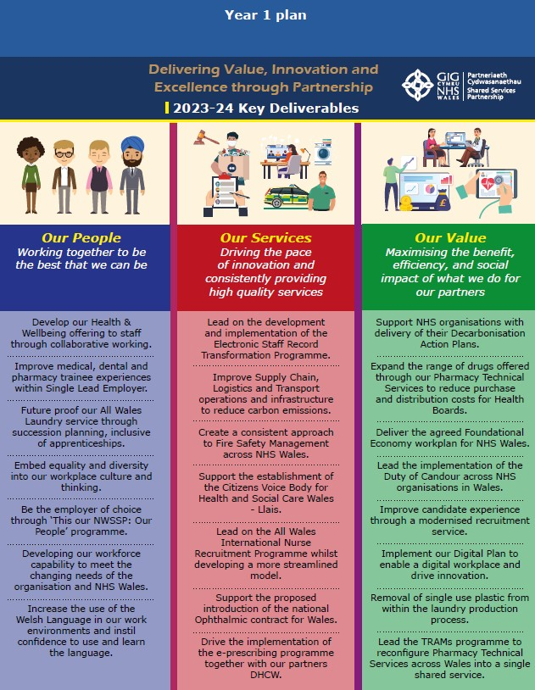



NHS Wales Shared Services Partnership
Welsh Language Annual Performance Report 2021-2022

Contents:
- Introduction 3
- Background 4
- Accountability and Support 4
- Service Delivery Standards 5
- Policy Making Standards 6
- Operational Standards 6
- Record Keeping Standards 8
- Projects & Translation Services 12
- Priorities for 2022/23 14

Introduction

This report is NHS Wales Shared Services Partnership’s (NWSSP) third Welsh Language Annual Performance Report, reporting on the period from 1st of April 2021 to 31st March 2022.

NHS Wales Shared Services continues in its commitment to deliver our services in both languages and also to encourage confidence in the use of the Welsh language day to day at work in NWSSP.

Circumstances remained challenging for us as an organisation during 2021/22 where staff have been working to achieve the delivery of its goals in the context of the COVID19 pandemic, whilst catching up with operations, project and plans that were put on hold during the previous year. We continue to have to review our priorities to address, respond and support other NHS organisations during the pandemic.

NWSSP continued to work during difficult and challenging times during 2021/22, where plans were made, were rapidly implemented, and are reassessed daily to meet shifting and changing demands. Staff have demonstrated, and are still demonstrating, dedication and commitment to ensuring that our service-users receive their service in their language of choice and that a bilingual service is provided.

Background – The Duty of the Welsh Language Standards
The Welsh Language (Wales) Measure 2011 establishes a legal framework that places a duty on NHS Wales Shared Services Partnership (NWSSP) to comply with the Welsh Language Standards (no.7) in relation to the Welsh language.

The individual standards explain how we are expected to:
- Develop and deliver our services through the medium of Welsh.
- Develop and implement policies and protocols that support the use of the Welsh language.
- Ensure that the Welsh language is considered and incorporated into our operational plans.
- Report on our performance annually.

The Language Standards are divided into five specific areas:
- service delivery
- policy making
- operational standards
- record keeping

As a hosted organisation of Velindre NHS Trust, NWSSP received a compliance notice from the Welsh Language Commissioner under Section 4 of the Welsh Language (Wales) Measure 2011, on 30 May 2019. This notice specifies the precise standards the NWSSP is required to comply with.

This is the third Welsh Language Standards Annual Report to be published by NWSSP.

We are immensely proud of our achievements during 2021/22, where we’ve been able to adapt our plans to meet the ever-changing circumstances we’ve found ourselves during the Covid 19 pandemic. The majority of our services continued to be delivered through the medium of Welsh, despite staff working from home, and having to prioritise and re-focussing our resources to address the challenges the pandemic presented to us as an organisation and the wider NHS in Wales. The year ahead still remains uncertain and undoubtedly will present further challenges. We intend to retain an agile working model as part of our plans for the future and the Welsh language is at the heart of our future plans.

Accountability and Support
Alongside the Welsh Language Services Manager, the Director of People and Organisational Development is the executive lead for the Welsh language in NWSSP.

There is a network of Welsh Language Co-ordinators in each division who work closely with the Welsh Language Unit and the Translation Team in providing advice, guidance and support regarding the Welsh Language Standards and promoting the use of the Welsh language internally.

We also have a team of Translators at NWSSP to support us as an organisation in delivering Welsh language services as well as supporting other NHS organisations. During this year, we’ve also established a bank of translators in order to deliver our translation services to a wider client base within NHS Wales

Service Delivery Standards
We have continued to comply with the service delivery standards during the year under the challenges of the pandemic.

- Written Correspondence (Standards 1 – 7)
- Telephone Services (Standards 8 – 20)
- Meetings and events (Standards 21 – 33)
- Producing and Publishing Documents (Standards 34 – 38)
- Website, social media, Apps (Standards 39 – 46)
- Signage (Standards 47- 49)
- Reception Services (Standards 50 – 53)
- Procurement and Contracts (Standards 57 – 59)
- Communications and Corporate Identity (Standards 60 – 62)
- Public Address systems – (Standard 64)

Several guidelines have been published and reviewed/updated for staff outlining the requirements in relation to compliance with the Standards. The guidelines are available on our Welsh support page on the intranet. Managers are aware of the availability of the guidelines and continue to advise their teams to familiarise themselves with the information and guidance made available to them. The Guidelines include:
- Protocol on written correspondence
- Protocol for answering and phone bilingually and handling Welsh calls received
- A guide for reception staff in welcoming visitors to our buildings/offices across Wales
- A Protocol on arranging and conducting meetings and public meetings bilingually
- Writing in Welsh – handy phrases
- Templates – signs, forms etc
- Guidance for web authoring and the use of social media
- Guidance on signage and public address systems
- Communications and corporate identity
- Welsh language considerations in the publication of procurement documents and specification of tenders detailing contractual obligations on the contracting/sub-contracting of services on behalf of NHS Wales.

Regular communication is distributed to staff across the organisation about the Welsh language standards, the importance of offering a Welsh language service, respecting the customer’s choice. Staff are referred to the intranet Welsh language support page for this information.
Since the implementation of the Welsh language standards, the demand on our Welsh language translation team has continued to increase, and 2020/21 has been no exception.

The demand for our translation services are increasing to unprecedented levels, and have been greater than ever ensuring that communication directly associated with the pandemic has been available from NWSSP. We have also been supporting other NHS organisations in communicating effectively with the public, and patients directly about Covid-19 through the medium of Welsh.

Complaints/Concerns received regarding services:
A complaint was received through the Welsh Language Commissioner’s office in April 2021, about the lack of Welsh language services in our payroll division.

Following an internal investigation, we ensured that all staff were aware that a protocol is in place to respond to enquiries received through the medium of Welsh and all members of staff must follow that protocol.

Additional training was given to all Payroll staff across our offices in north, south east and south west Wales.

We reported to the Commissioner’s Office on the steps we were taking to address the complaint and no further investigation was required by the Commissioner’s Office at that time.

Policy Making Standards
All NWSSP policies are provided by Velindre NHS Trust.

Any protocols that we develop locally are required to undergo a comprehensive equality impact assessment. This provides the opportunity to give specific reference to the Welsh language, where the protocol would influence the use of the Welsh language as part of the organisations service delivery. The Welsh language is embedded in the decision-making processes across the organisation. The Welsh Language Services liaises with the Corporate Services Manager with regards to protocols and EQIA’s for service development proposals.

We have ensured that all relevant documents related to employment are available through the medium of Welsh. Contracts of employment are sent to staff in both Welsh and English. A review of all People & OD documents has been undertaken during 2021-22, and all documents are complaint with the requirements of the Welsh language standards.

Operational Standards:
Internal Administration (Standards 79 – 82)
Complaints (Standards 83 – 85)
Disciplinary Cases (Standards 86 – 88)
Information Technology, the intranet and apps (89 – 95) Developing Welsh language skills (Standards 96 – 105) Recruiting and appointing (Standards 106 – 109)
Signage and notices in the workplace (Standards 111 – 113)

Internal Administration:
As previously mentioned, there are designated pages on the organisation’s intranet page on the internal use of the Welsh language that staff can access to promote and increase the use of the Welsh language at work.

Documentation relating to staff employment as well as documentation such as performance objective setting, and career planning documents are available bilingually. All Wales policies such as Behaviour in the workplace, Absence from work and Health and well-being at work are available in both Welsh and English and published on intranet. The Welsh Language Services Manager has been supporting NHS Employers Wales on bilingual matters and translation support for all Wales policies.

Technology, Intranet and Apps.
The intranet pages outlined in our compliance notice are available in Welsh. There is a Welsh language support page for staff to access on our intranet site.
A review of the People and Organisational Development pages will be undertaken in 2022/23 to ensure that any new policies/reviewed policies are available through the medium of Welsh.

Cysgliad is available to all staff to download to their computers/laptops and the use of Cysgliad by Welsh learners or those members of staff who are less confident in using the language.

We continuously update staff of any apps that are available to them to support them in using the Welsh language at work on a daily basis.

TRAC/NHS Jobs 3
We continue to update the interfaces, documents, notifications and forms on the TRAC recruitment system, the Student Awards System, the Student Streamlining System and the GP Wales System.
NHS Jobs3 was launched during 2021/22 and this launched successfully in both languages at the same time.

ESR – Electronic Staff Record
ESR is the Electronic Staff Record that manages staff annual leave, pay, sickness absence and training across the NHS in Wales. NHS Wales has a 6% share in ESR across the UK, and the current ESR system, which was originally developed to manage payroll payments, has been extended on to such a point where it is technologically challenging to translate the whole system.
However, in the autumn of 2021, NWSSP’s Workforce Information Systems and the Welsh Language Unit worked in collaboration with the NHS Business Authority and IBM to translate the portlets on ESR, by creating a skin over the existing portlets. We are pleased to report that Health Boards and Trusts have welcomed this development.

Training and Learning Welsh at Work:
During 2021/2021, we recruited 110 staff into vacancies at NWSSP. All new members of staff have received Corporate Induction, which includes Welsh Language awareness training. Training is now provided on two platforms, TEAMS or Zoom.

Microsoft TEAMS has been the platform used for training and learning Welsh at work. This platform has made learning Welsh and enabling staff to commit to completing the course much easier. It has also enabled tutors to record sessions so that staff can re-visit the learning and classes that they may have missed. Staff attendance and retention rates have improved, due to the courses being available online. However, prioritising workload remains challenging to managers and staff.
The following courses were offered to staff during 2021/22:
- Entry Level 1, 2 x 30-week courses. 32 members of staff attending
- Entry Level 2, 1 x 30-week course. 6 members of staff attending
- Foundation Level 2, 1 x 2 30-week course. 6 members of staff attending
- Intermediate Level 30-week course. 10 members of staff
- Higher Level 30-week course. 8 members of staff.

In addition to these mainstream courses, we’ve offered staff the opportunity to meet and use their Welsh language skills in ‘Clybiau Clonc’ to practice their Welsh in those sessions in order to support

staff who are learning Welsh or staff wanting to increase confidence in using their Welsh. We’ve hosted a number of those sessions for each level during the year, resulting in 52 members of staff attending those sessions.

We have also responded and supported staff wishing to learn Welsh in their own time, enabling them to attend Welsh courses in the community outside of work hours, as this arrangement suits these members of staff better than learning Welsh during working hours.
We recognise the importance to offer flexibility to our staff to learn Welsh and to make the learning of the language accessible and easy to reach. We have a number of staff who wish to learn some basic practical phrases, and we’ve tailored some sessions to cover the following areas and provided learning opportunities to a number of staff by providing these:

- 10 Welsh Language Taster courses during year (one off 2 hour courses) 37 members of staff attended.
- 6 Welsh Language Opening/Closing and chairing meetings in Welsh (one off 2 hour courses) 42 members of staff attended.
- 6 Greeting and welcoming (on off 2 hour courses) to 22 members of staff

We regularly promote the opportunities to learn Welsh to all our staff across all our sites.
We also regularly promote opportunities to use the Welsh language at work and socially in local communities.

Recruiting and appointing staff
In the later part of 2021/22 we’ve undertaken a consultation on a local protocol on the advertising, recruiting and appointing staff. This piece of work has been considerable, with stakeholders from People and OD, Employment Services and the NWSSP Welsh Language Unit.

The protocol will be launched in the 1st quarter of 2022/23, where all NWSSP vacancies will be advertised bilingually. This will enable us to be compliant with Standards 106, 106A, 107, 107A.

Record Keeping Standards:

Welsh Language Skills Across the Workforce:
All members of staff are required to complete a Welsh language skills assessment on the electronic staff record platform. During 2020/21 we saw a drop in the number of staff recording their skills during the year, this was in most part due to the pandemic, and staff working from home and the establishment of the single lead employer programme.
We have been addressing this by taking the following steps to improve skills recording:
- Reduce the number of staff not recorded on ESR – deteriorating position due to Covid-19 mass recruitment. The Welsh Language Services Manager and the People and Organisational Development team intend to identify any gaps and reach out to managers and supervisors in order to capture the missing data.
- Identify members of staff who have not recorded their skills and communicate directly with those members of staff with a ‘how to’ guide to record their skills on ESR.
- To put in place a strategy to encourage those on level 0 to move to level 1.

We have publicised the online taster sessions and have put on taster sessions for staff during the year to enable them to record their speaking level as Level 1.
- To put in place a strategy to encourage those on level 1 to move to level 2.
- To put in place a strategy to encourage those on level 2 to move to level 3.
We have produced an animation in both Welsh and English to enable staff to identify the correct level to record on ESR. We’ve also produced a guide to help staff find where to record Welsh language skills on ESR. We’ve identified that the majority of staff do have level 1 speaking skills, but they have a confidence issue in terms of using the Welsh language skills that they have.

Welsh Language Skills - Speaking & Understanding
1% recorded Level 4
2% recorded Level 2
3 % of staff recorded Level 5
2% recorded Level 2
7% recorded Level 1

37% of staff have not recorded skills on ESR.

48% of staff recorded that they have no understanding of the


Welsh Language Skills - Reading
2% recorded Level 3
1% recorded Level 4
2% recorded Level 2
3 % of staff recorded Level 5
7% recorded Level 1
37% of staff have not
recorded skills on ESR.
48% of staff recorded that they
have no understanding of the language


Welsh Language Skills - Writting
2% recorded Level 3
2% recorded Level 2
5% recorded Level 1
1% recorded Level 4
3% recorded Level 5
38% of staff didn't record skills
49% of recorded Level skills in writing.

New and vacant posts:
The table below details posts that were advertised between 1st of April 2021 and 31st of March 2022:

Total Number of vacancies advertised 01/04/2020 to 31/03/2021 | 735
Total Number of vacancies advertised as Welsh Essential | 8
Total Number of vacancies advertised as Welsh Desirable | 682
Total Number of vacancies advertised as Welsh Needs to be Learnt | 0
*Total Number of vacancies advertised as Welsh not a required skill | 45

*The vacancies that were advertised as ‘Welsh not a required skill’ were internal vacancies for internal candidates within the organisation and had been assessed for language skills requirements.

Projects and Translation Services 2021/22:

Translation Support Services
The Welsh Language Unit, in NHS Wales Shared Services Partnership have provided translation services for the following NHS organisations during 2021/22:
  - NHS Wales Shared Services Partnership’s divisions and hosted programmes
  - Public Health Wales NHS Trust
  - Digital Health and Care Wales
  - Velindre University NHS Trust
  - Health Education Improvement Wales
  - Wales Ambulance Service Trust in the translation of the 111 Website
  - Welsh Health Specialised Services Committee
  - The All Wales Value in Health Care programme
  - Supported NHS Employers in the translation of Job Descriptions and Person Specifications
Totalling over 4.5million words translated during 2021/22, through 2437 separate requests.
Over the last 6 years there has been a significant increase in the demand for Welsh Language translation services. The diagram below shows an increase of 1878.59% increase between 2016-17 and 2021-22.

We intend to invest further in our translation resources in 2022/23 which will enable us to provide further support to NHS organisations in 2023/24 onwards.
Demand for NWSSP Translation Services over 6 years
5,000,000
4,500,000
4,000,000
3,500,000
3,000,000
2,500,000
2,000,000
1,500,000
1,000,000
500,000
0
2016-17 2017-18 2018-19 2019-20 2020-21 2021-22

NWSSP 2,917,390 words
62%
WAST - 120,000 words (2.5%)
VIHC - 30,000 words (0.5%)
WHSSC 50,000 words
(1%)

HEIW – 100,000 words (3%)
VUNHST 250,000 words
(6%)
DHCW 500,000 words (SLA) (11%)
PHW – 600,000 words (SLA) (14%)
Translation services provided to NHS Organisations by NWSSP's Welsh Language Unit 2021/2022

We had an a SLA in place to support PHW, DHCW and VUNHST during 2021/22 and will continue to support these organisations in 2022/23.

We took on work for WHSSC in Q3 and Q4 of the financial year to assist with enabling compliance.

We took on work for HEIW and WAST in Q4 to assist with additional translation requirements.

Establishment of a Translation Bank
The NHS is facing unprecedented demand for translation services, this is in response to meeting the requirements of the Welsh language standards in the most part, but also to respond to the need/demand amongst patients and the public.
It is becoming increasingly difficult to recruit qualified and experienced translators to full- time permanent vacancies, and it is also becoming challenging to retain staff, due to the recruitment market being extremely competitive.
In order to be able to respond to this situation we’ve established a bank of translators who can work flexibly for us as we require their services. The bank was established in autumn 2021, and our existing arrangements are working well to date. Our approach to agile working also means that we are able to recruit translators from different parts of Wales and beyond to assist us with our ability to respond to the demand for translation services.

Student Streamlining
NHS Wales Shares Services have improved the customer journey through Student Streamlining Service by ensuring that the system provides a Welsh language journey throughout the process.
We audited and reviewed our processes, automated services, and templates to ensure that there is now a seamless Welsh language offer to students engaging with our service.
As part of this project, we also translated adverts and job descriptions to enable Health Boards to be able to advertise the opportunities through the Student Streamlining programme through both the medium of Welsh and English.

All Wales Patient Information Leaflets
We undertook a comprehensive audit and review of over 350 Patient Information Leaflets during 2021/22. The leaflets are given to patients as part of the consent process. The audit and review enabled us to make improvements to the language used in the leaflets, to have consistency in terminology as well as making the leaflets wholly bilingual for patients in Wales. Previously Welsh and English versions were available separately. This work will continue in 2022/23 with work being undertaken in partnership with Eido Healthcare to translate easy read versions of the leaflets.

ESR Portlets available in Welsh
The Welsh Language Unit and the Workforce Information Systems team at NHS Wales Shared Services Partnership worked collaboratively with the NHS Business Services Authority and IBM on the development of Welsh Language Portlets on ESR in the autumn of
2021. This now means that the portals on ESR are available to NHS Staff in both Welsh and English in order to satisfy the requirements of Standard 81 of the Operational Standards.

Contact Centre Review Project
The purpose of this review project was to audit our existing centre services, establish how our customers currently engage with us, identify improvements, and to increase and improve the self-serve element of the services we provide.
As part of this work, the Welsh language provision of services was also scrutinised, and a survey circulated to NHS staff identified that between 10% and 20% of NHS staff wished to engage with us through the medium of Welsh.
Further work will be undertaken with contact centres throughout NWSSP over the coming year, with a view to create local action plans to increase capacity within customer service/helplines to offer more of our services through the medium of Welsh.

TRAC Recruitment system updates
We have continued to work with the developers of the TRAC system to ensure that the interface for the system continues to be up-to-date and consistent in both Welsh and English.

Informed Consent & Capacity Course for NHS Wales Staff
The Welsh Risk Pool and the All Wales Committee have created an educational module about patient consent for NHS staff. The course’s focus is on critical elements of informed consent, and we have ensured that there is a specific section on making staff aware about the importance and the right of a patient to be able to consent in their language of choice. We worked in collaboration with Betsi Cadwaladr University Health Board on the production of a video that outlines the importance of communication in the consent and capacity course for NHS clinicians across NHS Wales.

The Foundational Economy in Wales
Over the course of the last two years, the focus on the ability to offer hybrid working for staff and looking closer at the foundational economy has become an important part of service planning and delivery. We are looking closer at the opportunities that the

Foundational Economy will bring and capitalise on this in order to increase our capacity in delivering bilingual services.

Priority Areas for 2022/23
- Increase capacity to train more staff in language awareness.
(We eagerly await the launch of the Welsh Government funded Welsh Language Awareness Module for ESR for NHS Staff, we are currently awaiting launch date).
- Create a Croeso Cymraeg booklet for all new members of staff to NWSSP.
- Increase interest in learning Welsh and up-skilling the workforce, targeting areas where we need to increase capacity to deliver more robust bilingual services.
- Promote a 10 hour online self-taught course to all staff scoring 0 Skills to Skill level 1.
- Review our communication plan to engage with staff across the organisation
- To become fully compliant with Standards 106A and 107A(Ch).
- A communications and training programme for recruitment managers regarding Standards 106, 106A, 107, 107A.
- Procurement of a system that will support Student Streamlining and Student Awards to offer a fully bilingual service to customers.
- A review of our Contact Centres and how we respond to customers through the medium of Welsh, with a view to increase capacity and resource to deliver more robust bilingual services.
- Continue to support NHS Organisations with translation services.
- Recruitment Identification System that will function bilingually.
- Occupational Health System that will operate with bilingual functions
- Translation of easy read patient information leaflets for Welsh Risk Pool, Health Boards and Trust from English to Welsh.
- More Than Just Words Strategy 2022 – 2027 Action Plan for NWSSP, integrated with the Welsh Language Standards.
- Capitalise on the Foundational Economy Agenda in Wales to be able to optimise our bilingual services.
- Work with the People and Organisational Development team and external stakeholders to expand on the widening access to us as an employer of choice.

Adroddiad Perfformiad Blynyddol yr Iaith Gymraeg 2021-2022 Partneriaeth Cydwasanaethau GIG Cymru

Cynnwys:
- Cyflwyniad 3
- Cefndir 4
- Atebolrwydd a Chymorth 4
- Safonau Cyflenwi Gwasanaethau 5
- Safonau Llunio Polisi 6
- Safonau Gweithredu 6
- Safonau Cadw Cofnodion 8
- Prosiectau a Gwasanaethau Cyfieithu 12
- Blaenoriaethau ar gyfer 2022/23 14

Cyflwyniad

Dyma drydydd Adroddiad Perfformiad Blynyddol yr Iaith Gymraeg Partneriaeth Cydwasanaethau GIG Cymru (PCGC). Mae’n adrodd ar y cyfnod rhwng 1 Ebrill 2021 a 31 Mawrth 2022.

Mae Partneriaeth Cydwasanaethau GIG Cymru yn parhau i ymrwymo i ddarparu ein gwasanaethau yn y ddwy iaith a hefyd i annog hyder wrth ddefnyddio’r Gymraeg yn y gwaith o ddydd i ddydd yn PCGC.

Roedd amgylchiadau’n parhau i fod yn heriol i ni fel sefydliad yn ystod 2021/22. Bu’r staff yn gweithio tuag at gyflawni nodau’r Bartneriaeth yng nghyd-destun pandemig COVID19, a hynny wrth ddal i fyny â gweithrediadau, prosiectau a chynlluniau a gafodd eu gohirio yn ystod y flwyddyn flaenorol. Mae’n rhaid i ni barhau i adolygu ein blaenoriaethau er mwyn ystyried gofynion sefydliadau eraill y GIG, ymateb iddynt a’u cefnogi yn ystod y pandemig.

Parhaodd PCGC i weithio yn ystod cyfnod anodd a heriol drwy gydol 2021/22. Gwnaethpwyd cynlluniau, cawsant eu gweithredu’n gyflym a’u hailasesu’n ddyddiol i fodloni gofynion cyfnewidiol. Mae’r staff wedi dangos, ac yn parhau i ddangos, ymroddiad ac ymrwymiad i sicrhau bod ein defnyddwyr gwasanaeth yn derbyn eu gwasanaethau yn eu dewis iaith a bod gwasanaeth dwyieithog yn cael ei ddarparu.

Cefndir – Dyletswydd Safonau'r Gymraeg
Mae Mesur y Gymraeg (Cymru) 2011 yn sefydlu fframwaith cyfreithiol sy’n gosod dyletswydd ar Bartneriaeth Cydwasanaethau GIG Cymru (PCGC) i gydymffurfio â Safonau’r Gymraeg (rhif 7) mewn perthynas â’r Gymraeg.

Mae’r safonau unigol yn egluro sut y disgwylir i ni wneud y canlynol:
- Datblygu a darparu ein gwasanaethau drwy gyfrwng y Gymraeg.
- Datblygu a gweithredu polisïau a phrotocolau sy’n cefnogi’r defnydd o’r Gymraeg.
- Sicrhau bod y Gymraeg yn cael ei hystyried a’i hymgorffori yn ein cynlluniau gweithredol.
- Adrodd ar ein perfformiad yn flynyddol.

Rhennir y Safonau Iaith yn bum maes penodol:
- darparu gwasanaethau
- llunio polisi
- safonau gweithredu
- cadw cofnodion

Fel sefydliad a letyir gan Ymddiriedolaeth GIG Felindre, derbyniodd PCGC hysbysiad cydymffurfio gan Gomisiynydd y Gymraeg o dan Adran 4 o Fesur y Gymraeg (Cymru) 2011, ar 30 Mai 2019. Mae’r hysbysiad hwn yn nodi’r union safonau y mae’n ofynnol i PCGC gydymffurfio â nhw.

Dyma drydydd Adroddiad Blynyddol yr Iaith Gymraeg a gyhoeddir gan Bartneriaeth Cydwasanaethau GIG Cymru.

Rydym yn hynod falch o'r hyn yr ydym wedi’i gyflawni yn ystod 2021/22. Rydym wedi gallu addasu ein cynlluniau i gwrdd ag amgylchiadau cyfnewidiol pandemig Covid-19. Parhaodd y mwyafrif o’n gwasanaethau i gael eu darparu drwy gyfrwng y Gymraeg, er bod staff yn gweithio o gartref. Bu’n rhaid blaenoriaethu ac ail-ffocysu ein hadnoddau i fynd i’r afael â’r heriau a wynebom fel sefydliad a’r GIG ehangach yng Nghymru yn sgil y pandemig. Mae'r flwyddyn i ddod yn parhau i fod yn ansicr ac yn ddi-os bydd yn dod â heriau pellach. Rydym yn bwriadu cadw model gweithio ystwyth fel rhan o’n cynlluniau ar gyfer y dyfodol ac mae’r Gymraeg wrth galon y cynlluniau hynny.

Atebolrwydd a Chymorth
Ochr yn ochr â Rheolwr Gwasanaethau’r Gymraeg, y Cyfarwyddwr Pobl a Datblygu Sefydliadol yw arweinydd gweithredol y Gymraeg yn PCGC.

Mae rhwydwaith o Gydlynwyr Iaith Gymraeg ym mhob isadran sy’n gweithio’n agos gyda’r Uned Iaith Gymraeg a’r Tîm Cyfieithu i ddarparu cyngor, arweiniad a chefnogaeth ynghylch Safonau’r Gymraeg a hyrwyddo’r defnydd o’r Gymraeg yn fewnol.

Mae gennym hefyd dîm o Gyfieithwyr yn PCGC i’n cefnogi ni fel sefydliad i ddarparu gwasanaethau Cymraeg yn ogystal â chefnogi sefydliadau eraill y GIG. Yn ystod y flwyddyn hon, rydym hefyd wedi sefydlu banc o gyfieithwyr er mwyn darparu ein gwasanaethau cyfieithu i sylfaen ehangach o gleientiaid yn GIG Cymru.

Safonau Cyflenwi Gwasanaethau
Rydym wedi parhau i gydymffurfio â’r safonau cyflenwi gwasanaethau yn ystod y flwyddyn yn sgil heriau’r pandemig.

- Gohebiaeth Ysgrifenedig (Safonau 1 – 7)
- Gwasanaethau Ffôn (Safonau 8 – 20)
- Cyfarfodydd a Digwyddiadau (Safonau 21 – 33)
- Creu a Chyhoeddi Dogfennau (Safonau 34 – 38)
- Y Wefan, Cyfryngau Cymdeithasol, Apiau (Safonau 39 – 46)
- Arwyddion (Safonau 47- 49)
- Gwasanaethau’r Dderbynfa (Safonau 50 – 53)
- Caffael a Chontractau (Safonau 57 – 59)
- Cyfathrebu a Hunaniaeth Gorfforaethol (Safonau 60 – 62)
- Systemau Annerch Cyhoeddus – (Safon 64)

Mae nifer o ganllawiau wedi'u cyhoeddi a'u hadolygu/diweddaru sy'n amlinellu'r gofynion mewn perthynas â chydymffurfio â'r Safonau ar gyfer staff. Mae’r canllawiau ar gael ar ein tudalen cymorth Cymraeg ar y fewnrwyd. Mae rheolwyr yn ymwybodol bod y canllawiau ar gael ac yn parhau i gynghori eu timau i ymgyfarwyddo â'r wybodaeth a'r arweiniad sydd ar gael iddynt. Mae’r Canllawiau’n cynnwys:
- Protocol ar ohebiaeth ysgrifenedig
- Protocol ar gyfer ateb y ffôn yn ddwyieithog ac ymdrin â’r galwadau Cymraeg a dderbynnir
- Canllaw i staff y derbynfeydd ar gyfer croesawu ymwelwyr i’n hadeiladau/swyddfeydd ledled Cymru
- Protocol ar drefnu a chynnal cyfarfodydd a chyfarfodydd cyhoeddus yn ddwyieithog
- Ysgrifennu yn Gymraeg – ymadroddion defnyddiol
- Templedi – arwyddion, ffurflenni ac ati
- Canllawiau ar gyfer ysgrifennu cynnwys ar gyfer y we a defnyddio’r cyfryngau cymdeithasol
- Canllawiau ar gyfer arwyddion a systemau annerch cyhoeddus
- Cyfathrebiadau a hunaniaeth gorfforaethol
- Ystyriaethau’r Gymraeg wrth gyhoeddi dogfennau caffael a manylebau tendrau sy’n manylu ar rwymedigaethau cytundebol ar gontractio/is-gontractio gwasanaethau ar ran GIG Cymru.

Cyfathrebir â staff ar draws y sefydliad yn gyson am Safonau’r Gymraeg, pwysigrwydd cynnig gwasanaeth Cymraeg a pharchu dewis y cwsmer. Cyfeirir staff at dudalen cymorth iaith Gymraeg y fewnrwyd i gael yr wybodaeth hon.
Ers cyflwyno Safonau’r Gymraeg, mae’r galw ar ein tîm cyfieithu wedi parhau i gynyddu, ac ni fu 2020/21 yn eithriad.

Mae’r galw am ein gwasanaethau cyfieithu yn cynyddu i lefelau digynsail, ac wedi bod yn fwy nag erioed. Mae hyn wedi sicrhau bod cyfathrebiadau sy’n gysylltiedig yn uniongyrchol â’r pandemig wedi bod ar gael gan Bartneriaeth Cydwasanaethau GIG Cymru. Rydym hefyd wedi bod yn cefnogi sefydliadau eraill y GIG i gyfathrebu’n effeithiol â’r cyhoedd a chleifion yn uniongyrchol am Covid-19 drwy gyfrwng y Gymraeg.

Cwynion/Pryderon a dderbyniwyd ynghylch gwasanaethau:
Derbyniwyd cwyn drwy swyddfa Comisiynydd y Gymraeg ym mis Ebrill 2021, am y diffyg gwasanaethau Cymraeg yn is-adran y gyflogres.
Yn dilyn ymchwiliad mewnol, sicrhawyd bod yr holl staff yn ymwybodol bod protocol yn ei le i ymateb i ymholiadau a dderbynnir trwy gyfrwng y Gymraeg a bod yn rhaid i bob aelod o staff ddilyn y protocol hwnnw.

Rhoddwyd hyfforddiant ychwanegol i holl staff y Gyflogres ar draws ein swyddfeydd yng ngogledd, de-ddwyrain a de-orllewin Cymru.

Gwnaethom hysbysu Swyddfa'r Comisiynydd ar y camau yr oeddem yn eu cymryd i fynd i'r afael â'r
gŵyn ac ni fu angen i Swyddfa'r Comisiynydd gynnal ymchwiliad pellach bryd hynny.

Safonau Llunio Polisi
Darperir holl bolisïau PCGC gan Ymddiriedolaeth GIG Felindre.

Mae'n ofynnol i unrhyw brotocolau a ddatblygwn yn lleol gael asesiad cynhwysfawr o'u heffaith ar gydraddoldeb. Mae hyn yn rhoi’r cyfle i gyfeirio’n benodol at y Gymraeg, pan fyddai’r protocol yn dylanwadu ar y defnydd o’r Gymraeg fel rhan o ddarpariaeth gwasanaeth y sefydliad. Mae’r Gymraeg wedi’i gwreiddio yn y broses o wneud penderfyniadau ar draws y sefydliad. Mae Rheolwr Gwasanaethau’r Gymraeg yn cysylltu â'r Rheolwr Gwasanaethau Corfforaethol mewn perthynas â phrotocolau ac Asesiadau o’r Effaith ar Gydraddoldeb ar gyfer cynigion i ddatblygu gwasanaethau.

Rydym wedi sicrhau bod yr holl ddogfennau perthnasol sy'n ymwneud â chyflogaeth ar gael trwy gyfrwng y Gymraeg. Anfonir cytundebau cyflogaeth at staff yn Gymraeg ac yn Saesneg. Cynhaliwyd adolygiad o holl ddogfennau Pobl a Datblygu Sefydliadol yn ystod 2021-22, ac mae pob dogfen yn cydymffurfio â gofynion Safonau’r Gymraeg.

Safonau Gweithredol:
Gweinyddu Mewnol (Safonau 79 – 82)
Cwynion (Safonau 83 – 85)
Achosion Disgyblu (Safonau 86 – 88)
Technoleg Gwybodaeth, y Fewnrwyd ac Apiau (89 – 95) Datblygu Sgiliau Iaith Gymraeg (Safonau 96 – 105) Recriwtio a Phenodi (Safonau 106 – 109)
Arwyddion a Hysbysiadau yn y Gweithle (Safonau 111 – 113)

Gweinyddu mewnol:
Fel y soniwyd eisoes, mae tudalennau dynodedig ar dudalen fewnrwyd y sefydliad ar y defnydd mewnol o’r Gymraeg y gall staff eu darllen i hyrwyddo a chynyddu’r defnydd o’r Gymraeg yn y gwaith.

Mae dogfennau sy'n ymwneud â chyflogi staff yn ogystal â dogfennau megis gosod amcanion perfformiad, a dogfennau cynllunio gyrfa ar gael yn ddwyieithog. Mae polisïau Cymru Gyfan megis Ymddygiad yn y Gweithle, Absenoldeb o'r Gwaith ac Iechyd a Llesiant yn y Gwaith ar gael yn Gymraeg ac yn Saesneg ac maent wedi'u cyhoeddi ar y fewnrwyd. Mae Rheolwr Gwasanaethau’r

Gymraeg wedi bod yn cefnogi Cyflogwyr GIG Cymru ar faterion dwyieithog a chymorth cyfieithu ar gyfer polisïau Cymru Gyfan.

Technoleg, Mewnrwyd ac Apiau.
Mae'r tudalennau mewnrwyd a amlinellir yn ein hysbysiad cydymffurfio ar gael yn Gymraeg. Mae tudalen cymorth iaith Gymraeg y gall staff gael mynediad iddi ar ein safle mewnrwyd. Cynhelir adolygiad o’r tudalennau Pobl a Datblygiad Sefydliadol yn 2022/23 i sicrhau bod unrhyw bolisïau newydd/polisiau sydd wedi cael eu hadolygu ar gael drwy gyfrwng y Gymraeg.

Mae Cysgliad ar gael i'r holl staff ei lawrlwytho i'w cyfrifiaduron/gliniaduron a gall y sawl sy’n dysgu’r Gymraeg neu aelodau staff sy’n llai hyderus wrth ddefnyddio’r iaith ei ddefnyddio hefyd.

Rydym yn diweddaru staff yn barhaus am unrhyw apiau sydd ar gael iddynt i’w cefnogi i ddefnyddio’r Gymraeg yn y gwaith yn ddyddiol.

TRAC/NHS Jobs 3
Rydym yn parhau i ddiweddaru’r rhyngwynebau, dogfennau, hysbysiadau a ffurflenni ar system recriwtio TRAC, y System Dyfarniadau Myfyrwyr, y System Symleiddio i Fyfyrwyr a System GPWales. Lansiwyd NHS Jobs3 yn ystod 2021/22 ac fe’i lansiwyd yn llwyddiannus yn y ddwy iaith ar yr un pryd.

ESR – Cofnod Staff Electronig
ESR yw’r Cofnod Staff Electronig sy’n rheoli gwyliau blynyddol, tâl, absenoldeb salwch a hyfforddiant staff ar draws GIG Cymru. Mae gan GIG Cymru gyfran o 6% yn y Cofnod Staff Electronig ar draws y DU. Mae’n dechnegol heriol i gyfieithu’r system ESR gyfan sydd ohoni, a ddatblygwyd yn wreiddiol i reoli taliadau’r gyflogres, gan ei bod wedi cael ei hymestyn gymaint.
Fodd bynnag, yn hydref 2021, gweithiodd Systemau Gwybodaeth y Gweithlu PCGC ac Uned y Gymraeg ar y cyd ag Awdurdod Busnes y GIG ac IBM i gyfieithu pyrth ESR, drwy roi croen dros y pyrth presennol. Mae'n bleser gennym adrodd bod Byrddau Iechyd ac Ymddiriedolaethau wedi croesawu'r datblygiad hwn.

Hyfforddiant a Dysgu’r Gymraeg yn y Gweithle:
Yn ystod 2021/2022, fe wnaethom recriwtio 110 o staff i swyddi gwag yn PCGC. Mae pob aelod newydd o staff wedi derbyn sesiwn Ymsefydlu Corfforaethol, sy'n cynnwys hyfforddiant ymwybyddiaeth o'r Gymraeg. Bellach, darperir hyfforddiant ar ddau blatfform, sef TEAMS neu Zoom.

Defnyddir y platfform Microsoft Teams ar gyfer rhoi hyfforddiant ynglŷn a’r Gymraeg ac ar gyfer dysgu’r Gymraeg yn y gweithle. Mae’r platfform hwn wedi galluogi staff i ymrwymo i gwblhau’r cwrs yn llawer haws ac wedi hwyluso dysgu’r Gymraeg yn sylweddol. Mae hefyd wedi galluogi tiwtoriaid i recordio sesiynau fel y gall staff ailymweld â’r hyn a ddysgwyd a’r dosbarthiadau nad oedd modd iddynt fod yn bresennol ynddynt. Mae cyfraddau presenoldeb a chadw staff wedi gwella, oherwydd bod y cyrsiau ar gael ar-lein. Fodd bynnag, mae blaenoriaethu’r llwyth gwaith yn parhau i fod yn heriol i reolwyr a staff.

Cynigwyd y cyrsiau canlynol i staff yn ystod 2021/22:
- 2 gwrs 30 wythnos Lefel Mynediad 1 Mynychodd 32 aelod o staff
- 1 cwrs 30 wythnos Lefel Mynediad 2 Mynychodd 6 aelod o staff
- 1 cwrs 30 wythnos Lefel Sylfaen 2 Mynychodd 6 aelod o staff
- Cwrs Lefel Canolradd 30 wythnos. 10 aelod o staff
- Cwrs Lefel Uwch 30 wythnos. 8 aelod o staff.

Yn ogystal â’r cyrsiau prif ffrwd hyn, rydym wedi cynnig y cyfle i staff gwrdd â’i gilydd a defnyddio ac ymarfer eu sgiliau Cymraeg mewn sesiynau Clybiau Clonc er mwyn cefnogi staff sy’n dysgu Cymraeg neu staff sydd eisiau gwella eu hyder wrth ddefnyddio’r Gymraeg. Rydym wedi cynnal nifer o'r sesiynau hynny ar bob lefel yn ystod y flwyddyn a daeth 52 aelod o staff i’r sesiynau hynny.

Rydym hefyd wedi ymateb i staff sy’n dymuno dysgu Cymraeg yn eu hamser eu hunain a’u cefnogi, gan eu galluogi i fynychu cyrsiau Cymraeg yn y gymuned y tu allan i oriau gwaith, gan fod y trefniant hwn yn haws i’r aelodau hyn o staff na dysgu’r Gymraeg yn ystod oriau gwaith.
Rydym yn cydnabod pwysigrwydd cynnig hyblygrwydd i’n staff ddysgu’r Gymraeg a’i gwneud yn hygyrch ac yn hawdd ei chyrraedd. Mae gennym nifer o staff sy’n dymuno dysgu ymadroddion ymarferol sylfaenol ac rydym wedi teilwra sesiynau i gwmpasu’r meysydd canlynol ac wedi darparu cyfleoedd dysgu i nifer o staff drwy ddarparu’r canlynol:

- 10 cwrs Blasu’r Gymraeg yn ystod y flwyddyn (cyrsiau 2 awr untro) bu 37 aelod o staff yn bresennol.
- 6 chwrs untro dwy awr o hyd ar Agor/Cau a chadeirio cyfarfodydd yn y Gymraeg. Bu 42 aelod o staff yn bresennol.
- 6 chwrs cyfarch a chroesawu untro 2 awr o hyd i 22 aelod o staff

Rydym yn hyrwyddo’n rheolaidd y cyfleoedd i ddysgu Cymraeg i’n holl staff ar draws pob safle. Rydym hefyd yn hyrwyddo’n gyson gyfleoedd i ddefnyddio’r Gymraeg yn y gwaith ac yn gymdeithasol mewn cymunedau lleol.

Recriwtio a phenodi staff
Yn ystod rhan olaf 2021/22 rydym wedi cynnal ymgynghoriad ar brotocol lleol ar hysbysebu, recriwtio a phenodi staff. Gwnaed y darn sylweddol hwn o waith gyda rhanddeiliaid o’r Gyfarwyddiaeth Pobl a Datblygu Sefydliadol, Gwasanaethau Cyflogaeth ac Uned Iaith Gymraeg PCGC.

Bydd y protocol yn cael ei lansio yn ystod chwarter cyntaf 2022/23, pan fydd holl swyddi gwag PCGC yn cael eu hysbysebu’n ddwyieithog. Bydd hyn yn ein galluogi i gydymffurfio â Safonau 106, 106A, 107 a 107A.

Safonau Cadw Cofnodion:

Sgiliau Cymraeg ar draws y Gweithlu:
Mae'n ofynnol i bob aelod o staff gwblhau asesiad sgiliau iaith Gymraeg ar blatfform y cofnod staff electronig. Gwelsom ostyngiad yn nifer y staff a gofnododd eu sgiliau yn ystod y flwyddyn 2020/21.

Roedd hyn yn bennaf oherwydd y pandemig, ac oherwydd bod staff yn gweithio gartref a sefydlu’r rhaglen Un Cyflogwr Arweiniol.
Rydym wedi bod yn mynd i’r afael â hyn drwy gymryd y camau canlynol i wella cofnodi sgiliau:
- Lleihau nifer y staff nad ydynt wedi'u cofnodi ar yr ESR - sefyllfa sy'n gwaethygu o ganlyniad i’r recriwtio torfol a wnaed oherwydd Covid-19. Mae Rheolwr Gwasanaethau’r Gymraeg a'r tîm Pobl a Datblygu Sefydliadol yn bwriadu nodi unrhyw fylchau ac estyn allan at reolwyr a goruchwylwyr er mwyn casglu'r data sydd ar goll.
- Nodi aelodau o staff nad ydynt wedi cofnodi eu sgiliau a chyfathrebu'n uniongyrchol â'r aelodau hynny o staff gan roi canllawiau iddynt allu cofnodi eu sgiliau ar ESR.
- Rhoi strategaeth ar waith i annog y rhai sydd ar lefel 0 i symud i lefel 1.
Rydym wedi rhoi cyhoeddusrwydd i’r sesiynau blasu ar-lein ac wedi cynnal sesiynau blasu ar gyfer staff yn ystod y flwyddyn i’w galluogi i gofnodi bod ganddynt Gymraeg Lefel 1.
- Rhoi strategaeth ar waith i annog y rhai ar lefel 1 i symud i lefel 2.
- Rhoi strategaeth ar waith i annog y rhai ar lefel 2 i symud i lefel 3.
Rydym wedi creu animeiddiad yn y Gymraeg a'r Saesneg i alluogi staff i ddewis eu lefel yn gywir a’i chofnodi ar ESR. Rydym hefyd wedi creu canllaw i helpu staff i ddod o hyd i’r man iawn i gofnodi eu sgiliau Cymraeg ar ESR. Rydym wedi nodi bod gan fwyafrif y staff sgiliau siarad lefel 1, ond nid oes ganddynt ddigon o hyder i ddefnyddio'r sgiliau Cymraeg sydd ganddynt.

Sgiliau Cymraeg - Siarad a Deall
Cofnododd 1% Lefel 4
Cofnododd 2% Lefel 2
Cofnododd 3% o'r staff Lefel 5
Cofnododd 2% Lefel 2
Cofnododd 7% Lefel 1

Nid yw 37% o'r staff wedi cofnodi'u sgiliau ar ESR.

Mae 48% o'r staff wedi cofnodi nad oes ganddynt ddim dealltwriaeth o'r iaith

Sgiliau Cymraeg - Darllen
Cofnododd 2% Lefel 3
Cofnododd 1% Lefel 4
Cofnododd 2% Lefel 2
Cofnododd 3% Lefel 5
Cofnododd 7% Lefel 1
Nid yw 37% o'r staff wedi
cofnodi'u sgiliau ar ESR.
Mae 48% o'r staff wedi cofnodi nad
oes ganddynt ddim dealltwriaeth o'r iaith

Sgiliau Cymraeg - Ysgrifennu
Cofnododd 2% Lefel 3
Cofnododd 2% Lefel 2
Cofnododd 5% Lefel 1
Cofnododd 1% Lefel 4
Cofnododd 3% Lefel 5
Nid yw 38% o'r staff wedi
cofnodi'u sgiliau ar ESR
Mae 49% o'r staff wedi cofnodi nad oes
ganddynt dim sgiliau ysgrifennu

Swyddi newydd a gwag:
Mae’r tabl isod yn manylu ar y swyddi a hysbysebwyd rhwng 1 Ebrill 2021 a 31 Mawrth 2022:

Cyfanswm nifer y swyddi gwag a hysbysebwyd 01/04/2020 hyd at 31/03/2021 | 735
Cyfanswm nifer y swyddi gwag a hysbysebwyd fel rhai Cymraeg yn Hanfodol | 8
Cyfanswm nifer y swyddi gwag a hysbysebwyd fel Cymraeg yn Ddymunol | 682
Cyfanswm nifer y swyddi gwag a hysbysebwyd fel Angen Dysgu Cymraeg | 0
*Cyfanswm nifer y swyddi gwag a hysbysebwyd fel rhai Cymraeg ddim yn sgil gofynnol | 45

*Roedd y swyddi gwag a hysbysebwyd fel 'Cymraeg ddim yn sgil gofynnol' yn swyddi gwag mewnol ar gyfer ymgeiswyr mewnol o fewn y sefydliad ac roeddent wedi eu hasesu ar gyfer gofynion sgiliau iaith.

Prosiectau a Gwasanaethau Cyfieithu 2021/22:

Gwasanaethau Cymorth Cyfieithu
Mae Uned y Gymraeg Partneriaeth Cydwasanaethau GIG Cymru wedi darparu gwasanaethau cyfieithu ar gyfer y sefydliadau GIG canlynol yn ystod 2021/22:
  - Is-adrannau a rhaglenni a letyir gan Bartneriaeth Cydwasanaethau GIG Cymru
  - Ymddiriedolaeth GIG Iechyd Cyhoeddus Cymru
  - Iechyd a Gofal Digidol Cymru
  - Ymddiriedolaeth GIG Prifysgol Felindre
  - Addysg a Gwella Iechyd Cymru
  - Ymddiriedolaeth Gwasanaeth Ambiwlans Cymru o ran cyfieithu Gwefan 111
  - Pwyllgor Gwasanaethau Iechyd Arbenigol Cymru
  - Rhaglen Gwerth mewn Gofal Iechyd Cymru
  - Cefnogwyd Cyflogwyr y GIG i gyfieithu Swydd-ddisgrifiadau a Manylebau’r Person Cyfieithwyd cyfanswm o dros 4.5 miliwn o eiriau yn ystod 2021/22, a ddaeth i law drwy 2,437 o geisiadau ar wahân.
Dros y 6 blynedd diwethaf, bu cynnydd sylweddol yn y galw am wasanaethau cyfieithu Cymraeg. Mae'r diagram isod yn dangos cynnydd o 1878.59% rhwng
2016-17 a 2021-22.

Rydym yn bwriadu buddsoddi ymhellach yn ein hadnoddau cyfieithu yn ystod 2022/23 a fydd yn ein galluogi i ddarparu cymorth pellach i sefydliadau’r GIG yn 2023/24 ymlaen.
Y galw am wasanaethau cyfieithu PCGC dros 6 blynedd
5,000,000
4,500,000
4,000,000
3,500,000
3,000,000
2,500,000
2,000,000
1,500,000
1,000,000
500,000
0
2016-17 2017-18 2018-19 2019-20 2020-21 2021-22

2021/2022
WAST - 120,000 o eiriau (2.5%)
Canolfan Gwerth mewn Iechyd Cymru - 30,000 o eiriau
(0.5%)
WHSSC 50,000 o eiriau (1%)
Addysg a Gwella Iechyd Cymru – 100,000 o eiriau
(3%)
Ymddiriedolaeth GIG Prifysgol Felindre - 250,000 o eiriau (6%)
Iechyd a Gofal Digidol Cymru 500,000 o eiriau (Cytundeb Lefel Gwasanaeth) (11%)
Iechyd Cyhoeddus Cymru – 600,000 o eiriau (Cytundeb Lefel Gwasanaeth) (14%)
Gwasanaethau cyfieithu a ddarperir i Sefydliadau’r GIG gan Uned y Gymraeg Partneriaeth Cydwasanaethau GIG Cymru
Partneriaeth Cydwasanaethau GIG Cymru - 2,917,390 o eiriau 62%

Roedd gennym ni Gytundeb Lefel Gwasanaeth ar waith i gefnogi Iechyd Cyhoeddus Cymru, Iechyd a Gofal Digidol Cymru ac Ymddiriedolaeth GIG Prifysgol Felindre yn ystod 2021/22 a byddwn yn parhau i gefnogi’r sefydliadau hyn yn ystod 2022/23.

Gwnaethom ymgymryd â gwaith i Bwyllgor Gwasanaethau Iechyd Arbenigol Cymru yn ystod chwarter 3 a chwarter 4 y flwyddyn ariannol i’w helpu i gydymffurfio.

Gwnaethom dderbyn gwaith gan Addysg a Gwella Iechyd Cymru ac Ymddiriedolaeth GIG Gwasanaeth Ambiwlans Cymru yn ystod chwarter 4 i’w cynorthwyo gyda’u gofynion cyfieithu ychwanegol.

Sefydlu Banc Cyfieithu
Mae'r GIG yn wynebu galw digynsail am wasanaethau cyfieithu. Mae hyn mewn ymateb i fodloni gofynion Safonau'r Gymraeg yn bennaf, ond hefyd i ymateb i'r angen/galw ymysg cleifion a'r cyhoedd.
Mae'n dod yn fwyfwy anodd recriwtio cyfieithwyr cymwys a phrofiadol i swyddi gwag parhaol llawn amser, ac mae cadw staff yn mynd yn heriol hefyd, oherwydd bod y farchnad recriwtio yn hynod gystadleuol.
Er mwyn gallu ymateb i'r sefyllfa hon rydym wedi sefydlu banc o gyfieithwyr sy'n gallu gweithio'n hyblyg i ni wrth i ni fod angen eu gwasanaeth. Sefydlwyd y banc yn hydref 2021, ac mae ein trefniadau presennol yn gweithio'n dda hyd yma. Mae ein dull o weithio'n ystwyth hefyd yn golygu y gallwn recriwtio cyfieithwyr o wahanol rannau o Gymru a thu hwnt i'n cynorthwyo gyda'n gallu i ymateb i'r galw am wasanaethau cyfieithu.

Y Cynllun Symleiddio i Fyfyrwyr
Mae Partneriaeth Cydwasanaethau GIG Cymru wedi gwella taith y cwsmer drwy Wasanaeth Symleiddio i Fyfyrwyr drwy sicrhau bod y system yn darparu taith Gymraeg drwy gydol y broses.

Gwnaethom archwilio ac adolygu ein prosesau, ein gwasanaethau awtomataidd a'n templedi er mwyn sicrhau bod cynnig Cymraeg di-dor bellach ar gael i fyfyrwyr sy'n ymgysylltu â'n gwasanaeth.
Fel rhan o'r prosiect hwn, gwnaethom hefyd gyfieithu hysbysebion a swydd ddisgrifiadau i alluogi Byrddau Iechyd i hysbysebu'r cyfleoedd drwy'r rhaglen Symleiddio i Fyfyrwyr drwy gyfrwng y Gymraeg a'r Saesneg.

Taflenni Gwybodaeth i Gleifion Cymru Gyfan
Gwnaethom gynnal archwiliad ac adolygiad cynhwysfawr o dros 350 o Daflenni Gwybodaeth i Gleifion yn ystod 2021/22. Mae'r taflenni yn cael eu rhoi i gleifion fel rhan o'r broses gydsynio. Galluogodd yr archwiliad a'r adolygiad i ni wneud gwelliannau i'r iaith a ddefnyddir yn y taflenni, sicrhau cysondeb o ran terminoleg yn ogystal â gwneud y taflenni yn gwbl ddwyieithog i gleifion yng Nghymru. Cyn hynny roedd fersiynau Cymraeg a Saesneg ar gael ar wahân. Bydd hyn yn parhau yn 2022/23 gyda gwaith yn cael ei wneud mewn partneriaeth ag Eido Healthcare i gyfieithu fersiynau hawdd eu deall o'r taflenni.

Pyrth ESR ar gael yn Gymraeg
Gweithiodd Uned y Gymraeg a thîm Systemau Gwybodaeth y Gweithlu ym Mhartneriaeth Cydwasanaethau GIG Cymru ar y cyd ag Awdurdod Gwasanaethau Busnes y GIG ac IBM ar ddatblygu Pyrth Cymraeg ar ESR yn hydref 2021. Mae hyn bellach yn golygu bod y pyrth ar ESR ar gael i Staff y GIG yn Gymraeg ac yn Saesneg er mwyn bodloni gofynion Safon 81 y Safonau Gweithredol.

Prosiect Adolygu'r Ganolfan Gyswllt
Diben y prosiect adolygu hwn oedd archwilio gwasanaethau ein canolfannau presennol, sefydlu sut mae ein cwsmeriaid yn ymgysylltu â ni ar hyn o bryd, nodi gwelliannau, a chynyddu a gwella elfen hunanwasanaethu'r gwasanaethau a ddarparwn.
Fel rhan o'r gwaith hwn, craffwyd hefyd ar y gwasanaethau Cymraeg a ddarperir, a nododd arolwg a ddosbarthwyd i staff y GIG fod rhwng 10% ac 20% o staff y GIG yn dymuno ymgysylltu â ni drwy gyfrwng y Gymraeg.
Bydd gwaith pellach yn cael ei wneud gyda chanolfannau cyswllt ar draws PCGC yn ystod y flwyddyn i ddod. Bwriedir creu cynlluniau gweithredu lleol i gynyddu capasiti o fewn gwasanaethau cwsmeriaid/llinellau cymorth i gynnig mwy o’n gwasanaethau drwy gyfrwng y Gymraeg.

Diweddariadau i System Recriwtio TRAC
Rydym wedi parhau i weithio gyda datblygwyr system TRAC i sicrhau bod y rhyngwyneb ar gyfer y system yn parhau i fod yn gyfoes ac yn gyson yn y Gymraeg a'r Saesneg.

Cwrs Cydsynio ar sail Gwybodaeth a Galluedd ar gyfer staff GIG Cymru
Mae Cronfa Risg Cymru a’r Pwyllgor Cymru Gyfan wedi creu modiwl addysgol am gydsyniad cleifion ar gyfer staff y GIG. Mae ffocws y cwrs ar elfennau hollbwysig o gydsynio ar sail gwybodaeth, ac rydym wedi sicrhau bod adran benodol ar wneud staff yn ymwybodol o bwysigrwydd a hawl claf i allu cydsynio yn ei ddewis iaith. Buom yn gweithio ar y cyd â Bwrdd Iechyd Prifysgol Betsi Cadwaladr ar gynhyrchu fideo sy’n amlinellu pwysigrwydd cyfathrebu yn y cwrs cydsynio a galluedd ar gyfer clinigwyr ar draws GIG Cymru.

Yr Economi Sylfaenol yng Nghymru
Yn ystod y ddwy flynedd diwethaf, mae ffocysu ar gynnig cyfleoedd gweithio hybrid i staff ac edrych yn agosach ar yr economi sylfaenol wedi dod yn rhan bwysig o gynllunio a darparu gwasanaethau. Rydym yn edrych yn agosach ar y cyfleoedd a ddaw yn sgil yr Economi Sylfaenol ac yn manteisio ar hyn er mwyn cynyddu ein capasiti i ddarparu gwasanaethau dwyieithog.

Meysydd Blaenoriaeth ar gyfer 2022/23
- Cynyddu'r capasiti i hyfforddi mwy o staff ym maes ymwybyddiaeth iaith.
(Rydym yn aros yn eiddgar am lansiad y Modiwl Ymwybyddiaeth Iaith a ariennir gan Lywodraeth Cymru ar ESR ar gyfer staff y GIG. Rydym yn aros am ddyddiad lansio ar hyn o bryd).
- Creu llyfryn Croeso Cymraeg i bob aelod newydd o staff PCGC.
- Creu mwy o ddiddordeb mewn dysgu’r Gymraeg ac uwchsgilio’r gweithlu, gan dargedu meysydd lle mae angen i ni gynyddu capasiti i ddarparu gwasanaethau dwyieithog mwy cadarn.
- Hyrwyddo cwrs hunanddysgu 10 awr ar-lein i bob aelod o staff sy’n sgorio 0 am eu sgiliau Cymraeg er mwyn iddynt gyrraedd Sgil lefel 1.
- Adolygu ein cynllun cyfathrebu i ymgysylltu â staff ar draws y sefydliad
- Cydymffurfio'n llawn â Safonau 106A a 107A(Ch).
- Rhaglen gyfathrebu a hyfforddi ar gyfer rheolwyr recriwtio ynghylch Safonau 106, 106A, 107 a 107A.
- Caffael system a fydd yn cefnogi’r Cynllun Symleiddio i Fyfyrwyr a Gwasanaethau Dyfarniadau Myfyrwyr i gynnig gwasanaeth cwbl ddwyieithog i’w cwsmeriaid.
- Adolygu ein Canolfannau Cyswllt a sut rydym yn ymateb i gwsmeriaid drwy gyfrwng y Gymraeg, gyda’r bwriad o gynyddu capasiti ac adnoddau i ddarparu gwasanaethau dwyieithog mwy cadarn.
- Parhau i gefnogi Sefydliadau'r GIG drwy ddarparu gwasanaethau cyfieithu iddynt.
- System Adnabod Recriwtio a fydd yn gweithredu'n ddwyieithog.
- System Iechyd Galwedigaethol a fydd yn gweithredu gyda swyddogaethau dwyieithog
- Cyfieithu taflenni gwybodaeth hawdd eu deall o'r Saesneg i'r Gymraeg i gleifion ar gyfer Cronfa Risg Cymru, Byrddau Iechyd ac Ymddiriedolaethau.
- Strategaeth Mwy Na Geiriau 2022 – 2027 Cynllun Gweithredu ar gyfer PCGC, wedi’i integreiddio â Safonau’r Gymraeg.
- Manteisio ar Agenda’r Economi Sylfaenol yng Nghymru i allu optimeiddio ein gwasanaethau dwyieithog.
- Gweithio gyda'r tîm Pobl a Datblygu Sefydliadol a rhanddeiliaid allanol i ehangu mynediad i ni fel cyflogwr o ddewis.



MEETING | Velindre University NHS Trust Audit Committee for NHS Wales Shared Services Partnership
DATE | 24 January 2023
PREPARED BY | Carly Wilce, Corporate Services Manager
PRESENTED BY | Carly Wilce, Corporate Services Manager
RESPONSIBLE HEAD OF SERVICE | Andy Butler, Director of Finance and Corporate Services
TITLE OF REPORT | Audit Committee Forward Plan 2022-23
PURPOSE

To provide a summary of items expected to be presented at forthcoming Audit Committee meetings, scheduled for 2022-23.

Velindre University NHS Trust Audit Committee for NHS Wales Shared Services Partnership
Forward Plan 2022-23

Month | Standing Items | Audit Reports | Governance | Annual Items
Q1 2022/23  5 April 2022  Boardroom NWSSP HQ, Unit 4/5  Charnwood Court, Heol Billingsley, Parc Nantgarw, Cardiff, CF15 7QZ | Minutes & Matters Arising External Audit Position Statement Internal Audit Progress Report  Counter Fraud Position Statement | Internal Audit  As outlined in the Internal Audit Operational Plan  Review of Internal Audit Operational Plan | Governance Matters  Tracking of Audit Recommendations  Corporate Risk Register | Internal Audit Charter
or by Teams (as appropriate) | NWSSP Update
Q2 2022/23 13 July 2022  Boardroom NWSSP HQ, Unit 4/5  Charnwood Court, Heol Billingsley, Parc Nantgarw,  Cardiff, CF15 7QZ  or by Teams (as appropriate) | Minutes & Matters Arising External Audit Position Statement Internal Audit Progress Report  Counter Fraud Position Statement  NWSSP Update | Internal Audit  As outlined in the Internal Audit Operational Plan  Review of Internal Audit Operational Plan  External Audit  Audit Wales Nationally Hosted IT Systems Report | Governance Matters  Tracking of Audit Recommendations  Corporate Risk Register  Review of Audit Committee Terms of Reference | Final Annual Governance Statement  Head of Internal Audit Opinion and Annual Report  Gifts & Hospitality Annual Report Declarations of Interest Annual Report
 |  | Audit Wales Management Letter |  | Counter Fraud Annual Report and Review
 |  | Internal Audit Quality Assurance & Improvement Programme
Q3 2022/23  11 October 2022  Boardroom NWSSP HQ, Unit 4/5  Charnwood Court, Heol Billingsley, Parc Nantgarw, Cardiff, CF15 7QZ | Minutes & Matters Arising External Audit Position Statement Internal Audit Progress Report  Counter Fraud Position Statement | Internal Audit  As outlined in the Internal Audit Operational Plan | Governance Matters  Tracking of Audit Recommendations to include Annual Review of Audit Recommendations Not Yet Implemented  Corporate Risk Register | Audit Committee Effectiveness Survey Results  Audit Committee Annual Report NWSSP Annual Review  Information Governance Annual Report 2021-22

Velindre University NHS Trust Audit Committee for NHS Wales Shared Services Partnership
Forward Plan 2022-23

or by Teams (as appropriate) | NWSSP Update
Q4 2022/23  24 January 2023  Boardroom NWSSP HQ, Unit 4/5  Charnwood Court, Heol Billingsley, Parc Nantgarw,  Cardiff, CF15 7QZ  or by Teams (as appropriate) | Minutes & Matters Arising External Audit Position Statement Internal Audit Progress Report  Counter Fraud Position Statement  NWSSP Update | External Audit  Audit Wales Office Proposed Audit Work  Internal Audit  As outlined in the Internal Audit Operational Plan | Governance Matters  Tracking of Audit Recommendations  Corporate Risk Register  Review of Standing Orders for the Shared Services Partnership Committee | Pre-meet between Audit Committee Chair, Independent Members, Internal and External Auditors and Local Counter Fraud  Health & Care Standards Welsh Language Annual Report
 |  |  | Review of Risk Appetite Statement and Assurance Mapping

